

**The value and impact of Scotland’s libraries**

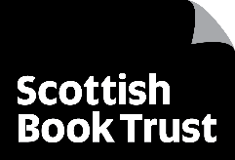

Preliminary findings from **primary school** librarian surveys

Report presented by Scottish Book Trust

Report authored by   
Éadaoín Lynch

10 December 2024

**scottishbooktrust.com**

**Contents**

Executive summary 4

Aims 4

Methods 4

Findings 5

Conclusion 8

Main findings 11

Settings and librarian roles 11

Local authority 11

Qualified librarians 12

Current role 13

Provision for primary school library services 16

Children and young people's reading for pleasure 22

Reading activities 24

Reading recommendations 26

Curriculum-based learning and the attainment gap 28

Poverty-related attainment gap 32

Digital inclusion: digital poverty, access and support 35

Digital inclusion: digital and media literacy 41

Active citizenship 43

Reaching a diverse audience 44

Safe spaces 45

Democratically engaged and informed communities 50

Final snapshot 52

Conclusion 55

References 57

## Executive summary

Beginning in Libraries Week 2023, Scottish Book Trust undertook an independent research project into the value and impact of both public and school libraries in Scotland, in partnership with the National Library of Scotland (NLS), the Scottish Library and Information Council (SLIC), and the Chartered Institute of Library and Information Professionals in Scotland (CILIPS).

Scotland's school libraries have no legal statutory duty for adequate library provision. Scotland's public libraries, though they do have a statutory duty for adequate library provision, have no enforced standard for what they must offer. As a result, across the public and school library sector, Scotland's communities face a lack of equitable access.

### Aims

Scottish Book Trust works across every local authority in Scotland, striving to offer opportunities for all people to tell their stories; as such, we are uniquely positioned to bear witness.

This research intends to showcase how both public and school libraries address inequality across many intersections of Scotland's communities, through the following thematic approaches:

* Reading for pleasure
* Learning opportunities / closing the poverty-related attainment gap
* Digital inclusion
* Active citizenship

### Methods

This interim report details preliminary findings from the survey completed by primary school librarians between October 2023 and January 2024.

A separate report details the findings from the secondary school librarian survey.

Further findings from in-depth librarian interviews, library user feedback, and quantitative data gathering will be available with the final report in early 2025.

There was one survey each for public librarians, primary school librarians and secondary school librarians. The response rate was positive:

1. Public librarian survey – 315 responses total  
   (The report arising from this survey is already available on the Scottish Book Trust website.)
2. Primary school librarian survey – 41 responses total
3. Secondary school librarian survey – 140 responses total

The low proportions in the response rate for primary school librarian findings may account for what the Great School Libraries statistic anticipated: where two-thirds of schools do not have a library budget, there will more than likely be no library, and therefore no librarian, to participate in research surveys.

A note on the term 'librarian': in this report, this term includes both qualified librarians and any other library staff seeking to support their service. School libraries are staffed variably by pupil volunteers, teachers, school management, and/or career librarians, all of whom have fed into these findings. The breakdown of qualified and unqualified librarians in the quantitative research serves to indicate those who have had specialised training in information management – it is not a value judgement on the quality of any one service. As such, 'librarian' in this report indicates any school library worker.

### Findings

Of the 41 primary school librarians (representing approximately 2% of Scotland's primary schools) who participated in the survey, these findings show that:

* Nearly 1 in 3 (29%) reported a restriction on funding / resources
* Over 2 in 5 (42%) receive provision from their local public library service
* Half (49%) noted their school library provision is managed by school staff – with a further 27% noting it is managed by volunteers

The small sample size means it is difficult to make broader conclusions, however, it is striking that these results generally correlate with the picture illustrated by the UK-wide stats as outlined in the 2023 Great School Libraries report[1]: almost a quarter (22%) of Scottish schools have no designated library space. Moreover, across all school types, Scotland has over a quarter fewer schools that have a dedicated member of staff for the library – 32% in Scotland vs. 41% for the whole of the UK.

Their report indicates further stark disparities across Scotland's school provision:

* '70% of [Scotland's] primary school libraries do not have a dedicated member of staff, the main reason for this being budget restrictions but a significant percentage shows that this is because the role can be fulfilled by another member of staff, which highlights the fact that school leaders do not fully appreciate what a great school librarian can do.'
* 'Only a quarter of schools in Scotland have a designated library budget compared with schools in England (25% compared to 36% in England).'

These research findings indicate a major, ongoing neglect of primary school libraries. In addition to constraints on staffing and funding, this report shows a concerning inconsistency of service, if not in some cases a profound lack, in promoting the four main themes of this research: reading for pleasure, digital access, closing the poverty-related attainment gap, and active citizenship.

Throughout this report it is important to note that primary school teachers are not necessarily trained in specialisms such as information literacy, research skills, or book selection, but continue to do their best to support the primary school library service in a librarian role.

However, without a well-stocked and designated library, or a qualified librarian, the quality of provision will be varied if not totally unpredictable. This situation effectively results in a postcode lottery as to whether or not pupils are appropriately supported or provided for by their library service.

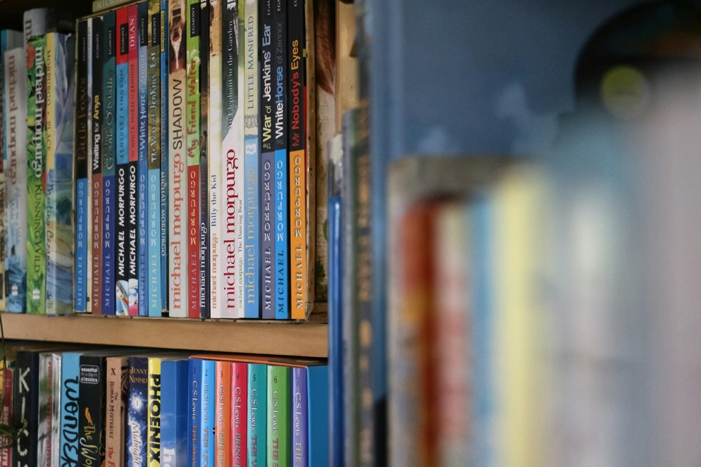

In promoting **reading for pleasure**, nearly 3 in 4 librarians (71%) noted time constraints as the barrier to offering reading recommendations or further support for pupil reading. 1 in 3 (32%) also cited capacity constraints, and a further 18% noted a lack of quality resources or access to appropriate stock:

* 'Too many other priorities. No new books.'

In closing the **poverty-related attainment gap**, 3 in 5 librarians (63%) feel the library is 'quite' or 'very' important in providing additional opportunities to their pupils (e.g. games clubs; creative writing clubs; coding class; ICT skills classes), yet over 2 in 5 (43%) reported their library offers none of these.

* 'We are continuing to struggle with cutbacks and reduced funding – to the extent that we have been told there will be no new books purchased this school year, and we've just had our Accelerated Reader program cut for our S1 and S2 pupils!'

Existing research confirms that one pupil in every five in the UK currently faces **digital poverty**, in a world that is increasingly online. These findings show 1 in 3 librarians reported that their school provides digital access, where 1 in 4 provide no digital devices or resource through the school library whatsoever.

Moreover, only 1 in 3 (33%) noted that the school supports pupils to develop media / digital literacy skills; 28% outlined that the library offers lessons on research skills or disinformation.

Over 3 in 4 librarians (78%) agreed their school library reaches a **strongly diversified audience.** When asked what barriers the library faces in providing a safe space, over a quarter (26%) of comments noted staffing constraints, 22% noted limited opening times, and 13% cited noise in the space (open plan or in a hallway). Nevertheless, 85% agreed their library offers a **safe space** to their pupils. For the 11% who 'neither agree nor disagree', they noted in comments that their pupils do not have access to the library without a class:

* 'It might be the most important thing. I like to think that I am welcoming towards everyone and anyone, that I will never discriminate and that I try to reflect our community in the stock I buy for the library (all sorts of ethnicities, LGBTQ+ people, disabled people). Kids who seem privileged from the outside can have issues of their own, such as around anxiety, learning differences or perceived difference from others. A library is an ideal place, in my opinion, to make everyone feel like they belong and to allow them to see themselves reflected in books.'

In addition to the final snapshot questions – which illustrated a reliance on the primary school library as a place that provides books, and aids reading skills and comprehension, but less so a service that can consistently offer additional learning opportunities, trusted sources of information, or more holistic social care in offering a quiet space – an overall picture emerges of how Scotland's primary school libraries are functioning.

### Conclusion

The evidence gathered from the librarian surveys clearly shows that school libraries have a profound, wide-ranging impact across all four themes of this research – reading for pleasure, learning opportunities, digital inclusion and active citizenship – and that they are crucial in addressing and resolving inequity.

Research from the Great School Libraries campaign illustrates a concerning picture for primary school libraries; in 2023, it reported that nearly 1 in 7 UK primary schools surveyed have no library space whatsoever[2]. Moreover, schools with high proportions of pupils in receipt of FSMs (free school meals) are less likely to have a library space, and if they do, it is open for fewer hours, has fewer physical resources, and is more likely to have had its budget cut[3].

Further research from the Primary School Library Alliance has also revealed that 25% of Scotland's state primary schools do not have a dedicated library area (more than twice the figure in England, where 11% do not have a dedicated library area)[4]. This is further reinforced by the Great School Libraries 2023 report:

'The proportion of schools with a designated school library area on-site varies by country; with nearly a quarter of schools [in Scotland] not having a school library space (22%).

Similarly, only a quarter of schools in Scotland have a designated library budget compared with schools in England (25% compared to 36% in England). Nearly two thirds (63%) report having no budget whatsoever; while 12% said they didn't know or would prefer not to say.'[5]

The findings below demonstrate an unpredictability across primary school library services, including responses from librarians based in private or independent schools where the picture is drastically different from their state school counterparts. Overall, there is a profound imbalance between how these services are supported, and an urgent need to build, support and promote state primary school library services.

There is no statutory requirement for Scotland's schools to have libraries, so there is no national standard for how they are run, stocked, accessed, or supported. Librarians across Scotland, many of whom have 10+ years of professional service, experience reduced job security, budgets, working space, time, and capacity against a backdrop of increasing demand / need for their services.

School libraries need funding, secure staffing provision and more public and management support to allow them to continue to be centres for unbiased information, a remedy for digital inequality, safe spaces without judgement or expectation, and a crucial point of contact to support pupil wellbeing and achievement.

Where the school library is promoted, supported and staffed appropriately, it will inevitably reach its intended community, offer a safe space, and empower people with reliable, freely accessible information.

Without those baseline supports, however, the library as a service is reduced to the library as a stockroom.

## 

## Main findings

### Settings and librarian roles

#### Local authority

The first question, which gained 41 responses, asked respondents to identify their local authority.

Just 12 local authorities in Scotland were represented in the primary school survey, with the highest response rates from Aberdeen City (37% of responses), South Lanarkshire (12%) and Aberdeenshire (10%).

Regarding the lowest response rates, potential causes are likely one of many. All local authorities across Scotland are facing budget cuts, which put a greater stress on librarians, who may feel unable to speak – even anonymously – to questions about their service, for fear of repercussions.

Findings from Great School Libraries' 2023 report[6] illustrate that nearly a quarter of schools in Scotland do not have a school library space, and two-thirds of school libraries in Scotland have no library budget at all. Ten years of service reductions in Scotland have left some local authorities with no librarians and many with one librarian serving between two or more schools[7].

In other words, the lower response rates could be indicative of the impact that library cuts and closures are already having on those communities.

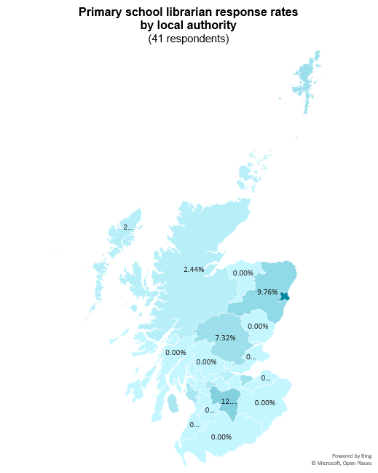

#### Qualified librarians

Each survey included a definition for a 'qualified librarian': 'someone who holds an undergraduate, postgraduate or Masters qualification obtained from a CILIP accredited course or has a level of CILIP Professional Registration such as Certification of Chartership'. Following this definition, respondents were asked if they were qualified librarians, which drew very mixed results:

Only 15% of responding librarians in primary schools are qualified.

Within this stat it is important to note that many primary school services are run by staff who will not see themselves as a 'librarian'. Reaching out to these informal librarians for responses is very difficult – few primary schools can access a qualified librarian, and most are served by volunteers.

#### Current role

The primary school librarian survey then sought further detail about the role the respondents played in their service. Results were much more split compared to the public librarian survey.

From those who chose 'Other (please specify)', there were three Depute / Depute Head Teachers, one parent, one pupil and one teacher.

The parent did not complete the survey, likely realising the survey was targeted at librarians.

The pupil did complete the survey, however, and their responses indicate their dedication to, and love of their library. In some open comment boxes at later points of the survey, they shared: 'Children need to read'; 'Our school is a school with ASN pupils as well as mainstream and every class gets a lesson at the library'.

15% of primary school librarian respondents were qualified librarians. When aligning this fact with the majority of their roles being split between 'teacher', 'librarian', 'assistant' and 'other', a clear picture emerges of how the library service runs in primary schools – libraries appear to be the main remit of teachers, deputes and assistants.

A similar unpredictability of experience was reflected in respondents' accumulated years of service to the library sector:

It is concerning to see that over one-third of respondents do not see themselves as working in a library-related role – likely because a teacher offering any extra time to the library service may not consider themselves to be 'working' there. This ad hoc approach indicates the reliance that many primary school libraries have on the volunteerism of the school staff, and the lack of structural support for their services.

Moreover, only 1 in 10 have a decade or more of experience in their role. Not only does this have an impact on the quality of the primary school library service, it indicates an overall lack of longevity in the sector.

### Provision for primary school library services

To gain a better picture of the current stresses on the primary school library service, the survey led with a question asking librarians to indicate from a checklist what restrictions or losses their service has recently faced.

The responses were strongly illustrative of how the school library sector is under-resourced and depleted:

Nearly 1 in 3 (29%) of responding primary school librarians reported a restriction on funding / resources. 1 in 10 reported a restriction on dedicated library space.

Out of the 1 in 5 librarians selecting 'other (please specify)', the open-ended comments reported:

* Loss of service or dedicated library space (22% of 'other' respondents)
  + 'At the moment our school doesn't have an in-school library. One of the reasons why the school library would be challenging to set up is the lack of adequate space and resources. Also, recently, the local library was shut down, which might have impacted young people and their ability to access books outside school.'
* Impact on community from closure of local public library (22% of 'other' respondents)
* Lack of adequate resources (22% of 'other' respondents)
* The service is dependent on parent volunteers (22% of 'other' respondents)
* Restricted opening hours; loss of school librarian; lack of adequate space (11% of 'other' respondents)
* Unsure (22% of 'other' respondents)

In seeking to understand what restrictions primary school libraries may be facing in running their service, the survey asked if the schools are funded by the relevant local authority:

Nearly three-quarters (71%) of respondents reported that their school is funded by their local authority; of the 5% that selected 'other (please specify)', they noted that their school is funded by 'integrated school / public library funded by local authority,' and a 'Leisure and Culture' Trust.

Many librarians reported their school also receives further external provision:

Over 2 in 5 primary school libraries receive provision from their local public library service.

Bearing in mind that librarians earlier in the survey reported a felt impact from the closure of the public library, this provision appears both important and unreliable.

Four librarians provided further comment:

* 'Visits for P1–3 and educational resources.'
* 'We haven't used them yet for books as we always used the SLO [Glasgow's School Library Outreach – defunct as of 2023[8]]. Now we are encouraged to use public libraries.'
* 'Don't know.'
* 'Don't think so, but I don't know for sure, I believe provision needs to come out of the school budget along with staff / parent donations.'

Because school libraries are not a statutory requirement in Scotland, there is no uniform standard for how they are accessed, stocked, supported or run – Scottish Book Trust asked primary school librarians to give insights into how their pupils can access the library service and when:

Only 24% of primary school librarians reported that pupils have open access to their library.

The overwhelming majority of respondents (83%) indicated that pupils access their school library as part of their individual class at set times. Additionally, 1 in 3 primary school librarians reported that pupils accessed the library at break time.

Out of the 1 in 5 librarians selecting 'other (please specify)', 44% of respondents reported restricted opening hours in their service, with a further 22% of respondents indicating their library is open for less than 12 hours a week:

* 'Availability for fortnightly class visits.'
* 'Access one afternoon 2–5 and 9.15–1pm two mornings.'
* 'I believe some teachers allow pupils to borrow books from the library outwith our set times but not sure to what extent the library space is used when we're not there.'
* 'Split public and school hours.'

In addition to better understanding when pupils can access their primary school library, the survey sought to understand what provision the library offered:

90% of respondents reported a dedicated library space in their school; 51% also reported book corners in all classrooms with a further 22% reporting book corners in some classrooms. 1 in 8 respondents reported there were library shelves in other shared spaces in their school. The one respondent who selected 'other (please specify)' noted that they had an 'outdoor library' space.

Considering the number of responses to this question – 41 total – compared to the number of primary schools in Scotland – 1,988[9] – there is a lack of sufficient data to reflect a 'typical' provision of the school library service. What this answer does indicate, however, is a dedication from engaged and aware school librarians.

Half of respondents (49%) noted their school library provision is managed by school staff – with a further quarter noting it is managed by a librarian (24%).

17% of respondents indicated their provision is managed by pupil assistants, and 27% by volunteers – this perhaps partly accounts for the majority of access to the library (83%) being allotted to individual classes at set times.

Of the 17% who chose 'other', comments ranged from 'School Library Assistant' or similar, to 'public library attached to primary school', 'the class teacher and PSA', 'Pupil Library Helpers', and 'unqualified "librarian"'.

Compared with the earlier finding that 85% of respondents were not qualified librarians, these stats demonstrate the ad hoc support given to primary school libraries across Scotland in the absence of a statutory requirement.

There is demonstrable evidence that appropriately trained school librarians contribute to improved student achievement, positive pupil engagement, improved reading skills and facilitating student learning[10]:

The most substantial and consistent finding is a positive relationship between full-time, qualified school librarians and scores in standardised tests of reading, writing, English language, arts[11].

### Children and young people's reading for pleasure

Sector research has proven the phenomenal statistic that whether or not a child enjoys reading is more important to their educational success than their family background. In other words, reading for pleasure is one of the most important indicators of a child's future success[12]. It is proven to support equity and wellbeing, impact learners' attainment, and encourage critical thinking, creativity, empathy and resilience[13]. Reading for pleasure can also tackle poverty[14].

When asked if, or how, the librarian or their library promotes children and young people's reading for pleasure, Scottish Book Trust received a wealth of responses (28 total) that showcase all the extra activities that primary school libraries across Scotland are running for their pupils:

* 1 in 4 librarians (25% of responses) noted reading challenges / competitions
* 1 in 4 librarians (25% of responses) also noted encouraging and diverse displays or stock
* Nearly 1 in 5 (18% of responses) noted recommendations from pupils and staff
* A further 14% of responses noted dedicated library lessons, storytelling events, and book events (like Book Week Scotland or World Book Day)

Their examples demonstrated the range of resilience and resourcefulness in schools across the country, as well as the challenges of promoting reading for pleasure:

* 'Organise Book Week around World Book Day. Provide books in multiple languages to promote equitable access, and encourage retention of mother tongue.'
* 'The school used to organise trips to the local library for the classes; however, this is no longer an option as it has now closed down. We also celebrate Book Week by implementing fun book-related activities where children can bring their own books to school and share what they like about them with their peers. The Nursery to P3 classes also receive a book gift from Santa each year.'
* 'We are only available to teenagers on Monday 4.3–5pm because of buses from secondary school and not open to 9–5pm parents.'
* 'Staff book club, where staff read and promote recent children's books. Posters of what staff are currently reading. Library helper scheme for older pupils, with first access to new books. A Battle of the Books-style house group quiz. A travelling book fair that gives commission to the school. Second-hand book sales. Regular book reviews between peers. Events for parents and infant children, like Books for Breakfast, where they share picture books before school. Storytelling for our associated pre-school. Book buddies between upper and lower school.'
* 'Provides access to online books like EPIC [[getepic.com](https://getepic.com)]. Personally, I think they are a poor substitute but there is no money to buy new books.'



#### Reading activities

Considering the barriers that librarians face in their schools, Scottish Book Trust sought to understand what, if any, activities their library was co-ordinating in the near future.

The most popular activity by far was [Book Week Scotland](https://www.scottishbooktrust.com/book-week-scotland) (47% of respondents), an annual celebration of books and reading that takes places across the country in November, run by Scottish Book Trust and supported by Creative Scotland and the Scottish Library and Information Council (SLIC).

This may be important for a number of reasons: organisations can apply for funding to run events as part of Book Week Scotland; schools will focus on reading for pleasure as part of Book Week Scotland or World Book Day – sustaining a reading culture outside of those date may be more variable; and Scottish Book Trust gifts free books to pupils in P1 as part of the Read, Write, Count programme.

The next most popular activity reported was storytelling sessions (35%), followed by author visits (26%) and book clubs / cafés (24%).

Notably, 21% of respondents noted that their library was due to co-ordinate 'none of the above.' That represents 1 in 5 of respondents whose library is not running any activity in the upcoming 12 months.

Of the 21% who chose 'other (please specify)', respondents noted:

* 'Recently, the school had a visit from the author of a book as part of the school assembly and took part in an illustration competition that included book awards. Also, our P1 classes had a storytelling session recently, which they enjoyed very much.'
* 'World Book Day.'
* 'Book fair.'
* 'The school itself co-ordinates some of these activities. Not the library.'
* 'Bookbug and Lego / design / Minecraft.'
* 'Family reading clubs and RWC [Read Write Count] family session.'
* 'I think we normally do activities around Book Week, and we take part in Summer [Reading] Challenge each year, I believe we're also working towards Reading Schools award.'

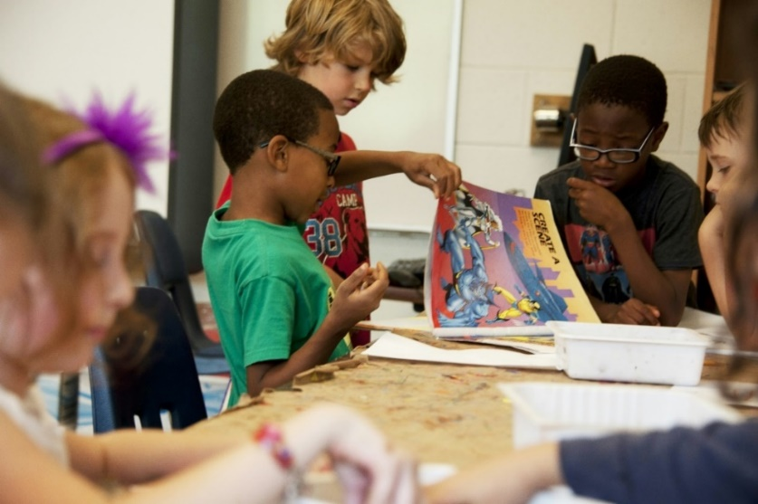

#### Reading recommendations

Having established that nearly 1 in 3 (29%) primary school librarians reported a restriction on funding / resources, and over 2 in 5 (42%) receive provision from the public library service, the survey asked librarians to reflect on how their school library caters to reading for pleasure, beginning with reading recommendations.

Over a third of respondents (35%) reported they recommend reading 'often / multiple times a week', with 'occasionally / weekly' being second most popular (29%), and 'daily / multiple times a day' coming in third (27%). Nearly 1 in 10 (9%) indicated they recommend reading 'once in a while / monthly' or 'never'.

Scottish Book Trust sought to understand the reason for this frequency, and asked librarians to reflect on what barriers they face to supporting pupil reading.

Of the 28 responses:

* Nearly 3 in 4 (71% of responses) cited their primary barrier as time constraints.
* Nearly 1 in 3 (32% of responses) cited capacity issues.
* A further 18% of responses noted a lack of quality resources or access to appropriate stock.

Some responses gave crucial detail on the stresses and successes of their school library provision, in reflecting on what barriers they face to supporting pupil reading:

* '1. Limited time in the library with a full class to get books checked back in and new books put in 15min slots with 2–3 volunteers the pupils are most often selecting themselves with those struggling offered not [a lot] of help.

Lack of knowledge base on what books we have in the library and what their genre / reading age etc. actually is.'

* 'Van delivery system has not been working well. One time waited five weeks for a delivery, meant to be every week. Van broken down or staff off.'
* 'Getting pupils to want to read rather than feeling like they have to due to class expectations.'
* 'Time, lack of resources. Class library funded by individual teachers. Not always the money to build an age-appropriate library to encourage reading.'
* 'Time constraints in service hours and own capacity. The requirements of providing children with the depth and breadth of learning experiences across all curricular areas limit your time to support pupil reading for pleasure only. However, regular weekly guided reading sessions and ERIC [Everyone Reading in Class] sessions are part of the learning routine. Children also have access to the books from the reading order in their free time.'
* 'Having a wide enough range of resources in suitable formats.'
* 'Too many other priorities. No new books.'

### Curriculum-based learning and the attainment gap

When asked what additional opportunities the school library offers to pupils, librarians provided mixed responses:

The same amount of respondents noted their library offered no additional opportunities, as those that reported running board games or games clubs (both 43%).

This divergence indicates a clear inconsistency across how different primary school libraries are managed.

The distribution of other responses – 1 in 5 noted their library offers digital skills / computing and IT, while in 1 in 10 noted coding class, creative writing opportunities and local history – further demonstrates this inconsistency.

Of the 13% who chose 'other (please specify)', their responses mentioned:

* 'STEM challenges and we have a dedicated STEM area for the children to explore and use.'
* 'Lego Club.'
* 'Bookbug and occasional craft sessions.'
* 'Not sure what all clubs school provides.'

Comparing this data to the average rating in the following question – 'On a scale of 1 (not at all important) to 5 (very important), how important would you say the library is in providing additional opportunities to pupils in your school?' – there is a demonstrable need for primary school libraries to be further resourced.

3 in 5 librarians feel the library is 'quite' or 'very' important in providing additional opportunities to pupils in their school.

When asked for comment, their responses shed light on this choice:

* 30% of respondents cited the importance of the school library as a safe, friendly, warm and inclusive space
  + 'Not all pupils are sporty or confident and the library offers a safe space for children to choose what they would like to do. Although the library is small there are defined areas for pupils to be able to sit on comfy chairs, sit at tables, lie down on rugs on the floor or on cushions. There are all types of books available and no judgement is made on what they choose to read. This is a safe, inclusive nonjudgmental space and I am also available to chat to or offer advice.'
* 17% cited the importance of books to children's development
  + 'Books are a massive source of imagination; without them, children's ability to write imaginatively is affected. Embedding reading for pleasure into their routine at school or home is crucial.'

Of those who chose 'a little important' (13%) or 'not at all important' (3%), many gave explanations to contextualise their choice:

* 'The library does feel a little confined to physical books due to the lack of technology supplied and the little time that students have access to the library. I try to involve myself in as many things as possible, but it's not as much as I would like.'
* 'We provide the children that wish it the chance to take a book home weekly so those that may not have their own at home have access to them.

The other skills / classes would require teacher or specialist input as myself and the other two volunteers don't have the knowledge base to provide them and are only there one morning a week.'

* 'The reason for selecting this option is due to the fact we do not have the staffing capacity to prove additional opportunities. If we had a dedicated librarian – even one day a week – it would be a wonderful opportunity to really promote the use of the space.'

Their comments also revealed the school library as a lifeline in the wider community, particularly those who are more remote, or in lower-income areas:

* 'We stay 25 miles away from the town centre therefore, the school library is a lifeline service to pupils and staff alike.'
* 'Lending digital technologies to [other] schools who would otherwise not have access to them. Offering STEM activities during holiday periods especially for low-income families is a great way of engaging children especially in holiday periods.'

### Poverty-related attainment gap

School libraries are proven to support improved attainment in their pupils[15]. SLIC's 2018 strategy *Vibrant Libraries, Thriving Schools* – written in partnership with COSLA and the Scottish Government – notes that:

'Professionally trained librarians and information experts drive improvement in all sectors of the education system and are central to reducing the attainment gap.'[16]

The link between school library provision and reduction of the poverty-related attainment gap relies on understanding the benefits of reading for mental health and wellbeing, improved literacy, as well as the necessity of access to a safe space and to reliable, accurate information.

No library can raise a child out of poverty or compensate for the barriers to learning they might face within and outwith their school – but all school libraries are crucial to offering a pupil the best chance of achieving those ends.

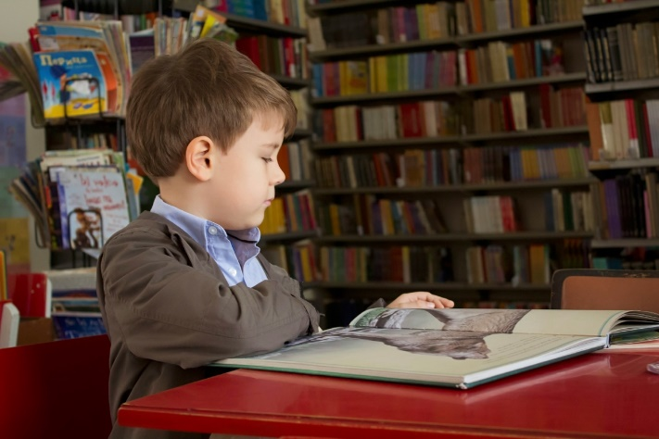

To better illustrate this point, the survey asked librarians to reflect on the ways they feel school libraries help (if at all) to close the poverty-related attainment gap. This was an open question with a comment box of unlimited length attached.

Their 28 responses centred on four main themes: free and equal access to books; access to books for families with no other provision; ability to loan or own books; and tailored support for pupils' literacy. Additional reflections included the benefits of reading for writing and language skills, encouraging reading for pleasure, and provision for the whole local authority.

* 'Giving all nursery – P3 book bags to take home during Book Week was a good way. Also that the library is there for everyone to use so those who can't afford books can borrow them and take out favourite books multiple times.'
* 'By encouraging pupils from all backgrounds to come to the library and choose books that can be taken home and shared with the family, for many this is their only opportunity to have books at home, parents are encouraged to visit the library at school and borrow books to read with their children.'

A small number of librarians also shared their honest responses about working in private schools that are less affected by poverty and the related attainment gap:

* 'We are a fee-paying school… so, whilst reading, and information inquiry figure, poverty is less likely to impact.'

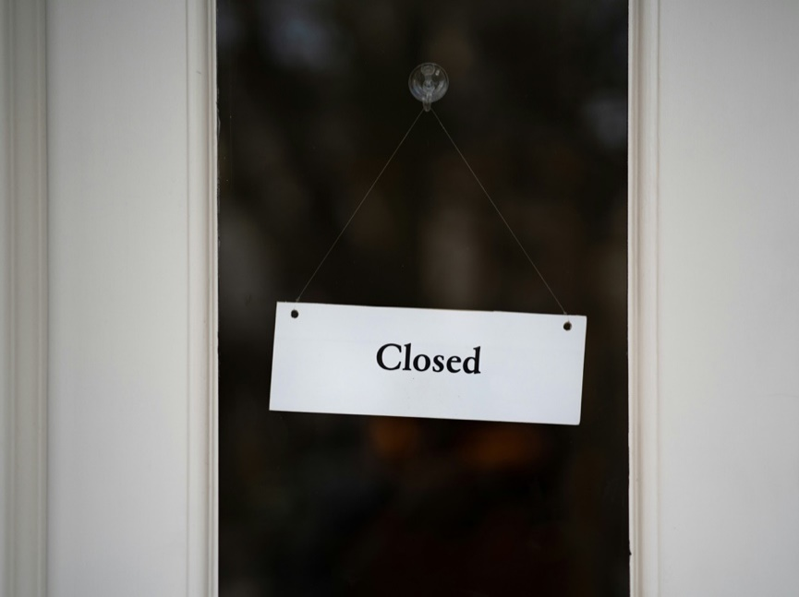

The survey then asked librarians to share what barriers (if any) their library faces to helping close the poverty-related attainment gap. Again, this was an open question with a comment box of unlimited length attached.

Their 30 responses focused on five main themes: poverty is a structural issue the library cannot solve alone; budgets / funding is insufficient; library provision needs to be kept high-quality and relevant; the school is doing its best but families need more help; and parental engagement is poor.

One librarian stressed that the school is actively trying to ameliorate the much wider structural problem of poverty:

* 'This is a massive question! In my opinion schools only play a very small part in this. Society needs help. Families need help from pre-birth to make decisions regarding affordability of having children… and ongoing needs of children and how to support with education. As a school we actively promote 'zero cost to the school day'… with all of what we have in place to support families we are still finding there is a poverty-related attainment gap.'

Alongside the school's best efforts to support the provision of services at low or no cost to pupils and their families, librarians reported their service is being cut back due to budget shortfalls:

* 'We are continuing to struggle with cutbacks and reduced funding – to the extent that we have been told there will be no new books purchased this school year, and we've just had our Accelerated Reader program cut...!'

In areas of lower income and greater economic disparity, librarians noted the challenge of overcoming shortfalls in school finance, as well as workarounds their school has adopted:

* 'Fundraising challenging, as many families are from low-income backgrounds and we don't want to keep asking them for funding.'
* 'My school have employed me. They recognised that they have amazing library space with lots of potential, but wasn't getting used. So I was employed to manage the library and turn it into an engaging inclusive place. I'm funded from the schools PEF funds [[Pupil Equity Funding](https://education.gov.scot/resources/pupil-equity-funding-looking-inwards-outwards-forwards-sharing-effective-practice-to-maximise-support-for-learners-and-practitioners/)] not the local council.'

Those who worked in private schools were again upfront about the comparably few barriers their pupils and school face, due to the absence of poverty:

* 'Most of our children are fortunate enough not to experience true poverty, which is actually quite embarrassing to type when I see the struggles others face.'

### Digital inclusion: digital poverty, access and support

Digital poverty is defined as 'the inability to interact with the online world fully, when, where, and how an individual needs to'[17] and includes people without access to a laptop / smart phone / tablet, or affordable, reliable internet.

When asked whether or not their school or its pupils face digital poverty, primary school librarians were split.

The high percentage of 'unsure' responses, when read alongside the comments offered, indicates the librarians' concern that their role is not in a position to observe or comment on pupils' home life or the wider community:

* 'I would expect some pupils from our school may – the children have access to digital technologies and internet related to their learning in school, it's likely that some may not have access at home (I'm aware that some were loaned tech to assist access to learning throughout the lockdown remote teaching period, but have no idea how many this would apply to).'
* 'As a volunteer I am unsure.'
* 'Generally this is an affluent area – but there are hidden pockets of deprivation.'
* 'We are a small island community and the school has good provision of ICT for the pupils. It is difficult to know if there are families who do not have the means to offer their children ICT at home.'
* 'I think at home many families face digital poverty, but provision of iPads to pupils in school is helping close some of the gap.'

Among these 'unsure' responses, the majority acknowledge deprivation in their area and the measures their school is undertaking to support.

Indeed, among the 36% of respondents who chose 'no', many comments indicate their answer was based on the provision offered by the school:

* 'We have a high number of devices and have targeted families that may need support in the form of a device to complete homework etc.'
* 'All pupils are provided with a Chromebook.'
* 'The school requires that students have their own Chromebook from P3.'

The qualitative data emerging from this question paints a clear picture of the digital inequality faced across the sector, and more nuanced than what was captured in a yes/no answer.

Moreover, these librarian comments indicate the extent to which primary school pupils rely on their schools to provide them with digital access and devices, regardless of SIMD decile or catchment area. This reliance is further evidenced in the question that follows:

2 in 5 respondents reported their school library offers computers with internet access for their pupils, and nearly the same amount offers photocopying / printing / scanning. 1 in 4 offer ebooks / eReaders and open access Wi-Fi.

Of the 18% who chose 'other digital equipment (please specify)', comments indicated that the school provides digital access, e.g. 'we have iPads and laptops – not through library'.

But 25% of respondents noted that their library offers none of these options – 1 in 4 of participating primary school libraries provide no digital devices or resource to their pupils.

In seeking to understand what financial barriers schools might face, librarians were asked if any of their library's digital resources were provided at a cost to the pupil.

The vast majority of respondents – 96% – indicated that digital resources are provided free of charge to their pupils.

Out of the 4% who chose 'Yes', two comments offered explanation for their choice:

* 'Printing – but this would only be undertaken outwith school time.'
* 'I only answered yes as we are a fee-paying school so the cost of these things is covered in tuition fees.'

Considering the prevalence and reliance on digital devices for education, Scottish Book Trust sought to further understand the value of digital provision in primary schools, from the librarians' perspective.

Well over three-quarters of respondents (78%) felt it was 'quite' or 'very' important that the library service supports digital access / inclusion for pupils.

In seeking to understand the role the library plays, in comparison to the whole school service, the survey prompted librarians to share individual examples of how the library supports digital access / inclusion for their pupils.

Out of 20 responses, two main themes emerged:

* 1 in 4 (20% of responses) noted that digital tools are crucial to their pupils
  + 'Although we don't have a school library, digital tools are crucial when using research skills. Also, for pupils who find writing and reading challenging, some apps, such as the Read and Write and Orbitnote apps, help them develop those skills.'
  + 'We live in a digital world and I feel it's very important that children can use technology to seek information but learn to do it safely and understand fake news etc., we do library lessons in fake news and research skills.'
* However, over 1 in 3 (35% of responses) noted that the school provides digital access, not the library service.
  + 'Our library does not support digital access for pupils. The school have ITU time that provides this.'
  + 'Our library does not but the school does – see touch screens, Chromebooks and desktops are available to pupils under direction of their teachers for certain learning tasks.'

Another respondent reported an unfortunate reality in their service: 'lack of a school librarian means lack of opportunity to work with pupils'.

### Digital inclusion: digital and media literacy

One of the greatest social challenges arising from digital poverty is reduced digital and media literacy. National Literacy Trust reported in 2018 that only 2% of children and young people in the UK currently have the skills they need to tell if a news story is real or fake[18].

School libraries can help their communities to parse disinformation (deliberately false data) and misinformation (false data, usually not deliberate), and understand how to keep their personal data safe online.

Scottish Book Trust asked primary school librarians if their library currently supports pupils with media / digital literacy skills.

When considering that the majority of respondents reported their library offers their pupils digital devices with Wi-Fi, there is a responding need for commensurate support in media / digital literacy. Here, the exact equal split between 'yes' and 'no' (each 43% of respondents) is better contextualised by the librarians' comments below, which illustrate that media / digital literacy skills are often provided by the school rather than the library service.

Out of 18 responses, two main themes emerged:

* The school supports pupils with media / digital literacy, not the library (33% of responses)
  + 'We don't have the school library; however, we fully support internet safety awareness. Through whole school assemblies and Houses, the children learn how to stay safe online and use digital tools safely. The school also share information with parents regarding all available workshops for parents.'
  + 'This is done in within the classrooms in the school not exclusively in the library. Our library is not a manned space, class teachers take their classes.'
  + 'That is under the remit of class teachers – again our volunteer parents are not qualified to do this.'
* The library offers lessons on research skills or disinformation (28% of responses)
  + 'We actually talk about this in library lessons. I do a series of lessons about information literacy in P6 and P7, and I also talk about it if I see students doing their own research (e.g. we have a boy who is extremely into trains and was making his own PowerPoint). I recently bought a book called 'Killer Underwear Invasion' by Elise Gravel, which is an amazing graphic novel-style non-fiction book about fake news and misinformation on the internet.'
  + 'Yes I provide library lessons in fake news and researching, I often do fun displays explaining what it means.'

Other comments noted the lack of a school librarian to support this; cooperation with parents; ad hoc requests from pupils rather than scheduled lessons; and no planned support provided in the school at all.

### Active citizenship

As the final theme of research, 'active citizenship' investigates the library's role in fostering pupils to be informed about their democratic rights and access, to be empowered to voice their concerns and decisions, and to engage with their local authority, all with the goal of shaping local and national services to their needs.

Research from SLIC[19] and CILIP[20] shows that libraries:

1. Reach a strongly diversified audience across all protected characteristics
2. Offer safe spaces for people to remain indefinitely, without expectation of payment
3. Provide access to trusted, accurate information which empowers communities to make informed decisions

In these ways, libraries are a key conduit to active citizenship for their community. In the school librarian survey, Scottish Book Trust asked questions to gather further evidence on each of these points: (1) reaching a diverse audience; (2) safe spaces; and (3) democratically engaged and informed communities.

Scotland's Curriculum for Excellence (CfE) is designed to support 'children and young people [to] gain the knowledge, skills and attributes needed for life in the 21st century'[21]. School libraries are key to delivering on the CfE's aspirations, in particular its focus on 'successful learners' and 'confident individuals' – not only because the library is a safe space, a support for literacy and personal development and a curated pathway to information, but also because the library is a central resource in school for the CfE's aims outwith subject silos.

#### Reaching a diverse audience

Over 3 in 4 librarians (78%) agreed their school library reaches a strongly diversified audience. Where 18% neither agreed nor disagree, they offered comments for their answer, for instance:

* 'We have a diverse community in terms of student and staff races and ethnicities but their backgrounds are broadly similar, in the sense that most people are upper-middle class and have not experienced real poverty or financial hardship. They have a similar level of access to education, and most of their parents have, too.'
* 'We have been working to ensure that all collections reflect the users in our library space while also offering books that create empathy around other groups. This is something that needs more work.'

In fact, a third of respondents (33%) noted that the main reason they felt their library reached a strongly diversified audience was due to the stock being inclusive. In addition, respondents shared their approach to inclusivity:

* 'Our local community is very diverse and our school has over 27 different languages spoken in it. We try to use this to learn about other countries and cultures.'
* 'We cover most bases; race, ethnicity, gender identity, sexuality, class, language, disability; but we're only open to school families, so, obviously, that rules out some people.'

One librarian working in an island community reflected the significance of the school library's outreach when sharing the limits of its access in their local authority:

* 'Our community is not especially racially diverse. We do reach all other members of our community with our school library.'

#### Safe spaces

To better understand the role of libraries as safe spaces – that is, a place that provides a physically and emotionally safe environment for a person or group of people, free of fear, bullying or harassment – Scottish Book Trust asked primary school librarians to what extent, on a scale of 1 (strongly disagree) to 5 (strongly agree), they agreed that their library offers a safe space to their pupils.

The scale was followed by an open comment box encouraging respondents to share how important they feel a safe space is for their school.

85% agreed their school library offers a safe space to their pupils. For those 11% who 'neither agree nor disagree' their comments illustrated the context, for example: 'pupils do not have access to the library without the class'.

Out of 21 responses, four main themes emerged:

* Being a safe space is key to a library's role (33% of comments)
  + 'I think it is one of the foundational roles of a school library and a key job of the school librarian – pupils should feel that they are safe and supported in the library and that they are reflected in the texts in the library and that they are respected in that space.

We can have a unique relationship with pupils due to the nature of our job and so it is one that should be safe for the pupils.'

* + 'The library as a safe space for students seems to be something that is universally recognised. Students often know that the library will be a good place for them before they've even stepped foot in it. There are so many expectations placed on students in all areas of the school building and the library can be a place for them where they're not expected to do anything but enjoy themselves.'
* Pupils need to feel respected and safe (43% of comments)
  + 'It might be the most important thing. I like to think that I am welcoming towards everyone and anyone, that I will never discriminate and that I try to reflect our community in the stock I buy for the library (all sorts of ethnicities, LGBTQ+ people, disabled people). Kids who seem privileged from the outside can have issues of their own, such as around anxiety, learning differences or perceived difference from others. A library is an ideal place, in my opinion, to make everyone feel like they belong and to allow them to see themselves reflected in books.'
* The library is an open, comfortable, inviting space (29% of comments)
  + 'A place where they can relax and choose a book get advice about books if needed.'
  + 'Chill zone, library reading time.'
* Pupils use the library as a time out when they need it (33% of comments)
  + 'Pupils have often chosen to come to the library when they feel overwhelmed in the rest of the school and pupils regularly comment on how they feel safe and loved in the library.'

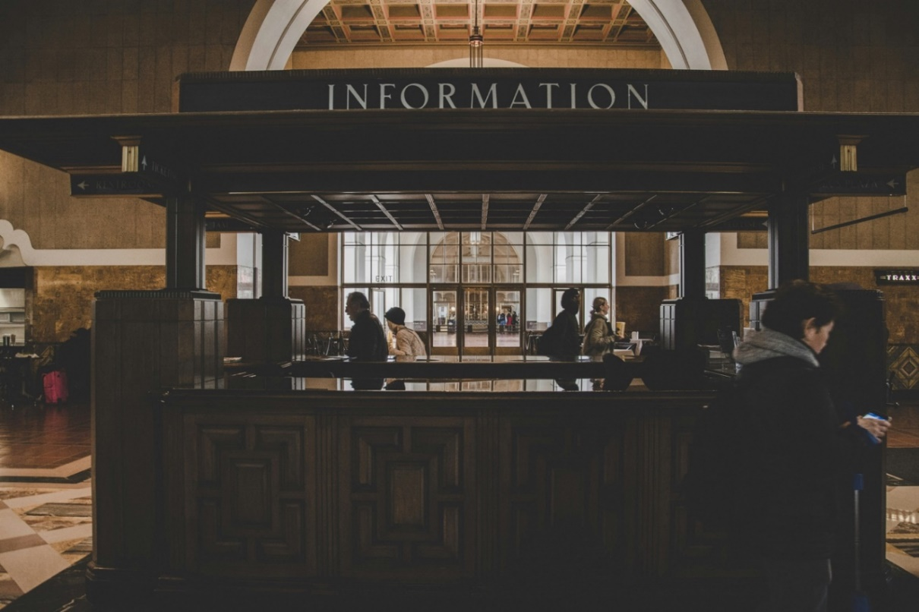

The survey then asked school librarians to share what barriers (if any) their school library faces in providing a safe space to their pupils, with an open comment box.

Out of 23 responses, four main themes emerged:

* Staffing constraints (26% of comments)
  + 'The limited opening hours is a real barrier for us as students are mainly only in the library for their lessons. We also have issues with short staffing as our school runs three libraries (junior, lower and upper) with only two librarians. This means that one is often standing empty and unable to be used.'
  + 'No staff.'
  + 'No librarian.'
  + 'Limited hours. Limited pupil support assistants available to assist with class visits.'
* No barriers faced in providing a safe space (26% of comments)
  + 'No barriers as I am always in the library during the school day. I eat lunch here and I take my breaks in here! It's my safe space too!'
* Limited opening times (22% of comments)
  + 'Limited opening to the school and also limited opening in community time. Staffing is at the limit.'
* Space is noisy (13% of comments)
  + 'Due to the open-plan library placement (next to a corridor) sometimes there can be a lot a noise coming from other children moving around the school.'

Additionally, one librarian shared that their school management discouraged the use of the library space, having a deeper negative impact on some of their pupils:

* 'The only thing is that the school likes children to be outside and socialising with others. A lot of emphasis is placed on this. Quieter children who like to stay inside are discouraged from doing so and now have to have lunch passes to be here. This is unfortunate, because they feel safe in the library. It's just putting a barrier in their way.'



#### Democratically engaged and informed communities

SLIC's *Forward* strategy notes that, 'as the mechanics of learning have moved beyond print, the role of libraries as curators of the vast array of information sources has been amplified'.

The same strategy envisions a future in which, 'libraries will open access to and build trust in public data to increase participation in the democratic process'[22].

The survey prompted librarians to share their thoughts on how important libraries are to building informed and democratically engaged pupils. Many commented on the stresses already mentioned above:

* ‘I am a custodian of information and it is my job to disseminate the information to as many people as possible to enable them to make informed, balanced decisions and choices.

This may involve ensuring information is translated, in large text, can be read out loud or is printed out to read later.

It is not my job to censor information, only to ensure it is reliable and current.'

* 'As technology advances so too does the role of libraries in respect of information provision.'
* 'We get much of our information now through the internet / social media. The role of the libraries will be to enable citizens to make sense of Public Data in a way that is accessible and easily understood.'

To round out the questions on active citizenship, the survey asked librarians to reflect how often their school library operates as a student hub for informed debate / decision-making.

The majority reported their library never operates as a hub for informed debate or decision-making; only 1 in 5 reported that it happens 'regularly' or 'on occasion.' 1 in 4 reported it happens 'rarely'. Considering the varied and multiple barriers of restricted opening hours, staffing constraints, and pupil access reported earlier in these findings, the inability to foster informed debate or decision-making seems to follow as a natural consequence.

### Final snapshot

A final two quantitative questions were asked of primary school librarians at the end of the survey. These were both matrices, scaled from 1 (no, not at all) to 5 (yes, a lot).

The first question asked librarians to reflect on the extent to which their library supports seven essential needs: access to books; access to digital devices / Wi-Fi; access to essential warm spaces; access to learning resources and training; access to trusted sources of information; having a quiet space at school and opportunities for reading for pleasure.

The overwhelming majority indicated their library supports access to books ('yes a lot', 85%) and opportunities for reading for pleasure ('yes a lot', 73%).

Having a quiet space in school was ambiguously reflected, as was access to essential warm spaces, or trusted sources of information.

Almost 1 in 3 indicated their library did not support access to digital devices / Wi-Fi ('no, not at all', 31%), or access to learning resources and training ('no, not at all', 27%).

This snapshot reflects a reliance on the primary school library as a place that provides books and opportunities to read, but less so a service that offers a quiet space, or a warm space, or trusted sources of information – and very restricted provision for digital access or learning resource.

The last question asked librarians to reflect on the extent to which their library addresses the six following issues: addressing social isolation; closing the poverty-related attainment gap; developing media / information literacy; improving literacy; mental health and wellbeing support; and tackling poverty and cost-of-living crisis.

Here there is a marked ambiguity in responses. Just over a quarter of librarians felt their library 'moderately' (27%) addresses social isolation. Similarly with closing the poverty related-attainment gap: 30% chose 'moderately', with 19% 'no, not at all'.

Half felt their library addresses 'improving literacy' and 'mental health and wellbeing support'.

However, half also felt their library does not develop media or information literacy, or tackling poverty and the cost-of-living crisis.

What emerges here is a picture where primary school libraries are treated and evaluated on the basis of reading skills and comprehension, and the library's function as a service that offers holistic, person-centred provision in terms of social care, or media or information literacy, is not consistently represented or felt.

## Conclusion

The evidence gathered from the librarian surveys cannot be seen as comprehensive, due to the low response rate (representing 2% of Scotland's primary schools); however, it clearly shows that primary school libraries can have a wide-ranging impact across all four themes of this research – reading for pleasure, learning opportunities, digital inclusion and active citizenship – and that they are crucial in addressing and resolving inequity.

Research from the Great School Libraries campaign illustrates a concerning picture for primary school libraries; in 2023, it reported that nearly 1 in 7 UK primary schools surveyed have no library space whatsoever[23]. Moreover, schools with high proportions of pupils in receipt of FSMs (free school meals) are less likely to have a library space, and if they do, it is open for fewer hours, has fewer physical resources, and is more likely to have had its budget cut[24].

Further research from the Primary School Library Alliance has also revealed that 25% of Scotland's state primary schools do not have a dedicated library area (more than twice the figure in England, where 11% do not have a dedicated library area)[25]. This is further reinforced by the Great School Libraries 2023 report:

'The proportion of schools with a designated school library area on-site varies by country; with nearly a quarter of schools [in Scotland] not having a school library space (22%).

Similarly, only a quarter of schools in Scotland have a designated library budget compared with schools in England (25% compared to 36% in England). Nearly two thirds (63%) report having no budget whatsoever; while 12% said they didn't know or would prefer not to say.'[26]

The findings in this report demonstrate an unpredictability across the sector of primary school library services, including responses from librarians based in private or independent schools where the picture is drastically different from their state school counterparts. Overall, there is a profound imbalance between how these services are supported, and an urgent need to build, support and promote state primary school library services.

School libraries need funding, secure staffing provision and more public and management support to allow them to continue to be centres for unbiased information, a remedy for digital inequality, safe spaces without judgement or expectation, and a crucial point of contact to support pupil wellbeing and achievement.

*Scottish Book Trust recommendations will be published with the final reporting arising from this research project in 2025.*

## References

1. Great School Libraries. (2023). *Equal futures? An imbalance of opportunities.* <https://www.greatschoollibraries.org.uk/_files/ugd/8d6dfb_b6f1af1fa9ec48b08b93566dc7608d95.pdf>
2. Ibid.
3. Ibid.
4. Libraries for Primaries. (2022). *Working together towards a library in every primary school: An update from the Primary School Library Alliance.* <https://www.librariesforprimaries.org.uk/_files/ugd/69334c_778cf710d4574b84894c47fe3cef3605.pdf>
5. Great School Libraries. (2023). *Equal futures? An imbalance of opportunities.* <https://www.greatschoollibraries.org.uk/_files/ugd/8d6dfb_b6f1af1fa9ec48b08b93566dc7608d95.pdf>
6. Ibid.
7. Hepburn, H. (2023, February 23). *School librarians being 'wiped out' in parts of Scotland.* Tes. <https://www.tes.com/magazine/news/general/school-librarians-scotland-wiped-out>
8. Daly, J. (2023, September 18). *Ending the Schools Library Outreach service is a mistake.* Glasgow Times. <https://www.glasgowtimes.co.uk/news/23794863.john-daly-ending-schools-library-outreach-service-mistake/>
9. Learning Directorate, Children and Families Directorate. (2023). *Summary statistics for schools in Scotland 2023.* Scottish Government. <https://www.gov.scot/publications/summary-statistics-for-schools-in-scotland-2023/pages/headline-school-and-early-learning-and-childcare-elc-statistics/>
10. Brettle, A., & Maden, M. (2015). *What evidence is there to support the employment of trained and professionally registered library, information and knowledge workers? A systematic scoping review of the evidence*. CILIP. <https://cdn.ymaws.com/www.cilip.org.uk/resource/resmgr/cilip_new_website/research/value_trained_information_professionals/value_trained_lik_pro_report.pdf>
11. School Library Association. (2023). *Impact and effectiveness of school libraries*. <https://www.sla.org.uk/Shared_Content/Resources/impact-school-libraries.aspx>
12. Kirsch, I., de Jong, J., Lafontaine, D., McQueen, J., Mendelovits, J., & Monseur, C. (2002). *Reading for change: Performance and engagement across countries: Results from PISA 2000.* OECD. <https://www.oecd.org/education/school/programmeforinternationalstudentassessmentpisa/33690904.pdf>
13. Scottish Book Trust. *Research-informed practice on reading for pleasure.* Retrieved November 15, 2024, from <https://www.readingschools.scot/uploads/store/mediaupload/525/file/Research-informed%20practice%20on%20reading%20for%20pleasure.pdf>
14. Lynch, É. (2024, March 13). *How reading for pleasure can tackle poverty.* Scottish Book Trust. <https://www.scottishbooktrust.com/articles/how-reading-for-pleasure-can-tackle-poverty>
15. Williams, D., Wavell, C., & Morrison, K. (2013). *Impact of school libraries on learning: Critical review of published evidence to inform the Scottish education community.* Robert Gordon University, Institute for Management, Governance & Society (IMaGeS). <http://hdl.handle.net/10059/1093>
16. Scottish Library and Information Council. (2018). *Vibrant libraries, thriving schools: A national strategy for school libraries in Scotland 2018–2023*. <https://scottishlibraries.org/media/2108/vibrant-libraries-thriving-schools.pdf>
17. Allmann, K. (2022). *UK digital poverty evidence review 2022.* Digital Poverty Alliance. <https://digitalpovertyalliance.org/uk-digital-poverty-evidence-review-2022/>
18. National Literacy Trust. (2018). *Fake news and critical literacy: The final report of the Commission on Fake News and the Teaching of Critical Literacy in Schools.* <https://literacytrust.org.uk/research-services/research-reports/fake-news-and-critical-literacy-final-report/>
19. Scottish Library and Information Council. (2021). *Forward: Scotland's public library strategy 2021–2025.* <https://scottishlibraries.org/media/3462/slic-public-library-strategydigital_final.pdf>
20. CILIP. (2018). *Public libraries: The case for support.* <https://cdn.ymaws.com/www.cilip.org.uk/resource/resmgr/cilip/information_professional_and_news/press_releases/2019_10_report_case_for_support/public_libraries_-_the_case_.pdf>
21. Education Scotland. (2017, January 1). *What is Curriculum for Excellence?* <https://education.gov.scot/curriculum-for-excellence/about-curriculum-for-excellence/what-is-curriculum-for-excellence/>
22. Scottish Library and Information Council. (2021). *Forward: Scotland's public library strategy 2021–2025.* <https://scottishlibraries.org/media/3462/slic-public-library-strategydigital_final.pdf>
23. Great School Libraries. (2023). *Equal futures? An imbalance of opportunities.* <https://www.greatschoollibraries.org.uk/_files/ugd/8d6dfb_b6f1af1fa9ec48b08b93566dc7608d95.pdf>
24. Ibid.
25. Libraries for Primaries. (2022). *Working together towards a library in every primary school: An update from the Primary School Library Alliance.* <https://www.librariesforprimaries.org.uk/_files/ugd/69334c_778cf710d4574b84894c47fe3cef3605.pdf>
26. Great School Libraries. (2023). *Equal futures? An imbalance of opportunities.* <https://www.greatschoollibraries.org.uk/_files/ugd/8d6dfb_b6f1af1fa9ec48b08b93566dc7608d95.pdf>