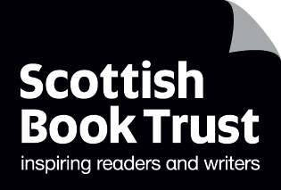

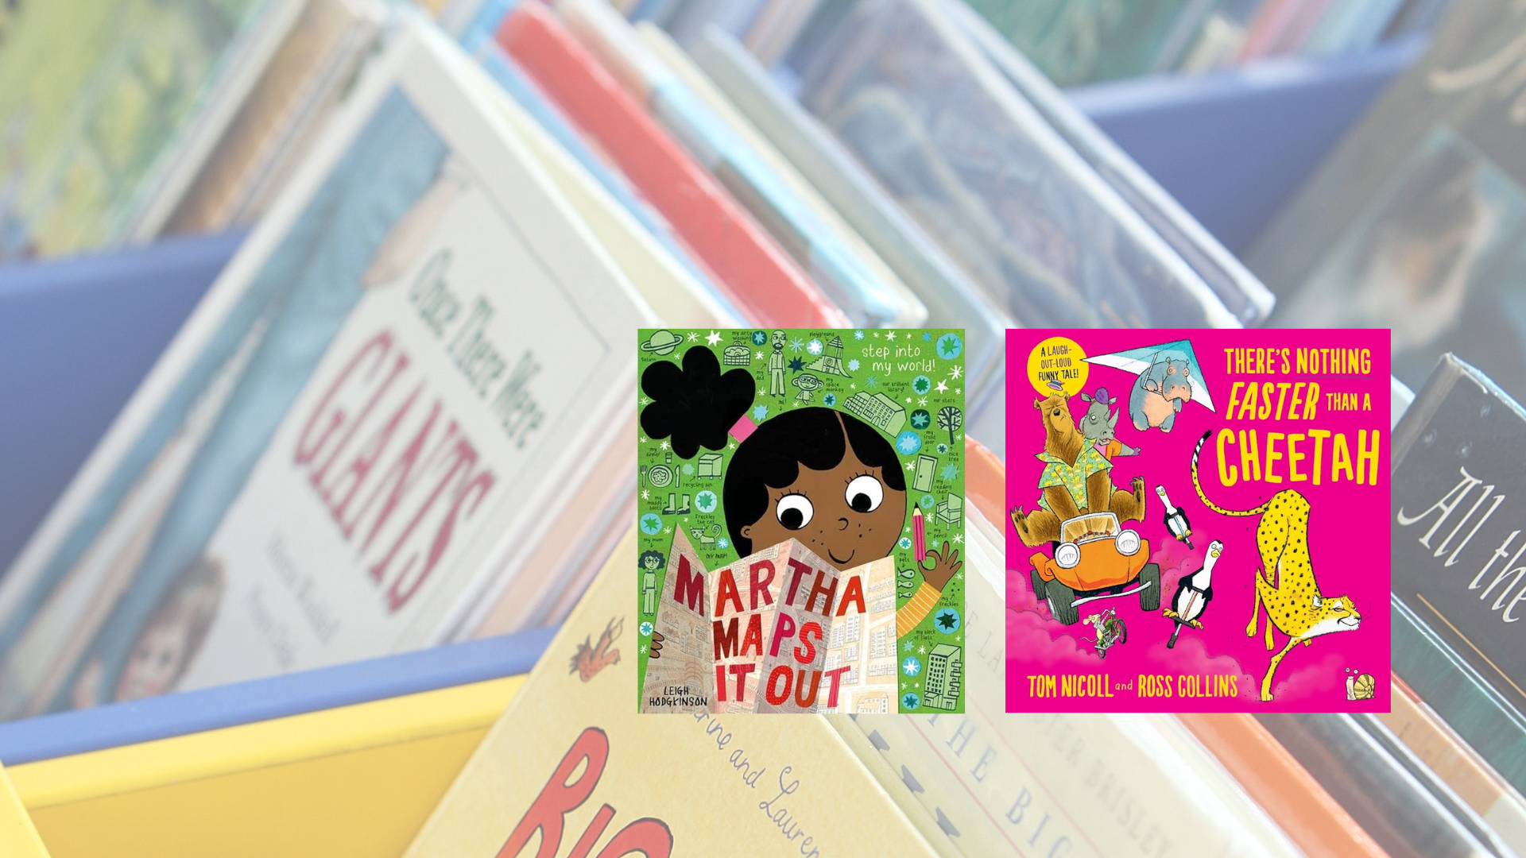

**Read Write Count library pack: P3 bag**A library session for the Read Write Count P3 bag including songs, crafts and worksheets and printables

## Decorative image

scottishbooktrust.com



Scottish Book Trust is a registered company (SC184248)

and a Scottish charity (SC027669).

## Contents

About this resource 2

Shiny cards 3

Welcome to the session 4

Songs and rhymes 4

Craft activity 5

Goodbye and finding books to take home 6

Printable 1: What to read after your Read Write Count books 7

Printable 2: Make your own animal race boardgame 8

Printable 3: Create your own super speedy snail 11

Printable 4: Map grid references 12

## About this resource

We’ve put together a session for each of this year’s Read, Write, Count bags so you can run interactive family sessions in your library. These can be adapted to suit the duration of storytelling sessions in your library.   
  
Each session includes:

* Reading the book together
* Choices of songs to sing together
* Choices for a main activity or arts and crafts
* Suggestions to help families find their next read

In this resource we’ve included suggested songs, activities as well as some printables you can use as part of your session.  
  
Whilst Read, Write, Count gifts bags to children in P2 and P3, **you can keep these sessions open to all families** and they don’t rely upon the families having prior knowledge of the books. The contents of this year’s bags are as follows:

### P2

* *How to Make a Story* by Naomi Jones and Ana Gomez
* *My First Book of Dinosaurs* by Zoë Ingram
* A parent activity booklet and pencil
* A tangram
* A pack of cards which includes Dominoes, Story Cards, Talk It Out and Act it Out

### P3

* *There’s Nothing Faster Than a Cheetah* by Tom Nicoll and Ross Collins
* *Martha Maps It Out* by Leigh Hodgkinson
* A parent activity booklet and pencil
* A tape measure
* A deck of cards containing Galactic Fantastic, Story Cards and Prompts, Search and See and Mindfulness cards

## Shiny cards

All libraries will be eligible to receive Read Write Count Shiny cards, which add another card to each of the packs of cards in the P2 and P3 bag. These cards have been designed to encourage children to visit their library and borrow further books after receiving their bags.   
  
The cards are as follows:

* P2: A library card which adds a setting to their Story Cards
* P3: A Libby alien card which adds an alien to their Galactic Fantastic cards

Welcome to the session   
Welcome everyone to the session, saying hello to all the adults and children in turn. You could use [“The Hello Song”](https://www.scottishbooktrust.com/songs-and-rhymes/the-hello-song-audio) from the Bookbug Song and Rhyme Library or Bookbug app to warm the group up.   
  
Reading the books   
Read There’s Nothing Faster Than a Cheetah aloud to the group, making sure everyone can see the pages and hear you. Allow the children to stop and ask questions or take time to look at the illustrations. Now, look through Martha Maps It Out together. Allow the children some time to look at the maps and different details. Afterwards, you could ask the children to talk about which of the books they liked more.

## Songs and rhymes

For singing together, you could choose between:

* [“A Leopard Has Lots of Spots”](https://www.scottishbooktrust.com/songs-and-rhymes/a-leopard-has-lots-of-spots) - change the lyrics to include a cheetah! Ask the children to help you come up with some lines for the other animals in the book – e.g. “a bear has lots of fur” or “a crocodile has lots of scales”.
* [“Zoom, Zoom, Zoom”](https://www.scottishbooktrust.com/songs-and-rhymes/zoom-zoom-zoom-audio) – blast off into space together, like Martha and her Space Monkey!

### A Leopard Has Lots of Spots

Via [Bookbug Song and Rhyme Library](https://www.scottishbooktrust.com/songs-and-rhymes/a-leopard-has-lots-of-spots)

A leopard has lots of spots  
What a lot of spots he's got.  
  
A tiger has stripes  
Like long, thin pipes.  
  
But a leopard has lots of spots, spots, spots, spots, spots...

### Zoom, Zoom, Zoom

Via [Bookbug Song and Rhyme Library](https://www.scottishbooktrust.com/songs-and-rhymes/zoom-zoom-zoom-audio)

Zoom, zoom, zoom,  
We’re going to the moon!  
  
Zoom, zoom, zoom,  
We’ll be there very soon.  
  
If you want to take a trip,  
Climb on board my rocket ship.  
  
Zoom, zoom, zoom,  
We’re going to the moon!  
  
5-4-3-2-1-BLAST OFF!

## Craft activity

### Option 1: Make your own board game

Use our activity sheets on page 8, 9 and 10 to create an animal racing board game. Younger children can use our version, whereas those who are older might like to make their own version. You can keep a version in the library so children can come back to play it again!

### Option 2: Speedy snails

Print our activity sheet on page 11 to allow the children to create their own super powered speedy snail. What do they need to be faster than a cheetah?

### Option 3: Make a map!

Using *Martha Maps It Out* for inspiration, you could ask the children to create their own map – whether of your town, based on their own book or creating their own fantasy world. You can use the activity sheet on page 12 to create one with grid references, or just use blank paper.

## Goodbye and finding books to take home

At the end of your sessions, you can explore some books that are similar to *There’s Nothing Faster Than a Cheetah* and *Martha Maps It Out* in theme or topic. Explain to the children they can borrow them and take them home. See page 7 for a printable collection of books we’d recommend as next reads

## Printable 1: What to read after your Read Write Count books

If you enjoyed *There’s Nothing Faster Than a Cheetah* by Tom Nicoll and Ross Collins, we think you might like:

* *There’s Nothing Cuter Than a Puppy* by Tom Nicoll and Ross Collins
* *Gorilla Loves Vanilla* by Chae Strathie and Nicola O’Byrne
* *Oi Aardvark!* by Kes Gray

If you enjoyed *Martha Maps It Out* by Leigh Hodgkinson, we think you might like:

* *Kitsy Bitsy’s Noisy Neighbours* by Polly Faber and Melissa Crowton
* *You Choose!* By Pippa Goodhart and Nick Sharratt
* *Our Tower* by Joseph Coelho and Richard Johnson

And here’s some space for you, your librarian or your family to write down some books you might like:

|  |
| --- |
|  |

## Printable 2: Make your own animal board game

You will need:

* A blank piece of paper
* Pencils or pens
* A number spinner (see the template on the next page) or dice
* Animal tokens (see the template on the next page, or make your own!)



1. Start by drawing a long wiggly racetrack on your piece of paper
2. 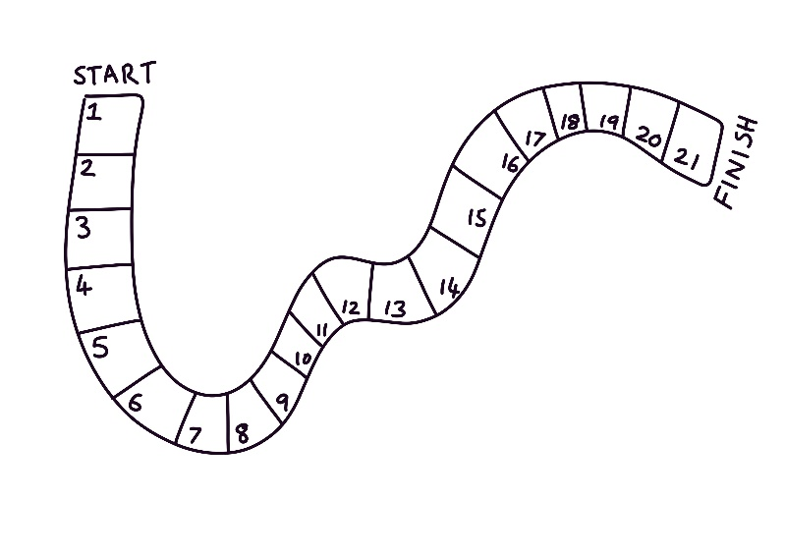Draw lines across the track to create boxes and number them. Write START at the beginning and FINISH at the end.
3. 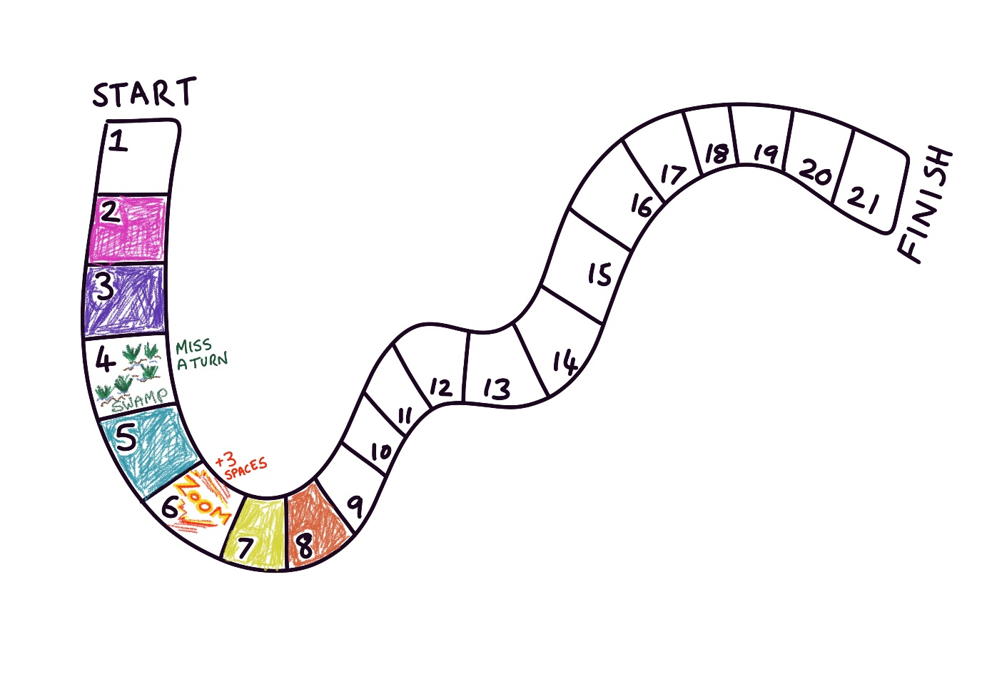Colour in your track. You could choose some boxes to have obstacles – for example you could have a SWAMP box where players who land on it miss a turn, or a ZOOM box where you move forward three places.
4. Create some different looking animal tokens. You can use the template on the next page, draw your own, or use something you already own (e.g. beads) torepresent the animals.
5. Make a number spinner or use dice to play. Take turns to spin or roll a number and move forward. First animal to the FINISH wins!

### Number spinner

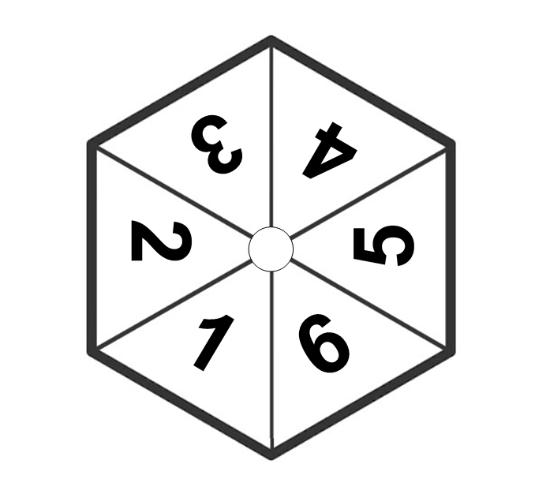Cut out the spinner. Then carefully push a pencil or small stick through the centre circle (put a small ball of Blu Tack or putty underneath to help you do this safely). Spin the pencil and whatever the number spinner lands on is your movement for this turn.

Animal player tokens – cut out and colour in

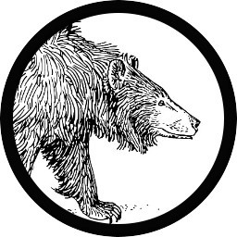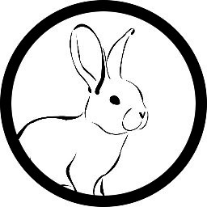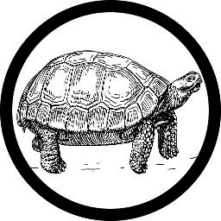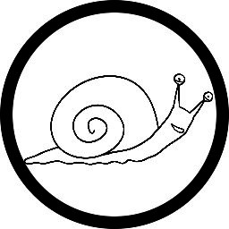

## Printable 3: Create your own super speedy snail

Boost this snails speed by adding things to make it go faster. Jet packs, roller skates, engines, friends, wheels or whatever you can imagine.

Printable 4: Map grid referencesDraw your own map like *Martha Maps it Out*.You can then use grid references to describe to a partner the location of different things on your map!

|  |  |  |  |  |  |  |  |  |  |  |
| --- | --- | --- | --- | --- | --- | --- | --- | --- | --- | --- |
|  | A | B | C | D | E | F | G | H | I | J |
| 1 |  |  |  |  |  |  |  |  |  |  |
| 2 |  |  |  |  |  |  |  |  |  |  |
| 3 |  |  |  |  |  |  |  |  |  |  |
| 4 |  |  |  |  |  |  |  |  |  |  |
| 5 |  |  |  |  |  |  |  |  |  |  |
| 6 |  |  |  |  |  |  |  |  |  |  |
| 7 |  |  |  |  |  |  |  |  |  |  |
| 8 |  |  |  |  |  |  |  |  |  |  |
| 9 |  |  |  |  |  |  |  |  |  |  |
| 10 |  |  |  |  |  |  |  |  |  |  |