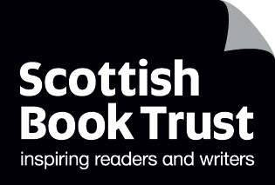

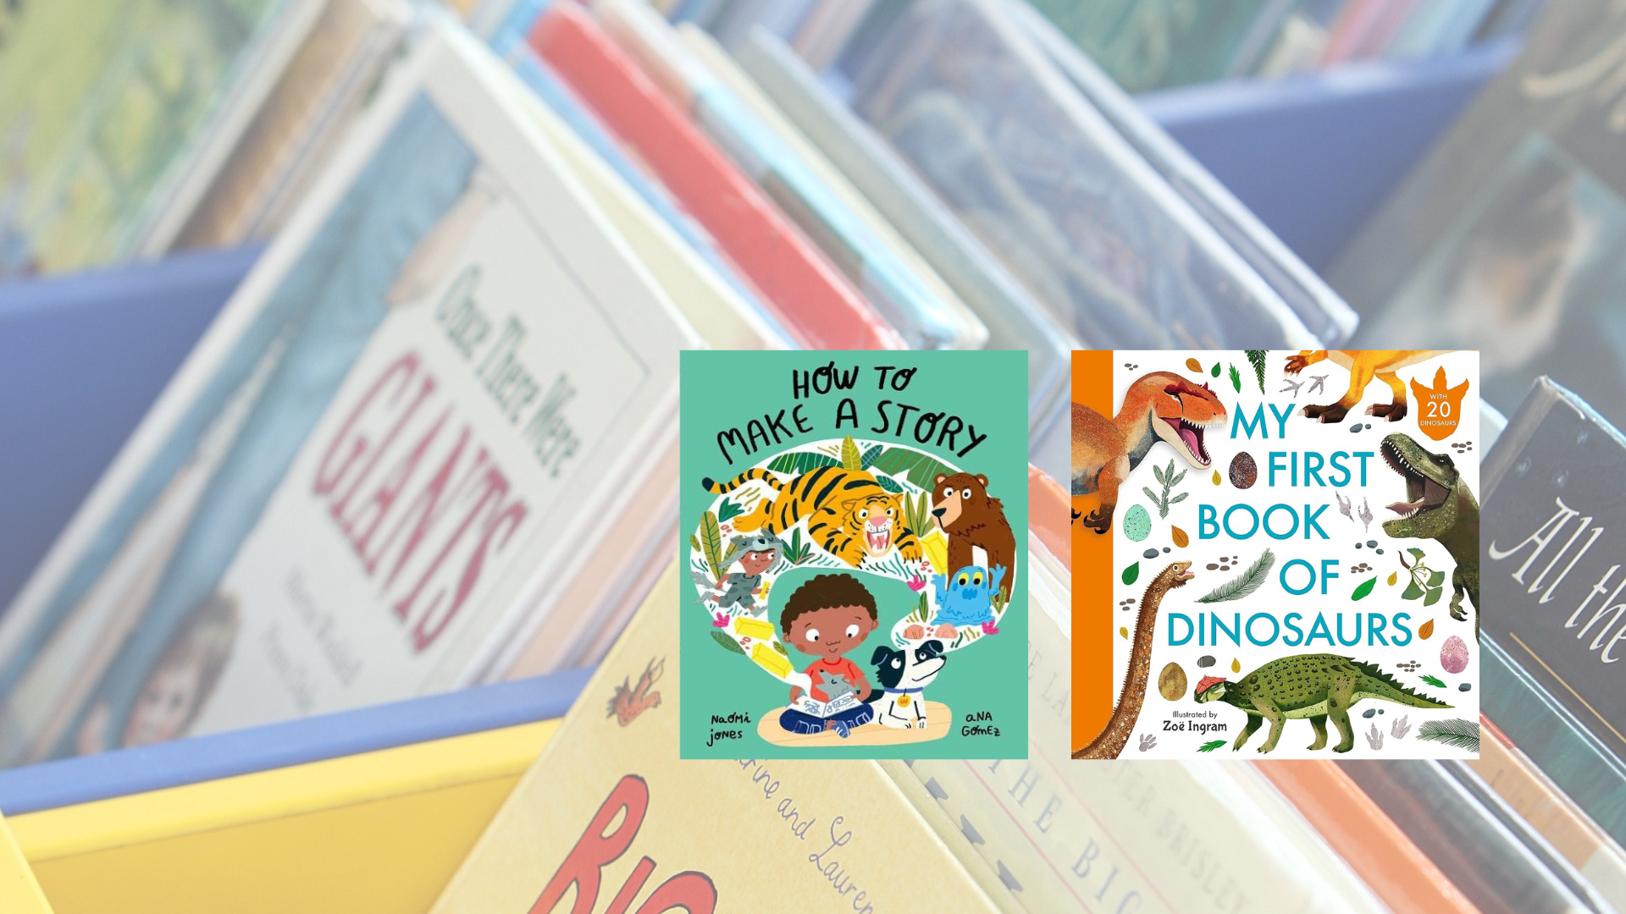

**Read Write Count library pack: P2 Bag**A library session for the Read Write Count P2 bag including songs, crafts and worksheets and printables

## Decorative image

scottishbooktrust.com



Scottish Book Trust is a registered company (SC184248)

and a Scottish charity (SC027669).

## Contents

About this resource 2

Shiny cards 3

Welcome to the session 4

Songs and rhymes 4

Craft activity 7

Goodbye and finding books to take home 7

Printable 1: What to read after your Read Write Count books 8

Printable 2: Create your own dinosaur wordsearch 9

Printable 3: Design your own new dinosaur 10

Printable 4: Comic strip 11

## About this resource

We’ve put together a session for each of this year’s Read, Write, Count bags so you can run interactive family sessions in your library. These can be adapted to suit the duration of storytelling sessions in your library.   
  
Each session includes:

* Reading the book together
* Choices of songs to sing together
* Choices for a main activity or arts and crafts
* Suggestions to help families find their next read

In this resource we’ve included suggested songs, activities as well as some printables you can use as part of your session.  
  
Whilst Read, Write, Count gifts bags to children in P2 and P3, **you can keep these sessions open to all families** and they don’t rely upon the families having prior knowledge of the books. The contents of this year’s bags are as follows:

### P2

* *How to Make a Story* by Naomi Jones and Ana Gomez
* *My First Book of Dinosaurs* by Zoë Ingram
* A parent activity booklet
* A writing pencil
* A tangram
* A pack of cards which includes Dominoes, Story Cards, Talk It Out and Act it Out

### P3

* *There’s Nothing Faster Than a Cheetah* by Tom Nicoll and Ross Collins
* *Martha Maps It Out* by Leigh Hodgkinson
* A parent activity booklet
* A writing pencil
* A tape measure
* A deck of cards containing Galactic Fantastic, Story Cards and Prompts, Search and See and Mindfulness cards

## Shiny cards

All libraries will be eligible to receive Read Write Count Shiny cards, which add another card to each of the packs of cards in the P2 and P3 bag. These cards have been designed to encourage children to visit their library and borrow further books after receiving their bags.   
  
The cards are as follows:

* P2: A library card which adds a setting to their Story Cards
* P3: A Libby alien card which adds an alien to their Galactic Fantastic cards

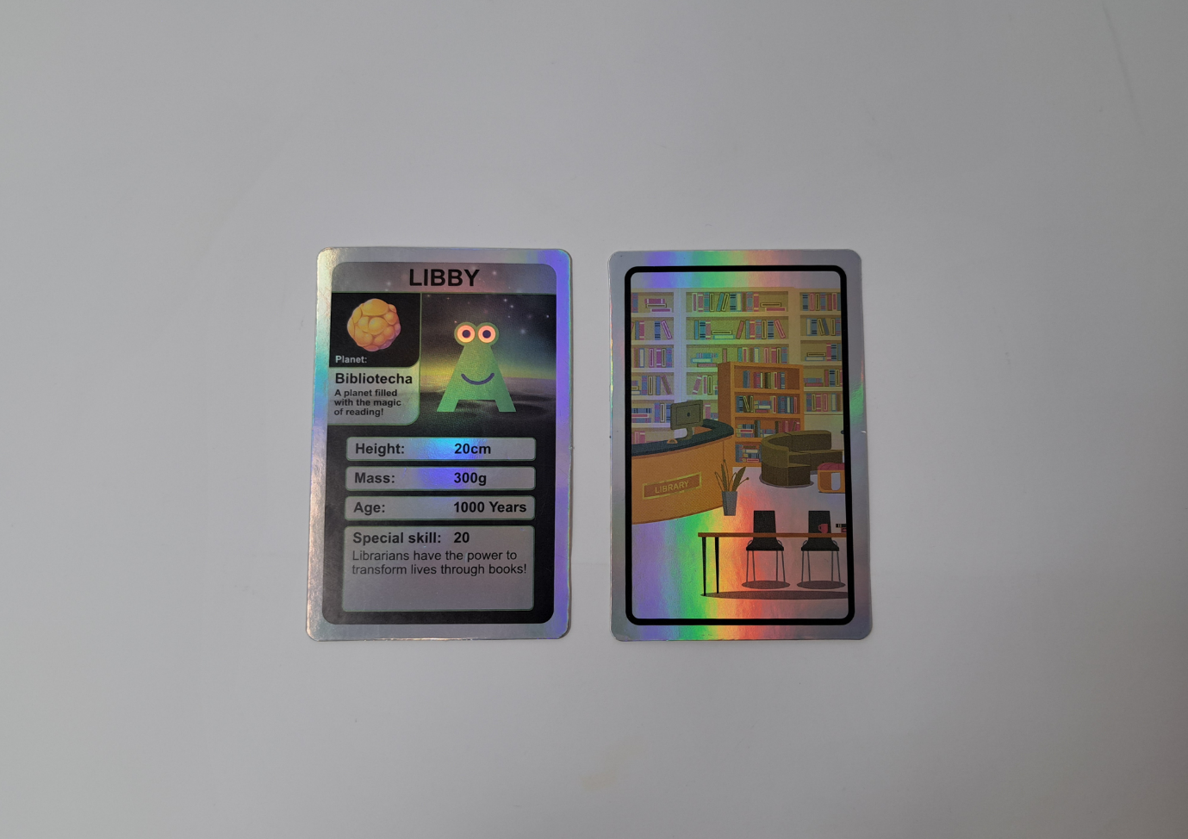

Welcome to the session   
Welcome everyone to the session, saying hello to all the adults and children in turn. You could use [“The Hello Song”](https://www.scottishbooktrust.com/songs-and-rhymes/the-hello-song-audio) from the Bookbug Song and Rhyme Library or Bookbug app to warm the group up.   
  
Reading the books   
Read *How to Make a Story* aloud to the group, making sure everyone can see the pages and hear you. Allow the children to stop and ask questions or take time to look at the illustrations. Now, look through *My First Book of Dinosaurs*. Afterwards, you could ask the children to talk about which of the books they liked more – and, if any of them have a favourite dinosaur!

## Songs and rhymes

For singing together, you could choose between:

* [“What Do You See?”](https://www.scottishbooktrust.com/songs-and-rhymes/what-do-you-see) – change the lyrics for things you can see in the library, or what Milo saw in his story! (a wolf, a tiger, two monsters, a treasure chest!)
* [“The Dinosaur Went”](https://www.kidsparkz.com/preschool-sings-dinosaurs.html)

### What Do You See?

Available via [Bookbug Song and Rhyme Library](https://www.scottishbooktrust.com/songs-and-rhymes/what-do-you-see)

What can you see?  
What can you see?  
I see cars, I see cars.  
Looking all around,  
Looking up and down,  
Please tell me,  
What you see.  
  
What can you see?  
What can you see?  
I see a bus, I see a bus,  
Looking all around,  
Looking up and down,  
Please tell me,  
What you see.  
  
What can you see?  
What can you see?  
I see children, I see children,  
Looking all around,  
Looking up and down,  
Please tell me,  
What you see.  
  
What can you see?  
What can you see?  
I see clouds, I see clouds,  
Looking all around,  
Looking up and down,  
Please tell me,  
What you see.

### The Dinosaur Went

Available via [KidSparkz](https://www.kidsparkz.com/preschool-sings-dinosaurs.html)

The Pteranodon's wings went FLAP, FLAP, FLAP,  
FLAP, FLAP, FLAP, FLAP. FLAP, FLAP  
The Pteranodon's wings went FLAP, FLAP, FLAP  
All around the swamp.  
  
The Tyrannosaurus Rex went GRRR, GRRR, GRRR,  
GRRR, GRRR, GRRR, GRRR, GRRR, GRRR,  
The Tyrannosaurus Rex went GRR, GRR, GRR,  
All around the swamp.  
  
The Triceratops horns went POKE, POKE, POKE  
POKE, POKE, POKE, POKE, POKE, POKE,  
The Triceratops horns went POKE, POKE ,POKE,  
All around the swamp.  
  
The Brontosaurus went MUNCH, MUNCH, MUNCH,  
MUNCH, MUNCH, MUNCH, MUNCH, MUNCH, MUNCH  
The Brontosaurus went MUNCH, MUNCH, MUNCH,  
All around the swamp.  
   
The Stegosaurus tail went SPIKE, SPIKE, SPIKE,  
SPIKE, SPIKE, SPIKE, SPIKE,  
SPIKE, SPIKE,  
The Stegosaurus tail went SPIKE, SPIKE, SPIKE,  
All around the swamp.

## Craft activity

### Option 1: Draw a comic panel

At the end of *How to Make a Story* we see Milo’s story laid out like a comic strip. Print the activity sheets on page 11 and 12. Ask the children to draw their own comic panel – they can create their version of Milo’s story or a whole new one!

### Option 2: Designasaur

Design your own dinosaur by printing the activity sheet on page 10. Attendees can colour them in – then either you can make a display in the library!

## Goodbye and finding books to take home

At the end of your sessions, you can explore some books that are similar to *How to Make a Story* and *My First Book of Dinosaurs* in theme or topic. Explain to the children they can borrow them and take them home. See page 8 for a printable collection of books we’d recommend as next reads.

## Printable 1: What to read after your Read Write Count books

If you enjoyed *How to Make a Story* by Naomi Jones and Ana Gomez, we think you might like:

* *The Biggest Story* by Sarah Coyle and Dan Taylor
* *Stuck* by Oliver Jeffers
* *It’s Mine!* by Emma Yarlett

If you enjoyed *My First Book of Dinosaurs* by Zoë Ingram, we think you might like:

* *The Girl and the Dinosaur* by Hollie Hughes and Sarah Massini
* *The Worrysaurus* by Rachel Bright
* *My First Book of Minibeasts* by Zoë Ingram

And here’s some space for you, your librarian or your family to write down some books you might like:

|  |
| --- |
|  |

# Printable 2: Create your own dinosaur wordsearch

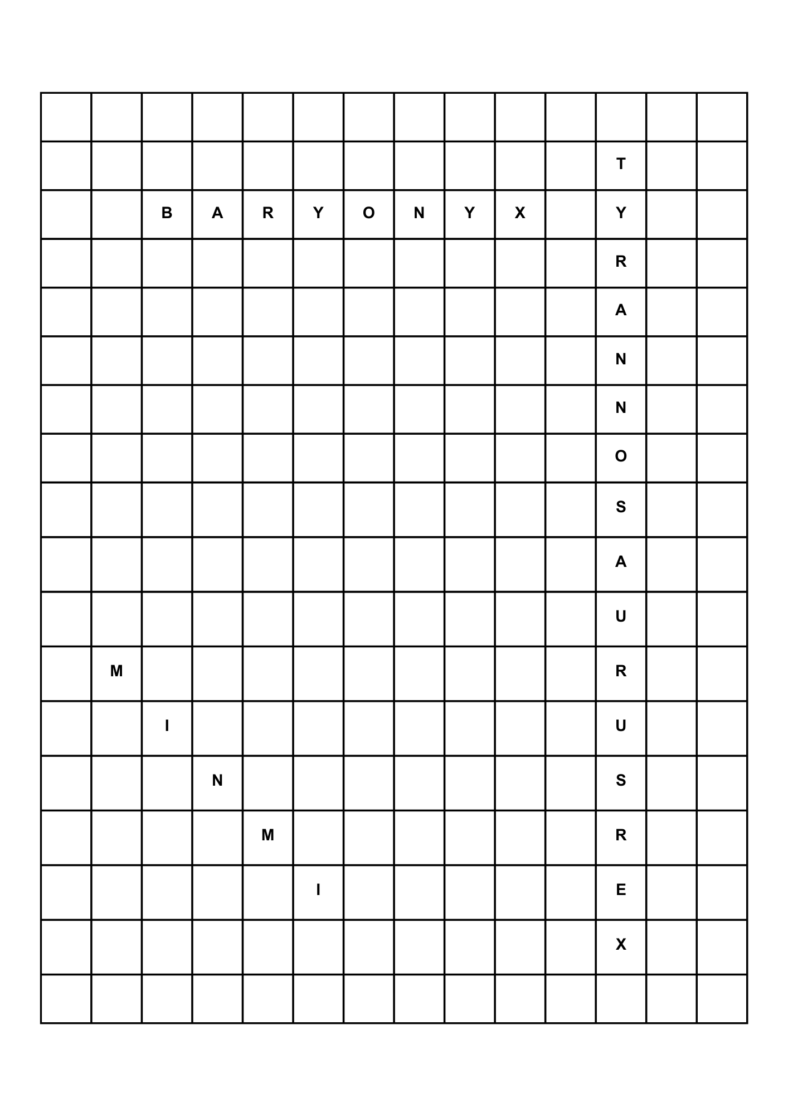Use some of the names of the dinosaurs in *My First Book of Dinosaurs* to create your own wordsearch! If you’re stuck, there’s some words at the bottom of the page you can use for inspiration.

Words you could use for your wordsearch: CLAW, TOOTH, TAIL, FOSSIL, DINOSAUR, PREHISTORIC, EXTINCT, HERBIVORE, CARNIVORE

# Printable 3: Designosaur - *Design your own new dinosaur*

Remember animals evolve to fit their environment. Think about this when you design yours. For example: a long neck would help to reach leaves at the top of a tree, sharp teeth would be useful for hunting other creatures, camouflage would help it hide, and webbed feet would be great for swimming. Look at your book for ideas.

My Dinosaur

|  |  |
| --- | --- |
| What is it called? |  |
| Where does it live? |  |
| What does it eat? |  |
| How big is it? |  |
| A fun fact about my dinosaur is.. |  |

## Printable 4: Comic strip

Use these comic strip templates to tell a story like Milo in *How to Make a Story*! If you’re stuck, you could use your Talk it Out cards as inspiration. For example, "if you were an animal what would you be and why?" could lead to you imagining yourself turning into an animal. What would you do with your day if this happened?