

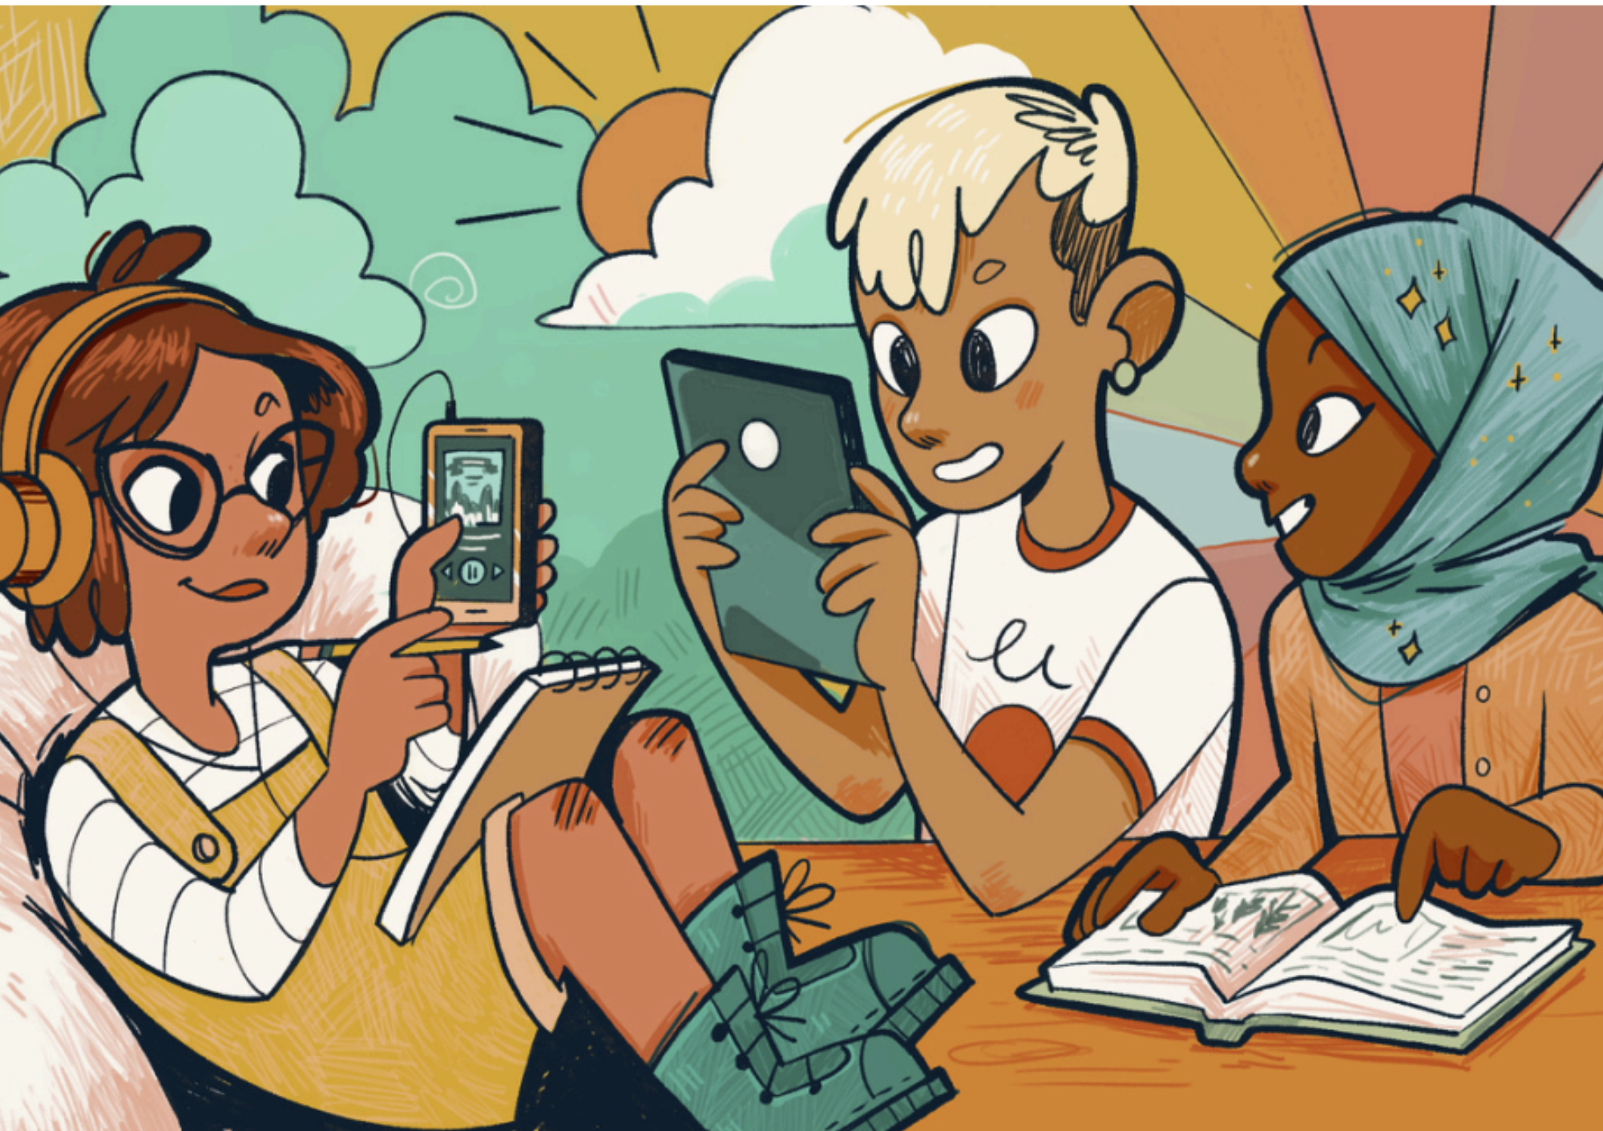

# Supporting Teenagers’ Reading Enjoyment and Engagement: A Guide for Teachers and Librarians

This guide has been created for secondary school teachers and librarians to support teenagers’ enjoyment and engagement with books.

## Decorative imageAuthors: Dr Charlotte Webber, University of Edinburgh and Prof Sarah McGeown, University of Edinburgh

scottishbooktrust.com



Scottish Book Trust is a registered company (SC184248)

and a Scottish charity (SC027669).

## Contents

About this resource 2

Summary 4

What was The Young People’s Reading Project? 4

Key terms 6

Why do teenagers think it is important to read? 8

Reading for personal outcomes 9

Reading to develop interpersonal skills and relationships 11

Reading to develop academic skills and future employability 12

What stops teenagers reading for enjoyment? 13

Access 16

Choice 17

Autonomy 19

Social factors 21

Relatable messaging 22

Environments conducive to reading 23

Time and competing activities 25

Next steps 26

Appendix 1: Additional resources 28

Appendix 2: Terms of use 29

## About this resource

This resource is a plain text version of the guide created by Dr Charlotte Webber and Prof Sarah McGeown. To see the rich text version, and find out more about the research visit [the project website](https://blogs.ed.ac.uk/literacylab/current-projects/yprp/).

Funding information  
This project was funded by the Economic and Social Research Council (ESRC) and Scottish Book Trust and managed by the Scottish Graduate School of Social Sciences (SGSSS). Grant number ES/P000681/1. Additional funding came from the ESRC Impact Acceleration Account. Grant number ES/X00466X/1.

Contact information  
Dr Charlotte Webber: [cwebber@ed.ac.uk](mailto:cwebber@ed.ac.uk)   
Prof Sarah McGeown: [s.mcgeown@ed.ac.uk](mailto:s.mcgeown@ed.ac.uk)  
You can also visit the [University of Edinburgh Literacy Lab on the University of Edinburgh website](https://blogs.ed.ac.uk/literacylab/).

### Collaborators and contributors

* Katherine Wilkinson, Scottish Book Trust
* Dr Lynne Duncan, University of Dundee
* Sophia, Harry, Teagan, Emily, Ava and Hannah*, Young People’s Advisory Group (*some names may be pseudonyms, as requested by group members)

### Acknowledgements

Thank you to all the schools, teachers, librarians, and young people who took part in The Young People’s Reading Project and in the development of this guide.

### To cite this resource

Webber, C. & McGeown, S. (2024). Supporting Teenagers’ Reading Enjoyment and Engagement: A Guide for Teachers and Librarians. The University of Edinburgh and Scottish Book Trust. U.K.

### Terms of use

For the purpose of open access, the authors have applied a Creative Commons Attribution (CC-BY) license to any Author Accepted Manuscript version arising from this submission. For full terms of use, see Appendix 2.

## Summary

Reading enjoyment and engagement - sometimes called “volitional reading” or “reading for pleasure” - fosters intellectual, emotional, social and academic development. However, many teenagers do not choose to read books in their own time.  
  
The Young People’s Reading Project explored teenagers’ (13-15-years-old) motivation to read for enjoyment. By learning more about why teenagers choose to read outside of school – or not – we gained insights into what might inspire them to read more.

This guide provides an overview of the project findings, including:

* Teenagers’ perspectives on why reading for enjoyment is/could be important to them.
* Teenagers’ perspectives on what stops them from reading for enjoyment.
* Teenagers’ perspectives on what could help them to read more.
* Suggestions for how to apply the findings in your classroom or school library setting.

## What was The Young People’s Reading Project?

The Young People's Reading Project was a 3.5-year research project conducted at the University of Edinburgh and Scottish Book Trust and carried out in collaboration with teenagers across Scotland between 2020 and 2024. For more information, visit [the project website](https://blogs.ed.ac.uk/literacylab/current-projects/yprp/).  
  
There is an extensive body of research to demonstrate that reading enjoyment and engagement supports intellectual, emotional, social and academic development. However, motivation to read typically declines between childhood and the teenage years.

While some research has investigated why this might happen, very few projects centre young people’s voices when trying to understand their reading experiences and find ways to support them to (re)discover a love of reading.  
  
In collaboration with Scottish Book Trust, researchers at The University of Edinburgh worked with a Young People’s Advisory Group to design, plan and carry out The Young People’s Reading Project. Together they interviewed over 45 young people (13-15-years-old) about what helps them feel more motivated to read books in their free time.

### The Young People’s Advisory Panel

When we carry out research into teenagers’ lives, decisions about the aims and objectives are usually taken by adults and the research itself is usually carried out by an adult research team.  
  
Doing research in this way leads to a power imbalance, where adults risk making assumptions about teenagers' lives, opinions and experiences and about the best ways to study them. It also means that research can be out-of-touch with teens' real needs and priorities.

To make sure The Young People's Reading Project was more in line with teenagers’ priorities and experiences, we adopted a participatory approach, aiming to meaningfully include teenagers throughout the research project.  
  
Six secondary school students (13-15-years-old) from across Scotland formed the Young People’s Advisory Panel. They worked together with the adult research team to plan the project, carry out interviews with their classmates and interpret the project findings.

If you are interested in how we worked with the Young People's Advisory Panel, you can read an open-access version of our research article: [Working with a young people’s advisory panel to conduct educational research: Young people’s perspectives and researcher reflections](https://www.sciencedirect.com/science/article/pii/S0883035523001714) in International Journal of Educational Research.

## Key terms

This guide refers to both “reading motivation” and “reading engagement”. These concepts are defined below.

### Reading motivation

Reading motivation reflects ‘the drive to read resulting from an individual’s beliefs about, attitudes toward, and goals for reading.’[1]

* Beliefs: the perceptions and judgments about our reading ability and about the value of reading itself.
* Attitudes: the feelings and level of interest we have towards reading.
* Goals: our specific reasons for reading.

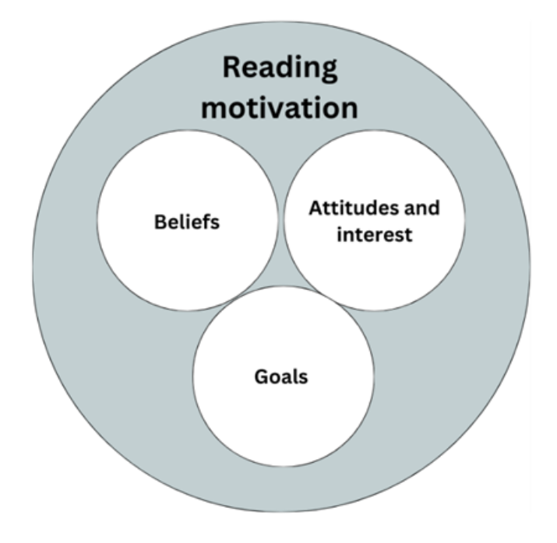

1. Beliefs
2. Attitude and interest
3. Goals

### Reading engagement

Reading engagement has four elements[2]:

* Behavioural: frequency, duration and/or breadth of reading.
* Cognitive: cognitive effort and strategy use (e.g. decoding) to support comprehension.
* Affective: emotional experiences, enjoyment, interest and immersion.
* Social: talking about books, being part of a “reading community”.

Reading motivation is usually thought to lead to reading engagement. However, the relationship between them is complex, and it is likely that they have a ‘dynamic and reciprocal relationship with one another’[3].  
  
The relationship between reading motivation, reading engagement and outcomes from reading (for example, improved vocabulary, knowledge or empathy) are illustrated below.

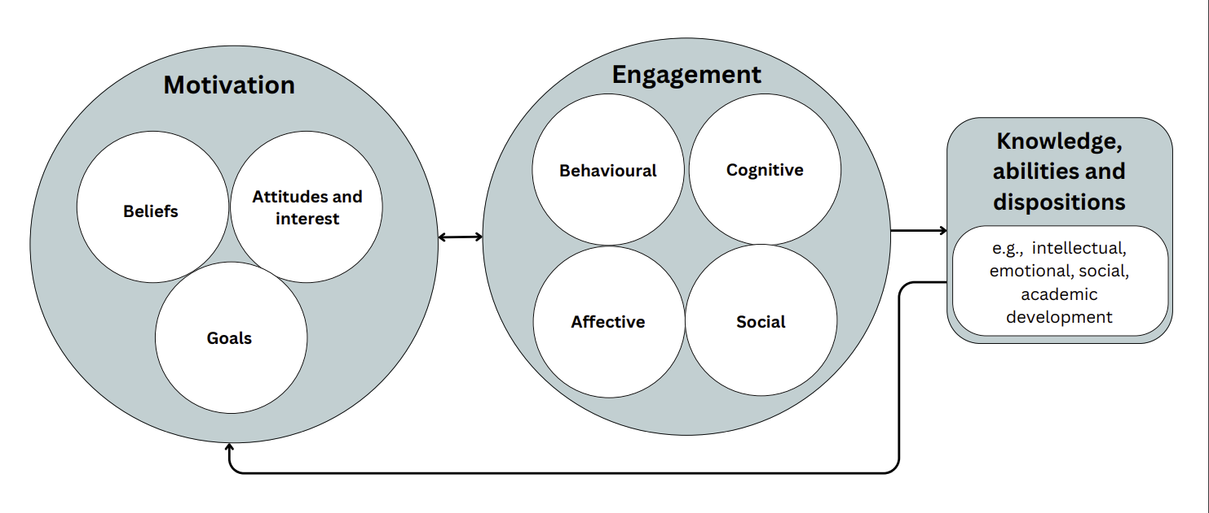

## Why do teenagers think it is important to read?

Academic research has previously explored the benefits of reading. These studies have found evidence for:

* Intellectual and academic outcomes: increased vocabulary knowledge and attainment
* Personal outcomes: identity development, self-awareness and positive emotions
* Social outcomes: learning about others and increased empathy

However, these studies often haven’t asked teenagers which outcomes are most important to them. This means the messaging we create for teenagers about why reading is important might not feel relevant to them.

As part of *The Young People’s Reading Project*, teenagers shared which outcomes are especially important for them.  
  
In order of importance, teenagers said that reading is important for:

1. Experiencing positive personal outcomes (e.g. promoting positive mental health and wellbeing)
2. Developing interpersonal skills and relationships
3. Developing academic skills and future employability

Of course, not all teenagers will want to read for the same reasons, and the same student is likely to want to read for different reasons at different times. It is important to help teenagers learn about the range of benefits they can get from reading and reflect on which outcomes are most important to them.  
  
In the following sections, we’ve linked each of these outcomes with some ideas for helping teenagers reflect on how reading can help them achieve different goals.

### **Something to try**

It might be helpful to encourage teenagers to think about how reading might help them achieve certain goals. Our [young person-friendly research paper on Frontiers for Young Minds website](https://kids.frontiersin.org/articles/10.3389/frym.2022.658925) explains what happens in our brains when we read fiction, which might be helpful to teenagers when they’re reflecting on our goals for reading.

### Reading for personal outcomes

Teenagers said that positive personal experiences were central to seeing reading as something they wanted to do. In particular, they said reading can:

* Be an opportunity to escape from the stresses of everyday life
* Promote positive mental health and wellbeing
* Help them experience positive emotions, like happiness, interest, reassurance and comfort
* Help them overcome personal struggles by reading about characters who successfully navigate adversity

Testimony: ‘When you can really relate to a character and, like, you can watch them overcome their struggles, you can apply it to your daily life. So, if you’re ever in a situation, like, similar to what they went through you know you can go through it.’  
  
Testimony: ‘I think it helps to really relax, like, if you’re stressed you can start reading and it just, like, relaxes you and helps you, like, go into, like, a different mood.’

#### How to help teenagers have positive personal experiences with books

* Provide access to books which reflect their personal experiences, and which explore themes which are important to them. Discuss with pupils which themes they’d like to read about.
* Provide comfortable spaces to read. This might include having comfortable seating and minimising distractions.
* Set aside dedicated times for extended reading to help them become immersed in texts.
* Help students develop the skills to choose books and genres which align with their interests. This could include helping them reflect on films, TV shows, or games they’ve enjoyed and finding books which provide the opportunity to step into similar fictional worlds.
* Match pupils with high-interest texts which reflect their skill level.
* Help them develop the skills to know when they’re not enjoying a book and empathise that it’s okay to swap for a new one.

#### Something to try

It might be helpful to encourage teenagers to reflect on the wellbeing benefits of reading, and to share your own. You could reflect on a particular book which has helped you learn more about yourself, which has helped you through a difficult time in your life or which helped you experience positive emotions.

### Reading to develop interpersonal skills and relationships

Teenagers said that reading could help them connect with others by:

* Giving them opportunities to learn about people different from themselves through the experiences of fictional characters
* Giving them opportunities to take others’ perspectives
* Sparking conversations with friends, peers, and teachers

Testimony: ‘Let's say, like, if a book is about, like, a person in a situation that you've never been in before and you don't really understand or that you’ve never experienced, so you can read it and then you can understand how they felt and, like, understand, like, people in the real world that will feel that.’  
  
Testimony: ‘And it feels like you can relate ̶ , you can talk to other people about it if they've read the book as well.’

#### How to help teenagers develop interpersonal skills and relationships through books

* Encourage teenagers to read broadly, including about experiences different from their own.
* Create spaces for discussions around books. This could be through themed book clubs, informal discussion in class, or talking about your own reading habits/interests.
* Utilise social media by providing access to books which are trending and encouraging pupils to recommend books they’ve seen online.
* If possible, have more than one copy of the same book so pupils can read at the same time as their friends.

#### Something to try

You could combine this with other activities around learning about and celebrating difference - help pupils see books as a way of taking others’ perspectives and broadening their understanding of the world around them.

### Reading to develop academic skills and future employability

Teenagers said that they thought there was sometimes an overemphasis from adults on reading for academic outcomes (e.g. to pass exams). However, they also said that reading to develop their literacy skills and future employability was important to them.  
  
Testimony: ‘It can help you a lot if you're, like, trying to describe things in, like, a better way and, like, if you're writing an essay or something like that, because you can learn from authors, like, how to write better.’  
  
Testimony: ‘I'm trying to be a mechanic in the future, so I'm reading a lot about the mechanic stuff… I sometimes read just for fun when I'm bored or something, but overall, it is to learn for the future.’

#### How to help teenagers explore academic and employability goals through books

* Recognise that an overemphasis on academic outcomes from reading can contribute towards some teenagers feeling like all types of reading are the same as “schoolwork”.
* Discuss with pupils what their academic and/or career goals are and link them with texts which reflect these (if they are interested in this).

Overall, teenagers told us that they think reading is important for having positive personal experiences, developing their interpersonal skills and relationships, and for their academic attainment and future employability.   
  
To help teenagers achieve these outcomes, we need to know about the factors which support and restrict their reading motivation and engagement.

## What stops teenagers reading for enjoyment?

In *The Young People’s Reading Project*, teenagers told us about the things which inhibit and/or demotivate them to read books. Based on what they said, we identified six themes. These were:

Diagram 3: A diagram of linked reasons that stop teenagers reading for enjoyment. These are written in plain text beneath the diagram.


From left to right:

1. Poor or inconsistent access to books
2. Mismatch between available books and own interests
3. Social factors (e.g. feeling judged for reading)
4. Negative reading experiences in school
5. Negative emotions associated with reading
6. Time and competing activities

### What would help teenagers to read more?

Teenagers also told us what they thought could help them, or their peers, read more. Based on what they said, we identified six themes. These were:

Diagram 4: A diagram of linked reasons help teenagers read more. These are written in plain text beneath the diagram.



From left to right:

1. Regular and easy access to books
2. Skills and experience to successfully choose books
3. Autonomy
4. Relatable messaging
5. Social factors (e.g. discussing reading with friends)
6. Environments conducive to reading

Not all of these themes were the same for all teenagers; some talked about one thing in particular which stopped them reading or which made them feel more motivated to read, others talked about multiple, overlapping things.   
  
Perhaps unsurprisingly, there was some overlap between the things teenagers said stopped them reading books and the things they thought could motivate them to read more. In the following sections, we’ve synthesised these 12 themes into 7 key factors which can support more teenagers to read, enjoy reading and get more out of their reading experiences.

### What are the key factors teenagers think could help them to read books more?

Diagram 5: A diagram of linked factors that could help teenagers read more often. These are written in plain text beneath the diagram.



Clockwise from the top:

1. Access
2. Autonomy
3. Relatable messaging
4. Time and competing activities
5. Environments to conducive to reading
6. Social
7. Choice

### Access

Being able to physically access books in a preferred format is fundamental to reading for enjoyment. However, in *The Young People’s Reading Project*, teenagers reported several barriers to accessing reading material, including:

* Not having up-to-date and interesting books at home or in school
* Not having the financial means to buy books for themselves
* If their school had a library, finding it difficult to borrow books and/or not having sufficient opportunities to visit

Testimony: ‘Well, this is going to sound really bad but, like, our school library, it doesn't get updated a lot… if you update that and gave us more access to different kinds of books that would help out.’  
  
Testimony: ‘It would help as well if I had a lot of good books at home, which I don't. Most of my books are from, like, when I was ten years old or nine years old, some even picture books from when I was like, five, so yeah. So, if I had some good books, even at school, it would help.’  
  
Teenagers told us that to feel more motivated to read for pleasure, they would like access to:

* Age appropriate, high-interest books
* Shorter/“thinner” books
* Free or reduced cost texts to have at home
* Alternative types of text (e.g. audiobooks, online versions of books)

Having access to books is essential – but not sufficient – to motivate reading. We should not assume that simply increasing the size of school library collections (where budget allows) will improve reading motivation and engagement per se. We also need to:

* Make sure that the books available in classrooms and school libraries are attractive, diverse, and relevant to teenagers’ interests, lives, and experiences
* Make sure book collections are refreshed regularly (where possible). This includes “weeding” to make it easier to search through what is available
* Make sure pupils have the skills to search for and choose books which align with their interests

#### Ideas from practitioners

* Have regular library periods where pupils get plenty of time to choose books
* Ensure the library is open outside of lesson times (if possible)
* Have themed shelves and displays, keeping these regularly updated
* Involve pupils in choosing library stock as much as possible
* Run trips to bookshops to choose books for the library
* Have as many front-facing books as possible so pupils can ‘see what’s there’
* Help pupils get to know their local library and help them sign up for a library card Send reading suggestion lists home before school holidays
* Run ‘book swaps’ or donation drives using pre-loved books from home
* Recommend non-fiction as well as fiction

### Choice

Once teenagers have access to a diverse range of interesting books, they then need the skills to successfully choose books they are most likely to enjoy or be interested in. Where there is lots of choice – especially for teenagers who don’t read regularly – it can be very daunting to choose a book they feel confident they’ll enjoy. Some teenagers said that choosing a new book felt like taking a bit of a “risk” , especially if they weren’t sure they were going to enjoy it. To help them get more successful at choosing books they’re likely to enjoy, they suggested:

* Getting experience reading different books and genres (e.g. having more structured opportunities to engage with and reflect on different genres and formats)
* Having more information about a book prior to starting it.
* Getting recommendations from friends, teachers or social media. Knowing someone else has enjoyed a book reduces the “risk” associated with “committing” to something new.

Testimony: ‘It's really about finding the kind of books you like, ‘cause you may like graphic novels, or, like, certain types like horror or, like, fantasy, you might like those kind of things. I feel like they almost just need a bit of practice with lots of different genres, or enough of them.’

Testimony: ‘With a movie you kind of get a trailer, so you get a taste of what it's going to be like. With books you don't really get much about what's going to be like, apart from the blurb. So, I think if we had more, like, information on what books are like so that people could actually get, like, a sense of what they're going to read and then not just be like, “I'm not gonna read that 'cause, what if I didn't enjoy it?”.’

To help teenagers make successful book choices, we need to:

* Explicitly teach choosing strategies (e.g. reading the blurb and the first few pages, knowing about different genres)
* Provide accurate information about books so teenagers feel they can be confident they know what to expect - e.g. book tasters, reviews from other teenagers
* Help them reflect on why they like/don’t like particular books/genres, using this to guide future choice

#### Ideas from practitioners

* Ask pupils to create mini-reviews or “shelf shouters” to recommend books to peers
* Run “book tasting” or “speed dating” sessions to introduce pupils to different genres
* Encourage teachers to read YA books to help them make better recommendations to pupils
* Encourage pupils to read a few pages to see if they like the book before “committing”
* Organise books by genre or theme
* Help pupils reflect on why they want to read - is it to escape, to pursue interests, to learn more about others etc.
* Conduct a “know yourself as a reader” questionnaire or activity
* Use pupils’ favourite films, TV shows or games as a starting point for recommendation Provide themed book lists (e.g. books trending on TikTok)
* Let pupils know that it's okay to not like a book and to swap it for something else

### Autonomy

Having a sense of autonomy is about feeling in control of your actions and doing things for reasons which are important to you, rather than because you have been told to or feel you “should”. Autonomy may be especially important for teenagers as they are becoming more independent and developing their own identities.  
  
Research shows that doing something for personal reasons (e.g. because you are intrinsically interested in it) is more motivating than doing something for external reasons (e.g. because a teacher told you to).  
  
Teenagers told us that for them to feel motivated to read, they had to feel like they had autonomy (control) over when, where, how, what and why they were reading.

Testimony: ‘It’s gotta be people’s choice because if you’re trying to force someone into it, they’ll get bad feelings associated with it.’  
  
It might be difficult to help students feel autonomous in school, especially when there are certain things that they must do to meet curriculum requirements. However, it is still possible to support their autonomy by:

* Helping them to define their own goals and standards for success (e.g. discovering a new author or genre, recommending a book to a friend)
* Providing extended periods for “free reading” and encouraging them to engage with texts however they want to during that time. This could include listening to an audiobook, writing a book review, reading a set-text (if they are enjoying it) or reading a book they have brought from home
* As much as possible, include them in choices about books which are read/studied in school
* Encourage them to bring their own experiences to the books they read in school – this can help them feel like the books they are reading a relevant to their lives

#### Ideas from practitioners

* Provide the option to read for pleasure if there is downtime (during any class) once they have finished their work
* Make a clear distinction between academic success and successful leisure reading
* Support and validate choices pupils’ reading choices - staff should not disparage any kind of reading and encourage pupils to pick what they’re interested in
* Include pupil voice as much as possible and involve pupils in the school reading strategy
* Be open to learning about why pupils aren’t enjoying reading and find solutions together

### Social factors

The teenage years are often thought of as time where relationships with friends and “fitting in” to social groups becomes increasingly important. Therefore, some teenagers might be especially tuned into information about the ‘social acceptability’ of different activities, choosing to focus time on things which bring them closer to others.  
  
In The Young People’s Reading Project, some teenagers said that teens might be worried about reading garnering negative judgement from others either in real life, or on social media.  
  
They also said that portrayals of readers as “nerdy” in other popular media contributed towards an image of reading as “not cool”.  
  
Testimony: ‘[On] social media, like, so people actually judge people who read books. They’s be like “oh my gosh, she’s such a nerd”, and then like, you just feel so insecure and then you just stop reading.’  
  
Testimony: ‘Like, in the movies which we like, they portray it as being, like, uncool or nerdy, and, you know, like, something that you don’t want to do. I think that has an impact.’  
  
However, some teenagers also thought that the image of reading as uncool was an outdated stereotype. Others felt that even if the stereotype did exist, it didn’t affect their motivation to read.   
  
There are also other social factors which can motivate teenagers to read more. For example:

* Being able to discuss books with friends and teachers
* Knowing others around them are also “readers”
* Reading the same books as their peers (especially popular/ “viral” books)
* Being recommended books by friends

Testimony: ‘Most of my friends like reading books so it's-, not like-, it's not like a conversation where it's like-, it’s just we all like reading books so it's actually quite nice, you know, to know that people around you like to read as well.’  
  
Testimony: ‘I've got a friend that sometimes gives me books, and so we sort of chat about it. And if I'm on a certain part she’d be like, “oh that's a good bit”, like, “keep reading on” and stuff. So yeah, I think that's better to do it that way because you've got somebody to talk to about it.’

#### Ideas from practitioners

* Give pupils time to talk to their friends about books during reading periods
* Timetable in opportunities for talking about books
* Staff have “ask me what I’m reading” and “currently reading...” posters
* Teach discussion skills
* Take an interest in what pupils are reading and ask questions about their books
* Ask pupils to choose your next book for you!

### Relatable messaging

Teenagers told us that it was important to see reading being promoted, but that it should be promoted in ways which resonate with them and which are genuine and relatable.   
  
They said that the messages they receive from adults about reading didn’t always align with their own goals for reading. To make messaging more relevant, they suggested:

* Being given information about how reading can support a variety of outcomes which are relevant to them (e.g. mental health and wellbeing, learning about others)
* Being recommended books by friends or teachers whose opinions they trust
* Being recommended books on social media or other sources which use language they are familiar with
* Seeing those they respect and look up to being genuinely positive about reading

Testimony: ‘They do need to advertise reading a little more…it's the same thing over and over again if they do advertise it like, you know, is it way to escape or something like that, which is true, but it’s on every single poster or every single advertisement.’  
  
Testimony: ‘If someone I look up to would say ‘read more, it's good for you’ , then probably would read a bit more.’  
  
How to make the messaging around reading more relatable to teenagers:

* Link reading to their own goals and interests - ask pupils themselves what outcomes from reading they would value most and centre your messaging around these
* Look for existing messages from sources which are more relatable to teenagers (e.g. using TikTok recommendations)

### Environments conducive to reading

Teenagers also said that the physical environment could help them feel more motivated to read, make it easier for them to engage with books and make their reading experiences feel more positive.  
  
They said it was particularly important for the reading environment to:

* Have comfortable spaces to sit
* Be quiet/peaceful
* Have minimal distractions
* Not feel like a classroom
* Feel like there is a sense of reading culture or community

They also said that having a regular reading schedule or routine could help them form a reading habit. However, it is important that these schedules be **designed with teenagers themselves**, to make sure they fit in with their lives and help them feel autonomous.  
  
Testimony: ‘I think going on library trips is quite a good idea because there’s, kind of, like, a library culture which some people enjoy cause it’s kinda quiet and peaceful and everyone’s there doing the same thing.’  
  
Testimony: ‘You’ve got that, like, 10 minutes reading in English, that’s a thing that's handy. And because it does give you that opportunity if you do want to read something... it gets you in that mindset of, like, reading every day.’  
  
We know that teachers and librarians always try to make learning enjoyable for teenagers. However, some teenagers said that there were some aspects of the reading they did in school which affected their motivation to read for pleasure. For example:

* Feeling like they “have to” read certain books (e.g. for English)
* Having to write essays and take exams about the books they read in school
* Not having a comfortable space to read in (e.g. plastic chairs and tables)
* Having a lot of distractions

#### Ideas from practitioners

* Include pupils in planning library space
* Allow pupils to listen to music on headphones when reading if they'd like to
* Include a range of seating choices, for example beanbags, comfy chairs and “social areas”
* Go outside for reading periods on warm days
* Maintain a comfortable level of noise or having “quiet areas” and “noisy areas”
* Create reading nooks and bookshelves throughout the school

### Time and competing activities

Some teenagers told us that they had more pressures on their time than when they were younger, meaning they had less time for reading. For example:

* More homework
* Extracurricular activities
* Responsibilities at home (e.g. looking after younger siblings)

As well as things they had to do in their free time, they also said there were other activities that they preferred to do in their free time. For example:

* Spending more time with friends
* Seeking entertainment through TV, film, YouTube and social media
* Spending time on other hobbies

As well as feeling like they had less time to read, teenagers also said that they thought reading was a time-consuming activity. Therefore, when they did have free time, they sometimes felt that choosing to read was still too big a time commitment.  
  
Some ways to help teenagers read more when they feel like they have less time for reading could be:

* Providing more time in the school day for extended periods of reading
* Providing access to shorter texts, or texts which are easier to “dip in and out of”
* Helping to break down the perception that reading is always time-consuming

Testimony: ‘Some people prefer to watch TV…it's a bit more, like, engaging and not as hard. But like, when you're reading…it's like, to get through it can be quite, like, tiring, I guess.’  
  
Testimony: ‘[When you're reading] in your house… you're like, 'oh I kinda have to plan this out, how long am I gonna read for? Like, do I really want to read for that long?’

#### Ideas from practitioners

* Provide access to audiobooks for reading “on the go”
* Share your own challenges with finding time for reading and the solutions that you use
* Provide access to quick and easy reads (e.g. anthologies, short story collections, graphic novels)
* Challenge pupils to read in “pockets” of free time (e.g. while tea is cooking, while on the bus)
* Try and find time for free reading within the school timetable, advocating for it across the school

## Next steps

As a next step, think about which themes are most relevant to your pupils and your school. Reflect on the questions below and think about how you could address some of them by working directly with your pupils. You might work through the questions yourself or ask pupils for their thoughts - you could even encourage them to have a look through this guide to see if any of the issues raised feel particularly relevant to them!

### Access

* Do pupils have access to a wide range of texts which align with their lives, interests, goals and skills?
* Do they know where to find these texts and have regular opportunities to explore them?
* Are they involved in choosing or recommending books for the school library?

### Choice

* Do pupils have the skills to choose texts that they’re likely to enjoy?
* Do pupils have the opportunity to develop these skills by reflecting on their reading experiences?

### Autonomy

* Do pupils have choice over when, where, what, why and how they read?
* Are there opportunities for them to be involved in choosing texts and/or reading activities?

### Social

* Do pupils have the opportunity to talk about books together and recommend books to one another?
* Do pupils have the skills to use social media to support their reading (e.g. finding book recommendations on TikTok or YouTube)?

### Relatable messaging

* Are the messages that pupils are receiving about reading relevant to them and in a language they relate to?

### Environments conducive to reading

* Does the physical space where reading take place feel relaxing and separate from school work?
* Are pupils involved in designing these spaces?

### Time

* Do pupils have regular opportunities to read for pleasure in school?
* Do pupils have strategies for fitting in reading around other activities?
* Have pupils developed a reading schedule which fits in with their other commitments?

## Appendix 1: Additional resources

### Summary of different approaches to supporting teenagers’ reading motivation

* Academic paper: [Approaches for supporting adolescents' reading motivation: Existing research and future priorities](https://www.frontiersin.org/articles/10.3389/feduc.2023.1254048/full)
* Short-read version: [Motivating teenagers to read – how you can encourage reading for pleasure at school](https://www.scottishbooktrust.com/articles/motivating-teenagers-to-read-how-to-encourage-reading-for-pleasure-at-school)

### Summary of the barriers to reading for pleasure in the teenage years

* Academic paper: [Adolescents’ perspectives on the barriers to reading for pleasure](https://onlinelibrary.wiley.com/doi/10.1111/lit.12359).
* Short-read version: [What stops teens reading books for pleasure?](https://www.scottishbooktrust.com/articles/what-stops-teens-reading-books-for-pleasure)

### Summary of factors which motivate teenagers to read for pleasure

* Short-read version: [How can we support teens to read more books for pleasure?](https://www.scottishbooktrust.com/articles/how-can-we-support-teens-to-read-more-books-for-pleasure)

### Why connecting with fictional characters can be so powerful

* Easy-read academic article: [Connecting with Fictional Characters: The Power of Books](https://kids.frontiersin.org/articles/10.3389/frym.2022.658925)

## Appendix 2: Terms of use

© 2024, Charlotte Webber and Sarah McGeown assert their right to be identified as the authors of this handbook.   
  
Illustrations © UoE Literacy Lab   
  
This resources is published under a Creative Commons CC-BY-NC-ND 4.0 license: AttributionNonCommercial-NoDerivatives 4.0 International.   
  
You are free to:   
**Share:** Copy and redistribute the material in any medium or format. The team cannot revoke these freedoms as long as you follow the license terms below.

## Sharing and adaptation must take place under the following terms:

**Attribution:** You must give appropriate credit, provide a link to the license, and indicate if changes were made. You may do so in any reasonable manner, but not in any way that suggests the licensor endorses you or your use.   
  
**NonCommercial**: You may not use the material, including the illustrations, for commercial purposes. Commercial purposes include any that generate income for you or your organisation, including selling printed copies of materials, or charging people for training about them.   
  
**NoDerivatives**: If you remix, transform, or build upon the material, you may not distribute the modified material. Adaptations you might make to the materials could include: translating them into a language other than U.K. English. You can make these changes, but you cannot then distribute the new materials beyond your own school – you cannot post them on a website, email copies to other schools etc.   
  
**No additional restrictions**: You may not apply legal terms or technological measures that legally restrict others from doing anything the license permits. In plain English, this means that any copies of the resource that you share must be shared as freely as the originals. For example, you can’t photocopy the original resource, give it to someone, and then tell them they are not allowed to copy it again.   
  
You do not have to comply with the license for elements of the material in the public domain or where your use is permitted by an applicable exception or limitation.   
  
No warranties are given. The license may not give you all of the permissions necessary for your intended use. For example, other rights such as publicity, privacy, or moral rights may limit how you use the material. Please visit link [Creative Commons website for full details](https://creativecommons.org/licenses/by-nc-nd/4.0/) of the license terms and links to further information.  
  
**Clarification for Teachers**: You may print or photocopy the materials as much as you want, so long as you never sell them for profit. This license also means that you can adapt the resource for use in your own school, however, you may not distribute this adapted resource e.g. by sharing with another school or posting it online.

1. Conradi, K., Jang, B. G., & McKenna, M. C. (2014). Motivation terminology in reading research: A conceptual review. Educational Psychology Review, 26, 127-164. https://doi.org/10.1007/s10648-013-9245-z
2. McGeown, S., & Smith, K. C. (2024). Reading engagement matters! A new scale to measure and support children's engagement with books. The Reading Teacher, 77(4), 462-472. https://doi.org/10.1002/trtr.2267
3. Lee, Y., Jang, B. G., & Conradi Smith, K. (2021). A systematic review of reading engagement research: What do we mean, what do we know, and where do we need to go?. Reading Psychology, 42(5), 540-576. https://doi.org/10.1080/02702711.2021.1888359