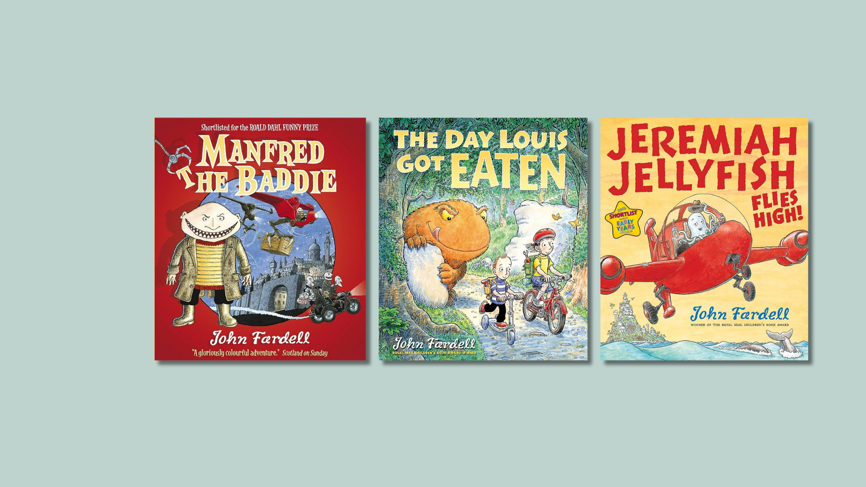

John Fardell learning activities
Creative activities inspired by Manfed the Baddie, The Day Louise Got Eaten, Jeremiah Jellyfish Flies High

Age 5-8

CFE First Level

Resource created by Scottish Book Trust

scottishbooktrust.com
Scottish Book Trust is a registered company (SC184248)
and a Scottish charity (SC027669).

Contents
About this resource 2
Manfred the Baddie learning activities 2
The Day Louis Got Eaten learning activities 4
Jeremiah Jellyfish Flies High learning activities 7
Further resources 8
Worksheet 1: Create your own hideout 9

About this resource
John Fardell is an award-winning writer and illustrator whose picture books and novels have delighted children since the publication of The 7 Professors of the Far North in 2004. As well as his fast-paced adventure novels, John writes and illustrates picture books, and both Manfred the Baddie and The Day Louis Got Eaten were voted the nation’s favourite picture book by Scottish children in 2009 and 2012.
This resource contains cross curricular activities to explore John Fardell’s picture books. You don’t need all three books – you can focus on just one. We encourage you to adapt these activities based on the children you work with!

If you are taking part in Reading Schools, the activities in this resource could support delivery of Key Area:
- 1.5.1: Access to high-quality books
- 2.2.2: Interdisciplinary book projects.

Manfred the Baddie learning activities
Manfred is a baddie; he is constantly kidnapping inventors, stealing from art museums, conducting acts of piracy on the high seas. Will Manfred ever learn his lesson and reform his ways?
Activity 1: Create your own hideout
ENG 1-31a, TCH 1-12a, EXA 1-03a
Manfred has a hideout on a rocky pillar up in the mountains. Use Worksheet 1 on page 9 to get pupils to think about hideouts and what their own hideout would be like. What would they need? How would it be decorated? Where would be a good place to build it? Up in the mountains like Manfred, or hidden in plain sight in a city? You can extend the activity by asking them to make a model of their own hideout using recycled materials.
Activity 2: Come up with your own invention
EXA 1-03a, LIT 1-28a
Most inventions start out being the answer to a problem. No one knows who first thought of the early inventions like the wheel, clothes or making fire, and they might well have been discovered by accident. Sticky notes were invented by accident by scientists trying to make stronger glue for use in aerospace.
Can your pupils think of an invention which would solve a problem, perhaps something that would make an everyday house, school or garden task easier to do? Perhaps there is a task or problem in your setting that they could invent a device to solve? Ask them to make a few sketches of different ideas, and then choose a favourite and write a short paragraph about it.
When your pupils have drawn and written about their favourite, challenge them to present it to the class, giving step-by-step instructions for its use and explaining all its benefits.

Activity 3: Comfort food
LIT 1-31a, HWB 1-15a
Manfred wants a bowl of warm soup when he isn’t feeling well. What do your pupils eat and drink when they’re not feeling well? What words would they use to describe the taste of these foods and drinks? Ask pupils to write a short poem or paragraph describing the way these things taste and how they make them feel.
Activity 4: Favourite stories
LIT 1-11a, EXA 1-12a
When Manfred isn’t well, he wants someone to come and read him a story. What kind of stories would your pupils like to hear if they were unwell? Would they want to hear a story about ghosts and monsters, or maybe something a bit gentler?
When someone reads us a good story, it can help us to forget about problems for a little while. Can your pupils find a good story that they think Manfred would enjoy and act it out as a play to help Manfred forget about his cold for a while? Scottish Book Trust offers a variety of resources to help you plan your play. You can search for these on the Scottish Book Trust website:
- Quick drama activities for performing picture books
- How to turn picture books into plays

The Day Louis Got Eaten learning activities
When Louis gets eaten up by a Gulper, his big sister Sarah knows she has to act fast to help him, and sets off in hot pursuit. However, rescuing a boy from a Gulper's tummy isn't so simple - especially when other strange and scary creatures are looking for their dinner too…

Activity 1: Make your own frog
MNU 1-11a, TCH 1-12a, EXA 1-02a
Louis’ sister uses a ‘hiccup frog’ to get Louis out of the various monsters’ stomachs. Your pupils can make their own frogs and use them for various activities.
Follow these instructions to make an origami jumping frog in this video. The instructions are excellent, but bear in mind the video has a slightly rude word at 4:17 (ass), so it may not be suitable for pupils, but it will show you clearly how to construct the frog! You can find lots of other origami videos on YouTube. The instructions can be downloaded as a PDF.
Origami can be quite complex, but this could be a good opportunity to get older pupils to come in and support younger ones.
Once the frogs are created, pupils can have a competition to see whose can ‘jump’ the furthest. This is a good chance to practice measuring skills, and pupils can create a chart afterwards to see which frog jumped furthest. Pupils can also find out how their frogs compare to real life frogs – the American bullfrog is 20cm long and can jump 10 times its own body length, for instance, so you can ask pupils to measure this out and see how theirs match up.
Pupils can find out more about frog behaviour on DK Find Out.

Activity 2: Food chains
SCN 1-02a
In the book, one thing is eaten by a bigger creature until we reach the top of the food chain with the biggest monster! This offers a great opportunity to explore food chains.
Here are some resources to help you introduce food chains:
- This short BBC video talks generally about how food chains work.
- This short presentation and game from the RSPB gives a slightly more in depth explanation, and is a nice game to play to test learning.
- This card sort activity from TES is also useful – you’ll need to create a free login for the site to access the resource. You could choose to cut off the text on the cards and ask pupils to get in groups, take a card each and stand in the correct order.

Activity 3: What habitat?
SCN 0-01a, SCN 1-01a
The creatures in the book all live in very different environments. Discuss the different landscapes and habitats they live in. Next, look in more detail at the monsters and discuss the different adaptions each creature has for where it lives. For example, the Undersnatch has webbed feet for swimming and Sabre-Toothed Yumper has fur to keep it warm in the caves up in the mountains.
Following on from this, play a habitat game. Present pupils with six images of clearly different habitats e.g. jungle, desert, icebergs, and pictures of lots of different animals that live in those habitats. Ask pupils to work in small groups to place the animals in the correct habitat. Once pupils have finished placing their animals, ask them to explain what made them think that animal might live there e.g. thick fur for the cold.

Activity 4: Health eating
HWB 0-32a, HWB 1-30a, HWB 2-30a
All the different monsters are clearly hungry, and hence bigger and bigger creatures keep eating Louise. Discuss with pupils what these creatures might find to eat – besides each other and Louis. Now ask pupils to think about what the animals might enjoy that they eat and ask them to plan a healthy menu for the monsters. They could also plan a healthy menu for Sarah and Louis, making sure they have healthy snacks for their walk in the wood.

Activity 5: Exploration of size and shape
MNU 0-01a, MTH 1-16a, MTH 1-16b
In the book, Louis is eaten by the Gulper who is eaten by the Grabular, who is eaten by an Undersnatch, who is eaten by a Spiney-back Guzzler who is gobbled up by a Sabre-toothed Yumper. They all fit inside each other like a Russian doll and this is beautifully illustrated by John towards the end of the book.
Ask pupils to bring in recycled objects of different shapes, or use shapes and materials you already have in your school or classroom. Talk about the different shapes that pupils have brought in, discussing shape properties and names. In groups, ask pupils to arrange the items into groups according to shape and then size. Now ask them to see which shapes fit into each other, like a Russian doll. How many items can they fit into each other? Are there shapes that won’t fit into one another? Why do they think this might be?

Activity 6: Walk in the woods
SOC 0-07, SOC 1-13, LIT 1-25a
The adventure started when Louis and Sarah were out in the woods. Go for a walk in the woods, local park or anywhere in your area. Watch out for different animals, people or things. Collect items on your journey. When you get back, write your own story as a class about what you saw. Use your objects to help shape your story.

Jeremiah Jellyfish Flies High learning activities
Join Jeremiah as he swims away from his shoal and changes places with the leader of the world’s biggest rocket plane factory. Jeremiah will fly high, but is there something missing from his new life?

Activity 1: World of work
HWB 0-20a/HWB 1-20a
Jeremiah swaps places with an executive and takes over the rocket business for a short while, attending lots of meetings and parties for work. Ask pupils to write down all the different things Jeremiah does as part of his new job. Would they enjoy this job? Why do they think the man might have wanted a change?
As an exploration of the world of work, ask parents and other members of the local community to come into school and talk about their jobs and the different activities they do as part of their role.

Activity 2: Letter writing
LIT 1-26a, LIT 1-28a/LIT 1-29a
Being a businessperson, Jeremiah has to write many emails and has important correspondence to make with clients and suppliers for the rockets. Ask pupils to write a letter to the manufacturer of the new rocket Jeremiah has been testing. According to Jeremiah, the rocket is “a little sluggish in the right hand turns”. Ask pupils to write a letter explaining the problem, and asking for suggestions of how to fix it.

Activity 3: Job advert
HWB 0-20a/HWB 1-20a, LIT 1-25a, LIT 1-26a, LIT 1-28a
Jeremiah tells his employees that they need to “employ more test pilots” for the rockets (as Jeremiah is too busy to test them all). Ask pupils to create a job advert for this role. What do they need to include in the poster or advert? Whom should applications contact? What skills or qualifications does the pilot need to have? Where will the job be based? Pupils should look closely at the text and images in the book to help them answer these questions and take notes, which they can use to help them compose their job advert.
You could extend this activity further by asking pupils to write an application or letter of response to the advert, and then role-play in small group’s interviews with Jeremiah to select the new test pilots.

Further resources
- For more First Level resources, use the age 6-8 filter on the learning resources section of our website
- For more picture book activities, see our resources 10 things to do with any book (primary), Creating a picture book in class or Quick drama activities for performing picture books

Worksheet 1: Create your own hideout
Print this page

Manfred has a hideout on a rocky pillar up in the mountains. Why do you think he chose this place to hide?
If you could make a hideout, where would it be?
What would it be made from?

Can you draw a picture of it below:

