Using picture books to explore bereavement
Activities to support children through grief and loss using books

Age 3-13

CFE Early to Third Levels

Resource created by Child Bereavement UK

scottishbooktrust.com
Scottish Book Trust is a registered company (SC184248)
and a Scottish charity (SC027669).

Contents
About this resource 2
The Memory Tree 3
The Garden of Hope 6
No Matter What 8
Further resources 10
Worksheet 1: Remembering fox 11
Worksheet 2: Emotional vocabulary sheet 12

About this resource
It is important to use the real words such as “dead” and “died”. Euphemisms including “lost” or “gone to sleep” may seem kinder but can lead to confusion for a child.
Personal experiences of bereavement will have an impact when talking about death and grief; even the most experienced professional can be affected emotionally. It is important to be prepared for this and to recognise when you need support for yourself. We also advise schools to inform parents or carers in advance as this can be an emotive subject and it gives an opportunity to enquire about a child’s previous experience of death, so they can be supported in the lessons.
This resource uses three picture books: The Memory Tree, The Garden of Hope and No Matter What, are used as a basis for activities which develop the understanding of death and the feelings of grief.
Each activity has a specific focus – memories, worries, listening – although they are all designed to encourage a wider use of emotional language, to learn new skills and to build resilience. This resource pack was created by Child Bereavement UK. They provide excellent resources to support bereavement in school, including the Elephant’s Tea Party resources and their schools information pack.

The Memory Tree

Remembering activity
HWB 0-04a/1-04a/2-04a/3-04a, HWB 0-07a/1-07a/2-07a/3-07a
Resources required:
- The Memory Tree by Britta Teckentrup
- Illustrations and text from the book (for each group)
- Recording sheet template (copied)
- Empty box, cartons or bottles,
- Optional: decorating materials, coloured pencils, pens
Read the book and make sure the children understand that Fox has died (use the word dead or died). Explore the feelings of the animals when they ‘…sat in silence for a very long time.’
Check the children’s understanding of the word grief/grieving and what it means. What does it feel like? Discuss emotions of grief – sad, angry, shocked, lonely. (Refer to examples of similar feelings which the children can relate to – lost or broken possession, special person going away) When you are sad, where do you feel it in your body?
Develop the emotional language of grief (frustration, anxiety, feelings of helpless/numb etc.) You could use Worksheet 2 on page 12 to used to support this. Where in your body do you feel these emotions? Draw outline of body and label.

Remembering fox
In groups, give pupils pictures and/or text from the book referring to the animals remembering Fox. Choose one animal’s memory of Fox and draw a picture of it.
Use Worksheet 1 on page 11 to show the animals’ memories of Fox, a feeling this relates to and create a simple symbol to represent it (e.g. Owl – leaf shape).
Ask the questions, “When they are remembering Fox, do the animals still feel grief?” “How do memories of Fox help the animals?” Encourage discussions about how memories make us feel – thinking back to a happy, fun or exciting time; remembering someone’s kindness/love; understanding that memories can be kept forever but not recreated.
Develop the understanding that memories are a way for the animals to maintain their relationship with Fox; explain that we make new memories every day; look ahead to something exciting, fun or new.
Ask the question, “What do we know about Fox?” and “How do we know this?” Allow the children to share their ideas about Fox as being ‘kind’ and ‘helpful’, giving examples.

Extension activities

Own memories
Pupils think of a special memory – prompt ideas (use pictures/photographs for younger pupils) – family days, fun with friends, birthdays, festivals, school trips. Draw a picture and/or write about the special memory – Who was there? Why was it special? What exactly can you remember? Pupils put this representation of their memory into a bottle or box to be saved and ‘treasured’.

Memory box for fox
In groups or as a class, pupils create a special memory box by decorating a box, packet or tub then filling it with special pictures, messages and items to remember Fox.
Draw pictures based on the animals’ special memories of Fox, paint pictures of Fox, collect leaves or grasses to remember the fun Fox had with his friends, write messages to Fox, create images of Fox’s animal friends, cut pictures out of a magazine which show the fun times that Fox had with his friends.
You could also write poems about Fox, decorate stones or pebbles, collect items which might mean something to Fox, write a letter to Fox from one of his animal friends.
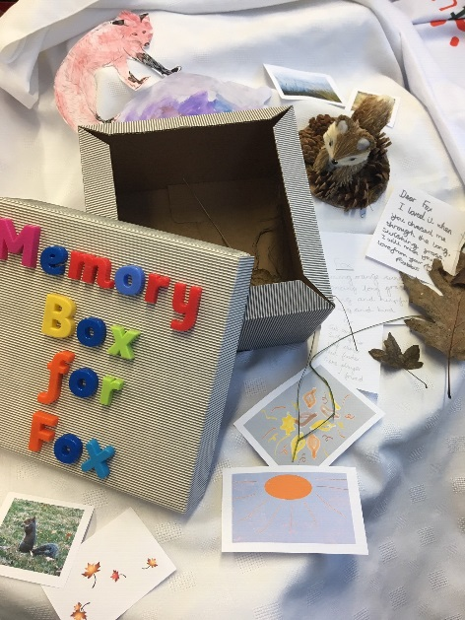

Poetry
Pupils chose some of their special memories and write a poem called ‘I remember when…’ where the lines always start:
- I remember when…
- This made me feel…
Create a printed template with the start of each line already included for them to fill in their own words or add pictures/cut out images from magazines or booklets.
You could also write a poem based on “I remember when…This made me feel…” using memories which have different feelings/emotions attached to them to add variety to the poem. Use a Thesaurus to develop the emotional language used.
You could take some time to discuss is it okay to laugh and have fun when remembering and grieving?

The Garden of Hope

Sorting our worries activity
HWB 0-01a/1-01a/2-01a/3-01a, HWB 0-03a/1-03a/2-03a/3-03a
Resources required:
- The Garden of Hope by Isobel Otter and Katie Rewse
- Scrap paper
- Guatemalan worry dolls information
- Paper
- Optional wool, pipe cleaners, hoop

Explain that Maya is grieving; explore what this means and who has died. In the story, some of the characters have worries. What do you worry about?
- Each pupil chooses one of these worries and writes it down onto a piece of scrap paper without using any names (one worry per piece of paper).
- They screw the papers up and throw them into a target area (hoop, opposite side of room, empty bowl/bucket).
- Pupils take turns to open and read out the worries, creating a class or group list.
- Common and shared worries are identified and discussed.

How do worries feel?
How do you feel when you have a worry? Where do you feel this? What can you do when you have a worry? Put a large piece of paper on each table and ask the pupils to come up with as many ideas as they can for people, strategies or things which can help when you have a worry.
Model ideas of what could help – tell someone, ask for help, talk to a teacher, take deep breaths/use a strategy, have a hug, do something fun etc. Make a poster of things to help when you have a worry.
What do you think Maya worried about? Why do you think that?
These could reference events or worries indicated in the book but could also be worries for any child. You could ask, “Does Maya worry about her friends at school?” “Does she worry about doing her homework/learning her spellings/going to clubs?”
What does Maya do when she has a worry? How does this help? When do you need to speak to an adult about a worry?

Guatemalan worry dolls
According to legend, children in Guatemala tell their worries and fears to the Worry Dolls and place them under their pillow when they go to sleep at night. The doll ‘looks after’ the worry or problem during the night, so the child can sleep peacefully. Remind the pupils that if they have big worries then they should talk to a trusted adult.
Make some worry dolls which could be:
- Paper cut out paper chain people (pupils write worries onto each one)
- Pom-pom pets (easier to make for younger children)
- Woollen tassel people
- Pipe cleaner worry dolls
- Create a display of worry dolls – sharing some of the things that members of the class worry about, with some strategies and helpful ways to minimise the worry and understanding when to get help
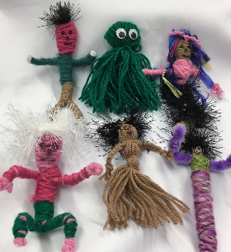
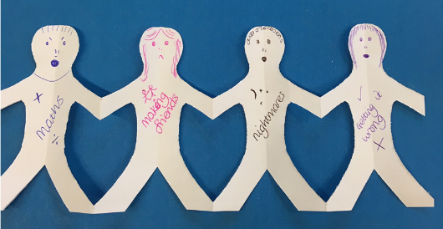

Easy to make pom poms:
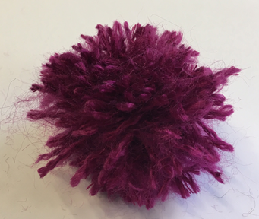
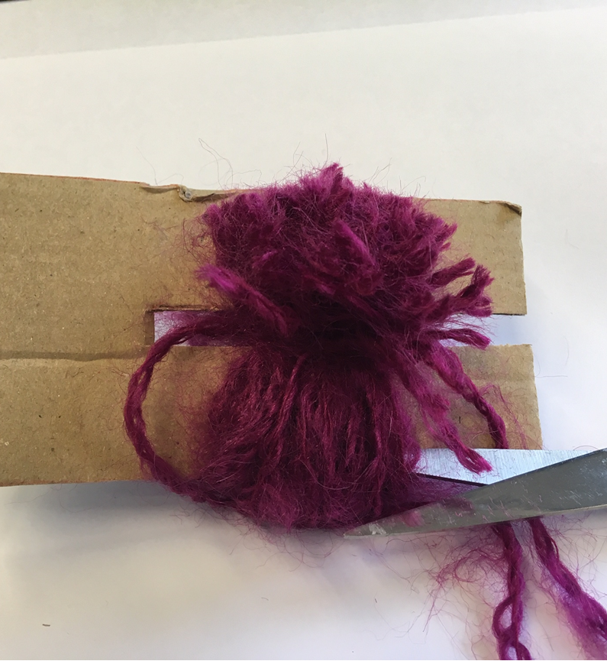
Wind wool around a piece of cardboard with a slit cut into it.
Slide the pom-pom out of the card and add any features.
Tie a piece of wool securely around the middle then snip the
top and bottom.

No Matter What

Listening ears activity
HWB 0-01a/1-01a/2-01a/3-01a
Resources required:
- No Matter What by Debi Gliori
- Illustrations from the story (on board or printed onto paper for tables)

At the beginning of the story, Small is feeling “grim and dark” what does this mean?
Pupils discuss these feelings and link them to Small’s actions, “…toss and fling and squash…” identifying Small’s feelings of anger. They could draw a picture of what angry looks like for them.
Pupils show feelings of anger using their body language only. Can you tell if someone is angry? Develop the language of anger, how does it feel when you are angry and what sort of thing you might do when you feel angry?

Calming down
Small calms down when he talks to Large about his worries. Ask the pupils, “Why is it important to talk about things which make you angry or worried?” “Who could you talk to?” Identify trusted adults in school. When someone talks, it is important to listen very carefully.
Pupils create a ‘mind map style’ picture with themselves at the centre showing all the people who can listen to them – include school adults and trusted family members.
Using illustrations of the story on the board (or sheets on tables), put children into pairs. Each pupil chooses their favourite picture and tells their partner which one they chose and why (limit the time 30 secs/1 minute). The ‘listener’ may not speak until the end and they can ask one question.
Partners swap over and the other person shares. Partners then change around so they all have a new partner and they must share their original partner’s choice. The new people check back to see if the information they received was correct.
Reflect on the activity, is it difficult to keep quiet and listen? Did you want to interrupt? Why is it important to listen carefully?
How could you tell if your partner was listening to you? What made it easier to listen? What makes a good listener? What skills do you need to be a good listener? Can you learn to be a good listener?

Further resources

Recommended by Child Bereavement UK
- Red Chocolate Elephants by Diana C. Sands is a book for children bereaved by suicide
- Benny’s Hat by Juliet Clare Bell and Dave Gray, My Brother and Me and I Miss My Sister by Sarah Courtauld are picture books that explore loss of a sibling
- Is Daddy Coming Back in a Minute? by Alex Barber and Anna Jarvis and My Daddy Is My Superhero by Michaelagh Broadbent and Foxhart are books that explore loss of a father
- Goodbye Grandma by Melanie Walsh is a life the flap book exploring death of a grandparent
- I Miss You: A First Look at Death by Pat Thomas is a more generic exploration of grief and loss

Scottish Book Trust resources
- You could use our Mental health awareness resources to extend some of the activities in this resource
- On our website you can find our book lists of recommended picture books and children’s books that explore grief and loss

Worksheet 1: Remembering fox
Print this page
Animal | Memory | Feeling | Symbol
Owl
Mouse
Bear
Rabbit
Squirrel

Worksheet 2: Emotional vocabulary sheet
Print this page
Angry | Frightened | Sad
Cold | Lonely | Surprised

Angry | Cold | Nervous | Surprised
Annoyed | Helpless | Quiet | Tearful
Afraid | Lonely | Sad | Worried

Angry | Cold | Quiet | Stressed
Anxious | Frightened | Sad | Tearful
Amazed | Lonely | Surprised | Worried
Calm | Needy | Scared | Weepy

Abandoned | Cross | Helpless | Scared
Angry | Detached | Hopeless | Surprised
Anxious | Disappointed | Isolated | Stressed
Apprehensive | Distant | Lonely | Tearful
Astonished | Furious | Needy | Thoughtful
Brave | Frightened | Numb | Uncertain
Bereaved | Glad | Panicky | Vulnerable
Calm | Greif-stricken | Peaceful | Withdrawn
Cold | Guilty | Quiet | Worried
Crushed | Heartbroken | Relieved | Weepy

