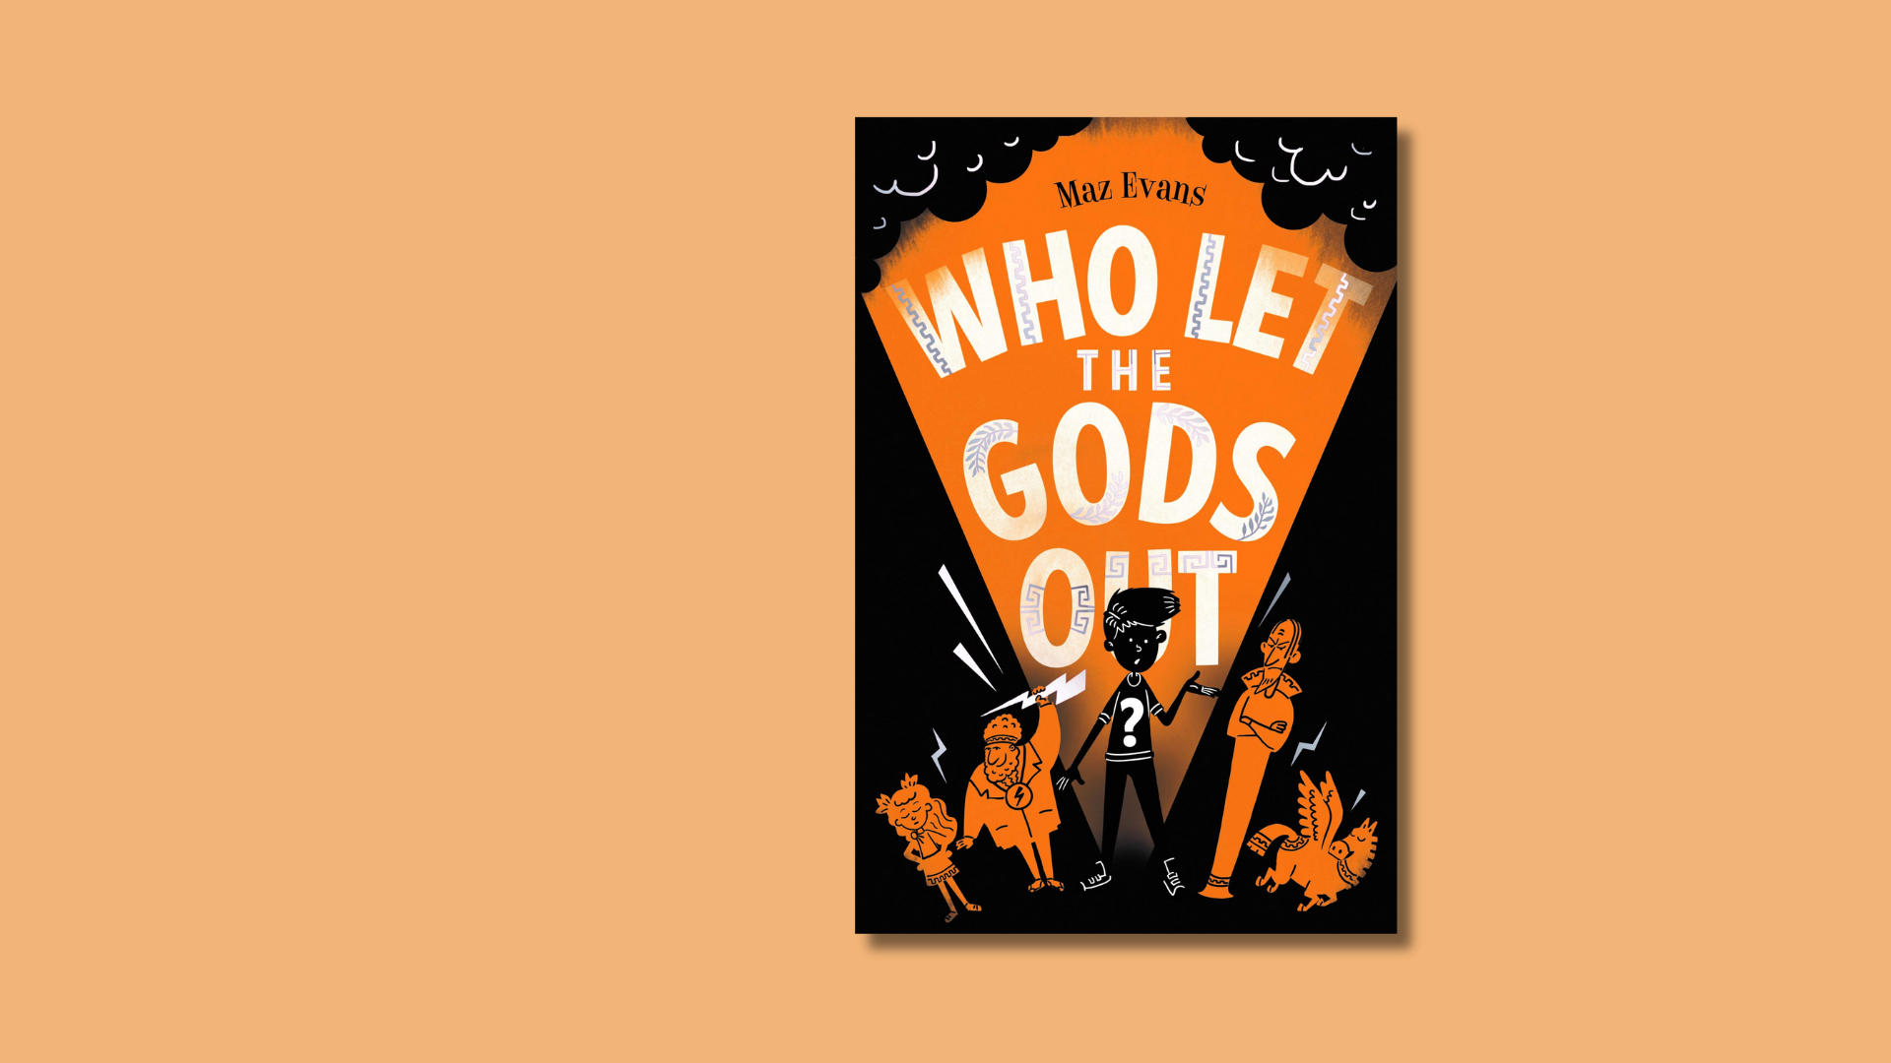

Who Let the Gods Out? learning activities
Creative activities inspired by Maz Evans’ novel

Age 8-12

CFE Second Level

Resource created by Scottish Book Trust

scottishbooktrust.com
Scottish Book Trust is a registered company (SC184248)
and a Scottish charity (SC027669).

Contents
About this resource 2
Learning activities 3
Further resources 7

About this resource
This resource is full of cross-curricular activities inspired by Maz Evans’ novel Who Let the Gods Out?
Things are not going well for Elliot; his mum is ill and his family farm is under threat of repossession. So when Virgo, a fast talking Zodiac constellation falls from the sky and destroys the cowshed he is not immediately thrilled. Things get even worse when he accidentally helps to release Thanatos, a powerful daemon set on taking over the world. Elliot and Virgo enlist the help of the Gods, but after centuries of cushy retirement on earth, are Zeus and his crew up to the task of saving the world – and helping to solve Elliot’s problems too?

If you are taking part in Reading Schools, the activities in this resource could support delivery of Key Area:
- 1.5.1: Access to high-quality books
- 2.2.2: Interdisciplinary book projects
- 2.3.4: Opportunities for learners to respond to what they’re reading

Learning activities

Activity 1: Retell your own Greek myths
LIT 2-01a, LIT 2-04a, LIT 2-05a, LIT 2-06a, LIT 2-20a, ENG 2-27a, ENG 2-31a
The Ancient Greeks told wonderful stories about their many gods, heroes and mythical creatures. These stories were a means for people to explain the world around them and the natural phenomenon which they encountered.
Play your class one of the Greek Myths from this series of BBC radio plays and then ask them to re-tell the myth from the first person point of view, assuming the identity of a character in the story.
In Who Let the Gods Out, Maz Evans incorporates ancient Greek mythology into our contemporary world. Your pupils could try and do the same with one of the myths in this series, updating the story to a modern setting. Or they could have a go at inventing their own myths to explain natural phenomena such as an earthquake or a thunder storm.

Activity 2: Record a podcast
ENG 2-27a, ENG 2-31a, TCH 2-04b
If you’ve come up with your own Greek myths (see Activity 1), you can record them as a class podcast or a radio play- you could continue the BBC series and add more myths to the series.
The basic equipment you need to record a podcast are a computer with recording ability (an internal or external microphone) and some recording software.
Audacity is a free piece of audio software which you can use to record and edit tracks and then export them as MP3 files. Alternatively, pupils could use their phones or an iPad to record and edit audio.
Once your pupils have recorded their podcasts you could upload them to your school website or to hosting sites such as the ones below:
- Soundcloud
- Buzzsprout

For a useful guide to making, recording and uploading podcasts you can look at the Buffer guide for podcast beginners.

Activity 3: Olympian family tree
LIT 2-14a, LIT 2-15a, EXA 2-02a, SOC 2-01a, SOC 2-06a
The Greeks believed that their gods and goddesses presided over all aspects of human life and each had their own power and personality. To give your pupils an overview of the Greek gods and goddesses, their powers and relationships, your class can create an Olympian family tree to display in your classroom.
Divide pupils into small groups and assign each group a Greek god or goddess to research for the family tree. The British Museum has a great website with artefacts from ancient Greece and the stories they depict which your pupils can use as a starting point for their research.
Using their research each group can create a “fact file” poster with an illustration of their God and the following information:

- Name:
- God of:
- Symbol:
- Festivals:
- Interesting facts and distinguishing features:

Once pupils have completed their posters you can display them in the classroom as a family tree. Ask pupils to help put the gods in the correct order and discuss the relationships and stories of the gods as you go. Veritable Hokum has a fun example of a Greek God family tree you could use for inspiration!

Activity 4: The Daily Argus
LIT 2-01a, LIT 2-28a, TCH 2-03a, TCH 2-04b
In this activity your pupils will record a news broadcast for The Daily Argus imagining they are a news team investigating reported sightings of Thanatos.
To begin with your class can read Chapter 11 of Who Let the Gods Out where Thanatos travels to Tartarus, the prison of the Titans. On this journey Thanatos meets a few interesting characters: Charon the ferryman; Cerberus the three-headed hound; Sisyphus, condemned to an eternity of rolling an immense boulder up a hill only to see it roll back down; and Tantalus, sentenced to eternal hunger and thirst in Tartarus. Each of these characters has seen Thanatos and will have a different account of his return, it is the news team’s job to piece together the story.
Split pupils into small groups and ask them to consider what makes up a news report, for example:
- An anchor’s introduction from the newsroom.
- An on the scene reporter.
- An interview with eye witnesses
- An expert’s account for example from a police detective.

To help pupils understand the structure of a news report you could show the class some clips from BBC Newsround and ask them to think the different aspects of the broadcast.
Ask pupils to look back through Chapter 11 to decide which characters they would like to interview and what information they want to include in their report. They can then allocate roles, plan and script their report.
The BBC has some great tips and resources on how to plan and structure a news report:
- How to make a video news report
- School News Report
Once the pupils have created and compiled their news reports it is time to get filming!

Activity 5: Create a comic book scene
LIT 2-16a, ENG 2-31a, ENG 2-19a, EXA 2-02a, EXA 2-03a
Adapting a scene from a book into a comic is a great way to get pupils thinking about
the writer’s craft and to explore key themes and ideas from the story.
The format of comics will probably already be familiar to your pupils and some of them might already be comic book fans. Start off by bringing different comic strips into class and giving pupils time to read them.
A brilliant resource for funny and accessible child-friendly comics is The Phoenix Comic, a weekly comic for 6–12-year-olds. Talk to your pupils about the similarities and differences between different comics and artist’s styles. Some ideas to discuss:
- Is there dialogue? How is it presented? Are there speech bubbles or captions?
- What are the characters doing? How is that shown?
- What is the shape of the comic frames? Do they look like a box? Are the corners rounded? Why do you think the illustrator made that choice?
- How is action, like movement, shown?
- What happens from one frame to the next?

You could use our resource on How to write a comic book scene, created by Metaphrog. Pupils can choose a scene from Who Let the Gods Out and then follow the activities in this resource to create their own comic strip.
If your pupils are less confident you can provide them with a simple layout sheet for their comic to help them get started. You can find lots of different printable layouts on the Printable Paper website.

Further resources
- For more cross-curricular book projects for Second Level, see our resources on A Kind of Spark, How to Train Your Dragon, Tidy or The Nowhere Emporium.
- For more creative writing ideas see our Creative writing activities for upper primary resource

