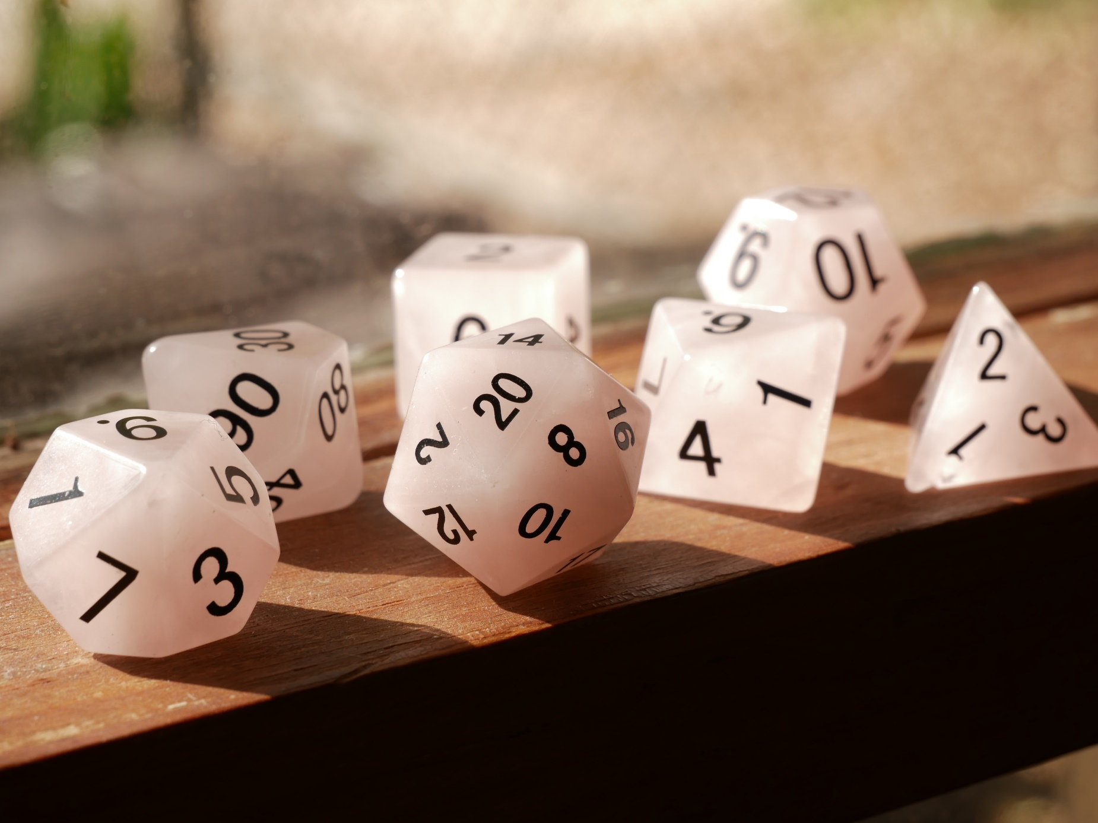

The benefits of using tabletop roleplaying games in classrooms and libraries
A guide to how tabletop role playing games (TTRPGs) promote learning, reading and writing and fulfil Curriculum for Excellence Experiences and Outcomes

Suitable for CFE Second to Fourth Level

Resource created by Scottish Book Trust

scottishbooktrust.com
Scottish Book Trust is a registered company (SC184248)
and a Scottish charity (SC027669).

Contents
About this resource 2
What are TTRPGs? 3
TTRPGs and Curriculum for Excellence 5
Further learning opportunities 7
Examples of games 7
Further resources 8
Glossary 9

About this resource
This resource has been designed to:
- help teachers and librarians understand what TTRPGs are and how they work as a form of teaching and learning
- show how running TTRPGs can support the delivery of key areas of Curriculum for Excellence
- offer advice on how to get started and run a game
This resource has been developed in consultation with teachers, librarians and writers who have created or used TTRPGs with the children they work with. Many thanks are due to the members of our focus group who offered insight and experience and helped shape this resource: Brian Tyrell, Lizy Simonen, Alison West, Frances Sinclair, Hayley Lockerbie, Kateri Wilson-Whalley and Derek France.
Throughout, we’ve tried to use accessible language – however we have included a glossary on page 9 for any terms or words that may be new to new players.

What are TTRPGs?
TTRPGs or “tabletop role playing games” are a type of game where players take on the role of a character that they have created who must navigate a fictional world. Through communal storytelling, players work together to create a narrative together – agreeing what they’d like to investigate or what problems they’d like to solve. This means they promote social interaction, working together and listening, creative literacy and problem-solving.
The most popular TTRPG is Dungeons and Dragons (“D&D”) which uses a medieval-style fantasy world. However, Dungeons and Dragons is only one TTRPG and there are many more which offer different types of character, gameplay and worlds to explore including historical settings, sci-fi settings or modern day.

What do I need to play?
Different TTRPGs will use different equipment in order for players to play, but the key things to have are:
- paper and pens or pencils
- a set of dice, or a dice-rolling app
- somewhere you can play where you can talk as a group, ideally with a table

What does gameplay look like?
The best way to learn what a TTRPG looks like is to play one. Typically, most games involve a Game Master, or “GM” – who describes the setting and helps set up the scenario the players will enter. Players then take it in turns to describe what their character is doing. For example, a bit of gameplay could run like this:
GM: “You are on the deck of a spaceship. You can hear the ship’s consoles gently beeping in the background. It’s late at night, and the other crew are in bed.”
Player 1: “My character would like to look around for anything unusual.”
GM: “When looking around you spot a piece of paper under the captain’s chair, it looks like someone has left her a note…”
Each game will have a goal, whether that’s finding a specific item or object or solving a mystery or puzzle. Most games will require players to work together – each utilising their specific skills to achieve the goal together.

How do I run a game?
We’ve pulled together a list of games (see pages 7 and 8) that are appropriate for use with children and in schools. The variety of formats, genres and styles of each game means there’s something for everyone – whether that’s short and simple or more complex and in-depth.
Each game will include information on:
- the equipment needed to play (e.g. dice, a deck of cards, etc.)
- anything you’ll need to print or provide players for them to track their characters (character sheets)
- number of players
- the rough amount of time it’ll take to play
The games will also contain information only for you (the Games Master) which give you tips and strategy for running the game. Make sure you keep that information secret from your players. Some games will come with easier “starter sets” for new game masters and you can also often find videos online (such as on YouTube) of either gameplay or tips and tricks.
For a more thorough guide on what this can look like, we recommend this article on “Setting Up a D&D Group in School” by Frances Sinclair from Stromness Academy Library.

TTRPGs and Curriculum for Excellence
TTRPGs are a brilliant and fun way to engage pupils with many aspects of Curriculum for Excellence across subjects. Because TTRPGs cover so many different types of games and learning experiences, our advice is to start from what you want the game to teach and use them as a form of learning – just as you would with a class text. For example:
- History: have players role play as key historical figures to better understand their context and motivations (SOC 2-03a/3-03a/4-03a)
- Modern languages: base a puzzle in the game around vocabulary in the language you’re learning (MLAN 2-01a/3-01a/4-01a)
- Literacy and English: use character creation or character sheets to develop skills in creative writing (LIT 2-28a/3-28a/4-28a)

Whilst TTRPGs can be completely flexible, the following section will outline the key skills that most TTRPGs will develop in learners.

Literacy and English
Communication and speech skills:
TTRPGs rely upon “communal storytelling” - including taking turns to suggest ideas, working with other players to solve puzzles or problems, describing a character or world, and even acting as that character.
LIT 2-02a/3-02a/4-02a, LIT 2-09a/3-09a/4-09a, LIT 2-10a/3-10a/4-10a,
ENG 2-03a/3-03a/4-03a, LIT 2-29a/3-29a/4-29a

Writing and note-taking:
Many mechanics of TTRPGs require players to take notes – including creating a character and keeping a track of events of a game or any items, features or characters they may have found or met.
LIT 2-05a, LIT 2-14a/3-14a/4-14a, LIT 2-15a/3-15a/4-15a

Creating characters:
TTRPGs involve players creating their own character to play. This includes creating backstories, motivations, skills, flaws, as well as understanding how their character would act in specific situations, as part of a team and as part of a wider world. You can explore creating character sheets – where all the key information about a character is laid out on a side of A4 – as way to explore developing characters including motivation, skills, flaws and backstory.
ENG 2-19a/3-19a/4-19a, LIT 2-25a/3-25a/4-25a, LIT 2-28a/3-28a/4-28a,
ENG 2-31a/3-31a/4-31a

Mathematics

Dice rolling
Many TTRPGs rely on the use of dice rolls to make decisions. This means players have to use addition and subtraction to figure out if they are able to do something in the game. It also involves a level of probability – for example, if a player knows they need to roll at least a 15 on a 20-sided dice, they need to predict how likely it is they’ll roll 15 or above.
MNU 2-03a/3-03a/4-03a, MNU 2-03c/3-03c/4-03c, MNU 2-22a/3-22a/4-22a

Health and wellbeing

Empathy
TTRPGs ask players to spend a lot of time thinking about how their, and others’, characters would feel based in a specific situation upon their backstory, motivations, personality (etc.) Most games also encourage working together as a group or party to solve problems.
HWB 2-01a/3-01a/4-01a, HWB 2-02a/3-02a/4-02a, HWB 2-04a/3-04a/4-04a

Escapism
Just like reading, playing a TTRPG is a form of escapism where players can explore different actions, emotions, worlds and characters without the consequences of “real life”.
HWB 2-06a/3-06a/4-06a, HWB 2-07a/3-07a/4-07a, HWB 2-14a/3-14a/4-14a

Expressive arts

Embodying characters
TTRPGs involve creating unique characters and encourages players to embody that character – considering their manner, voice, behaviour, motivations as well as skills and weaknesses.
EXA 2-12a/3-12a/4-12a, EXA 2-13a/3-13a/4-13a

Further learning opportunities
Roleplaying as a form of learning offers a lot of other opportunities, such as connecting with your local community. Here are just some ideas:
- You could run a game with other local schools or as a transition project between primary and secondary school
- You could invite parents or members of the community in for a “stay and play” where they join in with a game
- Work with your local library to create a display of books that link into your game, whether a similar genre like fantasy or sci-fi or non-fiction books that explore a specific era or idea that’s present in the game
- Our Live Literature database contains writers and illustrators, including games writers. You could apply for funding to bring in a games writer to help your pupils write their own game or run a game for your pupils.

Examples of games
These games have been chosen as they are short, and easy to set up and run, as well as appropriate for learners.
Game | Description
Dungeons on a Dime by Brian Tyrell | This book collects short 2-3 hour games, and is accessible for first time players and game masters. The story focuses on the theft of one enchanted gem – and the chaos it causes across a city!
Scurry! from Stout Stoat Press | Journey through Scotland as beasts! Players have to keep an eye on the time and make sure their character doesn’t succumb to exhaustion. Each game takes an hour to two hours.
Inspirisles from Hatchlings Games | Inspirisles is a cooperative game that reimagines the legend of Arthur and Guinevere whilst teaching players British and American sign language.
Omotenashi by One More Potato Chip | Work together to run a lodging house for visiting animals in this game inspired by the Japanese “omotenashi” – the concept of going above and beyond in hospitality.
Little But Fierce by DC Bradshaw | Little But Fierce adapts the 5th edition of Dungeons and Dragons for players as young as six, updating the rules, language and tone.
Numbskulls by K. Ramstack | Players are part of a skeleton crew who work for a powerful necromancer. The only problem is necromancy is forbidden, so you need to pretend to be humans – convincingly!
Monster of the Week from Evil Hat | Fight monsters in this game inspired by Buffy the Vampire Slayer, Supernatural and The X-Files. Players must face vampires, ghouls and trolls in each of these stand-alone stories.
Honey Heist by Grant Howitt | Play as criminal bears who want to undertake the greatest heist the world has ever seen!
Trash Bandits by Tally Winkle | This short game allows you to play as a group of raccoons planning a heist. Each game is roughly half an hour.
16 Mice Make Soup by Rosie Lav and Charlie Chorne | You, and up to fifteen other mice chefs, are premiering a new TV show on the Cheese Network. Players must work together to make a three course meal, including soup!
Amazing Tales by Martin Lloyd | This book contains a guide to creating stories together, using dice to add an element of change and drama. Settings include a spooky wood, a magical kingdom and a pirate ship!

Further resources
- For more resources on gaming, see our Gaming learning activities
- For book recommendations see our book list of Brilliant books for gamers
- For more information on supporting reading and writing through games see our article on how gaming can be used as a gateway to literacy
- As part of previous Book Week Scotland celebrations we have created two games you can use with your class - The Bookshop: A Roleplaying Game and Write your own quest
- For older pupils we have an article on writing games from Gavin Inglis, which suggests activities and ideas for learning about how to write both the narrative and codes for video games

Glossary
- Campaign – a series of games that are linked together to tell a longer narrative. If your players play the same character over several games – all those games are under the same campaign.
- Character sheet – a record, usually printed, of the information about a character. A player will use this to keep track of their character’s information including skills, weaknesses, backstory, or any items they may have.
- D&D or Dungeons and Dragons – a specific TTRPG set in a medieval style fantasy world. Originally created in the 1970s, the game is now in its fifth edition.
- D6, D10, D12, D20 - the names for different dice based on how many sides they have.
- DM or GM – Dungeon Master or Game Master, the person in charge of running the game.
- NPC – non-playable characters – any characters that are created and played by the GM which other players can interact with. For example, as part of your game your players might need to go to a shop and you would play the shopkeeper – the shopkeeper would be an NPC.
- TTRPG – table top roleplaying game: a game where players play as a character they have created in a fictional world.

