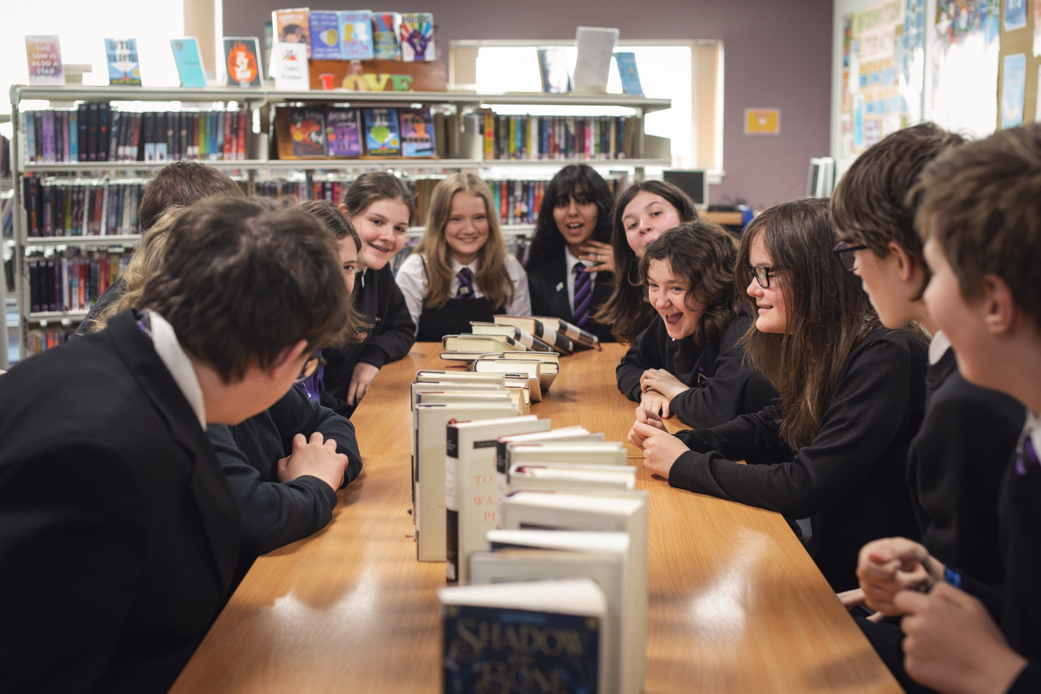

Celebrating World Book Day: secondary resource
A guide to World Book Day including suggested activities and ideas for your class and school

Suitable for secondary schools

Resource created by Scottish Book Trust and World Book Day
scottishbooktrust.com
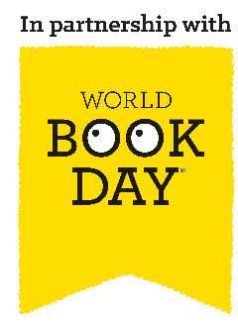
Scottish Book Trust is a registered company (SC184248)
and a Scottish charity (SC027669).

Contents
About this resource 2
Why celebrate World Book Day? 3
Preparing month by month 3
Suggested activities for World Book Day 6
Next steps 10
Sample letter to parents/families (dressing up) 11
Sample letter to parents/families (not dressing up) 13

About this resource
World Book Day 2024 is Thursday 7 March. This resource, created in partnership with World Book Day, contains advice and ideas for celebrating World Book Day in your class and school. Throughout, we’ve highlighted Scottish Book Trust resources you can use as part of your celebration, or to deliver further opportunities to read for pleasure. These can be adapted based on your context and the children you work with.
The key areas of this resource are:
- How to support pupils, and families, to use their £1 book token to choose a book and read together at home.
- How to work with staff and pupils to plan activities and delivery for World Book Day on Thursday 7 March.
- How to continue to support reading for pleasure in your school, build a reading culture and making reading fun using World Book Day and Scottish Book Trust resources and programmes.

Why celebrate World Book Day?
Reading for pleasure is a key indicator of a child’s future success, in fact, studies show its more important for a child’s educational success than the socio-economic class they grow up in. Reading for pleasure has benefits across the curriculum for a child’s skills and learning, as well as their motivation to learn. It also helps develop key life skills such as empathy, imagination, problem-solving and communication skills.
By celebrating days like World Book Day and giving reading for pleasure a high profile in your school, you are demonstrating to pupils that reading is a fun and worthwhile way to spend their time. By sharing your habits and preferences as a reader, you are also acting as reading role model, which is something that they may not have at home. Throughout this resource, we suggest ways to make reading engaging and fun, especially for reluctant readers, as well as how to extend these ideas in your school beyond World Book Day.

Preparing month by month

December
- Familiarise yourself with the World Book Day £1 book selection on the World Book Day website. You could show the covers to the pupils and ask them to describe what they think might happen in the book. Or you could read their blurbs aloud and ask them to pick which one they would like to read the most.
- Distribute the £1 tokens to children early to give them the best selection of books. £1 tokens can be exchanged from Thursday 15 February.
Don’t forget, your local bookseller can help you source books for children in your setting, for free. Early conversations make this more possible.

January

Staff briefing
To get your staff on the same page, we recommend running a staff briefing using the editable PowerPowerpoint template. Some key things to consider are:
Will you encourage pupils to dress up?
If so, read World Book Day’s Dressing Up guide for more information on how to make this accessible for families who cannot afford costumes. For example:
- Host a costume swap-shop.
- Ask pupils to dress up using only three items of clothing.
- Consider alternatives such as drawing a favourite character.

How does this tie into existing delivery at your school?
If you’re taking part in Reading Schools celebrating World Book Day could deliver key areas such as:
- 1.3.2 – School environment.
- 2.2.1 – Regular opportunities to read for pleasure.
- 2.2.3 – Creating learner social networks.
- 2.5.1 – Raising the profile of reading with families.

If you’re still looking to improve the reading culture in your school, you could use the Building a reading culture and Creating reading groups and events resources on the Scottish Book Trust website to begin planning what you’d like to deliver in your school. This resource includes suggestions for delivery as well as fun activities you could run on World Book Day such as Book Jenga, Extreme Reading or Book Speed Dating!
What do you want to run on the day?
See pages 11-14 of this resource for our suggested activities for World Book Day, use this with your colleagues and pupils to plan what you’d like to deliver on the day.

How can you involve pupils in organising events or activities for the day?
If you’re taking part in Reading Schools, your Reading Leadership Group’s could help plan and organise your celebrations on the day. Alternatively, you could use surveys to ask pupils what they’d like to do on the day or ask older pupils to create book boxes for the year below.

Promote all reading is good reading
Allow children full choice of what they’d like to read, including books, audiobooks, comics, graphic novels, and other texts. Read about why free choice of reading material is key in this article from Sarah Coyle on the Book Trust website.

Plan the events you’ll join in with
- Preparing for World Book Day 2024
- Overcoming barriers to Reading for Pleasure with The Open University
- BBC Live Lesson
- Great World Book Day Footy & Booky Quiz with The National Literacy Trust

How will you communicate with parents or families?
On pages 11-14 of this resource, you’ll find an editable letter template for parents with information about World Book Day and the £1 tokens. We’ve also gathered some links to activities and advice for families to support them to read at home.

February
- Check your World Book Day £1 tokens have arrived.
- Order your braille, audio, or large print £1 books via Guide Dogs, RNIB, NCBI and Calibre Audio. Visit World Book Day’s FAQs page for more information.
- If you haven’t already, look through the £1 books together in class. Talking about which book you’d pick, and why, could be a great way to role model reading.
- Look through the author’s websites together – have you heard of them before? Have you read any of their other books?

Suggested activities for World Book Day

Form time
Ask staff to pre-record an extract from a book, short story or poem that pupils can access in school. You could also create a library display of all the titles shared.
Make time for reading during form time – introduce a reading slot where you explore opening chapters, or current affair articles to read. Make some time for discussion about their thoughts, feelings and reactions.
Form time also offers a great opportunity for free reading! Encourage pupils to bring in, or borrow, a book they can read during form time.

Start of each period
Give your pupils ten minutes to read to start each lesson. This can be independent reading, group reading or being read to by a teacher. Teachers can also browse the Authors Live on Demand library by curriculum area to find broadcasts with children’s authors and illustrators that they can watch in class. Each broadcast comes with tie-in activities or resources, giving teachers inspiration for extending learning.

Secrets and surprises throughout the day
Story share – ask older pupils to read, or recommend, a book to younger pupils in the school, or write a brief recommendation postcard to display.
Carry a book – ask staff to carry a book with them on World Book Day, and encourage students to ask them questions about it.
Dress your door – Encourage staff to decorate their classroom doors with key information about their favourite book to promote discussion on entry. They could use images, key quotations, character names, fun facts etc., to recommend their book.
Book trail – Hide books around the school building and provide students with clues. The first to find can either keep or pass on.
Reading dares – Use the Bookzilla app to get a random reading dare or set yourself a reading challenge. Swap a book with a friend, re-read an old favourite, or try a new genre!
Books that made me… – Ask pupils to discuss the following:
- Books that made me smile
- Books that made me laugh
- Books that made me sad
- Books that changed my life
You can collate this list and display them around the school, or work with your local librarian to create a display of pupil’s top picks.
Reading recommendations – Explore the Reading Recommendations page of the World Book Day website with students. The lists are arranged according to authors, genres and general interests. There are even author videos to share. You could also look at Scottish Book Trust’s book lists, which you can filter by age and themes or topics.
Reading recommendations – Explore the author videos for the “fluent” and “independent” recommended reads or discover more with World Book Day’s partner AUTHORFY. In small groups, students could discuss their understanding of the topics and issues raised in the novels, such as cerebral palsy, identity and ethnicity, understanding other cultures and customs, trust and friendship.

Reading lunch
During lunch, you can offer some stalls or tables for pupils to visit:
- Your local bookseller could run a stall where pupils can buy books, or ask for recommendations of what to read.
- If your school has a library, you could create a World Book Day display for pupils to visit.
- Set up a room, or table, like a restaurant with books from different genres. You could make menus allowing them to get a flavour for each book. This can be a great way to draw attention to the books you already have in your school or library.
- Discuss the £1 books. Allow pupils some time to look over the titles and discuss which ones intrigue them.

In the library
Work with your local library to run some activities throughout the day. This could include:
- Paired reading – use Scottish Book Trust’s Paired reading toolkit for advice and activities.
- Get to grips with Bookzilla – Bookzilla is Scottish Book Trust’s free app which allows primary and early secondary pupils to explore books and set themselves challenges. On the Scottish Book Trust website you’ll find activities for Using Bookzilla in your school, including creating your own Genre fortune teller!
- Use World Book Day as an opportunity to start a book club. Scottish Book Trust has an article on Running a pupil book club with advice and World Book Day has activities, top tips and information for parents.

Just one lesson
In one of your classes, you could set aside time for a something fun, whilst still squeezing in some book chat:
- As an alternative to dressing up, ask pupils to decorate an egg or potato as their favourite character or topic. Staff can join in too!
- Invite pupils and staff to find a way to represent their favourite book that’s tricky to spot, e.g., carrying clues, wearing a pin badge, drop in catchphrases into everyday conversation. You could have prizes for sneaking clues past each other, or for guessing the most clues!
- Get each teacher to name and describe their favourite childhood book with clues. Students have a quiz sheet to question staff and figure out whose favourite book is whose. Alternatively, share a favourite childhood photo alongside a book cover and have them guess who the images are!
- Have a book bake off – have staff and students bring in book-themed goodies. You could host a bake sale to raise money for books in your schools’ library.

Getting books home
Host a free book swap at school. In the week leading up to World Book Day, encouraging pupils to bring in any books they’d like to exchange.
Alternatively, arrange for your local librarian to visit. If pupils don’t already have a library card, you could send home the form to sign up with every pupil to complete at home with some information for families.
Stage a rescue mission – encourage students to visit their local charity shop and “rescue” a book!

Next steps
Promoting reading for pleasure in your school is important all year, not just on World Book Day! For more support to build a reading culture in your school see:
- Our free Reading Schools programme which offers an accreditation for building a reading culture in your school, as well as support and resources to help you with delivery.
- Our Schools guide contains more information on the programmes, CLPL and resources from Scottish Book Trust created to support teachers, educators and librarians in schools.
- Our Building a reading culture webinar and resource contains a guide to building a reading culture in your school, including supporting pupils to read for pleasure, developing your staff’s knowledge and ideas for groups and activities
- World Book Day’s Resources Hub contains lots more reading for pleasure ideas, resources for World Book Day and all year round!

Sample letter to parents/families (dressing up)
Dear parents and caregivers,
World Book Day takes place on Thursday 7 March this year, and we hope you’ll join us to celebrate World Book Day across the school.
Dressing up or bringing books into school is a big part of World Book Day celebrations, and is something that children and families particularly enjoy. We are inviting children to dress up this World Book Day as it’s an exciting way for children to get book recommendations from each other.
The book choice is key – even if it’s just a prop or a clue make sure your child is recommending something to read with their costume.
We are aware that the cost of living crisis might make this difficult for some families, so we have organised the following events to make sure that our World Book Day is fun and inclusive for all.
We encourage you to use things you already have at home to make a creative costume.
We will also be hosting a costume swap on DATE/TIME.
We will be opening the setting with a selection of materials to make costumes on DATE/TIME
We’d love to include you in our celebrations by coming into school to:
- Read to them
- Sending your child’s chosen book in with them on the day so we can read it to them and their friends

Access to books
Getting a free £1/€1.50 book for your child is easy – simply take your £1/€1.50 book token to your nearest bookseller and swap it for a World Book Day £1/€1.50 book OR use it to get £1/€1.50 off any ANY book or audiobook costing £2.99/€3.99 or more. You can find your nearest bookseller at worldbookday.com/participating-retailers
We’ll also be hosting a very special book swap. Drop off any unwanted books in the box outside XXX, then come and browse! Please feel free to take something you would like to read whether you’ve donated a book or not.
Join our open library session on XXX and help your child choose their next book to read at home. This is a chance for you to become familiar with the books in school too.
We’re very much looking forward to celebrating World Book Day, which could not happen without the support of parents and carers – thank you.

Sample letter to parents/families (not dressing up)
Dear parents and caregivers,
World Book Day takes place on Thursday 7 March this year, and we hope you’ll join us to celebrate World Book Day across the school.
Dressing up or bringing books into school can be a big part of World Book Day. This year we are aware that the cost of living crisis might make this difficult for some families, so we are doing things a bit differently!
Instead of coming to school in costume, we will:
- Be making egg/potato of the children’s favourite characters. We can’t wait to see what the children’s creativity unleashes and to meet all of the egg/potato characters. How many will you recognise?
- Decorate our doors.
- Invite children to be their favourite character “in disguise” – how can they subtly be their favourite character without giving it away? They could wear pin badges, carry around written clues or learn some catchphrases off by heart.

Access to books
Getting a free £1/€1.50 book for your child is easy – simply take your £1/€1.50 book token to your nearest bookseller and swap it for a World Book Day £1/€1.50 book OR use it to get £1/€1.50 off any ANY book or audiobook costing £2.99/€3.99 or more. You can find your nearest bookseller at worldbookday.com/participating-retailers
We’ll also be hosting a very special book swap. Drop off any unwanted books in the box outside XXX, or just come and browse! Please feel free take something you would like to read whether you’ve donated a book or not.

Join our open library session on XXX and help your child choose their next book to read at home. This is a chance for you to become familiar with the books in school, too.
We’re very much looking forward to celebrating World Book Day, which could not happen without the support of parents and carers – thank you.

Source: “Reading for Change: Performance and Engagement across Countries”, PISA 2020
Source: “Motivation During an Excessively Challenging Reading Task: The Buffering Role of Relatvie Topic Interest”, The Journal of Experimental Education. 2011.
Source: “The role of home learning environment and emerging insights into the impact of the pandemic”. National Literacy Trust. 2022.

