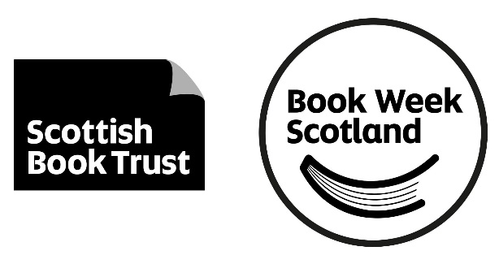
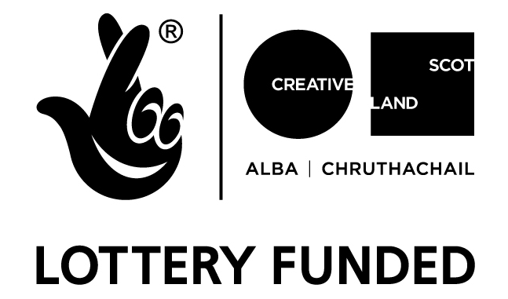

[Insert your logo]

FOR IMMEDIATE RELEASE
Read all about [your organisation]’s Book Week Scotland celebrations.
[Your organisation’s name] is holding a [your event] to celebrate Book Week Scotland 2019 (18 to 24 November).
Book Week Scotland is a national celebration of books and reading that brings hundreds of free events to a variety of venues across the country.
The theme for Book Week Scotland 2019 is Conversation and throughout the week we will celebrate everything from the blethers to our favourite gossip spots.
Those who want to spend the week reading will also have plenty of choice, with a free book which will be distributed to libraries and Book Week Scotland partners across Scotland in the run up to the week.
[Your organisation’s name] will take part in the celebrations by [write about the what, where and when of your event here].
[Include a quote, example below…Name and Job Title of person at this organisation] said:
“We are delighted to be holding [event], to celebrate Book Week Scotland and encourage everyone in the community to come along and share their love of reading. If you can’t make it along, remember there are lots of other ways to get involved in Book Week Scotland online. This is the perfect time to get signed up to your library or look out your membership card, stock up on books at home and make time to relax and read.”
[Add a second quote here if you have another person to quote.]
Working with a wide range of partners, Scottish Book Trust – the national charity changing lives through reading and writing – will deliver events and activities across the country during Book Week Scotland 2019, which runs from 18 November to 24 November, linked to this year’s theme of Conversation. Now in its eighth year, Book Week Scotland was initiated by the Scottish Government and is funded annually by Creative Scotland.
Hundreds of free events happen during Book Week Scotland across every region, including every Scottish Library service with the support of Scottish Library and Information Council (SLIC).
www.bookweekscotland.com
The following paragraphs should be used in the notes to editors section of all press releases. Also include a paragraph about your own organisation.
Scottish Book Trust
Scottish Book Trust is a national charity changing lives through reading and writing. We inspire and support the people of Scotland to read and write for pleasure through programmes and outreach work that include:
- Gifting books to every child in Scotland to ensure families of all backgrounds can share the joy of books at home.
- Working with teachers to inspire children to develop a love of reading, creating innovative classroom activities, book awards and author events.
- Supporting Scotland’s diverse writing community with our training, awards and writing opportunities.
- Funding a range of author events for the public to enjoy and promoting Scottish writing to people worldwide.
In addition to the funding we receive from the Scottish Government and Creative Scotland, we need the constant support of trusts and foundations, corporate sponsors and individual donors.
www.scottishbooktrust.com @scottishbktrust www.facebook.com/scottishbktrust
Creative Scotland
Scottish Book Trust is supported by Creative Scotland through Regular Funding. Creative Scotland is the public body that supports the arts, screen and creative industries across all parts of Scotland on behalf of everyone who lives, works or visits here. We enable people and organisations to work in and experience the arts, screen and creative industries in Scotland by helping others to develop great ideas and bring them to life. We distribute funding provided by the Scottish Government and the National Lottery. For further information about Creative Scotland please visit www.creativescotland.com. Follow @creativescots and www.facebook.com/CreativeScotland
About Book Week Scotland
For more information about Book Week Scotland, visit www.bookweekscotland.com. Follow @BookWeekScot on Twitter, check out #BookWeekScotland or ‘Like’ the Book Week Scotland Facebook page for updates.

