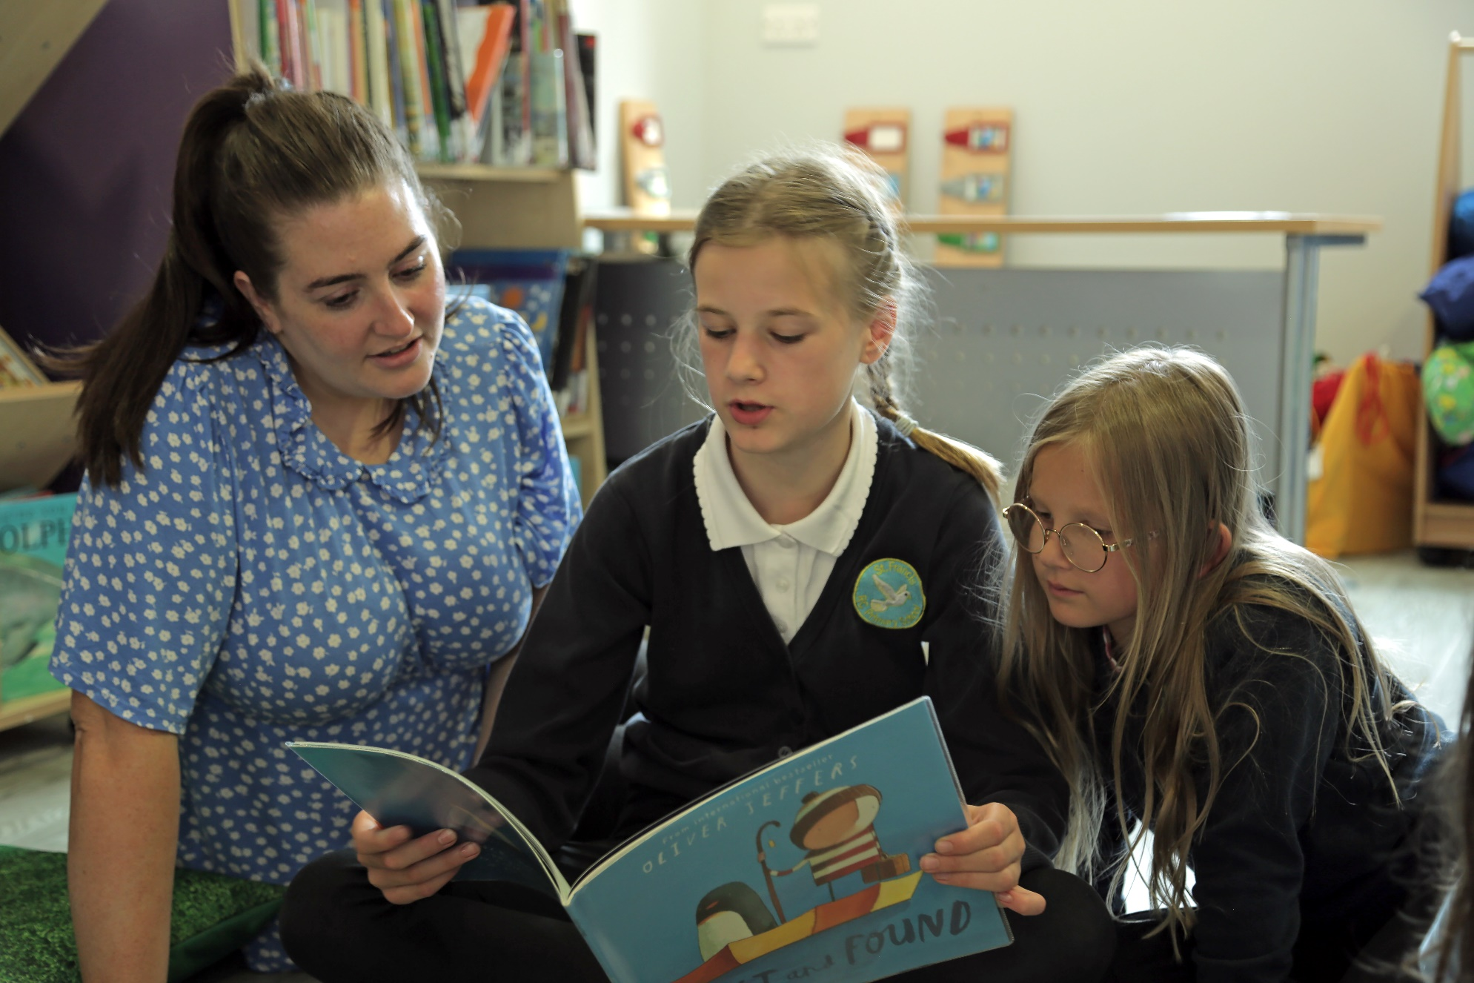

10 things to do with any book (primary)
Fun, creative activities for the classroom and library
Age 5–11
CFE Early, First and Second Level
Resource created by Scottish Book Trust

scottishbooktrust.com
Scottish Book Trust is a registered company (SC184248)
and a Scottish charity (SC027669).

Contents
About this resource 2
Early level activities 2
First level activities 3
Second level activities 6
Quick activities 7
Further resources 8

About this resource
The activities in this resource have been designed so that they can be used with almost any fiction text. They are designed to further children’s understanding of aspects such as setting, plot and character and to provide readers with opportunities to discuss, compare and share opinions about different texts. The resource is not a linear progression of activities but rather a range of ideas from which teachers can pick and choose.
If you are taking part in Reading Schools, the activities in this resource could support delivery of Key Area:
- 1.3.2: School environment
- 2.2.1: Regular opportunities to read for pleasure
- 2.2.2: Interdisciplinary book projects

Early level activities

Activity 1: Picture this
LIT 0-09b, LIT 0-31a
Give children images of settings, characters and events from their reading book. Ask them to create their own stories using the images. They can do this in pairs and then pairs can join together to share their own creations. The activity could be repeated, this time giving children 1 new image, not found in the text. Ask them to incorporate this into their story.

Activity 2: Invitation to play
LIT 0-09b, LIT 0-31a
Ask children to choose a character from a text they have read and to design a simple invitation, inviting him/her to their house. The invite should include a picture or sentence about what they will do during the visit (using information about likes/dislikes from the text).

For more Early level activities, see our resource 10 things to do with any book (early level)

First level activities

Activity 1: Who am I? Hot-seating
LIT 1-07a
Imagine you are a character from the text you have read (ensure a range of characters has been chosen). Write a short text or draw sketches to describe how you are feeling, your relationships with other characters and what has happened to you, but do not give your name!
Work in groups. Take it in turns to read aloud your short script. After each group member has read his/her script, others should try to guess who s/he is. Others should then ask questions to the character, who is now in the Hot Seat. Question starters could include…
- How did you feel when … happened?
- Why did you decide to …?
- What are you going to do next?

Repeat the activity until all group members have had a turn in the Hot Seat.

Activity 2: Through the keyhole
LIT 1-14a
Choose a scene from the chapter or text you have read. Imagine you are peeping through a keyhole to catch a glimpse of the scene. Draw a sketch using Worksheet 1 on page 9 to show what you would see. Include the setting and characters. Could you convey atmosphere through your use of colours or by including telling objects or details? Add labels to your sketch using post-its, taking phrases or words from the text as evidence. This evidence will show from where you have taken your ideas and justify the different aspects you have included in your sketch.

Activity 3: Story cube
LIT 1-14a
Choose a story or chapter from a book you have read. Use the template found in Worksheet 2 on page 10 (blown up to A3) to create a story cube about it. Use drawings, sentences and thought bubbles to show the information on each side, as follows:
- Setting
- Main characters
- Main event
- Prediction of what could happen next
- New words and their meanings
- Favourite part

Work with a partner and choose one person to start. Roll the cube to see which side lands face up. Explain what can be seen on the side to your partner. Repeat a few times and then swap over.

Activity 4: Comic strip
LIT 1-26a, EXA 1-04a
Work in pairs to identify six key events in the text. Create a comic strip of these main events. Insert text and dialogue to show how the story moves on and what the characters might say. The Comic Life software has excellent templates and formats which can be used. Alternatively, the grid (blown up to A3) and callouts (to be cut and pasted onto comic strip) in Worksheet 3 and 4 on pages 11 and 12 could be used.

Activity 5: Sharing opinions
LIT 1-07a, LIT 1-11a
This activity enables children to share and back up their opinions about a chosen aspect of a text they have read. It also encourages them to compare an aspect of a text to another book they have read. Ask children to choose either a character, an event or a setting from the text. Give them the following sentence starters:
- I think that [character/plot event/setting] is…
- Reason #1:
- Reason #2:
- This [character/plot event/setting] is similar to one in… [another text] because…

These opinions could be written onto pieces of coloured paper and made into a class book to be placed in the library. Children could refer to the class book when choosing a new text to read.

Second level activities

Activity 1: Conflict!
LIT 2-07a, LIT 2-14a
Every fiction text we read contains a conflict, dilemma or problem of some kind. These conflicts can broadly be divided into 4 types:
- Character v. Man (arguments, disagreements, friendships, etc.)
- Character v. Nature (storms, avalanches, volcanoes, the environment, etc.)
- Character v. Society (bullying, injustice such as racism or sexism, etc.)
- Character v. Self (worries, new experiences, dilemmas, etc.)

Think about the text you have read. Can you spot an example of each from the storyline? Hang four pieces of chart paper around the room, each with one of the above headings written at the top. Work in pairs and give each pair a marker pen. Explain that children should try to write down examples from as many books as they can, putting examples onto the correct piece of chart paper.
Now create a book blurb to briefly describe the conflict in a made-up story. For example: “Dan is about to embark on his first day at a new school. Terrified about making new friends and meeting new teachers, he heaves open the heavy front door to the building and his adventure at Salisbury High begins…”
Each pair should read aloud its blurb and peers should try to work out which conflict is being described (Character v. Self in the above example). As an extension, children could create their own Character v. Nature story.

Activity 2: Chat show
LIT 2-09a, EXA 2,12a, EXA 2-13a
Look at examples of theatre, restaurant or book reviews from magazines and newspapers to explore the style and language used. Write your own column about the text which has been read, giving opinions about the book and justifying these. Two pupils can then sit together and one can interview the other, who reads aloud his/her critique, as if on a chat show. A third child could video the interview. The video could be played on a school TV screen, in the library or to another class.

Activity 3: Roll the dice
LIT 2-13a
When you come across a new and unfamiliar word, roll a dice 3 times and complete the corresponding activities to help you understand and be able to use it for yourself:
- Write a synonym for your word
- Write an antonym for your word
- Illustrate your word
- Use the word in a sentence of your own
- Act out your word to a friend
- Create an alliteration containing your word and 2 others

Quick activities

Early level

Freeze frames
LIT 0-07a, EXA 0-12a
Ask all children to choose one character from the book and to act out something that they do in the story. Call ‘Freeze!’ and children should stand still as statues. Tap one child on the shoulder and ask them to continue acting, talking about what they are doing. Other children should guess which character is being shown. Repeat the activity several times to show different characters from the text.

First level

Character ranking
LIT 1-07a, LIT 1-15a
List all the characters from a text you have read and rank them according to different criteria. These could include most to least powerful, kindest to meanest or bravest to most scared, for example.

Thought bubbles
LIT 1-07a, LIT 1-28a
Write a thought bubble for a character at a chosen point in the text when they are not actually speaking. Describe feelings relating to events and other characters at that point in the story.

Second level

Postcards
LIT 1-26a
Look at examples of postcards and identify key aspects of the genre (careful choice of words as limited space, highly descriptive, inclusion of feelings). Choose a character and a setting from the text and write a postcard to a friend, describing the setting, the character’s feelings and key events in that setting. Illustrate the other side to show a pictorial representation of the setting.

Even better if…
LIT 1-26a, LIT 1-28a
Ask children to work in pairs or trios. Give each a sentence from the text and ask them to improve it. This could be through using more interesting openers, adding adjectives or adverbs or extending the sentence through use of a connective and further detail. Challenge them to keep the original meaning and tone of the text. Children can swap and try this for different sentences.

Further resources
- All of our learning resources can be filtered by age, including resources for
6–8 and resources for 9–11 year olds
- We have resources on Building a reading culture to support reading for pleasure in your setting

Worksheet 1: Through the keyhole
Print this page

Worksheet 2: Story cube
Print this page
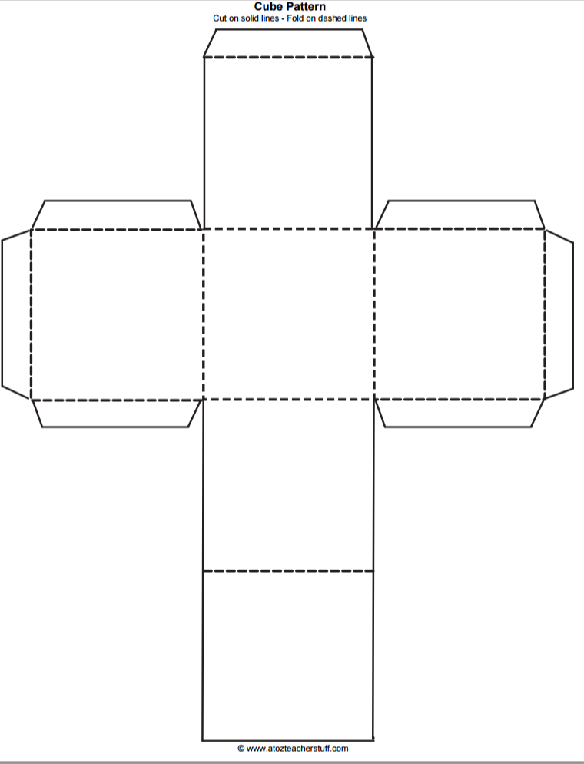

Worksheet 3: Comic panels
Print this page

Worksheet 4: Speech bubbles
Print this page

