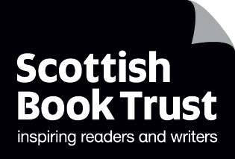
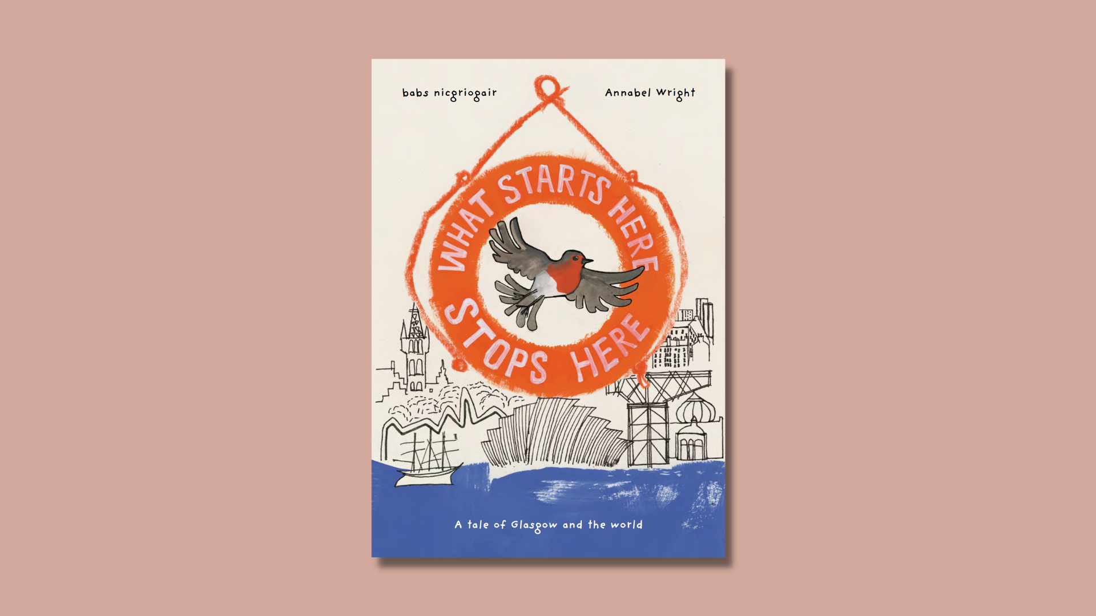

Exploring climate change and colonialism with What Starts Here Stops Here
Learning activities to learn and write about local history and future using What Starts Here Stops Here by the Hope Street Collective

CFE Second and Third Level

Resource created by Scottish Book Trust

scottishbooktrust.com
Scottish Book Trust is a registered company (SC184248)
and a Scottish charity (SC027669).

Contents
About this resource 2
Learning activities 3
Further resources 11
Worksheet 1: Timeline template 13
Worksheet 2: Local solutions 14
Worksheet 3: Help or harm 15
Worksheet 4: Fact file template 16

About this resource
What Starts Here Stops Here is a pamphlet picture book published by Hope Street – a feminist collective with roots in the Woodlands area of Glasgow, purchasable from Aye Aye Books. You can also find a video of the book being read aloud by the author on Climate Ready Schools YouTube channel (13 minutes, 40 seconds).
The book follows a robin who is blown off course by a gale, and journeys back in time through the history of Glasgow, specifically focusing on the connection between colonialism and climate change. The book looks at how these forms of injustice continue to impact us today, and how we can protest for a better world.
This resource focuses creating your own version of the book to reflect on your own local area. Each activity is designed to help your class gather material for the book by interacting with your local community, creating fact files and artwork, and learning more about colonialism, protest and climate change.
As with all our resources, we recommend you read both the book and this resource in full before you use it with your class and decide whether it is appropriate to use with the children you work with. For more information on the importance of teaching children about colonialism, see the end of this resource for articles and further resources.
Thanks to Dr. Stephen Mullen from the University of Glasgow, who recommended some of the educational resources linked in this resource.

Learning activities

Activity 1: What did Robin learn? (10-15 minutes)
LIT 2-02a/3-02a, LIT 2-04a/3-04a, LIT 2-07a/3-07a
Start by reading What Starts Here Stops Here as a class. After you’ve read it, if there’s any words that the pupils aren’t sure of, look at the glossary at the end of the book together.
Put pupils into groups and give each group a different question to discuss:
- What do they think the purpose of the book is? What is it trying to tell us?
- Why do you think Robin went back in time? What did he need to see in the past?
- What did Robin learn on his journey?
- Robin meets other animals – tigers and parakeets – what do they represent?
Ask each group to feedback, allowing time for discussion as a class.

Activity 2: People who caused change (15-20 minutes)
LIT 2-05a/3-05a, LIT 2-08a/3-08a, SOC 2-02a/3-02a, SOC 2-03a/3-03a,
SOC 2-06a/3-06a
Ask the pupils which part of the book they thought was true, and what might have been made up. Now look up one of the real-life figures in the book – using the guide at the end of the book to help you.
Using the timeline template on page 13, or creating one of your own, ask the pupils to write down a couple of sentences for each person, describing what they did and how it caused a change in Scottish society.

Activity 3: Climate solutions (15-20 minutes)
LIT 2-04a/3-04a, LIT 2-05a/3-05a, LIT 2-06a/3-06a, LIT 2-07a/3-07a, SCN 3-05b,
SOC 2-08a/3-08a, SOC 2-10a/3-10a
Look at the last few pages of the book together, starting from when Robin returns to the modern day. Ask the pupils to identify all the projects he spots which combat climate change:
- Taking the bus
- Make Do and Mend hubs
- Libraries
- Second hand clothing shops
- Bike co-ops
- Community owned food shops
- Potluck parties
- 15 minute neighbourhoods

Ask pupils if they’re familiar with all these concepts. Look up any they haven’t heard of and how they help combat climate change. Ask them to pick one of the projects and use the local solutions worksheet on page 14 to write down:
- What it is
- How it works
- How it helps combat climate change

Activity 4: Climate in your local community (30 minutes to 1.5 hours)
LIT 2-02a/3-02a, LIT 2-05a/3-05a, SOC 2-10a, SCN 3-05b
Using the list from Activity 3, ask the class:
- Has anyone been to or seen one of these initiatives?
- Are there any in your local area? If so, look them up online.
- Are there any other initiatives in your local area which encourage people to reuse, reduce and recycle (e.g. recycling bins, charity shops, libraries, clothes swap events etc.)?
If you’ve found a local initiative (no matter how small!) arrange a visit and ask to interview someone who works there about how their initiative helps the planet and what they do to reduce waste.
Alternatively, print one Help or harm worksheet on page 15 per pupil. Go for a walk and ask them to write down when they see something that could help or harm the environment and where they saw it. For example:
- Litter left on Main Street (harm)
- An advert for an upcycling course left on a lamppost near the woods (help)

Activity 5: What is colonialism? (20-30 minutes)
LIT 2-05a/3-05a, SOC 2-01a/3-01a, SOC 2-02a/3-02a, SOC 2-03a/3-03a,
SOC 3-05a, SOC 2-06a/3-06a
Ask your pupils if they know what colonialism is and if they know of any examples. If they don’t, look up the term together using an online dictionary.
One key example of colonialism is the British Empire which was established by England in the late 16th century. The end of this empire is often said to be in 1997, however the legacy of colonialism and the British Empire is still present across the world.
Watch the video “Life in the British Empire” (2 minutes) on the BBC Bitesize website. Ask the pupils to write down three of the methods of control the empire used (e.g. slavery, denying the ability to vote, famine, murder, seizure of land).
Read through the list of human rights from MyGov.Scot and ask the pupils to identify which rights the colonised people in the video were denied. You could do this in groups, giving them printed copies of the human rights and leaving time for any questions they might have. Give each group time to feed back then look at the page where Robin meets Olaudah and ask what rights he has been denied.
Next, display the map “The rise and decline of the British Empire” on a whiteboard, or allow pupils to look at it on devices, to see what countries the United Kingdom colonised over the centuries. Allow time for the children to look up any countries they aren’t familiar with.
Some key words or terms that might come up in your discussion are:
- Colonialism – when a country takes control of another country, usually to exploit it for resources and its people
- Empire – when an extensive number of countries are ruled over by a single ruler or monarch
- Imperialism – the practice of extending a country’s power through colonization or use of military force
- Slavery – the ownership of a person, or people, as property usually used in forced labour

Ask the pupils to write their own definitions of these words as they come up in your conversation. To extend this activity, use the National Geographic webpage on the British Empire for a more detailed look at the treatment of the people in colonised countries – see the sections “The British Empire and Indigenous People” and “Slavery and the British Empire”.

Activity 6: The importance of protest (30-40 minutes)
LIT 2-05a/3-05a, SOC 2-06a/3-06a, SOC 2-17a, EXA 2-04a/3-04a
Revisit the pages in the book where the Birdman of Pollok protests the building of the M77 (pages 24 and 25). Talk about how he – and some of the other people in the book – protest. Ask the children:
- What does protesting mean?
- What forms can protest take?
- Have they or anyone they know protested something or been to a protest?
You could talk about how the right to protest is one of your human rights in Scotland.
Next, visit the National Library of Scotland’s resources on Frederick Douglass, a campaigner who was born into slavery in America. In the 1840s, he made tours of Scotland, campaigning against slavery. You can use the map “Our Bondage and Our Freedom” to see if he travelled close to where you live.
Watch the video on Eliza Wigham and Frederick Douglass from BBC Bitesize (2 minutes, 23 seconds). Ask the pupils to write a paragraph about Frederick Douglass, or one of the others who worked with him, explaining who they are, where they went and what they did to protest slavery.
Next, learn about some children who have protested:
- 1967: Gorbals children protested to keep their playground
- 1996-2020: The campaign for the Children’s Wood in Glasgow
- 2019-Present: The global school strikes for climate change
Spend some time looking at local protests together. Are there any you could attend? Or could you run one yourself? If you ran one, what issue would you campaign for? Ask the pupils to create an A5 protest poster about an issue that’s important to them. You can use the Tate Kids webpage on protest posters to show them examples.
As a take-home activity, you could ask the children to chat to people in their family about protest. Has anyone in their family, or friends, protested something? Or have they attended a protest? When and why did they do it? You can print them a copy of the Fact file template worksheet on page 16 to capture what they learn.

Activity 7: Colonists close to home (10-20 minutes)
LIT 2-05a/3-05a, SOC 2-03a/3-03a, SOC 2-06a/3-06a, SOC 2-14a/3-14a
Display the Legacies of British Slavery map from University College of London on your whiteboard, or allow pupils to look at it on individual devices. Explain to the pupils that this map contains the addresses of different slave owners from across the United Kingdom. It isn’t complete, but you can use it to learn a bit more about how people profited from colonialist slavery.
Look at your local area and see how many people you can find. Click on them to find out some more information and ask pupils to note down information about them. Ask the pupils to note this down – you could focus on a key individual, using the Fact file template worksheet on page 16 to fill in any information.
If you live near a library or archive, you could contact them to see if you could find out any more information. Write your letter, or email, to them together as a class. Ask the pupils to consider what information they need to include, and what they would like to find out more about.

Activity 8: Connecting climate change and colonialism (15-20 minutes)
LIT 2-02a/3-02a, LIT 2-04a/3-04a, LIT 2-05a/3-05a, SCN 3-05b, SOC 2-12a
Colonialism involves taking land away from indigenous people. This land is often exploited for resources, including rubber, ivory and gold. A lot of colonial projects cause mass deforestation – as the tiger in the book says: ‘You chop down our forest homes to build your roads, plant your mega crops and graze your animals.’
Watch “Climate Justice According to a Kid” (7 minutes, 11 seconds). Split the children into groups and ask them to write a definition of climate injustice and some examples. Then, let every group look at each other’s mind maps and use post-it notes to add potential solutions to some of the injustices.
Look at the pages of What Starts Here Stops Here with the tiger (page 18 and 19) and the parakeets (page 20 and 21). They’ve left their homes in other countries due to the impact of climate change. Whilst they are animals, who are also affected by climate change, you could discuss how they could also represent displaced people who have had to leave their homes.

Activity 9: A book of local pasts, presents and futures (2+ hours)
LIT 2-20a/3-20a, LIT 2-24a/3-24a, LIT 2-25a/3-25a, EXA 2-02a/3-02a,
EXA 2-04a/3-04a
This activity involves pulling together all the learning, notes and ideas from previous activities to create your own version of What Starts Here Stops Here. From these previous activities your pupils should have:
- Notes or information about some key historical figures mentioned in What Starts Here Stops Here as well as others including Frederick Douglass and/or his colleagues
- Examples of climate solutions, including those in your area
- Examples of climate problems, including those in your area
- Definitions of terms surrounding colonialism and climate colonialism
- Some information about people who profited from colonialism in your area
- Their own protest posters
The book you create together will use these notes, as well as collaging to create a class book. You can also use our resource Creating a picture book in class for more ideas.

Who is your main character?

Start by thinking about who will be the protagonist for this book. Is there an animal or creature in your local area who would make a good guide? You could talk about what features the robin had, for example, he was able to fly, and was small enough to squeeze into tight spaces.
Once you’ve decided on an animal, ask everyone in the class to draw them. This will give you lots of different versions that you can cut out to stick directly on the different pages of your book.

Creating the backgrounds
What does the area around you look like? You could use photographs or maps you can find online, or go for a walk and take your own pictures or drawings to make up the backgrounds.

Who will your character meet?
Revisit the timeline from Activity 2, as well as the information gathered on slave owners and the anti-slavery campaigners from Activity 6 and 7. Discuss who you’d like to feature in the book and layout a chronological order of who lived at what time. This will help you decide in which order your main character will meet them.
Think about how you could present information about them to the reader, so that they get a sense of who they are. For example, in What Starts Here Stops Here, Robin has a conversation with each of the characters. But you could also make a fact file instead – this could be particularly useful for the slave owners, for example, where we don’t have their words recorded.
Think about who you can include from the modern day – is there anyone you can interview? If you managed to speak with someone as part of Activity 4, you could include them here. If not, you could ask the pupils to interview other pupils or teachers at your school about what climate change means to them, and how they’re trying to tackle it.

What is important in your community?
Revisit the protest posters you created as part of Activity 6. You could feature these in the book by asking each pupil to draw themselves with their poster then creating a collage page. Or you could use the posters to create a wall display, photograph it then print the photograph to stick into your book.

The pages
Your book, therefore, should end up having this layout:
- Pages 1-2: introduce the main character and your area
- Pages 3-4: the main character travels back in time and meets person 1
- Pages 5-6: meets person 2
- Pages 7-8: meets person 3
- Pages 9-10: the protest posters – what does your community believe in?
- Pages 11-12: sees the potential climate solutions in your town

You can always add in more pages for example, if you’d like your character to meet more than three people. Split the class into smaller groups and assign them each a double page spread to work on (i.e. Group 1 does pages 1 and 2, Group 2 does pages 3 and 4 and so on).

Activity 10: What next?
Now you’ve created your book together, you can think about how to share it. Here are some ideas:
- Invite families or community members for a book launch in your school or local library
- Create an exhibition in your school showing the artwork your class created
- Host a walking tour to some of the locations mentioned in your book
- Create information boards to place around some of the locations mentioned in your book – you could include a QR code that lets people read your book

Further resources
You can find out more about the Hope Street Collective on their Facebook page and Instagram.

Colonialism learning resources
- Education and Resources from the Museum of British Colonialism
- “Put your colonial history on the curriculum – then we’ll understand who we really are”, The Guardian
- “Teaching children our imperial past can help them understand Britain today”, British Future
- “5 ways to improve schools’ teaching about colonialism”, TES

Climate change learning resources
- Climate change resources from WWF
- Climate resources for school teachers from British Council

Protest learning resources
- “Protest is a human right” and “Children’s right to protest”, Amnesty International UK
- “Hannah Lavery on ‘Protest’, her first play for children”, Snack Magazine

Worksheet 1: Timeline template
Print this page
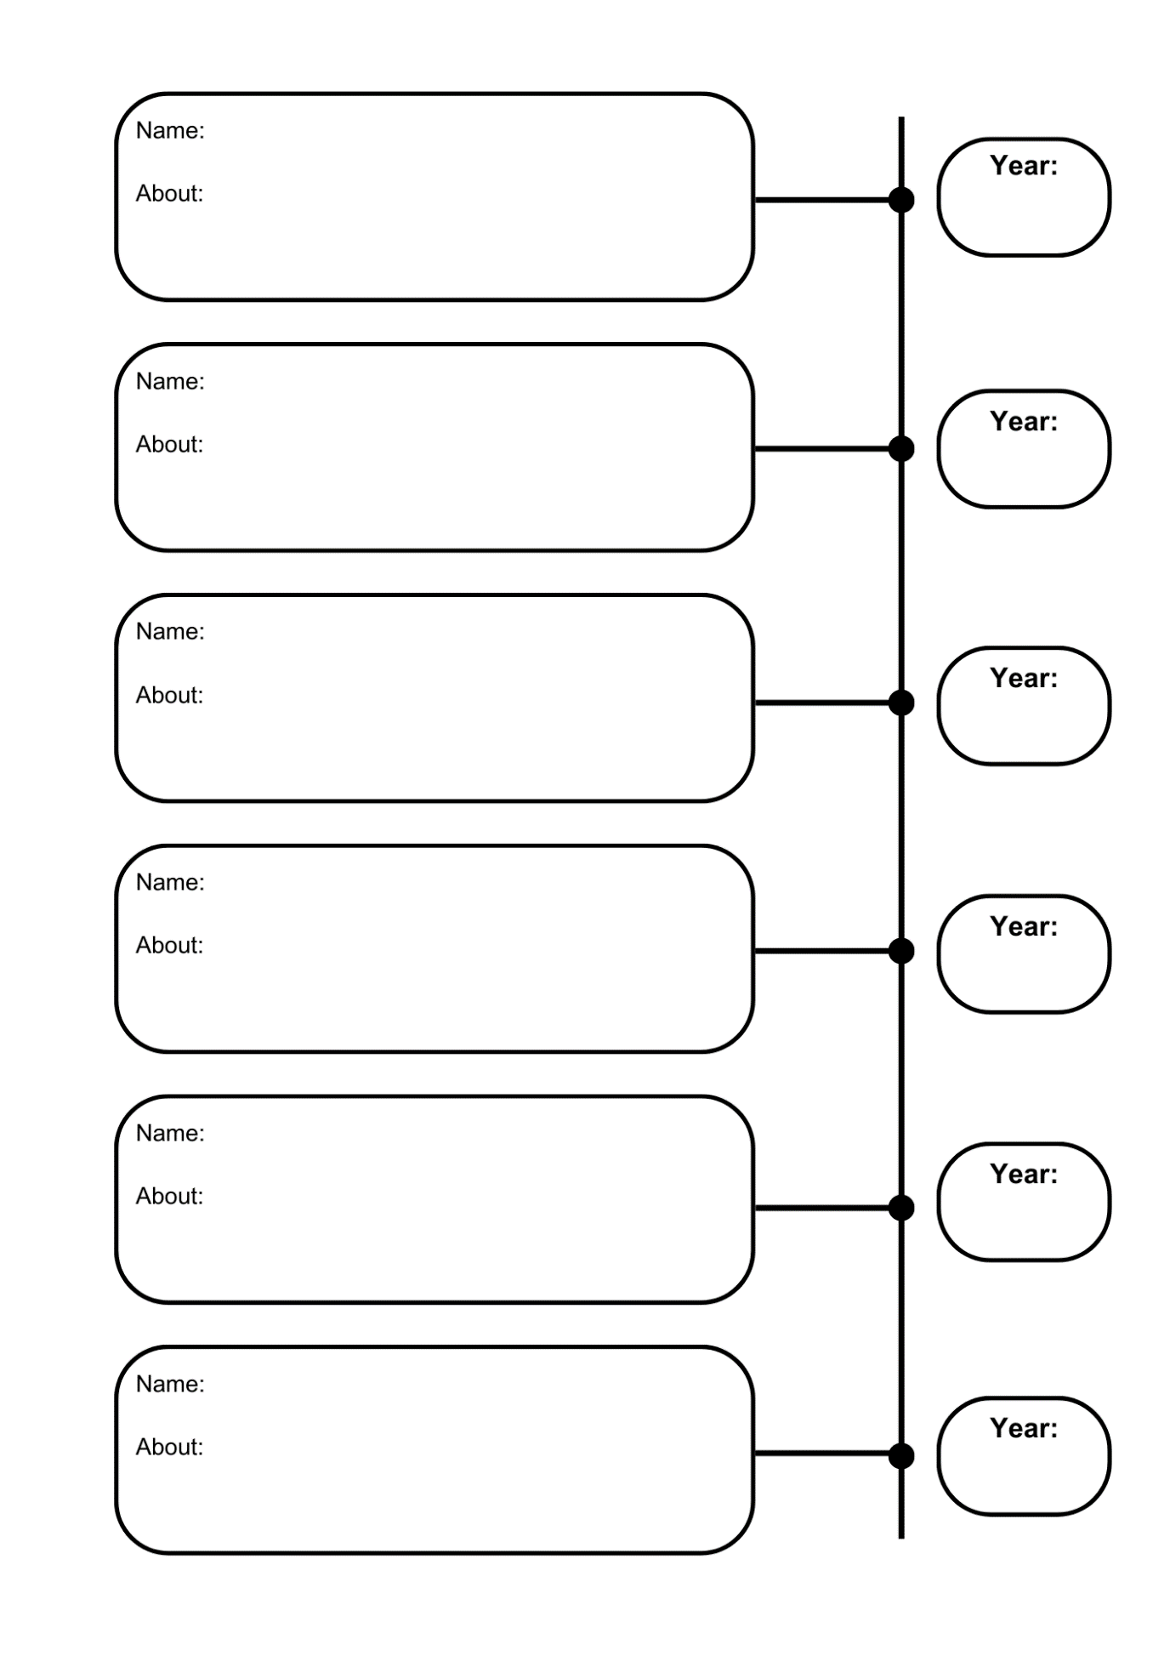

Worksheet 2: Local solutions
Print this page
What is your local climate change initiative?

Where is it?

What do they do?

How does this initiative help look after the environment?

Worksheet 3: Help or harm
Print this page
What did you see? | Where did you see it? | Is it a help or harm?

Worksheet 4: Fact file template
Print this page

Name: _____________________________________________________________
Date: ______________________________________________________________
About:
________________________________________________________________________________________________________________________________________________________________________________________________________________________________________________________________________________________________________________________________________________________________________________________________________________________________________________________________________________________________________________________________________________________

