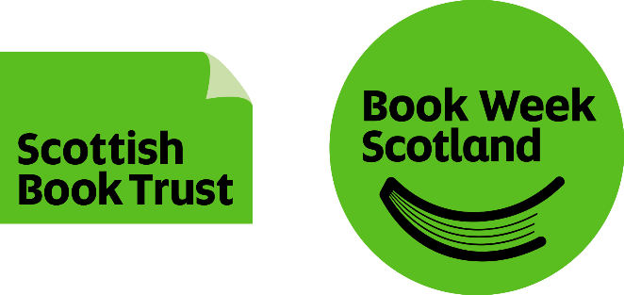
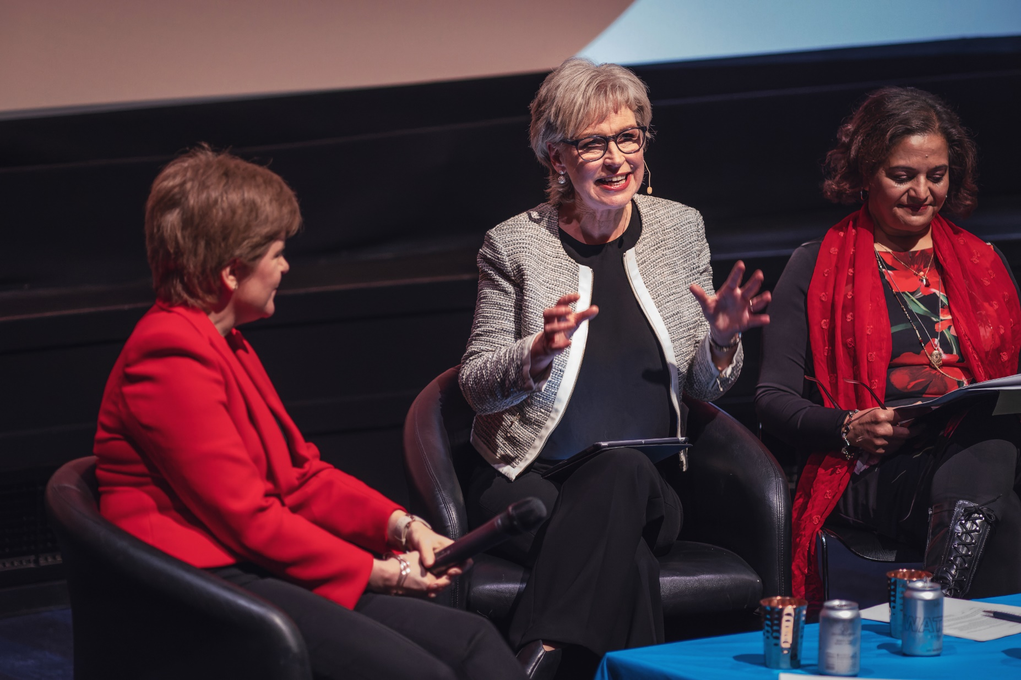

Book Week Scotland

Partner handbook

2023

Resource created by Scottish Book Trust

scottishbooktrust.com
Scottish Book Trust is a Scottish charity changing lives through reading and writing.
(SC027669)

Contents
Welcome 3
Key dates 5
Key contacts 6
Planning your event 7
Funding FAQs 14
Print materials 16
Event listings 19
Fundraising 21
Social media toolkit 23
PR toolkit 25
Book Week Scotland evaluation 28

About this resource
Welcome to Book Week Scotland! At Scottish Book Trust we are excited to share this week-long celebration of books and reading with you and your audiences. This handbook is an aid to carrying out your digital or in-person events or community activities. Whether you’re old hand or brand new, we can help with everything from funding to planning, publicising to evaluation. Use this resource for top tips on making your event as successful as it can be!

Welcome
Book Week Scotland is a week-long celebration of books and reading that takes place every November. This year, Book Week Scotland runs from Monday 13 to Sunday 19 November.
To build on the success of our past campaigns, we want to work with you to celebrate all things books and reading this November.
The theme Book Week Scotland 2023 is Adventure and within that we have five strands which you may wish to use as inspiration when planning your events or activities:
- New beginnings – We all yearn for a fresh start. The excitement of the unfamiliar is intoxicating, motivating us to reinvent ourselves or the path we are on. These are the stories of hope, the moments where we left something behind, started a new chapter and moved forward in our lives.
- When we were young – The adventures that are inextricably linked to our younger years. The stories we return to time-and-time again, that grounded our identity and paved the way for the path we are currently on. From heady, endless summers, whirlwind romances or learning to stand on our own two feet, these are the tales we find comfort in.
- Everyday adventure – Celebrating the quiet adventures we take every day, finding joy in the small, but equally important moments that make up our lives. From taking a new route to work or switching up to a new biscuit with our afternoon brew, no adventure is too small!
- Answering the call – The moments where we stepped up to the plate, took on a big adventure and came out the other side on top. From moving to a new country to start again, standing up for the cause worth defending or beginning a new career, these are stories about answering the pull deep down in our soul to challenge and surprise ourselves.
- Into the wild – Seeking out the excitement of adventure in our amazing landscapes and wildernesses. These stories celebrate our relationship with nature and however we choose to cultivate it. Whether it’s listening to the rhythmic lapping of waves by the beach, rambling through a secluded glen or wild swimming with friends, our outdoor adventures challenge, recharge and inspire, connecting us to nature and the ones we love.
We are planning a busy marketing campaign for Book Week Scotland 2023. All of our communication in these areas will focus on these key messages:
- Book Week Scotland is for everyone. Our events programme is designed to ensure anyone can find a way to take part that appeals to them.
- Book Week Scotland celebrates whatever it is that you enjoy reading.
- Book Week Scotland is a fantastic opportunity to share what you like to read and to try something new.
We will also build on our original objectives for Book Week Scotland:
- To raise public awareness of and celebrate the pleasures of reading.
- To work in partnership with libraries in every local authority in Scotland.
- To promote Scottish writing and writers.
- To convert participation in Book Week Scotland to increased and/or sustained engagement in reading activity.

Key dates
- Book Week Scotland
Monday 13 to Sunday 19 November
- Funding released to partners
Week beginning 4 September
- Deadline for print materials and book orders
Wednesday 27 September
- Print materials sent to partners
Week beginning 2 October
- Book orders sent to partners
Week beginning 16 October
- Deadline for event listings (for display at point of press launch)
Wednesday 11 October
- Book Week Scotland press launch
Monday 30 October
- Deadline for evaluation survey
Wednesday 13 December

Key contacts
We are always here to advise you on any part of your organisation’s Book Week Scotland event. Email addresses are listed below but if you would prefer to chat over the phone send us an email and we will give you a ring whenever it suits!
- Philippa Cochrane, Head of Reading Communities Programmes
philippa.cochrane@scottishbooktrust.com
- Nyla Ahmad, Reading Communities Manager
nyla.ahmad@scottishbooktrust.com
- Gordon Connelly, Reading Communities Co-ordinator
gordon.connelly@scottishbooktrust.com
- Rachel Gray, Reading Communities Administrator
rachel.gray@scottishbooktrust.com
- Danny Scott, Head of Social and Digital Marketing
danny.scott@scottishbooktrust.com
- Craig Laurenson, Design and Marketing Manager
craig.laurenson@scottishbooktrust.com
- Abi Baross, PR and Marketing Manager
abi.baross@scottishbooktrust.com
- Eilidh Cameron, Fundraising Officer
eilidh.cameron@scottishbooktrust.com

Planning your event
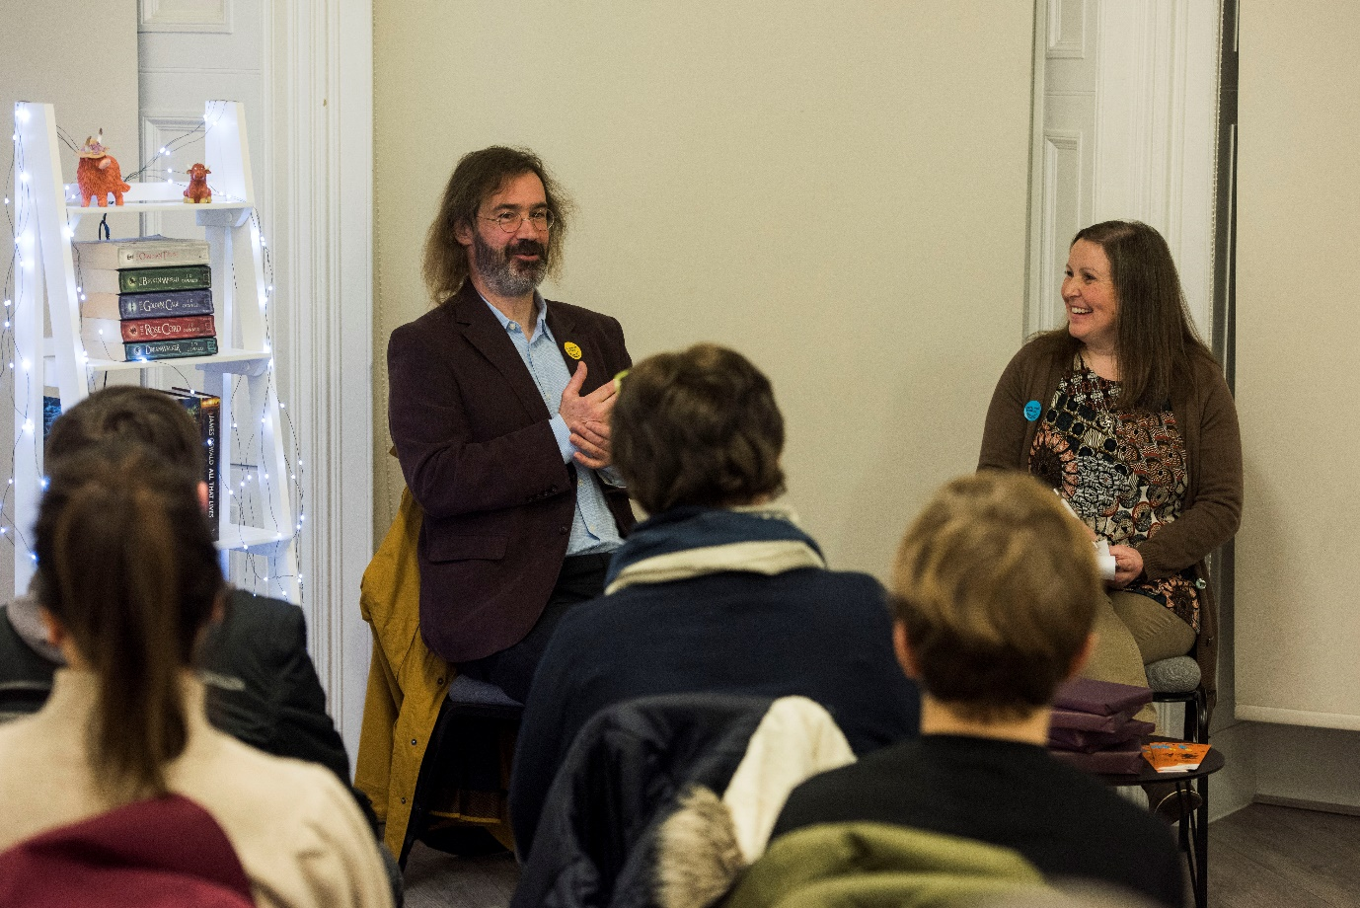
Whether your organisation is planning an in-person or digital event, we have compiled some tips to help you get the best out of your Book Week Scotland programme.

Digital events
Digital events have grown exponentially over the past few years, allowing organisations to reach new audiences and adapt their approach to programming. Digital is constantly evolving so there are many considerations to help give your audience the best possible experience.

Online Platforms
The first thing to decide is which platform you will be using to deliver your event.
There are a number of options including, but not limited to, Zoom, Microsoft Teams, Skype, Facebook Live and YouTube. Each platform has its own pros and cons list and which you choose will depend on your programming requirements. Zoom is one of the most popular platforms and the majority of our advice is based on its functionality (as it is the platform we have most experience with).
The most important thing is that the platform you choose has features that match your security needs. So, spend a bit of time researching the security options of each one before you commit to it for your event.

Should the event be live or pre-recorded?
Another advantage of digital events is that you can record your content in advance and choose when you release it to the public. That way your organisation can focus on getting the word out to your networks about where and when they can view it.
However, this may not be the best option if you want your audience to be able to get involved with questions and comments. So if you are trying to recreate the buzz of a traditional book event, streaming the event live is the best way to go.

Ticketing
Another key element to consider is where you will be advertising and asking attendees to sign up to your event from.
The easiest way to promote your content is through Eventbrite. Eventbrite allows you to control all the elements of your event including audience numbers, ticket prices and accessibility information.
If you are using a Zoom Webinar for your event, you’ll need to ask your attendees to register after they’ve signed up from the booking page.
After attendees have registered they will receive an email confirmation from Zoom with instructions on how to join the event on the day.
You can track who has registered for the event on the overview page on your Zoom account, just go to the webinar tab and select attendees.

Event length
The sweet spot for online events is between 45–75 minutes. If you plan to run a Q&A session, make sure you factor in enough time for this too.
A reminder that, in line with our Live Literature rate, authors should receive a minimum payment of £190 for a session of up to 90 minutes. For any event longer than 90 minutes, a second session payment (of minimum £190) will be required.
Make sure the author is aware of, and comfortable with, the running time. Online events require a bit more concentration and energy – for everyone involved!

Scheduling
If your event caters to a specific audience, or age group, think about when it would be easiest for them to get involved.
Early evening events work well for families, as most adults will have finished work by then. If you are running a workshop with limited sign-ups you can be more flexible with your timings.

Staffing
Having adequate members of staff to help with the delivery of your online event will ensure it runs smoothly for your audience.
If a member of your team is chairing the event, it is a good idea to have one or two colleagues managing the technical elements in the background such as:
- advancing slides
- muting and unmuting audience members that wish to ask a question
- flagging or responding to questions/comments from the audience in the chat box
- controlling any video/audio elements included as part of the event

Rehearsing with your author
If you are collaborating with an author, schedule a practice session with them to ensure your event runs as smoothly as possible. This allows everyone to feel comfortable with the technology and gives you a chance to iron out any kinks ahead of time.
Bear in mind that if you are planning to rehearse with your author more than once, it may be appropriate to increase their fee. Be clear with them on how many run-throughs you are planning and make sure they are comfortable with the level of work you expect.

Accessibility
Accessibility options for online events are constantly improving and there are many features you can implement to help make your audiences’ experience more straightforward.
We recognise that cost plays a huge role in what organisations can provide. The most important thing is to be open, approachable and clear with your audience. Within event descriptions, let people know what you will provide. Ask people to contact you in advance to discuss specific requirements.
The accessibility options you offer will be dependent on the type of event you are planning. We have listed some considerations for each below.
Live digital events:
- Can you provide a live BSL interpreter?
- Can you enable closed captions?
- Record your event to allow for closed captions to be added afterward.
- If your event is interactive, make slides easy to read.
- Allow for processing time during activities or exercises.
- Give an overview of the event’s accessibility features in your introduction.
- Can a colleague provide real-time updates to specific attendees if BSL interpreter or closed captions are not possible?
- Email reminders before the event.
- Can you improve the event's audio quality with specialist equipment such as an external microphone?
- Provide a simple guide (or link to an existing one) on your platform’s basic functionality.
- Schedule comfort breaks if your event has a long run time.
Pre-recorded digital events:
- Provide closed captions or transcription of the event.
- Provide a BSL overlay.
In-person events:
- Is the venue accessible?
- Are there accessible toilets and, if so, how many?
- Is there accessible parking?
The more time you spend testing your platform’s features, the easier this process will be. Companies are constantly improving their offering, so make sure you are up to date on any new features and their functionality.
It is a good idea to follow up with your attendees after the event to ask for feedback on what worked well and how you can improve.

Book sales
Offering book sales as part of your event can be a great opportunity for the author to promote their books.
The easiest way to offer book sales is to collaborate with a local bookshop; approach them well in advance to enable them to order copies of the author’s books.
If the bookshop has an online store, ask your chair to mention it in their introduction and provide an online link at the end of the event. You may be able to work out a special promotion or discount code for attendees with the bookseller beforehand.

Security and safeguarding
Keeping your audience safe online is a fundamental part of digital events.
You should always require attendees to enter a password to access your event. You can enable the password functionality on the webinar settings section of your Zoom account. The password will be included in the confirmation email from Zoom after attendees have registered for the event.
Circulating ground rules to participants prior to the event is a great way of ensuring people are clear on what is acceptable online behaviour. This gives clear parameters for what will and will not be tolerated within the space.
For detailed information on what you can do to keep your audience or participants safe, see our detailed resource page.

In-person events

Venue
Finding the right venue is key to the success of your event. Think about its capacity, how accessible it is, what the parking options are, how easy or difficult it is to travel to, the acoustics of the space, what technical equipment is available (e.g. microphones), the number of toilets, when you’ll be able to access the space on the day and if there’s a green room space for your author[s].
Be clear and open about the venue and its limitations wherever you are advertising the event. Make it clear in your event copy that if people are unsure of any element they can get in touch to discuss it with you.

Staffing
Ensuring you have the correct number of staff will allow your event to run smoothly. Get your team together well in advance to discuss responsibilities and potential queries from your audience.

Tickets
It is a good idea to set-up mobile tickets for your event. If you are advertising your event via Eventbrite, attendees will be able to use QR codes, either on their phones or on printed tickets, which staff can scan to check-in them in.

Incorporating digital
You might be able to include a digital element to your in-person event. Could you broaden your audience by live-streaming? Perhaps you could film the event and upload it to your website or social channels afterwards. This will involve a lot more planning and work on the day but if you are keen to expand your event’s reach it's worth considering.

Book sales
The best way to offer book sales at your event is to approach your local bookshop. Get in touch in advance so they can order stock. It is also worth double-checking if the bookshop will be able to provide contactless payments.

Other considerations for events

Marketing
Make sure you get the word out about your event in advance. You can use our free posters to promote it. Putting up these posters in and around your community is a great way to spread the word.
You can also use our digital assets to promote your event on your organisation’s website or social channels.

Ensure the date, time and venue of your event is consistent and visible in all marketing materials
There are lots of ways to market your event – take a look at the social media and PR toolkits (pages 23–27) for ideas. Scottish Book Trust can also promote your event in the Book Week Scotland online listings (pages 19–20).
You can order free marketing materials from our website (page 16–18).

Other events in your area
With so many great events taking place across the country during Book Week Scotland, promoting other events alongside your own can be a great way to increase the reach and success of the whole week. So, if you know another organisation is holding an event similar to yours that your audience or community may be interested in, please do share the information with them.

Funding FAQs

How much should I pay my author?
We are committed to ensuring authors are paid for the great work they do to plan and deliver events.
In line with our Live Literature rate, authors should receive a minimum payment of £190 for a session of up to 90 minutes. For events longer than 90 minutes, a second session payment (of minimum £190) will be required.
This increase reflects the decrease in median author earnings and mounting cost of living. Scottish Book Trust will continue to monitor and review this rate.

How will funding be released?
You have had an email with your funding agreement form. Please complete and return this to rachel.gray@scottishbooktrust.com by no later than Wednesday 16 August.
When you have returned your funding form we will release your funding via BACS payment to the bank account listed on your form. Funding will be released from the week beginning 4 September. You will receive an email from our finance team after the payment has been issued.
If you’ve still to complete your funding form, please do so ASAP. We can’t release your funding without it!

What can I use the funding for?
The funding can be used to pay for any expenses associated with putting on a Book Week Scotland event. These could include an author fee and travel/accommodation/subsistence expenses, or you could use the funding to pay for catering, prizes for a giveaway or competition, materials for your community activity – whatever you need to make your Book Week Scotland event possible. If you are unsure, please get in touch with us at Scottish Book Trust to discuss.

What should I avoid using the funding for?
You should not use your funding to pay for an existing role or post. You should not use your funding to pay for anything on which you will generate a profit, i.e. to buy books or catering for which you intend to charge.

What if I am not going to use all of the funding?
Sometimes you don’t manage to use all of the funding you have been awarded for a whole variety of reasons – an event may be cancelled, or things may cost less than you originally thought.
If you know that you are not going to use all of your funding, please:
- Try to use it in another way during Book Week Scotland. Could you run a prize draw at the event, or gift books in your community? Can you gift e-book vouchers to individuals or organisations who need them?
- If an event during Book Week Scotland is cancelled, could you rearrange it for some time soon after? (We would be very happy for this to happen!)
- Is there some way you could use the money to extend the impact of Book Week Scotland – buying library stock from the events for example, or running a follow up writing workshop on the same theme?
- If none of these options work for you and you wish to return your surplus funding, please get in touch with us as soon as possible and by Friday 1 December 2023 at the latest. We will issue you with a letter requesting the return of funding and this will give us time to find another use for it before the end of the financial year.

What if I overspend?
We can only guarantee to provide you with the funding we originally allocated. But if you find you are going to overspend on your allocated budget, please get in touch with us ASAP. Sometimes funding is returned to us and we can use it to provide support elsewhere. This is entirely dependent on partners returning unused funding and each request for additional money will be considered individually.

Print materials
You can order free materials from us to promote your event. These include postcards, bookmarks, posters and stickers.
To order your materials, go to our online Survey Monkey form. You can choose the items you want as well as the quantity. We will be accepting orders up until Wednesday 27 September.
Orders will be sent out from the week beginning 2 October. On the day of delivery, you will receive an email or text notification from the courier with a specific timeslot.
If you have any queries about your order, please get in touch with Rachel on rachel.gray@scottishbooktrust.com.

Book Week Scotland logo
To help people to recognise Book Week Scotland, it is important that you include the logo on all your marketing for the event. The logo comes in six different colours, and you can use whichever variant you think looks best. To download the logos, go to bookweekscotland.com/information.
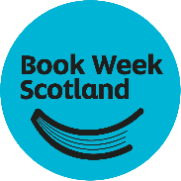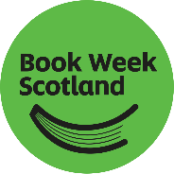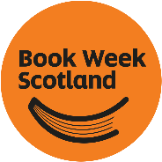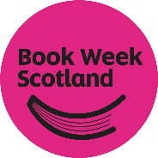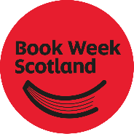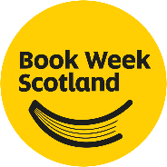
Book Week Scotland is delivered by Scottish Book Trust and funded by Creative Scotland. If you have room, we would like you to include both of these logos in addition to the Book Week Scotland logo. Each logo is available on our website. However, if you only have space for one, please make it the Book Week Scotland logo.
If you have any questions about logos or branding, please contact craig.laurenson@scottishbooktrust.com.

Adventure book orders
You can order copies of our free book, Adventure, made up of true stories from people all over Scotland, via our online order form. Help us spread a love of reading by book gifting – distributing copies to community groups, your workplace or to family and friends.
Please note:
- The deadline for book orders is Wednesday 27 September.
- Book orders will be sent to all partners from week beginning 16 October.

Book gifting
70,000 copies of Adventure will be winging their way around the country during Book Week Scotland.
Our free book has become one of the cornerstones of Book Week Scotland, allowing readers to connect to an array of experiences, fostering a love of reading and storytelling at the same time.
Year on year we are completely blown away by the hundreds of arts organisations, community groups and individuals that spread the book far and wide, helping us in our mission to get more people reading during – and beyond – Book Week Scotland.
Here are a few creative ways you could gift the book this November:
- Wrap the books in old newspaper, or gift-wrap, and hang them from trees around your community.
- Set up a library box outside your house so people can help themselves to copies.
- Organise an Adventure treasure hunt by sending out a series of clues for where friends and family can find their copies.
Don’t forget to connect with us on social to share how you’re gifting your copies. Use the #BookWeekScotland hashtag.
We will also have a downloadable eBook and PDF files at bookweekscotland.com as well as an audiobook should you wish to share the book with your audiences digitally.

Event listings
To help promote your event, you can submit an event listing that will be featured on the Scottish Book Trust website. This is not a requirement, but you are very welcome to if it will help with raising awareness and excitement for your event.
To submit your listing, complete our online Survey Monkey form.
Once you have completed the form a member of the team will format your listing for display on the Scottish Book Trust website.
We’ve tried to keep the form as simple as possible but if you do encounter any difficulty please contact Rachel on rachel.gray@scottishbooktrust.com.
Please note: we will be accepting listings up until Monday 6 November. However, if you would like your event to be featured on our website in time for the Book Week Scotland press launch, the deadline to complete the form is Wednesday 11 October.
Below are a few tips which should help you when you come to writing your listing:
- Keep it snappy. Having a concise title will grab your audience’s attention. About 70 characters or less would be perfect.
- Name your performers. It may sound obvious, but if you are collaborating with an author for your event make sure you include them in your listing.
- Make it exciting! Try to stand out from the crowd and get your audience excited about your event.
- Keep it simple. Make sure your title is easily understood so that audiences know exactly what to expect from the outset.

Examples of poor titles
- Billy Crimerton will come for a chat about his novels and why he likes writing about crime.
- Crime Event with Billy Crimerton.
- Billy Crimerton’s Blood Bath.

Examples of good titles
- Dismembering the Facts: A Conversation with Billy Crimerton.
- Crime Author Billy Crimerton Gets Bloody.
- Billy Crimerton Writes with Blood!

Keep your event description clear, interesting and honest
- Show off your event. Think about the kind of event descriptions that would appeal to you! Keep it under 200 words (too long and readers lose interest) and focus on the most important details.
- Be honest. Don’t overinflate your event by making unreasonable claims about the size/author/content. Stick to the facts – they’ll be enough.
- Include essential information. Is the event for adults or children? What are the names of your speakers/chair people? Will there be a book signing?
- Highlight the details. If your event has extras (free refreshments, surprise guests, prizes) don’t forget to mention them.
- Break up your text. Paragraphs are brilliant for making event listings easy to read, so break your description up. Think: intro, main description, conclusion.
- End on a high. Leave readers feeling fired up about your event, give them a good reason to sign up in your final sentence.

Fundraising
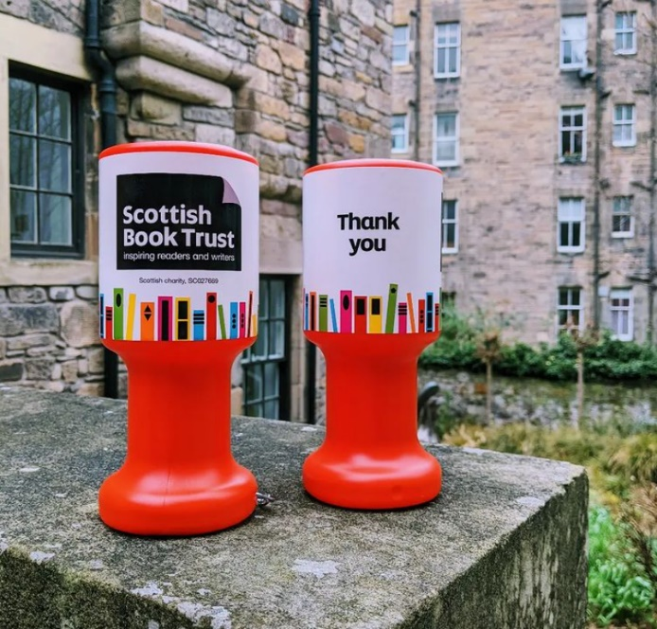
Did you know that Scottish Book Trust is the charity behind Book Week Scotland?
Our mission is to ensure people living in Scotland have equal access to books. Everyone should have the opportunity to improve their life chances through books and the fundamental skills of reading and writing. We support all communities across Scotland, with particular focus on those who are vulnerable, under-represented and most in need.
In addition to the funding we receive from the Scottish Government and Creative Scotland, we need the constant support of trusts and foundations, corporate organisations, community groups and individual book-lovers like you.

Could you help us change more lives through reading and writing by fundraising for Scottish Book Trust as part of your Book Week Scotland programme?
Here are a few simple fundraising ideas:
- Ask for a voluntary donation for free events.
- Tell your audiences about Scottish Book Trust and promote the Scottish Book Trust donation page during virtual events.
- If you are planning an author event, hold a competition raffle for a chance to win the author’s book.
- Contact us for some fundraising leaflets which we can post out to you, for you to display at your event or place on seats before audiences arrive.
Fundraising for us is entirely optional and we understand that it won’t be possible for everyone.
We also appreciate that some of our partners are charities who themselves need to raise funds. Could you use Book Week Scotland as an opportunity to fundraise and split the donations between your charity and Scottish Book Trust? Even something as simple as acknowledging your event is supported by Scottish Book Trust is deeply appreciated.
Together, we can turn Scotland into a nation of booklovers and change lives through reading and writing.

Social media toolkit
Book Week Scotland offers us all an opportunity to engage new audiences with reading. Our social media campaigns will bring a buzz to books, spread the word about events and keep people up to date with all things Book Week Scotland.

How we use social media
- Build new audiences: Book Week Scotland is a perfect opportunity to inspire a love of reading in new audiences online, across the world.
- Raise awareness: by engaging with Book Week Scotland online we can build awareness of your events and campaigns.
- Buzz: our combined social media activities will create excitement around Book Week Scotland, books, book shops, libraries and reading.
- Networking: social media will help us to build strong relationships with other organisations in Scotland, and beyond.
- Legacy: with targeted social media campaigns and digital events we can create an online legacy to encourage more and more people to make reading for pleasure a part of their lives.

Work with us!
We hope to start a national conversation around reading and books before, during and after Book Week Scotland. Part of this conversation will be sparked by your events and online activities. Working together on social media, we can promote Book Week Scotland, libraries, partners and all the events that are an integral part of this celebration.
We cannot publicise every single Book Week Scotland happening through our own social media channels, but we can help in other ways. For this, we need your help.
- Let us know which events you are planning at your earliest opportunity. We want to hear how you are celebrating Book Week Scotland. Share exciting news with us by emailing danny.scott@scottishbooktrust.com and we will do what we can to share your news on our social media channels.
- Tag @BookWeekScot or #BookWeekScotland in your X updates. On Facebook, mention Book Week Scotland by adding an ‘@’ symbol before ‘Book Week Scotland’ and selecting us from the dropdown.
- Use the #BookWeekScotland tag on Instagram.
- Encourage your audience to engage with Book Week Scotland on social media at events.

Facebook
- Please join our Facebook community at facebook.com/BookWeekScotland.
- Please share our own Book Week Scotland posts on your social media platforms, if and when possible.

X
- You can follow Book Week Scotland’s X updates at Twitter.com/BookWeekScot, and using the hashtag #BookWeekScotland.
- If your organisation uses X, please email our Head of Social and Digital Marketing (danny.scott@scottishbooktrust.com) to make sure we are connected.
- Tag your posts with #BookWeekScotland or @BookWeekScot to make sure we can see and repost them.
In order for Book Week Scotland to have the biggest impact possible on X, it is best if we all work together to create a bigger noise. Therefore, please use #BookWeekScotland rather than creating your own Book Week Scotland hashtag, specific to events happening in your local area or organisation.

Our online platforms
Here are all the different Book Week Scotland social media platforms.
Facebook: facebook.com/BookWeekScotland
X: twitter.com/BookWeekScot
Instagram: instagram.com/scottishbooktrust
YouTube: youtube.com/scottishbooktrust

PR toolkit
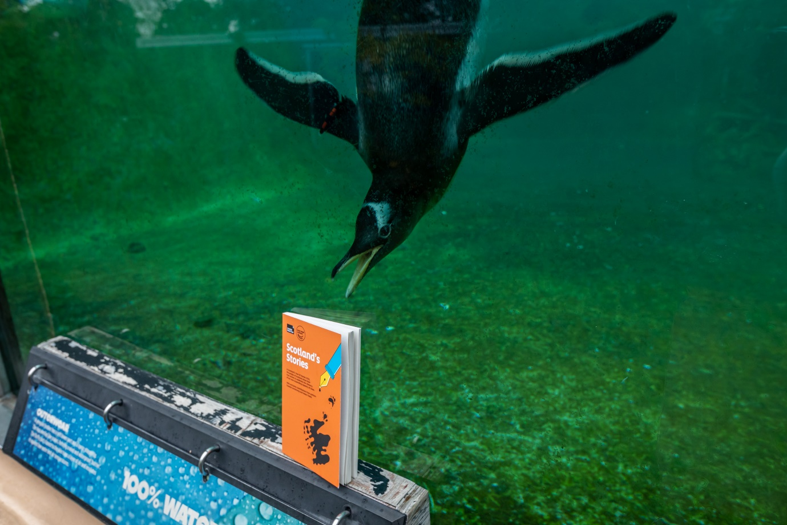PR is a great way to reach large audiences inexpensively. If the media are interested in you, they will bring you to the attention of their readers or viewers, raising your profile on a local – and perhaps even national – level. The way to get the media interested is to provide them with newsworthy stories and eye-catching photographs.

Types of media
- Broadcast media: TV and radio.
- Web-based media: blogs and websites.
- Print media: newspapers (local, regional and national).
- Magazines (trade and consumer – trade magazines are generally subscription only and related directly to a specific sector/business/organisation; consumer magazines are sold to the public).

Press release
This PR toolkit includes a press release template (Appendix 1). If you prefer to write your own, follow these tips:

Writing a press release
- At the top of the email write ‘PRESS RELEASE’ in block capitals, followed by ‘FOR IMMEDIATE RELEASE’ if this is the case, or ‘EMBARGOED UNTIL’ plus relevant date and time.
- Write a catchy headline to create interest without exclamation marks or exaggerations. Puns work well, e.g. ‘Read all about it! Book Week Scotland fun at Example School.’
- Your press release should be no more than 400 words and written in the third person. The following structure is a good guideline:
  - Summarise the release in the first line – include the who/what/when/why/where as relevant.
  - One or two paragraphs with further details.
  - A short quote or two (approx. 60 words) from relevant people. Good spokespeople include the head of your organisation, someone from a partner organisation or local VIPs.
- Insert Notes to Editors at the end of the release – this is information about your organisation and about Book Week Scotland. (Notes to Editors text about Book Week Scotland is provided in Appendix 2).
- Do not forget to include clear contact details and a mobile number at the end of the release.
- Make sure you include your organisation’s website in the body of the press release e.g. ‘For additional information, go to bookweekscotland.com.’

Distribution
- It is best to paste the text of the press release into the body of the email rather than sending it as an attachment.
- Find out the publication day and print deadlines of your local paper, and send them the release in plenty of time beforehand.
- If you would like a list of press contacts in your local area, please email abi.baross@scottishbooktrust.com

Important information to include in all press communications
The following paragraphs should be used in all communications materials when describing Book Week Scotland:
Working with a wide range of partners, Scottish Book Trust – the national charity changing lives through reading and writing – will deliver events and activities across the country during Book Week Scotland 2023, which runs 13–19 November, linked to this year’s theme of Adventure. Now in its twelfth year, Book Week Scotland was initiated by the Scottish Government.
Hundreds of free events happen during Book Week Scotland across many different local authorities, funded by Scottish Library and Information Council (SLIC).
bookweekscotland.com

Book Week Scotland evaluation
The events taking place this year are at the heart of Book Week Scotland 2023. With the evaluation this year we would like to understand:
- How many event and activities happened as part of Book Week Scotland 2023 and whether they occurred in-person or online
- How many people attended a Book Week Scotland in-person or digital event
- How many people are participating in Book Week Scotland
- Demographic information on participants
- What impact taking part in Book Week Scotland has for participants
- If people are likely to participate in future iterations of Book Week Scotland
- Event partners’ experience of organising events.
The data gathered will be used to report to Book Week Scotland’s funders and to inform future planning.
If you have any questions about any element of the evaluation please get in touch with one of the team – we’re always here to help!
rachel.gray@scottishbooktrust.com
gordon.connelly@scottishbooktrust.com
nyla.ahmad@scottishbooktrust.com

Evaluation methodology
There are several strands to the evaluation methodology for partners this year:

Audience feedback
To gather information on participants’ experience of Book Week Scotland, we will be asking them to complete a brief feedback form on Survey Monkey. Anyone who completes the survey will have the chance to enter a draw to win one of two £100 vouchers.
How you ask your audience to complete the form depends on whether you are programming a digital or in-person event:
- Digital events provide an excellent opportunity to link participants directly to our Book Week Scotland feedback survey following the event. With this in mind, we are asking that all partners delivering digital events:
  - Display a slide at the end of their event with a hyperlink to our feedback survey on Survey Monkey.
  - On booking pages – such as Eventbrite – clearly state that by supplying their email addresses participants’ agree to be contacted via email for evaluative purposes (this is essential to comply with GDPR regulations).
  - Contact participants via email after the event with a feedback reminder to complete the feedback survey.
- For partners delivering in-person events there are a number of ways you can point your attendees to the survey:
  - If you’re using a projector as part of your event, display a slide at the end of the event with a hyperlink to the survey. If you are not using a projector, ask your chair to mention the survey URL at the beginning and end.
  - Use our ‘empty belly’ posters to display the QR code that will take the audience to the online survey. Make sure to include some copy that makes it clear what the posters are for, i.e. ‘Enjoyed this event/activity? Share your thoughts to be in with a chance of winning a £100 voucher!’
  - If you have taken bookings for your event or activity via Eventbrite, send out an email to your attendees afterwards with a polite reminder to complete the survey. Again, make sure you have clearly stated in your event/activity copy that by providing their email addresses, attendees agree to be contacted for evaluative purposes.
  - Use your social channels to remind anyone that attended your event or activity to share their thoughts.

Partner survey
We will be asking one member of your organisation to complete our online survey – via Survey Monkey – this year.
The link to the survey will be sent out via email from the week beginning 20 November and the deadline for responses is by 5pm on Friday 15 December.
Please note that this survey will ask you for information about audience numbers from each of your digital or in-person events, and as such you may require members of staff running each event/activity to collate this information and report back to you. This information is incredibly useful to us so please keep a note of it!
The survey is split into two sections:

Section 1 – Audience data
We would like you to gather information about the audience for every Book Week Scotland digital or in-person event you run.
For digital events, please keep a note of the following:
- How many digital events you are running using Book Week Scotland funding
- How many, if any, digital events you are running in addition to those counted above
- The maximum capacity of the event (e.g. a Zoom webinar for 100 attendees)
- How many people signed up to the event
- How many people viewed the event (including those who viewed a recorded version of the event)
- For Library Services only – how many digital events you are running with SLIC funding
For in-person events, please keep a note of the following:
- How many in-person events you are running using Book Week Scotland funding
- How many, if any, in-person events you are running in addition to those counted above
- If you are asking participants to sign-up beforehand, how many have done so
- The number of people of people that participated on the day
- For Library Services only – how many in-person events you are running with SLIC funding

Section 2 – Organisational feedback
This section asks partners for general feedback of their experience of Book Week Scotland.
Questions include which elements, if any, of Scottish Book Trust’s curated programme partners engaged with throughout the week (and if they were useful to their audiences) as well as how their events positively impacted their participants.

Conversations and case studies
To gain a richer picture of their Book Week Scotland experience, Scottish Book Trust staff will collaborate with several partners to build a series of case studies.
These will be informal conversations, most likely over the phone, with a series of focused questions about partners’ experience of the week. Questions will be circulated in advance to allow partners to prepare for the chat.
If you would like to participate in a case study, please do get in touch with one of the team – we’d love to hear more about your experience of Book Week Scotland!

2023 evaluation timeline

Pre-Book Week Scotland
Evaluation tools sent to partners

Week beginning 20 November
Evaluation surveys for partner feedback sent out

Friday 15 December
Deadline for evaluation survey for partner feedback

That’s everything we’re asking of partners this year! Together with Scottish Book Trust’s own evaluative methods, this information will inform the final Book Week Scotland evaluation and give detailed insight about the project.

Appendix 1: Press release template
[Insert Scottish Book Trust, Book Week Scotland, and your own logo]
FOR IMMEDIATE RELEASE
Read all about [YOUR ORGANISATION]’s Book Week Scotland Celebrations.
[YOUR ORGANISATION’S NAME] is holding a [YOUR EVENT] to celebrate Book Week Scotland 2023 (13 to 19 November).
Book Week Scotland is a national celebration of books and reading. The theme for Book Week Scotland 2023 is Adventure. During Book Week Scotland, people of all ages and walks of life come together to share the joy of reading. Together with Scottish Book Trust's curated programme, our partners deliver hundreds of unique, exciting events and activities that celebrate the transformative power of reading. They are joined in this celebration by Scotland’s authors, poets, playwrights, storytellers and illustrators to bring a packed programme of events and projects to life.
Those who want to spend the week reading will also have plenty of choice, with a free book which will be distributed to libraries and Book Week Scotland partners across Scotland in the run up to the week.
[Your organisation’s name] will take part in the celebrations by... [WRITE ABOUT THE WHAT, WHERE AND WHEN OF YOUR EVENT HERE].
[INCLUDE A QUOTE, NAME AND JOB TITLE OF PERSON AT THIS ORGANISATION] said:
[ADD A SECOND QUOTE HERE IF YOU HAVE ANOTHER PERSON TO QUOTE]
Working with a wide range of partners, Scottish Book Trust – the national charity changing lives through reading and writing – will deliver events and activities across the country during Book Week Scotland 2023, which runs from 13 to 19 November, linked to this year’s theme of Adventure. Now in its twelfth year, Book Week Scotland was initiated by the Scottish Government.
bookweekscotland.com
ENDS

Notes to editors:
- [Add information about your organisation, and see Appendix 2 for further notes to add].
- For more information about Book Week Scotland, visit bookweekscotland.com. Follow @BookWeekScot on X, check out #BookWeekScotland or ‘Like’ the Book Week Scotland Facebook page for updates.
To find out more about [Your organisation’s name] event, contact [YOUR CONTACT NAME AND INFO, E.G. PHONE NUMBER AND EMAIL].

Appendix 2: Notes to editors
The following paragraphs should be used in the Notes to Editors section of all press releases:

About Scottish Book Trust
Scottish Book Trust is a national charity that believes everyone living in Scotland should have equal access to books. Our work provides opportunities to improve life chances through books and the fundamental skills of reading and writing. Access to books and a love of books bring many important benefits from family bonding and advancing children’s learning, to unlocking creativity, helping employability and improving mental health and well-being. Scottish Book Trust aims to support all communities across Scotland, with particular focus on those who are vulnerable and under-represented.
Our programmes and outreach work include:
- Gifting books to every child in Scotland to ensure families of all backgrounds can share the joy of books at home, through Bookbug and Read Write Count.
- Working with teachers to inspire children to develop a love of reading, creating innovative classroom activities, book awards and author events such as Authors Live with the BBC and our Scottish Friendly Children’s Book Tour.
- Supporting and nurturing Scotland’s wide-ranging literary talent, both emerging and established through our training, awards and writing opportunities including New Writers Awards.
- Creating events to share books and connect writers with communities, including Book Week Scotland.
- Providing support to people living with dementia, and their carers, through Reading is Caring.
In addition to the funding we receive from the Scottish Government and Creative Scotland, we need the constant support of trusts and foundations, corporate sponsors and individual donors.
Find us online at scottishbooktrust.com. Follow @scottishbktrust on X, @scottishbooktrust on Instagram or like Scottish Book Trust's Facebook page.

Book Week Scotland
Initiated by Scottish Government and supported by funds from the National Lottery through Creative Scotland Targeted Funding and SLIC, Book Week Scotland 2023 will be delivered by Scottish Book Trust from 13–19 November.
For more information about Book Week Scotland 2023 and how you can get involved, visit bookweekscotland.com where you can find information about all the events taking place in your local area. Follow @BookWeekScot and #BookWeekScotland on X, or like the Book Week Scotland Facebook page.

Creative Scotland
Creative Scotland is the public body that supports the arts, screen and creative industries across all parts of Scotland distributing funding provided by the Scottish Government and The National Lottery. Further information at creativescotland.com. Follow us on Twitter, Facebook and Instagram. Learn more about the value of art and creativity in Scotland and join in at ourcreativevoice.scot.

