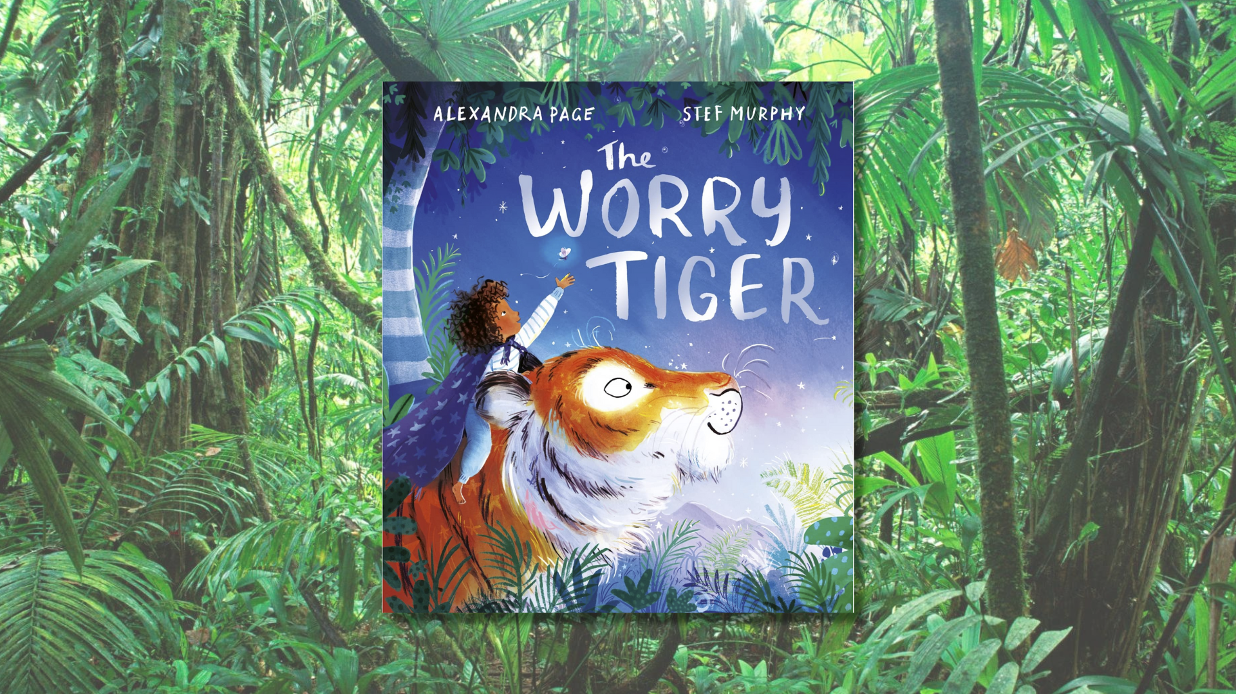

Read, Write, Count: The Worry Tiger STEM learning activities
STEM learning activities based on The Worry Tiger by Alexandra Page, illustrated by Stef Murphy

Age 6-8

CFE First Level

Resource created by Raising Aspirations in Science Education (RAiSE)

scottishbooktrust.com
Scottish Book Trust is a registered company (SC184248)
and a Scottish charity (SC027669).

Contents
About this resource 2
Learning activities 2
Further resources 5

About this resource
This resource was developed by Raising Aspirations in Science Education (RAiSE) and provides links to some suggestions for further STEM learning activities to complement and enhance children’s learning from one of the books included in this year’s Primary 3 Read, Write, Count bag. The key themes explored in these activities are: tigers and their jungle rainforest habitats, biodiversity and interdependence, shadows, sound, senses and engineering.
Please note that some resources, such as the ones from Explorify, require an account to view.

Learning activities

Activity 1: Build a den
TCH 1-09a, TCH 1-10a, TCH 1-11a, TCH 1-12a
“Rory curled up inside his den.” Can you design and build a den like Rory’s? Use the Waterproof Shelter Challenge from Learning through Landscapes to build your own outdoor den.

Activity 2: Shadow puppets
TCH 1-09a
“Shadows rippled over the wall.” Investigate light and shadows by making some shadow puppets – perhaps you could use them to retell the story? See the Hamilton Brookes website for inspiration!

Activity 3: Rain sounds
SCN 1-05a, SCN 1-11a, SCN 1-12b
“Rory and the tiger races back to the den, while raindrops pitter pattered all around them.” Investigate the science of sound using the Learning through Landscapes resource to create your own rainstorm. Can you make the sounds louder? Quieter?

Activity 4: Outdoor senses
SCN 1-12b, SOC 0-08a, SOC 1-07a
“The jungle was a jumble of strange shapes and sounds and smells…” Use all your senses to learn more about the outdoors with the RSPB Wild Challenge.

Activity 5: Smell that!
HWB 1-15a, SCN 1-12b
“Then breathe out like a tiger and tell me what you smell.” Explore the sense of smell by covering some plastic bottles using a sock and identifying what is inside from the smell alone, use this Activity on page 11 from this year’s British Science Week activity packs.

Activity 6: Fireflies
SCN 1-01a, SOC 1-12b
“‘Fireflies!’ Rory gasped.” Research fireflies using the National Geographic Kids fact file on fireflies. You could extend this activity by researching for other examples of bioluminescence in nature.

Activity 7: Worry dolls
TCH 1-09a, TCH 1-10a
Rory was lucky to have a Worry Tiger to help him feel calm. Design and create your own worry doll, or creature, using Craft Project Ideas guide or the Milton Monster Activity Sheet from Twinkl.

Activity 8: How tall are you?
MNU 1-01a, MNU 1-11a
Can you stretch and life your hands up high like a monkey? How high can you stretch? Warm up first, and use the BBC Supermovers Activity to explore units of measurement.

Activity 9: Two lungs
TCH 1-09a, TCH 1-10a
“‘Breathe in,’ said the tiger, ‘Let your tummy swell.’” Find out more about how our lungs work using the BBC Bitesize guide to how humans breathe, then watch the YouTube video from MEL Chemistry (1 minute, 28 seconds) to learn how to make your own model of a pair of lungs.

Activity 10: Rainforest habitats
SCN 1-01a, SCN 1-02a, SOC 1-12b
Use the BBC Bitesize guide to learn more about the rainforest habitat. You can also watch this BBC clip (2 minutes, 52 seconds) to see the plants and animals you can find there!

Activity 11: Survival
HWB 1-15a, HWB 1-16a, SCN 1-12a
Could you live in the rainforest? Use the Explorify resource on survival in the rainforest to think like a scientist and investigate what you’d need to do to survive!

Further resources
- Find more learning activities for all the books and resources included in the Read, Write, Count bags on our website:
  - Learning resources for the P2 bags
  - Learning resources for the P3 bags
- Find out more about RAiSE on the Education Scotland website

