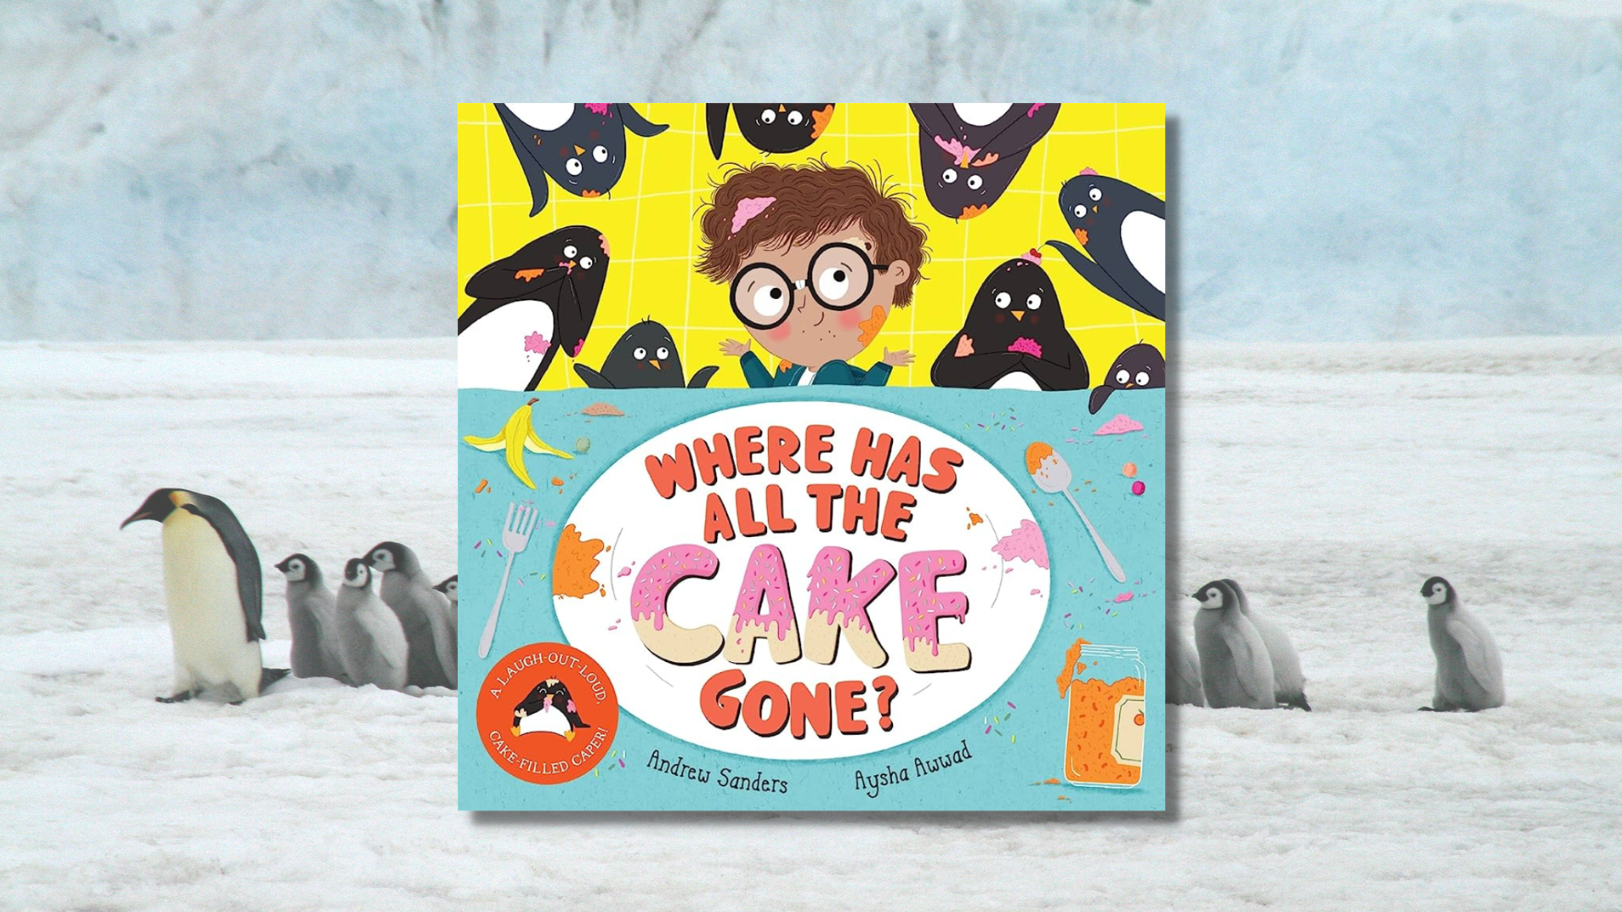

Read, Write, Count: Where Has All the Cake Gone? STEM learning activities
STEM learning activities based on Where Has All the Cake Gone?

Age 6-8

CFE First Level

Resource created by Raising Aspirations in Science Education (RAiSE)

scottishbooktrust.com
Scottish Book Trust is a registered company (SC184248)
and a Scottish charity (SC027669).

Contents
About this resource 2
Learning activities 2
Further resources 4

About this resource
This resource was developed by Raising Aspirations in Science Education (RAiSE) and provides links to some suggestions for further STEM learning activities to complement and enhance children’s learning from one of the books included in this year’s Primary 2 Read, Write, Count bag. The key themes explored in these activities are: forces, food technology, penguins and their habitat, and engineering.
Please note that some resources, such as the ones from Explorify, require an account to view.

Learning activities

Activity 1: What if penguins could fly?
SCN 1-01a, SOC 1-12b
Whilst the penguins did a lot of travelling in this story, it’s a well-known fact that, despite being birds, penguins cannot fly. But what if they could? The What if penguins could fly? resource from Explorify will get your pupils thinking like a scientist!

Activity 2: Push and pull
SCN 1-04a, SCN 1-07a
There are lots of examples of push and pull forces in the story. How many can you spot? Watch the BBC clip on Push and Pull (57 seconds) to learn more about forces in the world around us.

Activity 3: Friction
SCN 1-04a, SCN 1-07a
Albert and the penguins went skiing with kangaroos. Explore friction using this YouTube video activity from SSERC (7 minutes).

Activity 4: Journey sticks
SCN 1-12b, HWB 1-25a, SOC 1-07a
The penguins took Albert on quite a journey! Go for a walk around your playground or local area and record your journey using a journey stick. See the Scottish Wildlife Trust guide for inspiration.

Activity 5: Build a marmalade trailer
SCN 1-04a, SCN 1-07a, TCH 1-09a, TCH 1-10a
Use the engineering design process to support pupils to design and create a trailer that will transport Albert and his marmalade jar. You could use junk or class construction materials. For a great example of engineering design cycles see Let’s do Engineering’s website.

Activity 6: Create a cake
TCH 1-04a, TCH 1-04b
Design a cake – for a template see the activity sheet from Twinkl.

Activity 7: Clean up!
SCN 1-16a
In the story, Dad has to clean the kitchen. Find out how soap works with the YouTube video from CBBC (1 minute, 3 seconds).

Activity 8: Snowball catapults
TCH 1-09a, TCH 1-10a
The kangaroos and the penguins had a snowball fight. Using the resource from The Institution of Engineering and Technology, have a go at making these snowball catapults, investigate how far you can make your pompom or marshmallow snowballs go!

Activity 9: Baking engineering
TCH 1-04a, TCH 1-04b, HWB 1-30a
Education Scotland and Twinkl both have guides to developing technology skills through baking cakes or breads.

Activity 10: The right ingredients
TCH 1-04a, TCH 1-04b
You can’t make a cake without the right ingredients. In the activity from Barefoot Computing, creating a shopping list helps children develop their understanding of abstraction.

Further resources
- Find more learning activities for all the books and resources included in the Read, Write, Count bags on our website:
  - Learning resources for the P2 bags
  - Learning resources for the P3 bags
- Find out more about RAiSE on the Education Scotland website

