Suggested learning opportunities for Where Has All the Cake Gone? by Andrew Sanders and Aysha Awwad

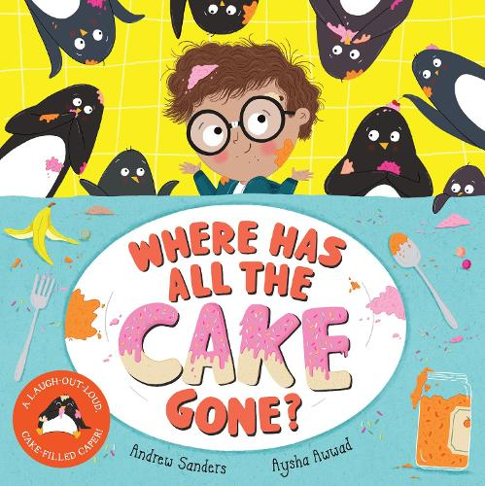
- Science, technology, numeracy and mathematics
- Literacy and English, Modern Languages
- Health and wellbeing, and social studies
- Expressive arts

Mathematics and numeracy
- The penguins are following a map when they get lost with Albert. Can you make a map showing your journey to school? Can you describe the route to someone else using directions? (MTH 1-17a, SOC 1-14a)
- There are different flags and signs in the book. Explore them as a class – are there any you don’t recognise? Look them up together. Use the worksheet to note your answers down. You could also explore sorting them into different criteria, e.g., colours, patterns etc. (MNU 1-20b)
- In the story the cake is constructed into a tall tower shape. What is the tallest tower that you can build? How tall do you think it is? Is it taller than your table? Who has the tallest tower? How could you work this out? (MNU 1-11a, TCH 1-09a)

- Albert and the penguins take a train. Use the Scotrail journey planner to plan a trip on a train. Look at what time it would leave and arrive and how much it would cost. Write down some different combinations of coins and notes you could use to pay for the journey. (MNU 1-09b,
MNU 1-10b)

Sciences
- The penguins try lots of different ways to move Albert in the marmalade jar. Talk about which way is safest and works best. Experiment with different ways of moving different types of containers – e.g., rolling, pushing, and pulling. Which works best and why? (SCN 1-07a)

Technology
- Talk about how the penguins act in the story. Use the internet to find more information about penguins, for example, videos or images of them in their natural habitat. (TCH 1-01a, TCH 1-02a)

- Albert and the penguins meet some kangaroos who are on a skiing holiday. Discuss the clothes that they are wearing and what they are made of. Explore what types of material are best to wear in different situations and why – e.g., when it’s raining, hot or cold? (TCH 1-10a, SCN 1-15a)

Literacy and English
- The penguins have a map to follow in the story. Create your own story map to retell the events of the story in sequence. (LIT 1-06a, LIT 1-15a, LIT 1-25a)
- Create another setting for the story. Where else could Albert go? He's been somewhere hot, cold, a city and even outer space – can you think of somewhere else? Describe what fun activities the penguins could do in this new place. (ENG 1-31a)
- On the last page, the penguins are looking in the kitchen window at Albert. What do you think will happen next? Create a new ending for the story. (ENG 1-31a)
- The story ends with Albert and his Dad making a cake. List the ingredients they put in the cake. Are there any other ingredients you would add? (LIT 1-28a, LIT 1-29a)
- At the end of the story, you can see on the fridge all the postcards Albert collected from the places the penguins took him. Create your own postcard from one of the places he visited and send it in the post to someone you know! (LIT 1-28a,
LIT 1-29a)

Modern Languages
- The penguins take Albert to France. Can you learn how to introduce yourself in French? (MLAN 1-02b)

Health and wellbeing
- Albert and his Dad talk about how they feel about the penguins eating all the cake. Can you think of a time you have felt disappointed or upset and what made you feel better? (HWB 1-04a)

Social studies
- The penguins make the kitchen very messy! Talk about some of the things we can do to look after our school, community, and environment. Create a poster to encourage others in your school or community.
(SOC 1-08a)
- Albert and the penguins travel around his local area. What things would they see if they left from your house? Create a map of your local area to guide them on their trip. (SOC 1-14a)

Art
- Compare the illustrations in this story to the illustrations in The Dragon Who Didn't Like Fire and discuss with your classmates how they are similar or different. Which do you prefer and why? (EXA 1-07a)

- Pick one of the places that Albert and the penguins visit, and draw yourself there. Think about the clothes you would wear – for example design your own spacesuit for the moon! (EXA 1-04a)

Drama
- Create your own café just like the one in the book, taking it in turns to act out different roles like waiter, chef and customer. Look up some examples of the kinds of food and drinks a café might sell. What would you sell? How much would each item cost? Can you give customers the correct change? (EXA 1-12a,
MNU 1-09a)

