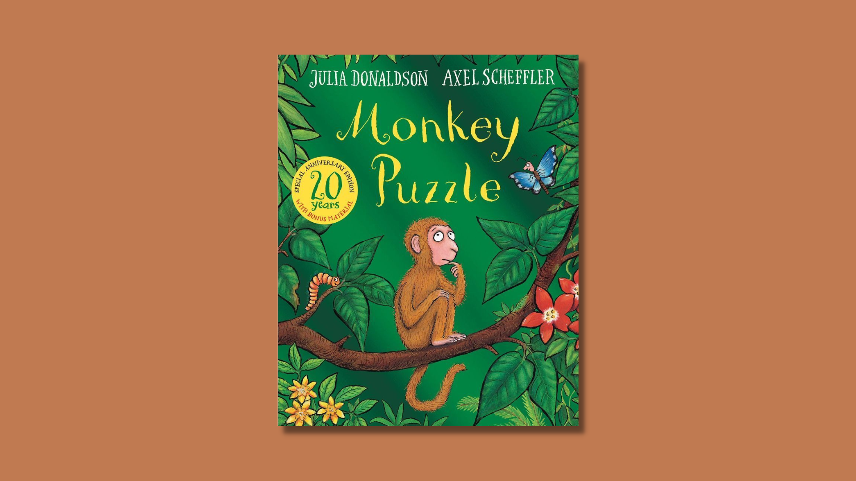

Monkey Puzzle learning activities
Ideas and activities to support using Julia Donaldson’s book in class

Age 3–8

CFE Levels Early to First

Resource created by Scottish Book Trust

scottishbooktrust.com
Scottish Book Trust is a registered company (SC184248)
and a Scottish charity (SC027669).

Contents
About this resource 2
Learning activities 2
Further resources 5

About this resource
This resource contains learning activities for class use of the book Monkey Puzzle which can be adapted to suit the children you work with. For further ideas to use with this book, see:
- 10 things to do with any book (primary)
- 10 things to do with any book outdoors

Learning activities

Activity 1: Perfect patterns
MTH 0-19a, MTH 1-19a
Look at the pictures of butterfly with her wings outstretched. The pattern on both sides is the same. Create your own symmetrical butterfly and use paint with sponges, potato printing or your hands to create a large symmetrical butterfly mural for the wall.
Extension activity: Look at the pictures in the story and find other symmetrical images (leaves, flowers, insects, bat for example). Go for a walk around the school playground or grounds and try to find other symmetrical shapes and objects in the environment. Take any that are lying on the ground back to class and make a symmetry collage of the objects you have found in nature.

Activity 2: Animal role play
EXA 0-12a
Choose one of the animals or insects from the story and role-play the creature, using actions and noises in a space of your own. Call out one name and that person should continue moving, whilst all others should freeze on the spot. Others should try to guess which creature they are being. When the teacher claps, you should all move again. Repeat the game until everyone has had a turn at showing their movements and others have guessed.

Activity 3: Explore nature
SCN 0-01a
Look at the different animals and insects in the story. Go on a nature walk in the school grounds or in a local park and see how many of them you can spot in your own local area. Take photos of the creatures that you find which also appear in the story. When you get back to school, draw a picture of one creature that you saw which does not appear in the story. Talk about the animals in the story which you did not see on your nature walk.

Activity 4: Standing statues game
LIT 0-01a, LIT 0-11a, LIT 0-20a
Listen to the story being read to you slowly, and stand up every time that you hear a word that has the same sound as another word from the story. Try to tell the class or group which two words sound the same. Examples could include ‘she’ and ‘me’ or ‘mum’ and ‘come’. Try to think of another work of your own which sounds the same.

Activity 5: People who help us when we are worried
HWB 0-03a
In the story, little monkey turns to butterfly to help him find his mother. They work together to find her and monkey changes from being worried and scared to being happy in the end. Think about a time that you have been worried or scared at home or school. Talk about who you would turn to help to you in each different situation, and how you felt once they had helped you. Paint or draw a picture of one of the different people in your life who helps you. Cut out all of the pictures and create a montage of ‘people who help us when we are worried’.

Activity 6: When you are worried
ENG 1-19a
Little monkey is lost and worried because he cannot find his mum. Think about a time that you were lost by yourself or with others. Think about how you felt when you were lost or when something or someone you care about got lost.
Look at the monkey’s face on the front cover and the first page of the story and talk about how he is feeling. Draw a picture of the time you got lost or you lost a person or thing and try to show how you were feeling by putting detail into the face. Share your picture with the class or a group, telling friends what happened and how you felt when you got lost.

Activity 7: Create a missing poster
LIT 1-14a
Look through the story for the different descriptions that little monkey gives of his mother. Create a MISSING poster that could be nailed to a tree in the jungle, giving all of the different details of what she looks like (look at the descriptions of her size, tail, legs, fur etc.). Remember to include information about where she was last seen and choose a reward that you would give if somebody/an animal found her.

Activity 8: Caterpillars and Butterflies
SCN 1-14a
Butterfly did not realise that little monkey looks like his mother as butterfly looks very different to her babies. You can watch how caterpillars turn into butterflies on this BBC Bitesize video.

Activity 9: Animal illustration
EXA 1-02a
Look at the illustrations of the different animals in the story. Choose 1 that you would like to create yourself. Draw a large outline of your chosen animal or insect on A3 sugar paper. Using the written descriptions of the animals and the illustrations, choose which media you would like to use to complete your picture.
Think about the wide range of materials available – cloth, fur, sugar paper, waste materials, pastels, watercolours, pens, pencils, buttons, shells, foil, foam, wool. . . Complete your picture and then describe it to the class, explaining why you chose the media that you did. Cover the wall in green and draw on lots of leaf shapes. Cut out and hang your pictures in front to create your own class jungle!

Further resources
- You can filter all our Learning resources by topic, including animals and nature as well as our Authors Live on Demand broadcasts
- Our book lists suggest more picture books that celebrate friendship, explore animals and our environment and books for outdoor learning
- Visit Julia Donaldson’s website to learn more about her other books, songs and plays

