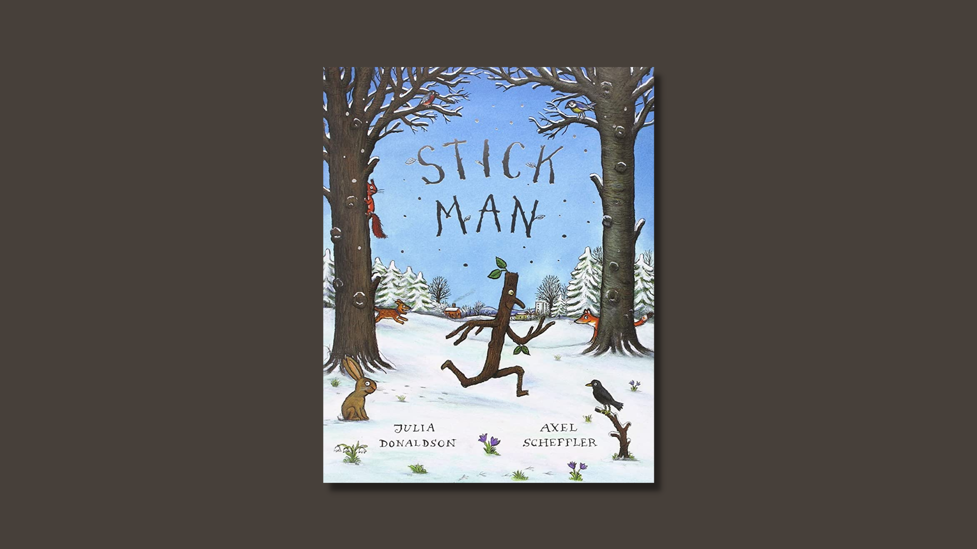

Stick Man learning activities
Ideas and activities to support using Julia Donaldson’s book in class

Age 3-8

CFE Levels Early to First

Resource created by Scottish Book Trust

scottishbooktrust.com
Scottish Book Trust is a registered company (SC184248)
and a Scottish charity (SC027669).

Contents
About this resource 2
Learning activities 2
Further resources 4

About this resource
This resource contains learning activities for class use of the book Stick Man which can be adapted to suit the children you work with. For further ideas to use with this book, see:
- 10 things to do with any book (primary)
- 10 things to do with any book outdoors

Learning activities

Activity 1: Make your own Stick Man
EXA 0-04a
Encourage the pupils to design their own Stick Man – they don’t have to make a perfect copy of the one in the book. Start by using, or painting, a kitchen roll tube. You can use crepe paper around a pipe cleaner for the arms and nose and tissue paper for any leaves or flowers.

Activity 2: Stick Man adventures
TCH 0-04b
In the story, Stick Man ends up in a variety of locations, often a long way from his family tree. Take your model of a Stick Man outside and around the school and put him in different places. Take a photograph of him in your chosen place and then print it off. Share with the class what Stick Man was doing in the place where you positioned him and what happened to him in the end. You could create a display or use them for creative writing, pupils can continue the story and explore what else could happen to Stick Man and where else he could end up.

Activity 3: Create a class story
ENG 1-31a
Following on from the Stick Man adventures activity, divide into groups and ask each group to choose an adventure to work with. Ask pupils to work together to create a short paragraph about their adventure. It can rhyme like Stick Man, but it doesn’t have to. Ask pupils to draw illustrations to accompany their paragraph. Use the different adventures and illustrations to create a class book telling a new story of Stick Man.

Activity 4: I’m Stick Man! I’m Stick Man!
LIT 0-19a
In Stick Man, people and animals use Stick Man for a variety of tasks. Think of other things that people might try to use Stick Man (or a stick or twig) for. Ideas could include building a raft, a walking stick or a using him as a stick for a bonfire night fire. Draw or paint a picture to show your ideas. Remember to show poor Stick Man in your picture!

Activity 5: Hot seating
EXA 1-12a
Take it in turns to be in the hot seat as Stick Man. Ask Stick Man questions about how he felt at different points in the story. Pupils should respond in role, imagining how they would feel when they met the different people and encountered the different situations.

Activity 6: Pooh sticks
HWB 0-25a
In the story, children play pooh sticks with Stick Man and send him down the river (to then be found by a swan). Go for a walk in your local area and find sticks to play pooh sticks. If you have a nearby river or steam, play pooh sticks from the bridge. If you don’t have a river nearby, you could experiment with the different sticks you have collected in the classroom. Do they float? Do any sink? Are they from the same or different trees? You could also research where the game pooh sticks came from!

Activity 7: Stick Man song
ENG 1-31a
Imagine Stick Man encounters someone else when he is out for the day – the tooth fairy, a superhero, the little pig who wants to build his house from sticks, for example! Write a verse of a song to describe what happens. Draw an illustration to accompany your verse.

Further resources
- You can filter all our Learning resources by topic, including animals and nature as well as our Authors Live on Demand broadcasts
- Our book lists suggest more picture books that celebrate friendship, explore animals and our environment and books for outdoor learning
- Visit Julia Donaldson’s website to learn more about her other books, songs and plays

