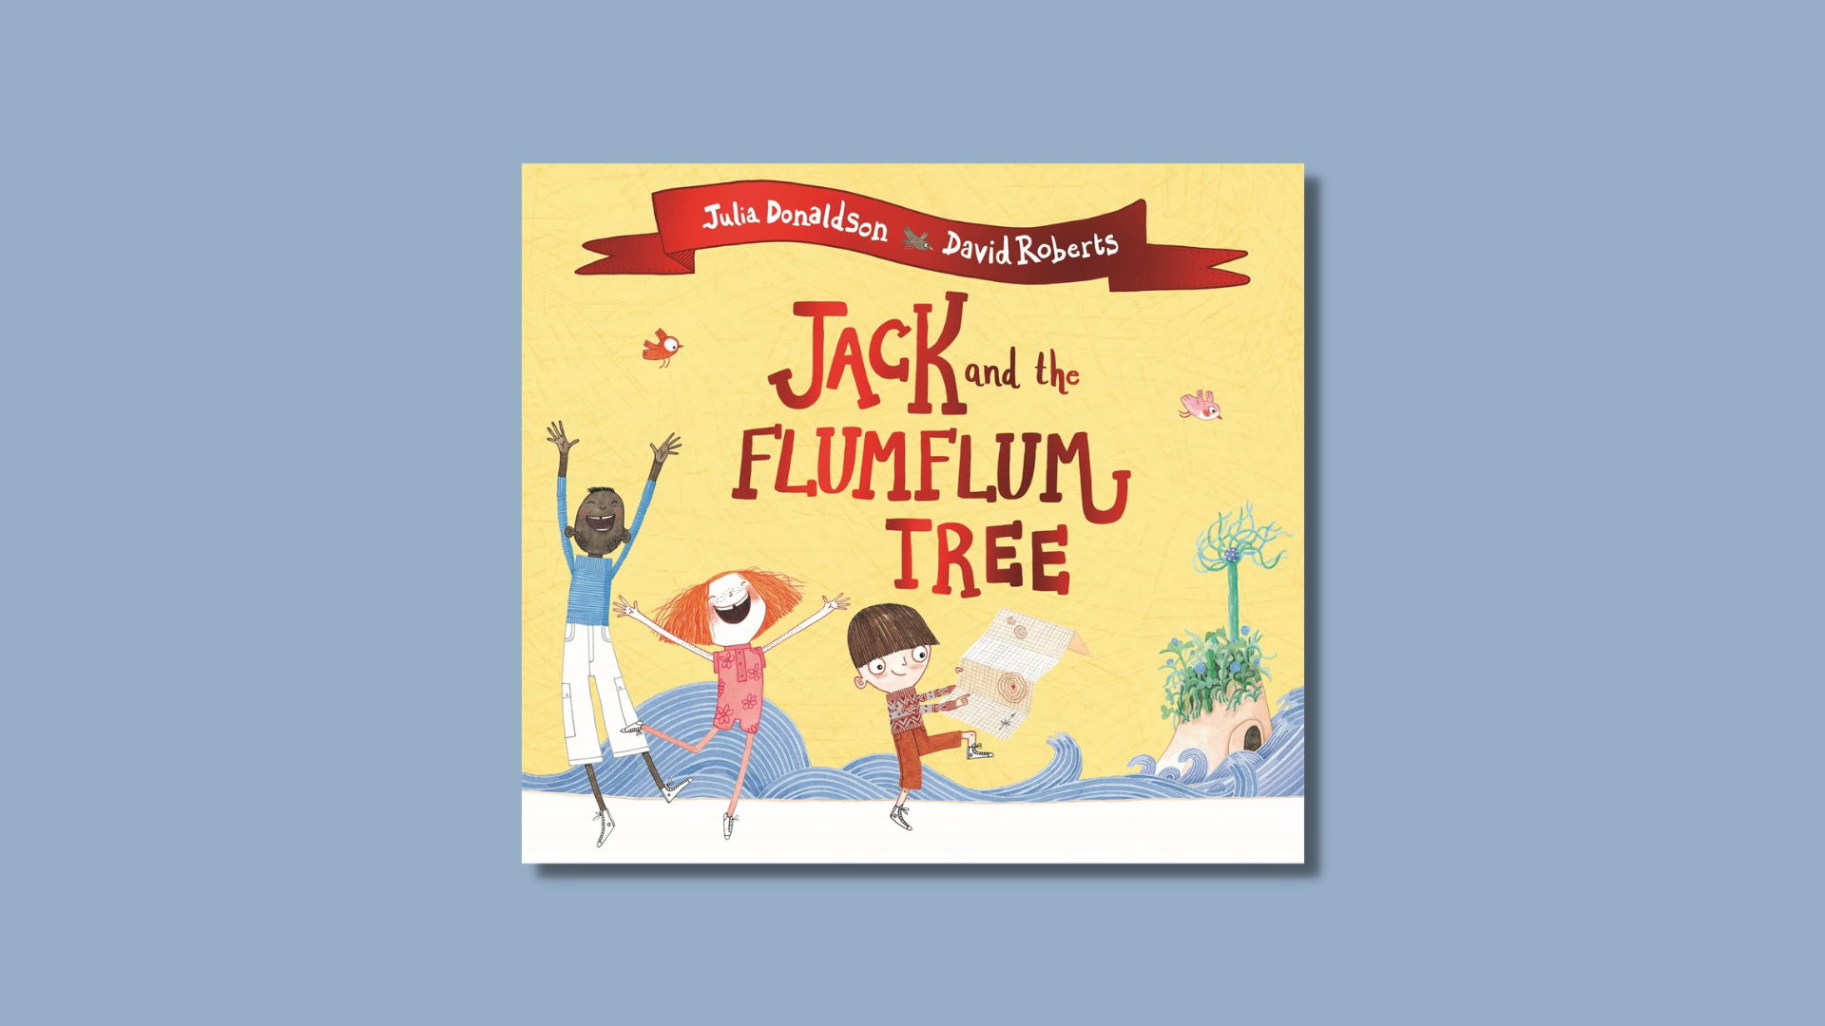

Jack and the Flumflum Tree learning activities
Ideas and activities to support using Julia Donaldson’s book in class

Age 3–8

CFE Levels Early to First

Resource created by Scottish Book Trust

scottishbooktrust.com
Scottish Book Trust is a registered company (SC184248)
and a Scottish charity (SC027669).

Contents
About this resource 2
Learning activities 2
Further resources 4

About this resource
This resource contains learning activities for class use of the book Jack and the Flumflum Tree which can be adapted to suit the children you work with. For further ideas to use with this book, see:
- 10 things to do with any book (primary)
- 10 things to do with any book outdoors

Learning activities

Activity 1: Grow your own Flumflum tree
SCN 0-04a, SCN 1-03a
The Flumflum tree only grows on the far away Isle of Blowyernose. Talk about different climates and what different plants need to grow. Think about plants you can grow and grow your very own ‘Flumflum’ tree.

Activity 2: Make your own patchwork sack
EXA 0-02a, EXA 1-03a, EXA 1-02a
Ask each of your pupils to make a square for the patchwork sack. You could make squares out of paper or fabric. Stitch or glue your patches together.

Activity 3: Memory game
LIT 0-02a, LIT 1-02a
Find (or make!) a patchwork sack. One at a time, ask the children to put an object inside while saying the phrase: “In my patchwork sack I would pack. . .” See if your class can remember what each pupil packed in the sack. For younger students, this activity may be best in small groups.

Activity 4: Tom Tom
EXA 0-17a, TCH 0-12a, TCH 1-12a
Make Tom-Toms as a class. You could experiment with different grains, pulses, rocks inside different containers. Tap a simple rhythm and have the pupils tap the same rhythm back.

Activity 5: What will float?
SCN 0-07a
When Jack’s boat gets a leak, he knows just what to do! Explore things that float. Try a variety of objects to see if they’ll float or sink. Make predictions and see if your class is right.

Activity 6: Make your own newspaper boat
TCH 0-12a, TCH0-14a, MTH 0-17a
Look through the pages of the book to find the small hidden newspaper boat. This video tutorial demonstrates how to make a boat using an A4 piece of paper. For this activity, it may be best to pair upper and lower primary students together to help each other.

Activity 7: Maps
SOC 0-09a, SOC 1-14a, LIT 1-28a
Jack and his friends use a map to help them find the Isle of Blowyernose. Make a map of your school or neighbourhood.

Activity 8: Postcards
LIT 0-09b, LIT 0-31a
Jack, Rose and Stu sail away to Blowyernose. Pretend that you’ve gone with them on the adventure. Design and write a postcard to send to Granny to tell her all about the Isle of Blowyernose.

Further resources
- You can filter all our Learning resources by topic, including animals and nature as well as our Authors Live on Demand broadcasts
- Our book lists suggest more picture books that celebrate friendship, explore animals and our environment and books for outdoor learning
- Visit Julia Donaldson’s website to learn more about her other books, songs and plays

