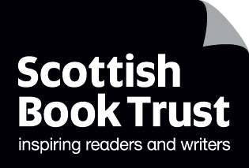
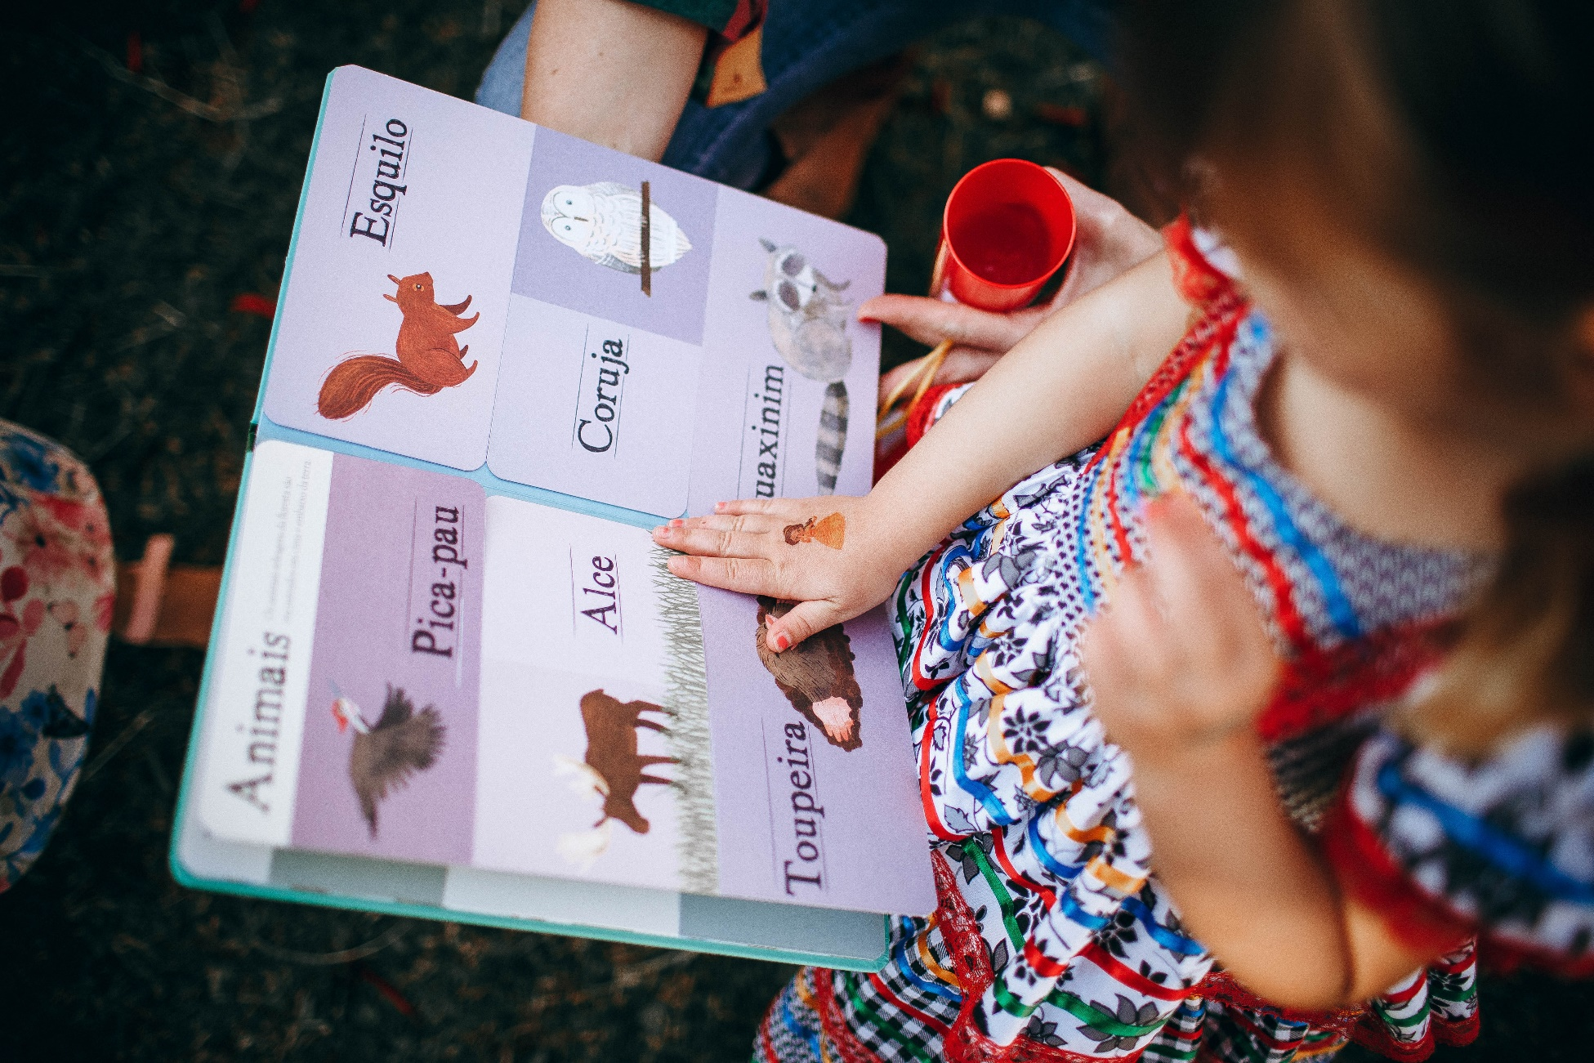

Supporting children with English as an additional language
Advice for finding texts and using them in your classroom, school or library

Resource created by Scottish Book Trust

scottishbooktrust.com
Scottish Book Trust is a registered company (SC184248)
and a Scottish charity (SC027669).

Contents
About this resource 2
Refugees 3
Bilingual books 3
Wordless books 4
Audiobooks and stories read aloud 6
Non-fiction 7
Graphic novels and comics 8
Chapter books 9
Further resources 10

About this resource
This resource will offer learning professionals advice for using texts with children who have English as an additional language (EAL). Each section will introduce a new format of text and ideas for how to use them with the children you work with.
As much as possible, all children should be offered a range of different texts. This includes different formats, genres, topics and styles. The more different ways a child encounters reading, the more likely they are to find something that works for them.
We also highly encourage using texts that are age and stage appropriate. Offering an older child a picture book, with the idea that it reflects their level of English, will often fail to engage them. Even with good intent, it can make them feel babyish or excluded from their peers.
There is also often an assumption that you have to find a book in the child’s language. Whilst this can be useful, taking a flexible approach to reading can be more beneficial.

Refugees
Not all children who speak English as an additional language are refugees, but some may be. All children are individual, and the way they come to live in Scotland and learn English could be a positive experience or traumatic. Whilst this resource has been written for all children with EAL, please do use your discretion about all activities and adapt them based on the needs and context of the children you work with. Further support for refugees can be found from:
- Scottish Refugee Council
- Refugee Survival Trust’s list of charities and organisations
- Refuweegee

Bilingual books
Bilingual books are printed in two languages – the ones we refer to use English and another language. Organisations such as Mantra Lingua, Little Linguists and Language Lizards offer dual language books in up to 60+ languages. They also sell talking pens which can read aloud the text from the books in the different languages they offer. This means, with the pen, even if you own one copy of the book, you can still access other languages read aloud.

Using bilingual books

Paired reading
LIT 0-01a/1-01a/2-01a/3-01a/4-01a, LIT 0-02a/1-02a/3-02a/4-02a
Bilingual books are great for paired reading with one person reading in English and the other reading the other language. Allow time for children to compare their languages, pointing at images at the book and sharing the different words for them in English or their language.

Errol’s Garden by Gillian Hibbs
This picture book is about a young boy who dreams of having a garden. When he runs out of room in his flat, the occupants of his building work together to create a community garden. This book could be used to prompt a discussion about gardening, growing and food. You could create a wall display of the different words we all use for different plants, fruits and vegetables. Or, try and grow your own garden with multilingual signs!

Mungo Makes New Friends by Gill Aitchison, illustrated by Jill Newton
This picture book, set in the Scottish Highlands, is about a horse called Mungo who makes friends with lots of different local animals. You could use this book to discuss different words for animals, what animals live in different countries – maybe you could go for a walk and see how many of the animals in the book you can see. It also contains a lot about friendship, so you could ask children to create posters or fact files about what makes a good friend.

Squirrel Monkey by Elizabeth Álvarez Alfaro, illustrated by Jesús Gabán
This picture book follows a young squirrel monkey who goes to the market with his mother and becomes overwhelmed by the noises, smells and sights. You could research some of the foods, animals and plants found in South America together – comparing them with a market, or supermarket, in your area. You could also use this book to talk about “big” or overwhelming feelings and who can help.

More resources on using bilingual books
- Our Paired reading toolkit contains activity ideas for running paired reading projects
- Our Exploring translation resource can be used to start thinking about translating and reading across languages

Wordless books
Despite not containing any text, wordless books still develop reading skills. Research from Neurophyschologia suggests that “readers use linguistic processes to construct meanings from sequences of images”. Even without reading text, readers are still using literacy skills, including visual literacy, to interpret meaning from the images and understand what the pictures are telling them.
For children with English as an additional language, wordless books offer them a form of reading where they aren’t “right” or “wrong”. Each child can bring their own interpretation to a wordless book. Wordless texts can be used as a whole class, group or school project. This means children with EAL aren’t segregated from their peers.

Using wordless books

Reading together
LIT 0-01a/1-01a/2-01a, LIT 0-02a/1-02a/2-01a, ENG 1-03a/2-03a
Share the book with the class, allowing time for each child to see all the pages. You can describe what you see as you read, or ask them in turn to describe what they see. You can point at different objects or places in the book and say what they are, for example, “bird”, “house” etc. As you turn the page you can say words like “and next” or “then” to demonstrate that it’s a connected narrative.

I see a. . . do you see a. . .?
LIT 0-01a/1-01a/2-01a, LIT 0-02a/1-02a/2-01a, LIT 0-04a/1-04a/2-04a
As you show the page say “I see a. . . do you see a. . .?” this allows them to input what they see. You can also encourage them to compare the English word with the word, or words, from their language.

Annotate
LIT 0-07a/1-07a/2-07a
Use sticky notes to add to the text. This could be speech or thought bubbles that add what a character is thinking, or the words for different things in the book – in English and the children’s languages.

More resources for using wordless books
- Our full resource on Using wordless picture books in schools and libraries
- Our book list of our favourite wordless books
- Our article on Advice for sharing wordless picture books
- Our cross-curricular resource on the wordless picture book Journey by Aaron Becker

Audiobooks and stories read aloud
According to National Literacy Trust’s research report, audiobooks improve speaking and listening skills such as pronunciation, tone and inflection. The report also suggest that listeners can have a stronger emotional connection to hearing a story read aloud.

Using audiobooks and stories read aloud
Reading aloud is another great way to explore books together in a group – again, ensuring that children with EAL are not excluded.

Reading whilst listening
LIT 0-01a/1-01a/2-01a, LIT 0-11a/1-11a/2-11a
Giving children a transcript or book to follow along whilst listening is incredibly useful. This allows children two ways of understanding the text. Play short excerpts and offer to replay them – perhaps more than once.
You can also spend some time discussing the audiobook with the group, or class, asking them to reflect on what they’ve understood. What you’re trying to gather from this is how much they understand and not whether they’re correct about the text, so framing questions like “What did you think of. . .” or “Why do you think. . .” allows them to have their own interpretation.

Songs, rhymes and stories
LIT 0-01a/1-01a/2-01a, ENG 1-03a/2-03a, EXA 0-17a/1-17a/2-17a
The texts you use don’t just have to be traditional audiobooks. You can also use songs – printing the lyrics out so children can refer to them as you listen or sing along.

More resources on using audiobooks and stories read aloud
- For stories read aloud see our Read, Write, Count videos of picture books read aloud or CBeebies Bedtime
- For songs and rhymes see our Bookbug Song and Rhyme Library and the Bookbug app
- Find your local library to see if they use apps like OverDrive or Libby, where you can borrow audiobooks (in multiple languages) for free
- Mantra Lingua sell bilingual books and PENpals which can read any of their books aloud in multiple languages
- Mama Lisa’s World hosts songs and rhymes in multiple languages

Non-fiction
Highly illustrated non-fiction books offer a wide range of different age and stage topics. This means they contain some of the visual benefits of picture books, whilst being more appropriate for readers of all ages.

Using non-fiction texts

So You Think You’ve Got it Bad? by Chae Strathie
LIT 0-04a/1-04a/2-04a, SOC 0-02a/1-02a, SOC 0-04a/1-04a/2-04a
Each book in this series explores the lives of children in different eras of history. Each section of text is accompanied by an illustration – meaning children can use the images to help them understand the words. You could also use these to talk about different histories, and histories from other countries. For example, if using the book on medieval history – look at what other countries looked like in that era.

A is for Bee by Ellen Heck
LIT 0-04a/1-04a/2-04a, SOC 2-19a
This highly illustrated book rethinks the alphabet. Each page shows a different letter, telling us that bee is “anu” in Igbo, “ari” in Turkish and “ammo” in Ojibwe. This book can be used to prompt a discussion about different languages, and how no two languages are the same. You could create a word display or class book of different words across the languages spoken in your class.

Magazines and newspapers
LIT 0-04a/1-04a/2-04a, LIT 1-08a/2-08a
Magazines and newspapers are highly visual. Often each fact is in its own bubble of text – meaning readers can read small pieces of information at a time – and accompanied by an image or photograph. Look at magazines and newspapers together online before deciding which one you’d like to buy as a class.
You could also have a magazine tasting, where you lay out some different options and give the children time to look through them together and see which ones they’d like to read. For more advice on picking magazines to read with young children, see our article on comics and magazines.

Graphic novels and comics
As mentioned with other highly visual texts, the images and artwork in graphic novels and comics acts as another “language”, meaning the reader has more than one way to understand the story.

Using graphic novels and comics

Paired reading
LIT 1-01a/2-01a/3-01a/4-01a, LIT 1-02a/2-01a/3-01a/4-01a,
ENG 1-03a/2-03a/3-03a/4-03a
As with other visual books, graphic novels and comics lend themselves to paired or group or class reading. Select some pages, or panels, and allow children time to go through them together. If there’s any words they don’t know, or are interested in, use sticky notes to annotate.

Create your own comics
LIT 1-20a/2-20a/3-20a/4-20a, EXA 1-04a/2-04a/3-04a/4-04a
Our resource on How to write a comic book scene can be used to create your own comics or class book. Some comics are as little as three panels and contain a joke. Compare jokes in different languages – are there any similarities or differences?

More resources on using graphic novels and comics
- Our resource on How to write a comic book scene gets children started with mapping out their own comics
- Our Authors Live broadcast with Mark Bradley on Comics and wellbeing can be watched online as a class
- Our article from Candice Purwin on Journaling for wellbeing looks at the positive effects drawing and doodling can have on mental health
- Our book lists of our favourite graphic novels for children and graphic novels for teenagers

Chapter books
For children with more advanced English reading skills, there are options for books or chapter books which may be more accessible. Barrington Stoke books are published to be accessible for readers with visual stress or dyslexia. This means their books are short, super-readable and published on cream paper. The titles are from recognised authors and are edited to ensure the text is as clear as possible, with no abstract or difficult words.
This means their books are ideal for children who are still developing their confidence with reading without being recognisably different. They allow children to read alongside their peers, and potentially find new authors or titles they’d like to read. This can help them read for pleasure or feel motivated to read.

Using chapter books

Book tasting
LIT 2-01a/3-01a/4-01a
A book tasting is where readers are allowed to sample books before they decide to read them. This could involve a trip to your library, or could just be taking all your class books out of the shelves and putting them out for pupils to look though. Barrington Stoke has the first chapters of their titles on their website, meaning pupils can read before you purchase anything.
A book tasting allows children to have an element of choice, which will give them more ownership over their reading. It also allows them to assess if they can, or would like to, read a book.

Further resources

Support for children with EAL
- The Scottish association for teaching English as an additional language (SATEAL)
- The Scottish EAL Co-ordinating Council (SEALCC) is a network of professionals across Scotland who are involved in the management of EAL provisions in schools
- Resources on supporting EAL from Highland EAL and Aberdeen City EAL
- For families with young children, find out more about Bookbug for parents and carers with English as an additional language
- “Support for multilingual families at home”, the National Literacy Trust
- Bilingualism Matters is a centre of research and language learning based at the University of Edinburgh

Purchasing books or texts
- Mantra Lingua
- Little Linguists
- Language Lizards

