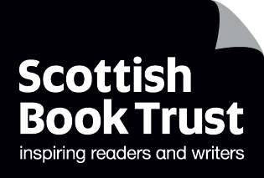
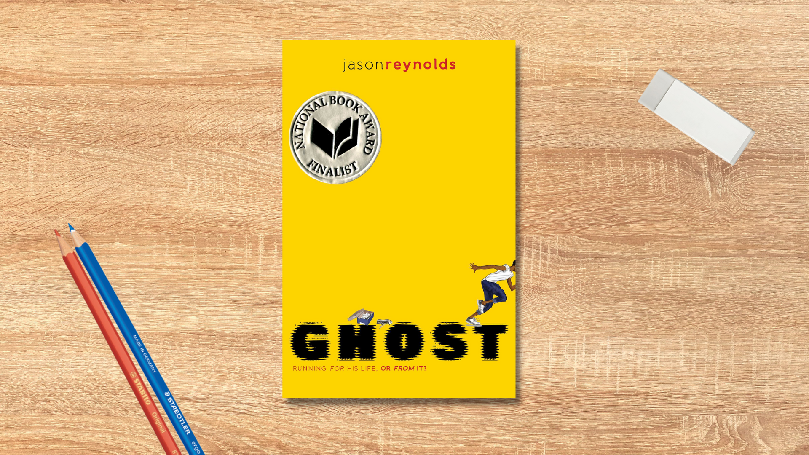

Read Woke: Ghost
Activity ideas to support classroom use of the book Ghost by Jason Reynolds.

CFE Second Level

Resource created by Scottish Book Trust

scottishbooktrust.com
Scottish Book Trust is a registered company (SC184248)
and a Scottish charity (SC027669).

Contents
Scottish Book Trust 2
Read Woke 2
Read Woke South Ayrshire 3
How to use this resource 3
Learning activities 4
Further resources 7

Scottish Book Trust
Scottish Book Trust is a national charity that believes everyone living in Scotland should have equal access to books. Our work provides opportunities to improve life chances through books and the fundamental skills of reading and writing. Access to books and a love of books bring many important benefits from family bonding and advancing children’s learning, to unlocking creativity, helping employability and improving mental health and well-being. Scottish Book Trust aims to support all communities across Scotland, with particular focus on those who are vulnerable and under-represented.

Read Woke
‘Read Woke is a movement. It is a feeling. It is a style. It is a form of education. It is a call to action; it is our right as lifelong learners. It means arming yourself with knowledge in order to better protect your rights.’
- Cicely Lewis, Founder of Read Woke.
The Read Woke challenge was developed by Cicely Lewis in Georgia, USA in 2017. Motivated by the political climate and seeing students grapple with issues of social injustice daily, Cicely realised the need to empower them with knowledge. Knowledge about the issues they (and others) face and knowledge about their own rights. The aim is to educate children and young people through reading. Find out more on the Read Woke website.

Read Woke South Ayrshire
The Read Woke challenge was brought to Scotland in 2020 via the School Library Improvement Fund. A collaboration of South Ayrshire secondary schools created a book list and incentivised reading programme for S1–6 students with the aim of improving representation within library collections, celebrating diversity and encouraging students to be socially aware. Further backing from the Scottish Library and Information Council has allowed this work to be expanded into a primary school setting with Read Woke South Ayrshire Primaries launched in February 2022. Providing carefully chosen books to schools – along with tailor-made resources and activities through the year – is allowing us to educate and empower students to engage with social justice issues and stand up for the rights of themselves and others. The resources produced will help schools embed themes of equality, diversity, social justice, and human rights throughout their curriculum from P1–7. Learn more on the Read Woke South Ayrshire website.

How to use this resource
Ghost by Jason Reynolds is a book for readers aged 9+. The story follows Ghost, real name Castle Cranshaw. At home, Castle lives in an area of multiple deprivation with his mother. Both of them are processing the trauma from a recent incident: where his father attempted to shoot both his mother and Castle. At school, he is bullied and struggles to control his emotions. Castle finds a sense of community and escapism on the running track, facing up to his fears, with the support of the coach and his elite running team.
With all Read Woke resources, we highly recommend that you read the book before using it with your class and use your best judgement about whether teaching about this topic is appropriate for the children in your class. It is important teachers are mindful of discrimination and inclusivity when approaching the book.

Learning activities

Activity 1: Pre-reading activity
LIT 2-04a, LIT 2-05a
The title and front cover give a hint of what the book might be about. Look at it together as a class and see what clues you can find about the book. Look at the phrase on the cover: “Running for his life, or from it!” Discuss what you think this might mean in context. Make a note of your findings to reflect on later.
Once you’ve read the book revisit your expectations of the title, cover, and phrase on the cover. Were your initial thoughts correct?

Activity 2: First lines
LIT 2-04a, LIT 2-07a
The beginning of a book is crucial for setting the scene and influencing the reader. Read through the first page together and discuss the following:
- Who do you think is telling the story?
- What is the effect of writing in the first person? How does it make you feel? (You could extend this question by reading aloud a passage from a book that’s written in third person and comparing the impact on the reader).
- Does this first page draw you in as a reader?
- What do we learn about the character in this opening piece?
- Does it make you want to read on?

Activity 3: Timeline of events
LIT 2-15a, LIT 2-25a, LIT 2-28a
Ghost is a chapter book that follows the many trials faced by the main character. Create a timeline of events to be added to as you read through the book, charting the key moments in Castle’s life that have had an influence on him. You could have positive influences above the line, and negative below – or use colour coding.

Activity 4: Identity
LIT 2-28a, MNU 2-20a, HWB 2-10a
Look at the characters of Castle and Coach Brody. As the story unfolds it becomes clear they have both had to overcome a difficult past – this is how the coach is able to support Castle through his emotions and turmoil.
Create an outline drawing of Castle and one of Coach Brody. Begin to add words and phrases that can be used to describe each character. Use a highlighter to show similarities between them or create a Venn Diagram to show how their characters have differences, but also overlap in some places.
Discuss how we are all unique but can have some things in common with others.

Activity 5: Good luck charms
LIT 2-04a, LIT 2-07a, HWB 2-02a
In the book there’s a lot of references to Castle’s running shoes. Ask the class why the shoes are important.
You could discuss how the shoes are a symbol. A symbol is something that shows up in a book to hint towards something. So whilst Castle needs his shoes to run, they are also a symbol of how he wants to run away from his own life (you can revisit the tagline on the cover).
Consider the importance of the running shoes:
- Why did Castle feel he needed to have the special running shoes?
- Did having them add to his problems or lessen them?
- Why do you think they are labelled ‘silver bullets’? Read this part again to see how they made Castle feel.

‘I put the shoes on. The nines fit perfectly. After I laced them tight, I stood up and bounced up and down a few times like Tia suggested. They felt amazing, almost like I didn’t have any shoes on at all. I stepped in front of the mirror to check myself out. Man, It looked like I was wearing spaceships on my feet. Or silver bullets! “How are they?” Tia came back over to check on me.’
Ask your pupils if there is anything that makes them feel better, stronger or empowered when they wear it. Do they have any good luck charms?

Activity 6: Quotes
LIT 2-01a, LIT 2-08a, ENG 2-31a, HWB 2-02a, HWB 2-06a
There are some inspirational quotes you can find throughout the novel:
‘And the same thing running did for me. . . I felt like it could do for you. . . Show you that you can’t run away from who you are, but what you can do is run toward who you want to be.’
‘Trouble is, you can’t run away from yourself. . . ain’t nobody that fast.’
‘Little. Don’t ever let someone call your life, your dreams, little. Hear me?’
‘Because for something to make you feel tough, you gotta be a little bit scared of it at first. Then you gotta beat it.’
Print these quotes, or some of your favourites, onto cards. In small groups discuss how these quotes prompted Castle to feel better about himself.
Ask your pupils to think about what makes them feel confident. It could be someone in their life, a specific hobby or activity they’re good at, or something they do to help them feel brave. Write a poem linked to feeling empowered. You can use our Introducing and exploring poetry resource or Performance poetry learning activities for further activity ideas.

Activity 7: Running and wellbeing
HWB 2-06a, HWB 2-15a, HWB 2-22a, HWB 2-24a
Castle is able to use his skill in running to find friendship, role models and find escapism from his problems. Running is an inclusive sport and can be a way to develop physical and mental wellbeing, helping build stamina and resilience.
Have your pupil’s start a personal log of how far they can run in a certain time. They can add to this and reflect on it over time – how do they improve over time? How do they feel after participating?
Create a classroom display of activities that can help support wellbeing e.g.: running, walking, reading, spending time outside, talking to someone.

Activity 8: World Records
LIT 2-04a, LIT 2-06a
Throughout the book Castle is obsessed with World Records. Research the history of the World Records together, and create a fact file of interesting examples. Ask each pupil to create their own poster of a World Record they’d love to break.

Further resources

Read Woke
- Read Work South Ayrshire website
- Read Woke resources on the Scottish Book Trust website

Scottish Book Trust
- Scottish Book Trust anti-racist resources including our book list on Black History month books for children and young adults and our understanding and challenging racism resource
- Scottish Book Trust sports resources including our Sports and literacy resource and our book list on Books for your P.E. Classroom

Anti-racist resources
- Black Lives Matter UK learning resources
- Show Racism the Red Card resources
- Black History Month website
- The Black Curriculum website

