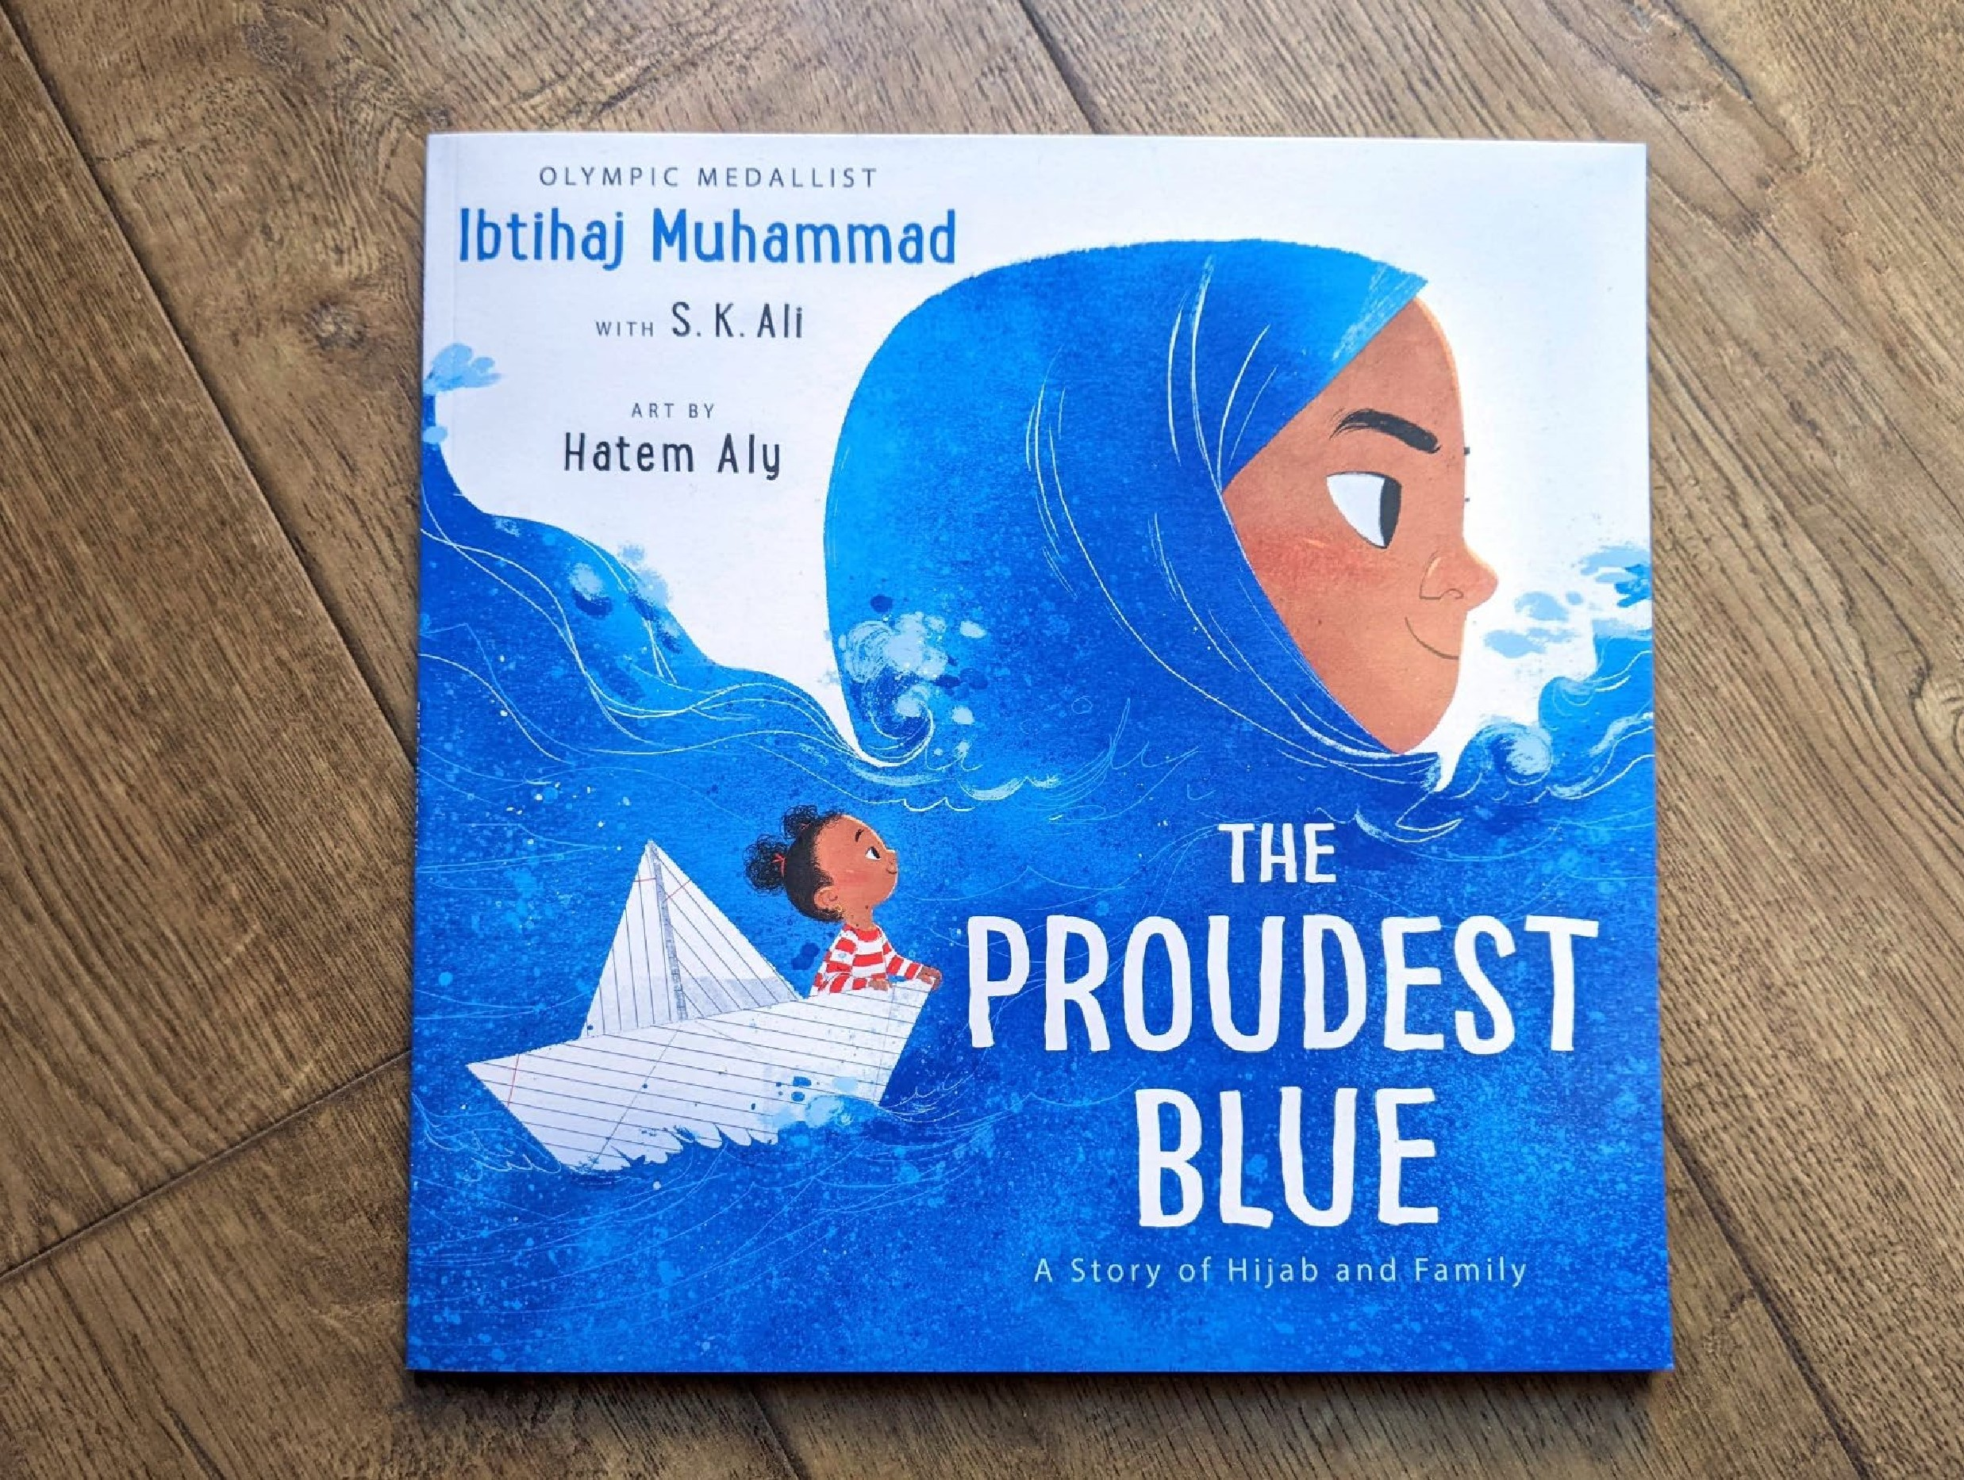

Read Woke: The Proudest Blue
Activity ideas to support classroom use of The Proudest Blue by Ibtihaj Muhammad and S. K. Ali, illustrated by Hatem Aly

CFE First and Second Level

Resource created by Scottish Book Trust

scottishbooktrust.com
Scottish Book Trust is a registered company (SC184248)
and a Scottish charity (SC027669).

Contents
Scottish Book Trust 2
Read Woke 2
Read Woke South Ayrshire 3
How to use this resource 3
First level activities for The Proudest Blue 4
Second level learning activities 9

Scottish Book Trust
Scottish Book Trust is a national charity that believes everyone living in Scotland should have equal access to books. Our work provides opportunities to improve life chances through books and the fundamental skills of reading and writing. Access to books and a love of books bring many important benefits from family bonding and advancing children’s learning, to unlocking creativity, helping employability and improving mental health & well-being. Scottish Book Trust aims to support all communities across Scotland, with particular focus on those who are vulnerable and under-represented.

Read Woke
‘Read Woke is a movement. It is a feeling. It is a style. It is a form of education. It is a call to action; it is our right as lifelong learners. It means arming yourself with knowledge in order to better protect your rights.’
– Cicely Lewis, Founder of Read Woke
The Read Woke challenge was developed by Cicely Lewis in Georgia, USA in 2017. Motivated by the political climate and seeing students grapple with issues of social injustice daily, Cicely realised the need to empower them with knowledge. Knowledge about the issues they (and others) face and knowledge about their own rights. The aim is to educate children and young people through reading. Find out more on the Read Woke website.

Read Woke South Ayrshire
The Read Woke challenge was brought to Scotland in 2020 via the School Library Improvement Fund. A collaboration of South Ayrshire secondary schools created a booklist and incentivised reading programme for S1–6 students with the aim of improving representation within library collections, celebrating diversity and encouraging students to be socially aware. Further backing from the Scottish Library and Information Council has allowed this work to be expanded into a primary school setting with Read Woke South Ayrshire Primaries launched in February 2022. Providing carefully chosen books to schools - along with tailor-made resources and activities through the year – is allowing us to educate and empower students to engage with social justice issues and stand up for the rights of themselves and others. The resources produced will help schools embed themes of equality, diversity, social justice, and human rights throughout their curriculum from P1–7. Learn more on the Read Woke South Ayrshire website.

How to use this resource
The Proudest Blue: A Story of Hijab and Family is written by Ibtihaj Muhammad and S. K. Ali with beautiful illustrations by Hatem Aly. Told by Faizah about her sister Asiya, the story explains the importance of hijab within the Muslim faith, while exploring the themes of family, sibling bonding and being true to oneself. The book is ideal for developing respect and an understanding of others and their beliefs. Pupils will see themselves reflected in this story and will relate to the ‘first day experiences’ of the characters.
In The Proudest Blue, issues of racism are part of the narrative. Asiya is shouted at and targeted by bullies because of her hijab. Towards the end of the story, Faizah is anxious about the ‘whispers, laughs and shouts’.
It is important that teachers are mindful of discrimination and inclusivity when approaching this book. There are some fantastic resources and support materials available from Show Racism the Red Card and in the BAME Writers Network resource bank.
Despite the racism the characters experience, this is a positive story which encourages readers to see the joy and pride of hijab. It is a celebratory story of love, family and faith.

First level activities for The Proudest Blue

Activity 1: Pre-reading activity
LIT 1-02a, ENG 1-03a
Gather pupils together for reading time. Cover the title of the book and let the children look at the cover. Ask them to think about:
- What do they think of first when they see the cover?
- What can they see in the picture?
- Who is there?
- Who do they think these girls are?
- What do they think it might be about?
- Can they think of a title for this story?
Make a mind map of their suggestions and add any experience or prior knowledge pupils would like to share. Now uncover the title and have a discussion again. Look back at their map and suggestions and discuss the cover again, and what they think might happen.

Activity 2: Proud
HWB 1-04a, HWB 1-05a
Think about the meaning of the word ‘proud’, and ask pupils to share what it means to them and how it makes them feel. What do they think might be the opposite of proud? Ashamed? And how does that make them feel?
At circle time, ask pupils to think of a time when they have felt proud. What makes them feel proud? Is it a good feeling? Look at the book again. What is Faizah proud of?
After circle time, create ‘I felt proud when…’ and ‘I am proud of…’ posters and display these in the classroom. Revisit the posters throughout the term, and update them at the end of term with any new achievements or activities pupils feel proud of.

Activity 3: Colours and choices
LIT 1-02a, HWB 1-01a
Look together at the first spread in book where Asiya and Faizah are in the shop with their mum. Talk about the fact Mum loves pink but Asiya wants blue. Explain that we are all different and can make our own choices about our likes and dislikes.
- Do they think it is important to be able to choose for themselves?
- Have they ever been shopping for something special?

Look again at the page and ask pupils to point out all the different colours they can see. And discuss:
- What is their favourite colour?
- Why is it special to them?
- Can they think of something that colour?
- How do they feel when they wear their favourite colour?

Activity 4: Exploring colour
LIT 1-07a, LIT 1-20a, LIT 1-25a
Faizah compares the blue of her sister’s hijab to the sea and the sky. Ask pupils to make a list of other things that are blue. Looking at the list, are some of the things different shades of blue? Discuss whether the sky is the same blue all the time, when does it change? Collect and display items, pictures and photos of items that are blue including different blue materials to look at and feel.
Next, use the blue display board to help create simple similes. Use the structure ‘as blue as…’ or ‘blue like…’ Use these similes to create a poem with the title ‘Blue’. This can be a class, group or individual activity depending on the pupils you are working with.

Activity 5: Faith, religions and celebrations
HWB 1-09, RME 1-04a, RME 1-04b, RME 1-07a
Explore faiths that are celebrated around the world and in Scotland. Compare a couple of faiths, including Islam. Use the BBC Bitesize resource “What is Islam?” to research the following together:
- What are the central beliefs of Islam? Compare them with another religion. What are the similarities and differences?
- How do Muslims beliefs impact how they act?
- Why do some Muslim people wear the hijab or other coverings? How does this tie into their beliefs? Look at other forms of clothing or coverings from other religions.
- Learn about some of the key Islamic celebrations, for example Eid ul-Fitr. BBC Bitesize have an educational resource on How Eid al-Fitr is celebrated around the world.

Activity 6: First Days
HWB 1-01a, HWB 1-04a, HWB 1-07a
Ask pupils to think of a time when they started something new: school, a club, moving house. How did it make them feel? Collect all the words onto a word wall. Explain that new beginnings are something we all go through at different times. Ask pupils to discuss how they think Asiya was feeling on her first day wearing hijab. How can they tell? Look again at the story, and especially the illustrations of Asiya’s face. How is she feeling?
Next, look at the page where Faizah is whispering to her classmate. Why do pupils think Faizah whispered to the girl in the line at first? How is Faizah feeling?
Explain that what helped Faizah cope better with her first day was having her big sister to show her strength in difficult situations. Ask pupils to think about who might help them when they feel uncertain, are unsure about things or don’t understand something.

Activity 7: Hurtful words
HWB 1-10a, HWB 1-05a
Look at the advice Asiya and Faizah’s mother gave them about hurtful words and bullies:
- ‘Don’t carry around the hurtful words that others say. Drop them. They belong only to those who said them.’
- ‘Some people won’t understand your hijab’, Mama had said. ‘But if you understand who you are, one day they will too.’
Think about the other characters in the story, such as the Year 7 boys who shout hurtful things and point and laugh. What would your class say to them? And what advice would they give to some of the other characters?
Working together, create your own picture with blue paint showing the sea and the sky with ‘no line between them’ and other quotes from the book. Add the two sisters and write on some of words and phrases that describe Asiya and her hijab.
Add the quotes and advice the class would give to the other characters onto your picture.

Activity 8: Numeracy
MNU 0-01a, MNU 0-02a
Throughout the story Faizah uses different number, when crossing the road, when looking for her sister, and when doing cartwheels. Read the story together and make a note of all the numbers she uses.
Next, work together to:
- Put the numbers in order from smallest to largest.
- Use counters or collect objects from around the room to make those numbers.
- Like Faizah, work out how many steps it takes to get somewhere in your school.
Look again at the book. What other numbers can you find in the story? Look at each page in detail. How many hijabs can you see in the shop? How many people are on each page? How many times do you see Faizah in her stripey top? How many stripes are on the top? Once pupils start looking, they will see lots of numbers to count.

Activity 9: Cartwheels
HWB 1-21a, HWB 1-22a
In the story Faizah does some cartwheels. How many does she do? As part of PE and a gymnastics or dance class, practise doing a cartwheel and ask pupils to record how many they each do to add to a class total.
Faizah also twirls around the garden before going to school because she is excited. Ask pupils to twirl to the left and then to the write. In small groups, ask pupils to make a short dance sequence including a twirl.

Activity 10: Make a paper boat
TCH 1-09a, TCH 1-10a
In the story we see Faizah in a paper boat. Find out how to make one of these and make your own boats in class. You can make one with author S. K. Ali in this YouTube video (4 minutes, 37 seconds). In the video, S. K. Ali talks about writing things on the paper first. Ask pupils to decorate their paper with:
- What they like about themselves
- Things they know to be true about themselves, such as a strength
- Anything else they are proud of (linking back to earlier discussion).

Activity 11: Picnic picture
EXA 1-04a, EXA 1-05a
Faizah draws a picture of two princesses having a picnic on an island where the ocean meets the sky, and we get a glimpse of what this picture might look like as Asiya and Faizah cross the road hand in hand.
Ask pupils to draw their own picnic picture. Who would they like to have with them on their imagined picnic? Where would it be?

Second level learning activities
The Centre for Literacy in Primary Education has created some great resources to support using The Proudest Blue in class, and their activities are ideal for sharing with older pupils.

Activity 1: Paired reading
LIT 2-10a, HWB 1-11a, HWB 1-12a
Pupils can practise reading for an audience so that they can engage in paired reading with P1/2 pupils, or younger children in an Early Years setting. The Proudest Blue is an especially good book to use for a paired reading project, as the reading partnership can mirror the supportive relationship that Faizah has with her older sister – her sister is supportive, and someone that Faizah looks up to. Explain to pupils the importance of being a reading buddy, and the important role they might play for their reading partner.
Explore Scottish Book Trust’s Paired Reading Toolkit for ideas and activities to support running a paired reading project, including special mission cards to engage reluctant readers and drama activities to improve their confidence in reading aloud.

Activity 2: Religious clothing
RME 2-07a, RME 2-09a, RME 2-09b
See Activity 5 on page 5 for some ideas on learning about the key beliefs of Islam, comparing it with another religion and links to resources. You can also use The Proudest Blue as a starting point to discuss different religious clothing with your class. Choose religions and clothing that pupils might see reflected in their community and use this as an opportunity to celebrate the diversity of belief in Scotland.
Learning for Justice has a great resource on Common Religious Clothing, and although this is focused on the American curriculum and audience, it can easily be adapted for a Scottish context.
Follow the lesson plan for Common Religious Clothing, and also Understanding Religious Clothing if you would like to extend this further for P6 or P7 pupils. At the end of the lessons ask pupils to reflect on the follow questions:
- Did they learn anything new during these lessons?
- Did it challenge any assumptions or preconceived ideas they had of these items of clothing?
- What did they learn about the religions they have studied through these items of clothing discussed?
You could run this as a discussion activity or ask pupils to quietly reflect and write their thoughts and feelings in their workbook.

