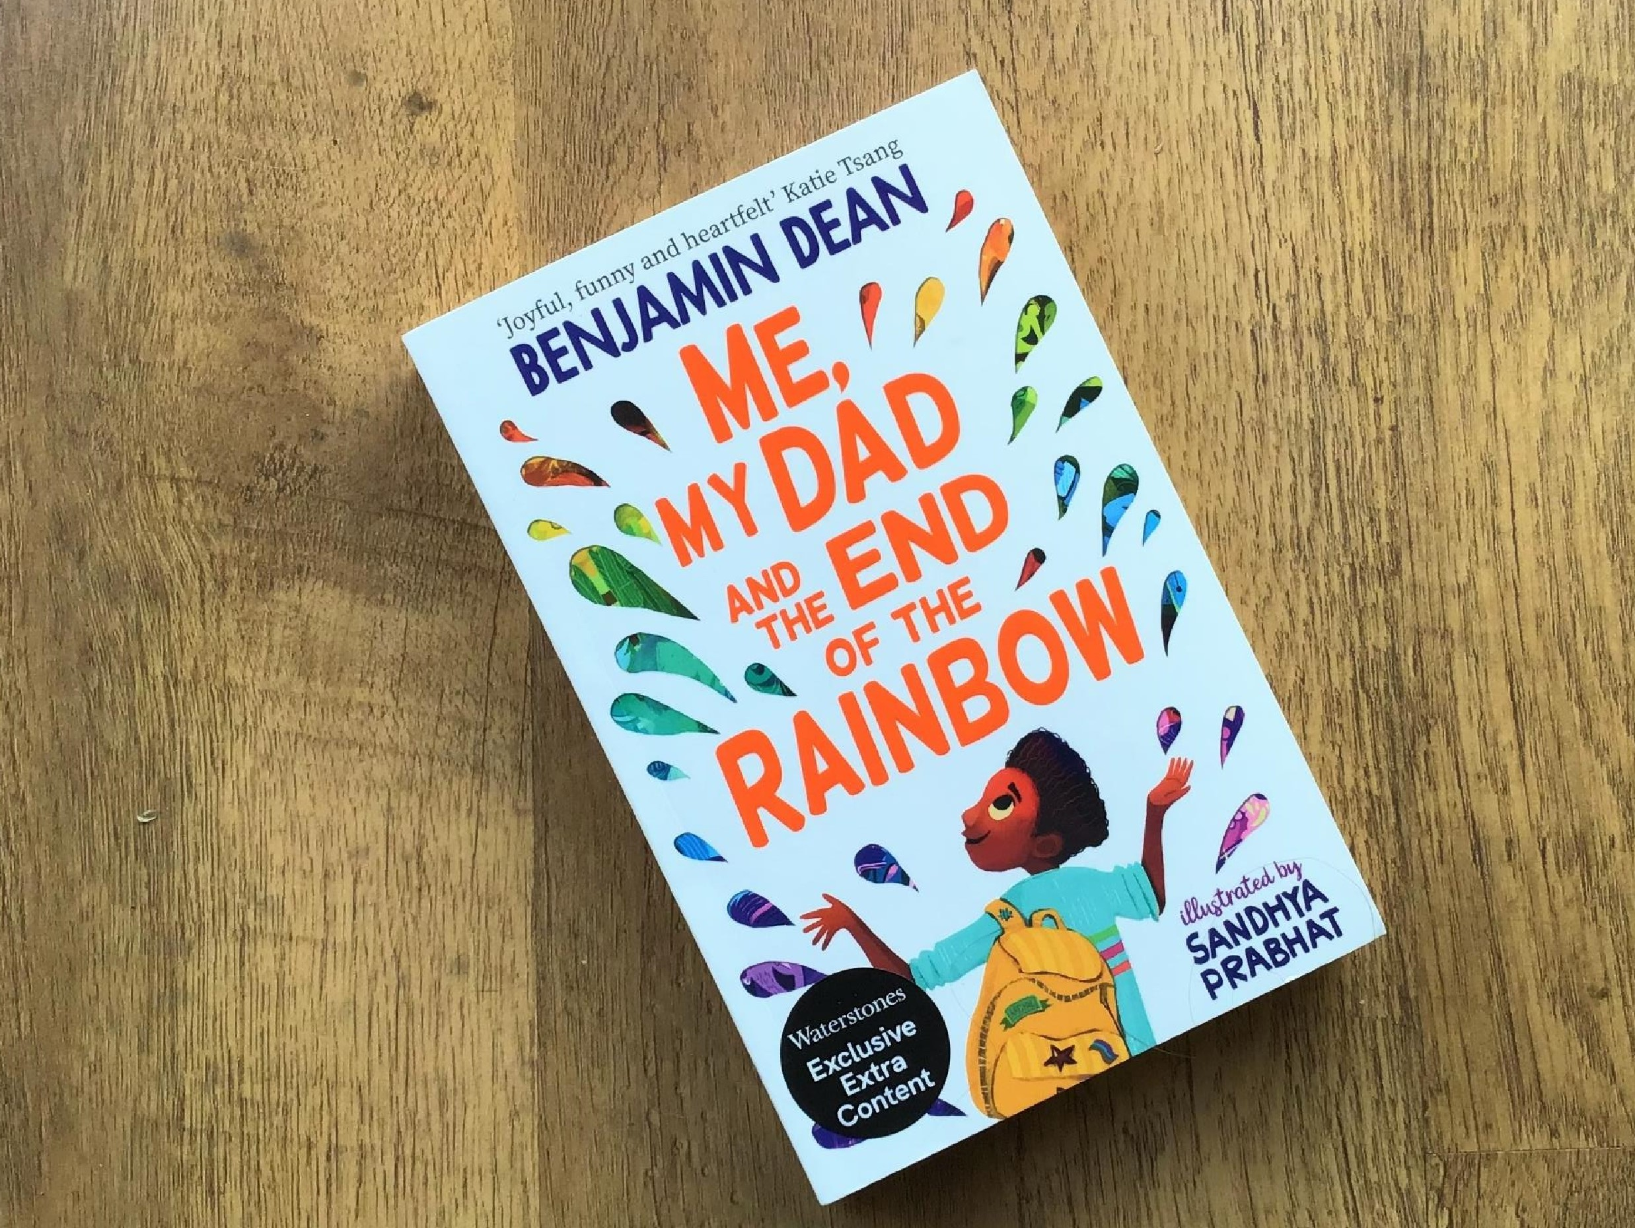
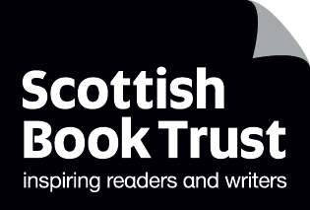

Read Woke: Me, My Dad and the End of the Rainbow
Activity ideas to support classroom use of the book Me, My Dad and the End of the Rainbow by Benjamin Dean, illustrated by Sandhya Prabhat

CFE Second Level

Resource created by Scottish Book Trust

scottishbooktrust.com
Scottish Book Trust is a registered company (SC184248)
and a Scottish charity (SC027669).

Contents
Scottish Book Trust 2
Read Woke 3
Read Woke South Ayrshire 3
How to use this resource 4
Learning activities 4
Worksheet 1: Costume design template 9
Worksheet 2: Prompt cards for Secrets activity 10

Scottish Book Trust
Scottish Book Trust is a national charity that believes everyone living in Scotland should have equal access to books. Our work provides opportunities to improve life chances through books and the fundamental skills of reading and writing. Access to books and a love of books bring many important benefits from family bonding and advancing children’s learning, to unlocking creativity, helping employability and improving mental health & well-being. Scottish Book Trust aims to support all communities across Scotland, with particular focus on those who are vulnerable and under-represented.

Read Woke
‘Read Woke is a movement. It is a feeling. It is a style. It is a form of education. It is a call to action; it is our right as lifelong learners. It means arming yourself with knowledge in order to better protect your rights.’
– Cicely Lewis, Founder of Read Woke
The Read Woke challenge was developed by Cicely Lewis in Georgia, USA in 2017. Motivated by the political climate and seeing students grapple with issues of social injustice daily, Cicely realised the need to empower them with knowledge. Knowledge about the issues they (and others) face and knowledge about their own rights. The aim is to educate children and young people through reading. Find out more on the Read Woke website.

Read Woke South Ayrshire
The Read Woke challenge was brought to Scotland in 2020 via the School Library Improvement Fund. A collaboration of South Ayrshire secondary schools created a booklist and incentivised reading programme for S1–6 students with the aim of improving representation within library collections, celebrating diversity and encouraging students to be socially aware. Further backing from the Scottish Library and Information Council has allowed this work to be expanded into a primary school setting with Read Woke South Ayrshire Primaries launched in February 2022. Providing carefully chosen books to schools - along with tailor-made resources and activities through the year – is allowing us to educate and empower students to engage with social justice issues and stand up for the rights of themselves and others. The resources produced will help schools embed themes of equality, diversity, social justice, and human rights throughout their curriculum from P1–7. Learn more on the Read Woke South Ayrshire website.

How to use this resource
The aim of this resource is to support the use of Me, My Dad and the End of the Rainbow by Benjamin Dean in a classroom setting. Activities reflect some of the central book themes and scenes and cover a range of curriculum areas at second level.
While Me, My Dad and the End of the Rainbow features LGBTQ+ characters, issues of equality and discrimination are not central to the narrative. LGBTQ+ characters are presented in positive and affirming ways, and themes of family and friendship are at the forefront of the story. Activities within this resource primarily reflect this positive representative theme.
However, it is important that teachers are mindful of discrimination and inclusivity when approaching LGBTQ+ topics. There are some fantastic resources and support materials available on the LGBT Education Scotland website, including guides for informing and involving parents, creating inclusive environments and for tackling homophobic language. You can also find helpful resources on the Time for Inclusive Education (TIE) website.

Learning activities

Activity 1: Family
ENG 2-30a, HWB 2-44a
In Me, My Dad and the End of the Rainbow we see that families come in all shapes and sizes, the ones we are born into but also the ones we make through friendships and love. Think about who you consider part of your family. This might include the people who care about you at home, but also your grandparents or wider family, your friends, your pets or even wider social groups you are part of, or the community you live in. Discuss what makes someone feel like ‘part of a family’.
Write a poem about what the word family means to you. If you wish, you could use the letters in FAMILY to create an acrostic poem.

Activity 2: Character viewpoints
LIT 2-26a, ENG 2-27a
Me, My Dad and the End of the Rainbow is told entirely from Archie’s point of view. Choose a scene from the book that includes several characters and re-write it from another character’s viewpoint.
Using clues from the book, try to understand the thoughts of your chosen character and think about how to express their personality and voice. You might consider how they feel at that moment, their relationships with the others in the scene, what they want to achieve, and how they might react to what is happening.

Activity 3: Lost
ENG 2-30a, ENG 2-31a
When Archie and Bell lose Seb in the crowd, they feel scared and sad. Archie plays through everything that has gone wrong in his head, and he begins to feel constricted and unable to breathe:

‘I tried to speak, to say something, anything, that might solve this nightmare. But my voice had snagged in my throat and vanished altogether. Everything seemed closer than before, pressing in on us from all sides. It felt like I couldn’t breathe, like if I even tried I might just break into little pieces. I thought about this morning, about the last few weeks, about how everything had mounted up until now, when it was all about to tip and come crashing back down.’
Ask your pupils if they have ever been lost or lost someone in a crowd or a public place. Discuss how this felt, or how any moment of panic feels, and then chat about what helps to calm us down and the emotions we feel when finally reunited. Gather some descriptive words to convey these feelings. Ask pupils to write a short story about being lost, with an emphasis on the emotions and internal feelings of the central characters.

Activity 4: Pride and protest
SOC 2-06a
In the book Seb explains that Pride is still considered a protest as well as a party. Discuss the history of Pride and the Stonewall riots with pupils and show them how this started as a movement for equality that quickly spread around the world. You could watch this short film about Stonewall and Pride (3 minutes, 54 seconds), or create your own presentation for the class using resources such as BBC Bitesize. Explain that many world-changing movements started with single events or small protests.
Next, ask pupils to choose a cause that they feel passionate about and research how that movement began. Working in small groups or individually, ask them to consider the pivotal moments and some of the influential people who shaped where their cause is today, and how much has changed or been achieved. Finally, ask them to create a visual timeline of their findings.

Activity 5: Planning
HWB 2-16a, HWB 2-17a, HWB 2-18a
In the book, Archie, Seb and Bell fail to properly plan their trip to London and things rapidly go wrong and they soon become separated. Split into groups and discuss what makes a good plan for a safe and fun day out. Different groups might choose a different location, for example: a hill walk, a day in the city, a trip to the beach or a train journey.
Ask groups to come up with two lists. The first list should include essential things they think they should take with them or do (such as inform a parent or buy a ticket). The second list should have things that would be nice to have on the trip but are not essential. Finally, get them to consider what might go wrong and come up with an action plan that would solve any problems that could arise.

Activity 6: Friendship
HWB 2-44b
Bell and Seb are really good friends to Archie and, even though their personalities are very different, they all look out for each other and support Archie when things are tough. Split into groups and discuss what makes a good friend and what might make someone a bad friend. Discuss how friends can support each other, what we would like our friends to help us with, and how we might be a good friend to others. Think about what it feels like when you feel lonely and need a friend to talk to.
Create a friendship display in the classroom and ask the class to think of ways we can ensure that everyone feels that they have a friend to chat to and play with when they feel lonely.

Activity 7: Oscar’s cake
MNU 2-07a
In the book Oscar uses a cake metaphor to explain how being gay is just a one part of who Archie’s dad is. Ask children to choose eight things that they think are an important part of who they are – this could be anything that reflects the activities they enjoy or how they see themselves. Are they Scottish? Dark haired? A gamer? Great at baking? A sister? Do they love chocolate?
Now ask them to create a pie chart (or cake chart in this case!) and choose how big a slice of their ‘personality cake’ each of these things represents, using percentages. They could use a spreadsheet to work it out or do it by hand. Ask them to draw out their cakes and colour in each slice to represent the different aspect they have chosen.
Looking at the cakes they have created, discuss how easy or difficult it was to choose only eight personality traits. Was this enough? How many would you need to get a real sense of who someone was? Does the percentage of a particular trait change depending on who we are with, or where we are, e.g. are we more of a ‘sister’ at home, or more ‘gamer’ with our friends? Is it really possible, or fair, to distil someone into just a few traits?
As a potential extension activity, you could explore the poem “Where I’m From” by Melanie Poonai with the class, and create your own poems about what makes us who we are.

Activity 8: Flyer
EXA 2-06a, LIT 2-24a
Finding the Pride Parade flyer soon leads Archie, Seb and Bell on an unforgettable adventure. Ask pupils to design their own colourful flyer for a Pride event. They can choose a real event that is happening nearby, make one up, or design one for an event somewhere else, e.g. Glasgow Pride.
Make sure to think about which design elements are important. Consider the information that should be included, how readable the font is, what size different sections should be and if the illustrations catch the eye. Does their flyer make it sound like a great event to go to and will someone picking it up know the right time, date and place?

Activity 9: Costume design
TCH 2-11a, EXA 2-05a
A large part of any Pride march or celebration are the wonderful, creative and colourful costumes and make up worn by some of the people attending and performing. Look at pictures of Pride events from across the world and you will see all kinds of rainbow clothing, glorious wigs, sparkling jewellery, fabulous face paints and stunning make up.
Using the template provided on page 9 of this resource, ask pupils to design a fabulous Pride costume for someone to wear.

Activity 10: Secrets
EXA 2-14a
Lots of people in the book keep secrets from each other, usually leading to awkward mistakes and misunderstandings. Discuss the way secrets can grow and sometimes put people in difficult situations.
Split children into small groups and ask them to come up with a drama about a secret that goes wrong, gets out of hand or grows into something spectacular. If the class needs some inspiration, you can ask each group to randomly choose one of prompt cards on page 10.
Groups can then perform their short sketches for each other. Ask the groups to reflect on their sketches. Discuss how it feels to be the person lying, or the person being lied to. What stops us from telling the truth and what kind of harm might come from these secrets and lies, both for the secret keeper and the people being lied to? How might the truth be beneficial?

Worksheet 1: Costume design template
Print this page
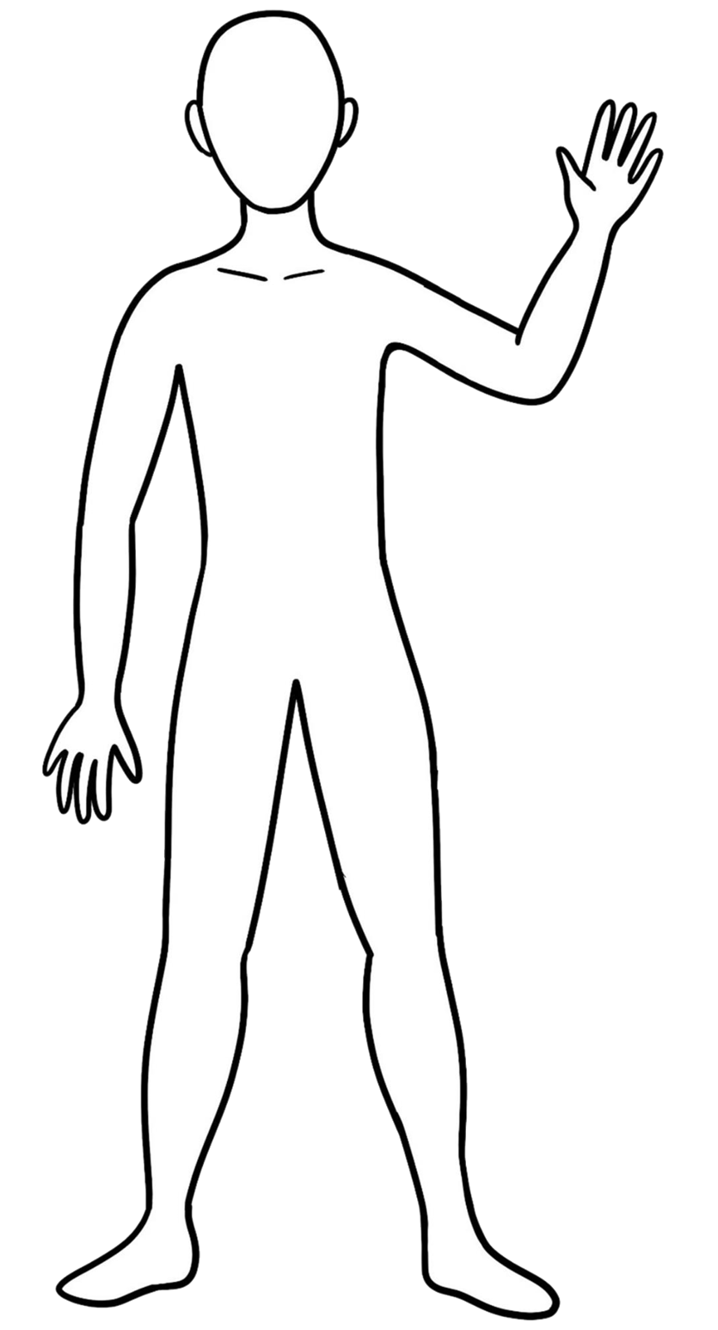

Worksheet 2: Prompt cards for Secrets activity
Print this page and cut out each of the squares

You lied about eating the chocolate cake | You told the teacher that the dog ate your homework (you didn’t do it) | You claimed to be best friends with a celebrity
You opened all your presents before Christmas | You told everyone you can sing very well (you can’t) | You found a bag of money on the street
You said you have five dogs (you don’t have any, and are actually allergic to dogs!) | You drew a moustache on the Mona Lisa | You haven’t told anyone you are in a silly TV advert
You secretly love knitting (but nobody knows) | You accidentally broke the neighbour’s greenhouse | You made a fake NASA ID card

