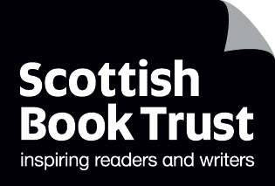
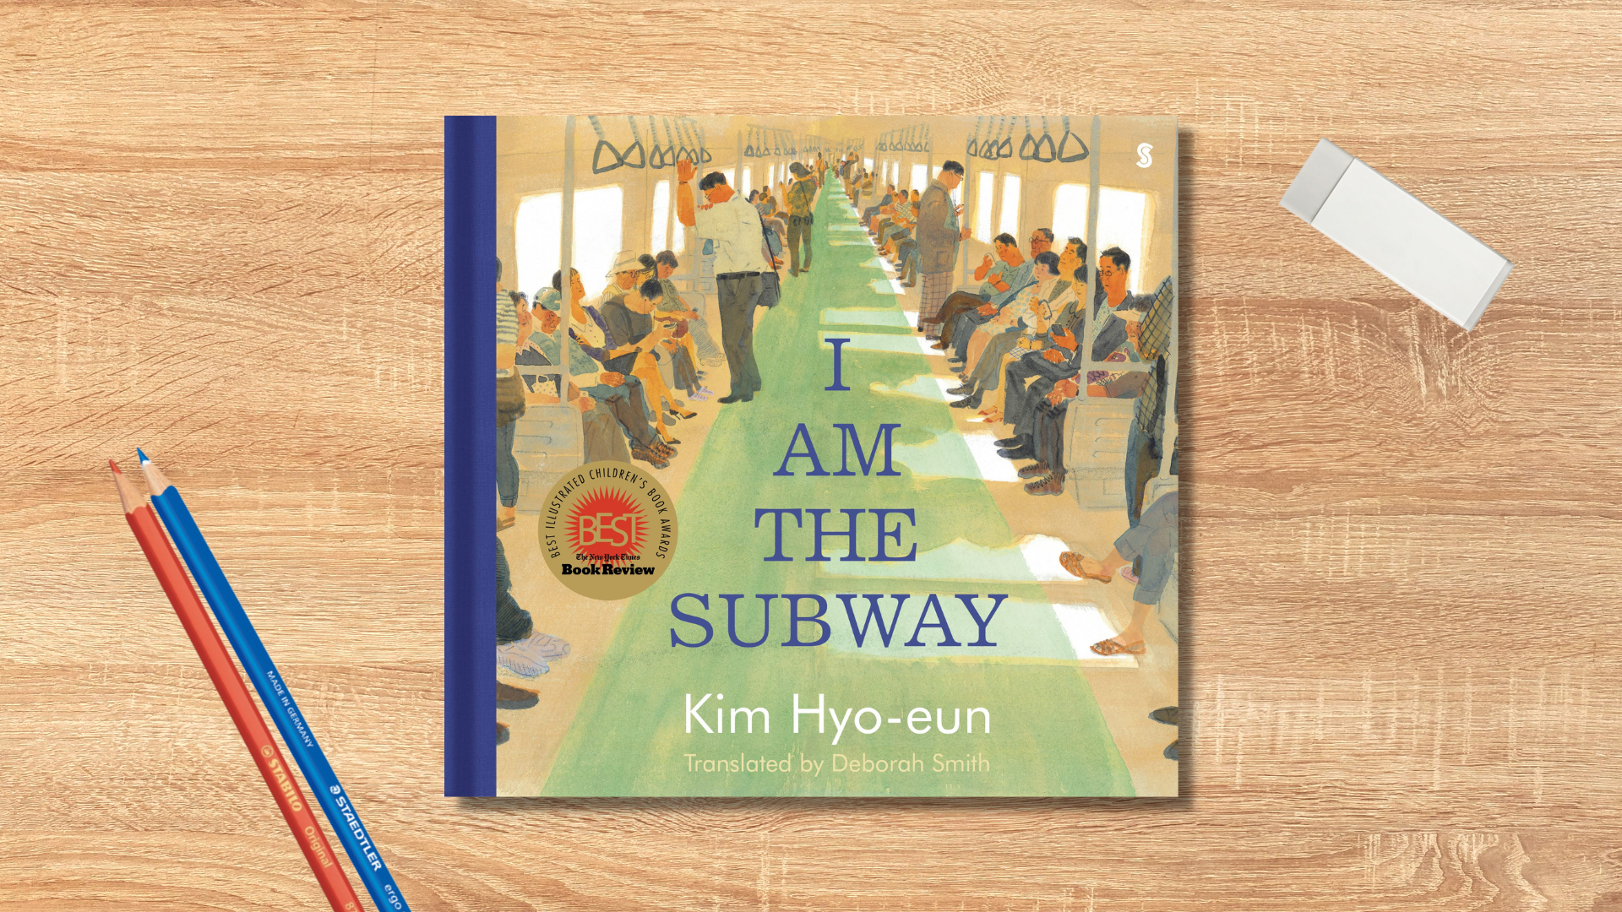

Read Woke: I Am the Subway
Activity ideas to support classroom use of the book I Am the Subway by Kim
Hyo-eun, translated by Deborah Smith.

CFE First and Second Level

Resource created by Scottish Book Trust

scottishbooktrust.com
Scottish Book Trust is a registered company (SC184248)
and a Scottish charity (SC027669).

Contents
Scottish Book Trust 2
Read Woke 3
Read Woke South Ayrshire 3
How to use this resource 4
Learning activities 4
Further resources 10

Scottish Book Trust
Scottish Book Trust is a national charity that believes everyone living in Scotland should have equal access to books. Our work provides opportunities to improve life chances through books and the fundamental skills of reading and writing. Access to books and a love of books bring many important benefits from family bonding and advancing children’s learning, to unlocking creativity, helping employability and improving mental health and well-being. Scottish Book Trust aims to support all communities across Scotland, with particular focus on those who are vulnerable and under-represented.

Read Woke
‘Read Woke is a movement. It is a feeling. It is a style. It is a form of education. It is a call to action; it is our right as lifelong learners. It means arming yourself with knowledge in order to better protect your rights.’
- Cicely Lewis, Founder of Read Woke.
The Read Woke challenge was developed by Cicely Lewis in Georgia, USA in 2017. Motivated by the political climate and seeing students grapple with issues of social injustice daily, Cicely realised the need to empower them with knowledge. Knowledge about the issues they (and others) face and knowledge about their own rights. The aim is to educate children and young people through reading. Find out more on the Read Woke website.

Read Woke South Ayrshire
The Read Woke challenge was brought to Scotland in 2020 via the School Library Improvement Fund. A collaboration of South Ayrshire secondary schools created a book list and incentivised reading programme for S1–6 students with the aim of improving representation within library collections, celebrating diversity and encouraging students to be socially aware. Further backing from the Scottish Library and Information Council has allowed this work to be expanded into a primary school setting with Read Woke South Ayrshire Primaries launched in February 2022. Providing carefully chosen books to schools – along with tailor-made resources and activities through the year – is allowing us to educate and empower students to engage with social justice issues and stand up for the rights of themselves and others. The resources produced will help schools embed themes of equality, diversity, social justice, and human rights throughout their curriculum from P1–7. Learn more on the Read Woke South Ayrshire website.

How to use this resource
I Am the Subway is a Korean picture book, told from the perspective of a subway train who narrates the lives of each of the passengers who come on board. This resource will share cross curricular ideas for exploring the book, including learning more about Korean culture, trains and transport and social skills including empathy.
With all Read Woke resources, we highly recommend that you read the book before using it with your class. Whilst this book does not contain any upsetting or graphic content, it’s worth being familiar with the text before you use it with your class.
Asian identities, including Korean, often experience racism. This article from We Are Teachers gives more information and tips for addressing anti-Asian racist behaviour. You can also find out more about the campaign Stop Asian Hate via the Student Voice website. On the Scottish Book Trust website we also have a resource on Understanding and challenging racism created with Give Racism the Red Card.

Learning activities

Activity 1: A trip to Seoul
SOC 2-12a, SOC 2-19a, SOC 1-21a, MNU 1-09a, MNU 1-10c
This book is set in Seoul, the capital of South Korea. Look at Seoul on a map and how far it is away from your school. Plan a trip to Seoul by researching the following:

The journey
- How far in miles/km away is Seoul?
- How long would it take you to get there?
- What transport would you need to use?

The culture and climate
- What time is it in Seoul versus where you are?
- What money do they use? How much will you need to take?
- How hot is it now? What clothes would you need to pack? Would you need sunscreen or a warm coat?

Sight-seeing
Watch this Seoul City Tour video from Expedia’s YouTube for some inspiration (3 minutes, 12 seconds).
- What is Seoul famous for?
- What sights would you like to go see? Can you take the subway like in the book?
- What food would you like to try in Seoul? Can you find any famous Korean dishes?

Activity 2: What’s their story?
HWB 1-01a/2-02a, HWB 1-02a/2-02a, LIT 1-01a/2-01a, LIT 1-02a/2-02a
‘Mr. Jae-sung’s gaze shifts from his newspaper to the other people’s shoes. He thinks he can guess the paths they might have walked.’
Each character is introduced to us as they board the train. Ask the pupils to choose one of the characters and write down what they think that character is feeling when they board the train. Put them into pairs and have them discuss the feeling they wrote down and why.
Then, ask them to write that character’s introduction from their perspective. How would they feel as Mr. Wanju running for the train? Or as Granny taking food to cook with her family? Or as Na-yoon after a long day?

Activity 3: Trains and transport
MNU 1-11a, MNU 1-20b/2-20b, SOC 2-14a, SOC 2-19a
The picture book takes place on Seoul subway system. As the first page tells us: ‘The Seoul subway network is one of the longest in the world and reaches far beyond the city limits. If you were to include all the lines that extend outside the city, it would easily be the longest subway in the world. It carries an average of 7.2 million people per day on the city lines alone.’
Ask the pupils to find all the subway stations in the book. Then look them up on a map and measure the distances between them.
- Hapjeong (pronunciation: hap-jong)
- City Hall
- Seongsu (pronunciation: song-su)
- Guui (pronunciation: goo-ee)
- Gangnam (pronunciation: gang-nam)
- Sillim (pronunciation: si-lim)
- Sindorim (pronunciation: sin-doh-rim)

You can also watch a video of the Hapjeong to Sindorim journey on YouTube. The entire video is 10 minutes 21 seconds, but the opening contains a map of the subway line and you can watch a couple of minutes to see what the subway carriages look like. Around 2 minutes 50 seconds in, the train crosses the Han River.
Research the difference between trains, subways and metros. Ask pupils to draw a table to compare their different environmental impacts.
Look up what your closest train station is. How far away is it? Where does the train line go? How much would a return ticket be? Use the Network Rail learning resources webpage to compare the train system in Scotland with the subway system in Korea. If you live in a city with a subway system you could also compare that.

Activity 4: Moments of kindness
HWB 1-05a/2-05a, RME 1-09b, RME 1-02a/2-02a, RME 1-04b/2-04b
If you look carefully at the illustrations, throughout the book you’ll find small moments of kindness as the characters interact with one another. Try and find as many of these as you can. Put the children into groups and ask them to create a mind-map of things they can do to be kind or look out for other people – no matter how small.
Compare these ways of acting with a religion you’re studying, for example, what do Christians believe about how we should treat one another? Compare and contrast this with another religious, or atheist position.

Activity 5: Names
SOC 2-19a, HWB 2-44a
Look at the pages where Yu-seon and her family are introduced. You can see a busy scene where she’s referred to as: darling, Mum, Yeon-woo’s mother and Aunty. Only her own mother calls her her name: Yu-seon.
In Korea, names are normally ordered as follows: [family name] [personal name]. It’s generally considered rude to address people by their personal name, especially if they are older than you.
It’s also very common for parents to be referred to by their children’s name, as we can see when Ye-seon is called “Yeon-woo’s mother”. Ye-seon is also called “aunty” (in Korean; “ajumma”). This doesn’t necessarily mean she is that characters aunt, as the term ajumma is frequently used as a term to address any middle-aged or married woman. You can see in the book an older woman is referred to as “Granny”.
Compare these traditions with Scottish traditions.
- Does anyone have someone in their lives who they call aunty, uncle, granny or grandpa even if they aren’t related?
- What names or nicknames do you get called at home?
- Korean names don’t normally have middle names, does anyone have a middle name? Do they know why it’s their middle name?
- Does anyone know what their name, first or surname, means?
- Does anyone have a middle name? You could create a graph of the most popular middle names in your class.

Find out more using Future Learn’s resources on Korean naming conventions. There’s also a video you can watch which explains the different types of names and how they are written (1 minute, 50 seconds). You could also research the meanings of your surnames or first names and use that to make a display in the classroom.

Activity 6: Fishing and food
HWB 1-35a/2-35a, SOC 1-09a/2-09a, SOC 2-19a
When we meet Granny at City Hall station, she tells us she grew up beside the ocean. You can see pictures of her diving throughout her life, gradually getting older.
These illustrations are based on haenyeo – women who dive without equipment off the coast of the Korean island, Jeju. Watch this video of a haenyeo diving on Great Big Story’s YouTube channel (2 minutes, 5 seconds).
Look at the different kinds of food the haenyeo catch in the ocean – Granny in the book mentions octopus and abalone. Look up some recipes for how they are cooked and their nutritional value.
Discuss what other food and resources we get from the sea. How do we fish in Scotland? Look at how the food reaches our table. Use WWF’s Food for Thought resource to compare how sustainable the haenyeo’s diving is compared with some of the farming or agricultural practices are in Scotland.

Activity 7: The sound of the train
EXA 1-16a/2-16a, EXA 1-17a/2-17a, EXA 1-19a/2-19a
Throughout the book is the sound of the train: ‘ba-dum, ba-dum’ as well as mentions of sounds like ‘rattle’ and ‘clatter’. Use percussion instruments to explore creating a rhythm that sounds like a train.
You could use this YouTube video of the train route for inspiration, tapping along with the sounds of the train. The entire video is 10 minutes 21 seconds, so select a section with some good sounds.
You could also research different types of Korean percussion instruments and drums and listen to what they sound like being played. This YouTube video from TEDx shows a Janggu percussion performance – the entire video is 8 minutes and 40 seconds long, but you could watch a short section to get the feel of the different instruments and ways of playing.

Activity 8: Point of view
SOC 2-08a, LIT 1-01a/2-01a, LIT 1-06a/2-06a
The entire book is written from the perspective of a subway train. Ask the pupils to pick an object they use every day and write from its perspective considering the following:
- Where does it “live”? Does it stay at home or in a specific room or come with them to school?
- How does the pupil use this item? Is it every day or only on special occasions?
- What does it “see”? What does it sit facing?

You could use this to talk about the environment. Look at what everyone’s objects are made of, where that material comes from, and how long it takes to break down.

Further resources

Read Woke
- Read Work South Ayrshire website
- Read Woke resources on the Scottish Book Trust website

Scottish Book Trust
- For more learning activities that explore translated books, use our Exploring translation resource. Or find your next read on our translated children’s book list.

South Korea learning resources
- National Geographic: learn about South Korea
- Globe Trotting Kids: facts about South Korea
- A-Z Animals: wildlife and animals in Korea
- Wondermondo: interactive map of sights in South Korea

