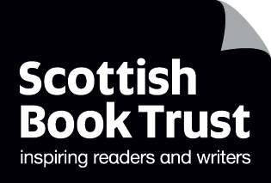
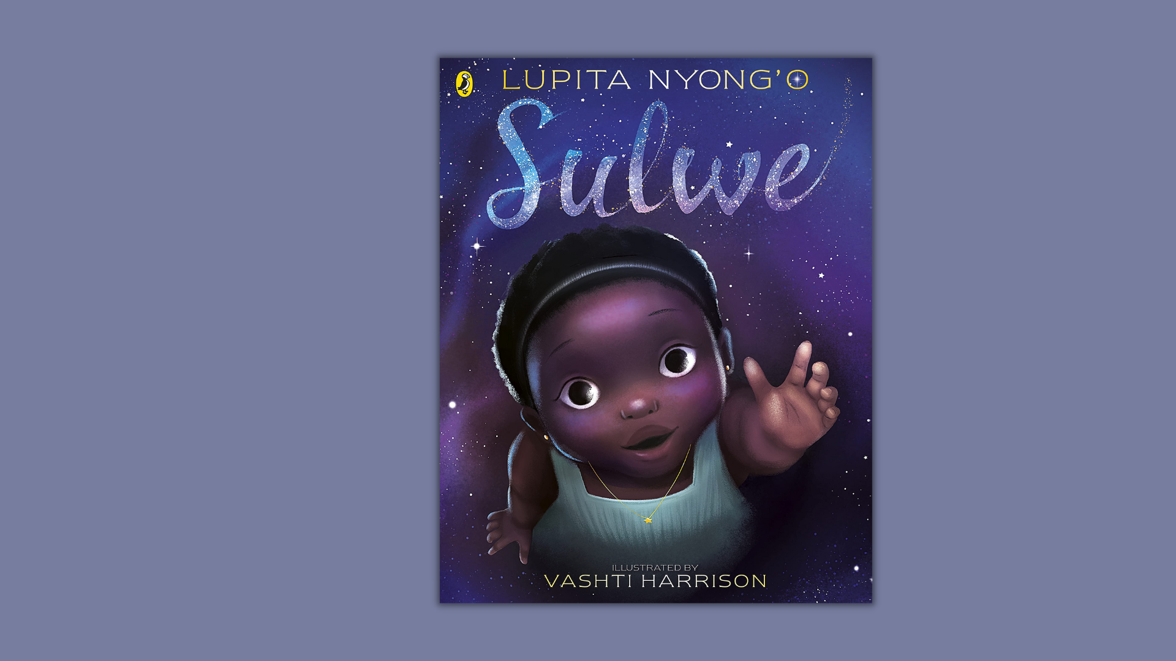

Read Woke: Sulwe
Activity ideas to support classroom use of the book Sulwe by Lupita Nyong’o, illustrated by Vashti Harrison.

CFE Early and First Level
Resource created by Scottish Book Trust

scottishbooktrust.com
Scottish Book Trust is a registered company (SC184248)
and a Scottish charity (SC027669).

Contents
Scottish Book Trust 2
Read Woke 3
Read Woke South Ayrshire 3
How to use this resource 4
Learning activities 4
Further resources 8

Scottish Book Trust
Scottish Book Trust is a national charity that believes everyone living in Scotland should have equal access to books. Our work provides opportunities to improve life chances through books and the fundamental skills of reading and writing. Access to books and a love of books bring many important benefits from family bonding and advancing children’s learning, to unlocking creativity, helping employability and improving mental health and well-being. Scottish Book Trust aims to support all communities across Scotland, with particular focus on those who are vulnerable and under-represented.
Read Woke
‘Read Woke is a movement. It is a feeling. It is a style. It is a form of education. It is a call to action; it is our right as lifelong learners. It means arming yourself with knowledge in order to better protect your rights.’
- Cicely Lewis, Founder of Read Woke.
The Read Woke challenge was developed by Cicely Lewis in Georgia, USA in 2017. Motivated by the political climate and seeing students grapple with issues of social injustice daily, Cicely realised the need to empower them with knowledge. Knowledge about the issues they (and others) face and knowledge about their own rights. The aim is to educate children and young people through reading. Find out more on the Read Woke website.

Read Woke South Ayrshire
The Read Woke challenge was brought to Scotland in 2020 via the School Library Improvement Fund. A collaboration of South Ayrshire secondary schools created a book list and incentivised reading programme for S16 students with the aim of improving representation within library collections, celebrating diversity and encouraging students to be socially aware. Further backing from the Scottish Library and Information Council has allowed this work to be expanded into a primary school setting with Read Woke South Ayrshire Primaries launched in February 2022.
Providing carefully chosen books to schools – along with tailor-made resources and activities through the year – is allowing us to educate and empower students to engage with social justice issues and stand up for the rights of themselves and others. The resources produced will help schools embed themes of equality, diversity, social justice, and human rights throughout their curriculum from P1 Learn more on the Read Woke South Ayrshire website.

How to use this resource
Sulwe is about a young girl with dark skin, darker than everyone else in her family, and she wants to change that. The book follows Sulwe trying to change her skin and her experiences of colourism, including being bullied with racist language. Sulwe has a magical experience that helps her see her own beauty – both inside and out.
Discussing this book will probably involve talking about both racism and colourism. The Reader’s Digest article “Colorism vs. Racism: What’s the difference?” defines the relationship between the two:
‘Racism is often defined as the prejudice and discrimination that a marginalized minority group receives on the premise of their ethnic origin; it is generally upheld by systemic infrastructures within society. Colorism, on the other hand, describes the preferential treatment of people within a minority group based on their lighter skin tone.’
It’s important to note that colourism is not just a problem in communities of colour, but something everyone has a responsibility to learn about as part of fighting racism more generally. For a more thorough definition, we recommend you read the full article from Reader’s Digest. Learning for Justice also has a free learning toolkit you can use to explore colourism.
With all Read Woke resources, we highly recommend that you read the book before using it with your class and use your best judgement about whether teaching this topic is appropriate for the children in your class.

Learning activities

Activity 1: My skin is the colour of. . .
LIT 0-04a/1-04a, LIT 1-06a, HWB 0-47a/1-47a
‘Sulwe’s skin is the colour of midnight; Mama’s the colour of dawn; Baba’s the colour of dusk; and her sister’s the colour of high noon.’

Have a display of different coloured items e.g. milk chocolate, cocoa, strawberry milk, corn, sand (digitally/real life) that children can explore. Encourage learners to use these images as inspiration to describe their own skin colour e.g. ‘My skin is the colour of. . .’

LIT 0-21b, LIT 0-26a/1-26a, EXA 0-05a/1-05a
As an extension activity children could mix paint colours to create their own unique skin-tone and create a self-portrait or handprints with their name and description of the colour of their skin alongside, as part of a class display.

Activity 2: My name means. . .
HWB 0-09a/1-09a, LIT 0-02a/1-02a, ENG 0-03a/1-03a, HWB 0-47a/1-47a,
EXA 0-02a, EXA 1-03a
‘Sulwe’s name means star.’
As a home-learning activity, ask children to find out the answers to the following questions:
- What is your full name?
- Why did your family choose your name?
- What does your name mean?
- Do you have any nicknames?

Following this, model for the children the story of your name, then engage in Think Pair Share activity in class for each question, encouraging the children to listen respectfully. Explain to children that your name is part of who you are – part of your identity. Draw children’s attention to the UNCRC Article 7 ‘You have the right to have a name.’

Create a class display celebrating children’s names as a unique part of their identity. Write their names in bubble writing for them or ask them to, depending on age/stage, and then decorate it in whatever manner they wish.

Activity 3: Sulwe’s prayer
LIT 1-0a, RME 0-03a/1-03a, RME 0-06a/1-06a, RERC 0-014a/1-14a, HWB 1-09a, HWB 0-03a/1-03a
Focus on the page where Sulwe is praying to God. Check learners’ understanding of this practice. Why do people pray? How do people pray? Why does Sulwe put her hands together and close her eyes? You can tie this into what religion you’re studying in your class. Invite children to share their experiences of participating or seeing prayer.
Draw children’s attention to UNCRC Article 14 ‘You have the right to think what you like and be whatever religion you want to be, with your parents’ guidance’ and Article 2 ‘You have the right to protection against discrimination. This means that nobody can treat you badly because of your religion.’ Ensure children know to turn to their trusted adult for support if they see or face discrimination.

Activity 4: Act it out
EXA 0-01a/1-01a, EXA 0-12a/1-12a, EXA 1-13a, EXA 0-14a/1-14a,
EXA 0-15a/1-15a, HWB 0-08a/1-08a
Look at the page where Sulwe is sitting alone thinking, while the other children play around her. Divide children into groups of around 4, ask them to consider:
- How would you feel if you were Sulwe?
- How would you like the children who are playing around Sulwe to react?

Ask the children to decide together what the reaction should be on seeing someone looking alone and upset in the playground, like Sulwe? Give children time to act out how they feel the children should respond to Sulwe.

Invite children to share their responses with the rest of the class. Discuss how the drama activity helped them imagine how different people might react to one situation. Talk about the different ways children can support children who are feeling alone.

Activity 5: See the sun
SCN 1-06a, MNU 1-11a
Take children outside to safely observe the sun (without directly looking at it). Create a human sundial by standing in one spot and drawing around your shadow at different times of the day. Mark each shadow with appropriate time of day.
Ask questions such as:
- Is it longer at lunchtime than at the start of the day?
- When is the shadow shortest?
- Where was the sun in the sky at the end of the school day?
- How long in centimetres is the shadow at 12.15?
- Was the sun higher or lower in the sky at 3.00 than it was at 10.30?

As a home learning activity children could be encouraged to observe what happens to the sky at night-time and what changes they notice (those working at first level, could record changes to the moon throughout the month).

Activity 6: Day and night
SCN 0-06a/1-06a, EXA 0-12a/1-12a, LIT 0-09b/1-09a, LIT 0-31a
Explore routines associated with day and night by setting up a home corner where children could act out daytime or night-time routines. This might include items such as cereal boxes, toy toaster, bed-time story books, curtains to open and close, bed, bedside lamp, pyjamas.

Activity 7: Rhyme basket
LIT 0-01a, LIT 1-11a, LIT 1-20a
Draw children’s attention to the rhyme sequence in the book (the prayer). Demonstrate how the ends of the words rhyme. Create a rhyming basket using a collection of small rhyming objects (small world play, loose parts etc). Invite children to find the rhyming pairs e.g. a toy car and star decoration from a Christmas tree. Can they think of any of their own rhyming words? Encourage them to point them out in the texts they encounter.

Activity 8: I love my. . .
HWB 0-05a/1-05a, TCH 0-01a/1-01a
Sulwe’s mother says that true beauty comes from within. Discuss with children what she means by that. Get children to think about things that they love about themselves that are not linked with their outward appearance. Get them to take a selfie using a class iPad/digital camera etc. and write or have scribed one or more thing that they love about themselves. This can be used to make a class Sway/Powerpoint and shared with the class as a way to recognise and celebrate their own and others’ value.

Further resources

Read Woke
- Read Work South Ayrshire website
- Read Woke resources on the Scottish Book Trust website
- Scottish Book Trust book list children’s books about Black identity and racism

Sulwe
- The Sulwe website contains more information about the book and downloadable activity sheets
- Watch author Lupita Nyong’o read Sulwe aloud on Netflix Jr.’s YouTube as part of their Bookmarks series, which shares children’s books by Black authors (11 minutes, 12 seconds)

Racism and colourism
- Learning for Justice’s website contains resources for learning about racial justice, including a toolkit for learning about colourism
- Find more learning resources to explore racism on The Black Curriculum’s website
- Find out more about anti-racist education on Show Racism the Red Card’s website
- Find books by British Creators of Colour on The Colourful Bookshelf

