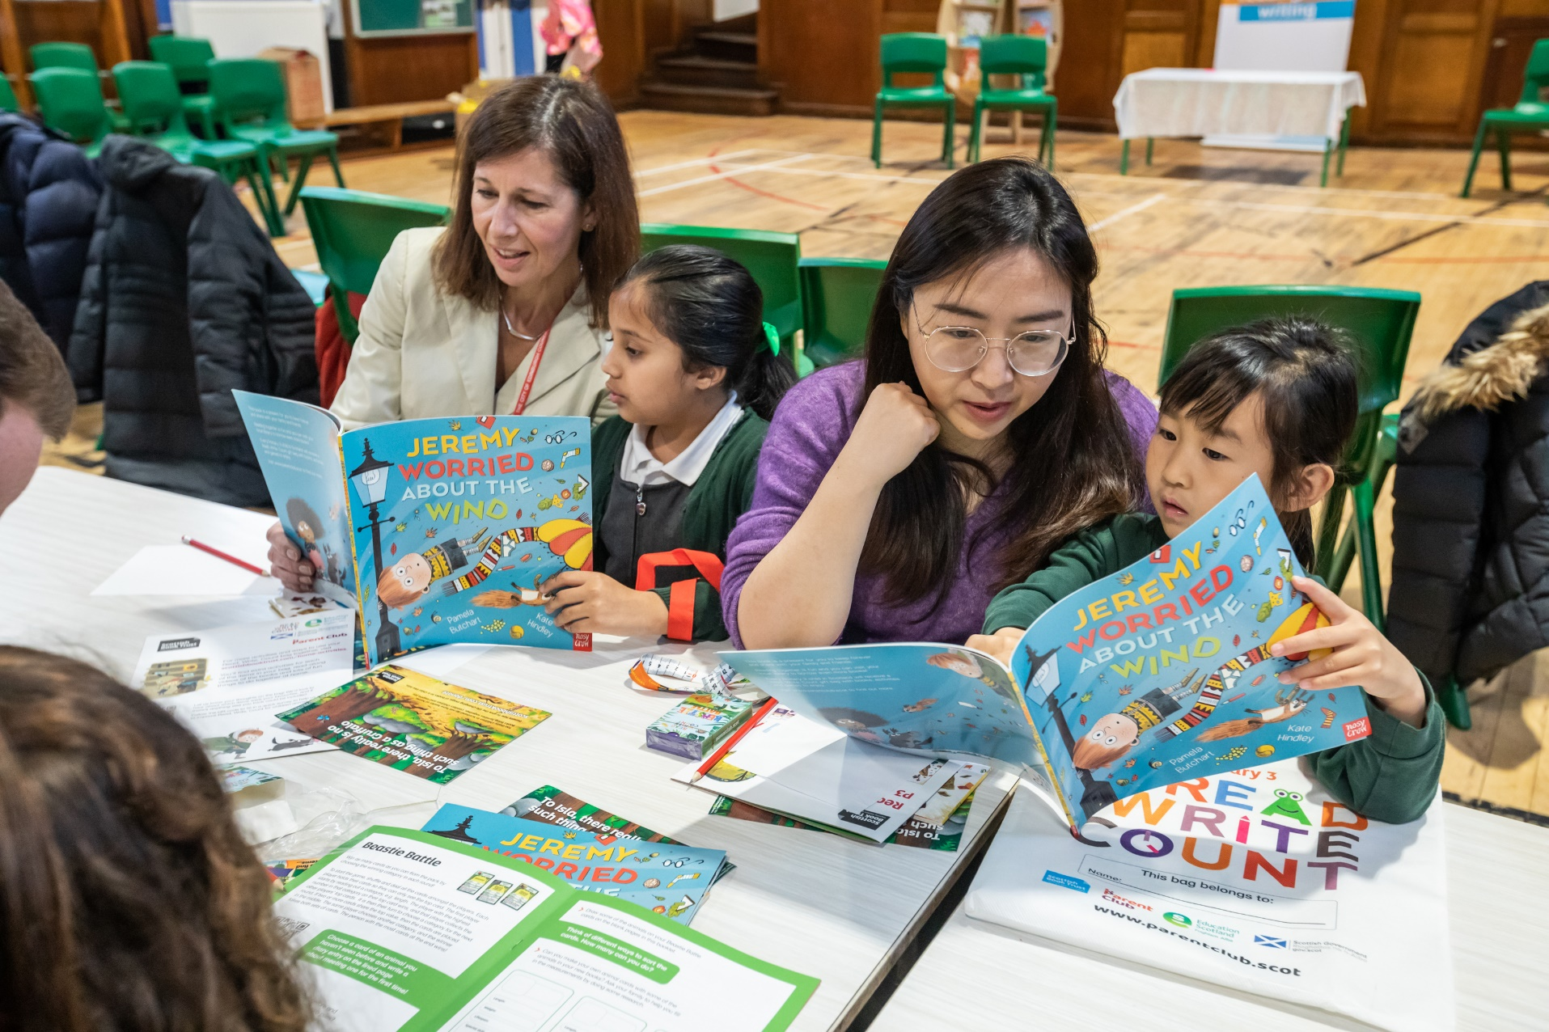

How to build a reading culture in your school
An introduction to a reading culture, its importance in education, and some inspiration for how to get started in your school

Age 5 to 16

CFE Levels First to Senior Phase

Resource created by Scottish Book Trust

scottishbooktrust.com
Scottish Book Trust is a registered company (SC184248)
and a Scottish charity (SC027669).

Contents
About this resource 2
Reading for pleasure is part of daily routine 2
Give reading a high profile 4
Reading role models 5
Embed reading across the curriculum 7
Conclusion 7

About this resource
This resource will take you through the four elements of a reading culture with suggested activities and ideas you can deliver in your school. The four areas are as follows:
- Reading for pleasure is integrated into daily routine
- Reading is celebrated and has a high profile
- Reading role models
- Reading is embedded in activities across the curriculum
You do not need to use all the ideas or activities in this resource, select what is most relevant for your setting and school priorities and adapt it for the children you work with.

Reading for pleasure is part of daily routine
‘Reading for pleasure’ is any form of reading which is chosen by pupils. This can include bringing in a book from home, borrowing one from the class or library, or reading ahead in a class text. It’s also important to promote that all reading is good reading, whether it’s books, audiobooks, electronic books, comics, graphic novels or magazines and newspapers.
Evidence shows that reading for pleasure is more important for a pupil’s educational success than the socio-economic class they grow up in and can also help tackle poverty. It also contributes to learning across the curriculum including problem-solving, motivation to learn, social skills. Reading for as little as six minutes a day can also reduce stress by up to 60%, making regular reading opportunities a great way to promote wellbeing in your school and help pupils feel more relaxed.
In general, when promoting reading pupils are much more likely to read if they have a choice and their preferences are listened to.
Making space to read for pleasure makes a clear statement to your staff and pupils that reading is important and worth spending time on. It can also help you build further elements of a reading culture by learning what and how your children like to read. This can be as simple as finishing your reading for pleasure time by asking if anyone would like to share a bit about what they’re reading and why they’re enjoying it.
Setting aside time to read for pleasure can look different depending on your school. It could be setting aside specific time – registration, after breaks/lunch to ease back into learning or at the end of the day. Or you can hold ERIC (Everyone Reading in Class) or DEAR time (Drop Everything and Read) time where there’s spontaneous time to read.
We’ll touch on reading role models later but it’s important to note when your class is reading, you should read too! This is a great way to highlight how important reading is and start a conversation with your pupils about your preferences and habits.

Reading for pleasure: next steps
Here are some ideas to help you start thinking about regular reading for pleasure:
- Identify regular time you can offer your pupils to read
- Speak with colleagues – can you do a full school DEAR time? Could you make it exciting with something like a bell or announcement?
- Identify what books you have in your classroom or space – these are vital for the children in your class who might not have books they can bring in. Consider having a book tasting with your class where you put all the books on a table and pupils can have a look at them and decide if there’s any they’d like to read. This prevents your class library being “background furniture” and can kickstart some conversations about reading!
- Think about setting personal reading goals with your pupils – allowing them to take charge of what they’d like to get out of reading means they’re significantly more likely to feel motivated to actually read. You can use our Bookzilla app to find a range of adaptable reading challenges that pupils could set themselves!

Give reading a high profile
Giving reading a high profile is about showing that books and reading are important and worth celebrating.
Celebrate reading achievements with certificates, reader of the week board displays or in assemblies. Letting learners set their own goals gives them ownership over what they’d like to achieve and a sense of motivation. You can use our app Bookzilla to choose, or create, a reading challenge. We also have resources you can use to create a mini book or use journaling to create a book diary.
You can also use displays – including interactive displays where children can add their own book recommendations. If you don’t have wall space, you can also create a digital space using apps like Thinglink, Instagram or Twitter to share short and visual reviews.
Events are also a great way to celebrate reading. You can hold celebrations for Book Week Scotland, National Poetry Day and World Book Day or tie reading into other school celebrations such as a Readathon or book sale for charity. You can also use reading across other events such as Pride Month, Black History Month or World Earth Day. Authors Live on Demand is a great way to access author’s events for free – and all of these can be filtered by different topics.
Regular social events are also incredibly valuable, whether this is a book group, playing games like Book Jenga or book speed dating – where pupils only have 60 seconds with a book to decide what they think. See our resource on reading social networks for more.
Using resources like Authors Live or bringing an author or storyteller into your school is another great way to give writing a high profile as well as inspire your pupils. Our guide to preparing for an author event shares ideas for how to prepare, plan and extend the learning from an author visit or reading. Keep an eye on our Scottish Friendly Children’s Book Tour to see if your school is eligible to be part of an author tour, or you can also apply for funding for an author visit through our Live Literature programme.

Giving reading a high profile: next steps
- Find somewhere, physical or online, to develop a display and let children share recommendations
- Pick a reading challenge of your own so you can share it with your pupils when you come up with your goals
- Have a look at your calendar for school or national events you can celebrate with reading
- Look through the Authors Live on Demand library with your class for any authors they recognise or events they’d like to watch

Reading role models
As a teacher you have a really important role as a reading role model. It’s important to remember you may be the only adult some pupils see reading.
Talk to pupils about your reading life including both the books you love, and your challenges. Chatting to your pupils about what you’re currently reading and inviting your pupils to do the same is a great first step. You can also display what you’re currently reading with a poster or whiteboard on your door or desk. For ideas on how to talk about reading and reading habits, you can find some prompts through our My Life as a Reader project.
We all experience challenges in our reading – whether it’s reading and re-reading before we understand something, not being able to finish a book or not knowing what to read next. A lot of pupils can feel that reading means they have to finish every book they start, so talking to them about not having to finish a book can really take the pressure off them!
Reading role models shouldn’t just be English teachers or librarians. All members of staff including teachers across subjects, janitors, senior management and beyond can be reading role models. If you have any visitors to your school you can also ask them to share what they’re reading. There’s loads of ways to share staff or visitors reading including assemblies, classroom visits, blogs, newspapers, podcasts or displays.
Pupils can also be great role models. You can run a paired reading project, or incorporate it into any existing buddying or mentoring schemes. You can also set up a reading leadership group, or reading ambassadors, who work together with a teacher to suggest reading events or initiatives they’d like to try in your school.

Reading role models: next steps
- Find time in your lessons to talk about or share your reading habits
- Find somewhere in your classroom to display what you’re currently reading
- Chat with other members of staff about what they’re reading and how you can share that with your pupils. A great way to get started is ask if staff can put what they’re currently reading in their email signatures – it’s a great way to start conversations!
- Think about reading role models or ambassadors from across the school. What would you like to put them in charge of? How often will you meet?

Embed reading across the curriculum
A reading culture is across the school, not just the library and English department, so look for ways you can use books and reading across the curriculum. For an example of an interdisciplinary book project, read our case study from Cathkin High School on the Reading Schools website.
There are fiction and non-fiction books relevant to every subject. To get started, look at our Book Lists for your Classroom for ideas, or speak to your local librarian for recommendations. Speak to your other colleagues across the school to brainstorm some ideas. You could work with the science department to run a science fiction month, or use music lessons to create a soundtrack for a favourite book.
Organising a cross-curricular book project can be a great way to incorporate a book across the curriculum, teaching different subjects and skills at the same time. Our examples use Tidy, Journey and The Hunger Games, however you could also use them as a template to plan activities for any book you’d like to explore, or one your pupils have really enjoyed.

Embed books across the curriculum: next steps
- Look at our Book Lists for your Classroom for inspiration on books from across the curriculum
- Search our Learning Resources by areas of the curriculum to find activities to tie in with different subjects
- Chat with colleagues about how you can all be encouraging reading across the curriculum
- Spend time with colleagues looking at the books in each of your classrooms, identifying what you have, how many genres/formats are represented and if any books can be swapped or moved around. You could do a book tasting with the staff to refresh their knowledge of what you already have.

Conclusion
Hopefully this resource has given you inspiration to start building, or keep developing, the reading culture in your school. If you are getting started, we do recommend starting with regular opportunities to read for pleasure. Just setting aside that time to spend reading helps you celebrate and role model reading, as well as develop your own knowledge of what your pupils are interested in. From there, you can use their interests to shape your other delivery.
If you’ve already got started building a reading culture and want more inspiration, our programmes our designed to support you and develop your skills. The First Minister’s Reading Challenge celebrates reading cultures in classrooms, libraries and community groups with annual awards. Our Reading Schools accreditation programme is designed to take a whole school approach with an evidence plan you can add evidence to with no deadlines.

Further resources
- Find more activities to explore books and reading on the learning resources section of our website
- Learn more about building a reading culture in your school with our webinar and resource on running reading groups and events
- Read our article on motivating teenagers to read and reading for pleasure in your school

