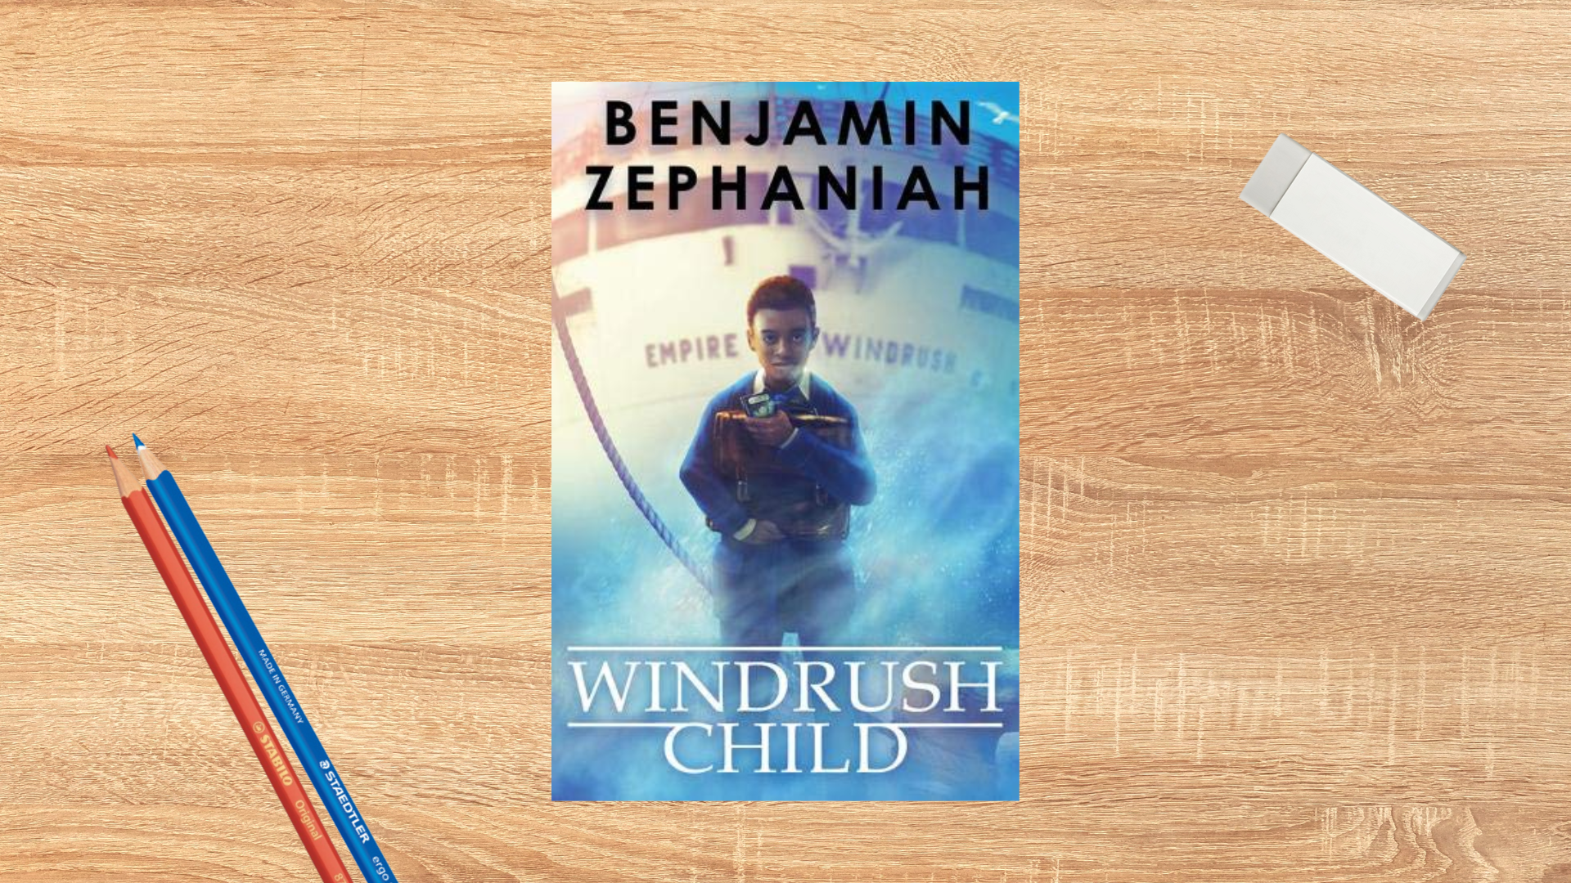

Read Woke: Windrush Child
Activity ideas to support classroom use of the book Windrush Child by Benjamin Zephaniah.

Second level

Resource created by Scottish Book Trust

scottishbooktrust.com
Scottish Book Trust is a registered company (SC184248)
and a Scottish charity (SC027669).

Contents
Scottish Book Trust 2
Read Woke 2
Read Woke South Ayrshire 3
How to use this resource 3
Learning activities 4
Further resources 7

Scottish Book Trust
Scottish Book Trust is a national charity that believes everyone living in Scotland should have equal access to books. Our work provides opportunities to improve life chances through books and the fundamental skills of reading and writing. Access to books and a love of books bring many important benefits from family bonding and advancing children’s learning, to unlocking creativity, helping employability and improving mental health & well-being. Scottish Book Trust aims to support all communities across Scotland, with particular focus on those who are vulnerable and under-represented.

Read Woke
‘Read Woke is a movement. It is a feeling. It is a style. It is a form of education. It is a call to action; it is our right as lifelong learners. It means arming yourself with knowledge in order to better protect your rights.’
– Cicely Lewis, Founder of Read Woke
The Read Woke challenge was developed by Cicely Lewis in Georgia, USA in 2017. Motivated by the political climate and seeing students grapple with issues of social injustice daily, Cicely realised the need to empower them with knowledge. Knowledge about the issues they (and others) face and knowledge about their own rights. The aim is to educate children and young people through reading. Find out more on the Read Woke website.

Read Woke South Ayrshire
The Read Woke challenge was brought to Scotland in 2020 via the School Library Improvement Fund. A collaboration of South Ayrshire secondary schools created a booklist and incentivised reading programme for S1–6 students with the aim of improving representation within library collections, celebrating diversity and encouraging students to be socially aware. Further backing from the Scottish Library and Information Council has allowed this work to be expanded into a primary school setting with Read Woke South Ayrshire Primaries launched in February 2022. Providing carefully chosen books to schools - along with tailor-made resources and activities through the year – is allowing us to educate and empower students to engage with social justice issues and stand up for the rights of themselves and others. The resources produced will help schools embed themes of equality, diversity, social justice, and human rights throughout their curriculum from P1–7. Learn more on the Read Woke South Ayrshire website.

How to use this resource
The aim of this resource is to support the use of Windrush Child by Benjamin Zephaniah in a classroom setting. Activities reflect some of the central book themes and scenes and cover a range of curriculum areas at second level.
Windrush Child features issues of racism, racist language and discrimination which can be explored and discussed within the classroom. Themes of family, friendship, loss and resilience are at the forefront of the story. Activities within this resource primarily reflect this positive representative theme.
With all Read Woke resources, we highly recommend that you read the book before using it with your class and use your best judgement about whether teaching about this topic is appropriate for the children in your class. It is important teachers are mindful of discrimination and inclusivity when approaching the book. For more information on learning about Windrush and racism, see the end of this resource.

Learning activities

Activity 1: Joy journal
HWB 2-02a, LIT 2-16a, LIT 2-23a, LIT 2-16a, LIT 2-23a
What strategies did Leonard use to help him when he was finding it difficult to adapt to a new home? Discuss in small groups. (Talking to others, working hard, making friends, dancing). What do you do when things are difficult or you are feeling unhappy?
Keep a journal of good things which have happened, nice things said, happy moments and exciting experiences. When you feel unhappy you can go back to read about joyful moments and think about ways to create more of them in your life.

Activity 2: Home collage
EXA 2-03a
In groups, create a collage of some of the things which were important to Leonard in Jamaica – his grandmother, mangoes, yams, pumpkins, goats, lizard, hummingbirds, running in the bush. Think about the colours, shapes and dimensions.
As an extension to this activity, you could also ask pupils to create a collage based on things in their homes including their favourite foods and colours as well as photographs of pets or family members.

Activity 3: Act it out
EXA 2-14a, EXA 2-15a, TCH 2-04a, TCH 2-08a
In groups of 3 allocate the roles of Leonard, his mother and his father and sit together to show them when they meet up for the first time in years. Give each character the chance to express and communicate their thoughts and feelings. Record and play back the groups in action and invite peer assessment for each of them.

Activity 4: My rights
RME 2-02b, RME 2-05b
Read through the UN’s Convention on the Rights of the Child on the UNICEF website. Discuss the racist behaviour that Leonard and his parents experienced when they came to England and ask the pupils to identify which human rights they were denied.
Talk about your class and school. What could you do to include others, to make sure they are treated fairly and that their human rights are being met? Make a class plan of actions you will all commit to. You could create a charter that you’ll sign and display in your classroom or school.

Activity 5: Leonard’s house
TCH 2-02b
In the book, Leonard’s home was incredibly cold and the family lived in one room. Try to heat your classroom using clay pots, tealights, a bun tray and a foil tray. You can use this YouTube video from Gem Webb for guidance. Use a thermometer to record the heat of the room before and after the experiment. What difference did it make? Do you think this is an effective way of heating a room?

Activity 6: Jamaican cooking
HWB 2-35a
Try cooking some Jamaican recipes to taste and enjoy together, for example:
- Peas and rice
- Peanut porridge
- Mango ice cream
You can also make buying the ingredients a class trip involving researching where to buy them, planning the route, and counting how much money they need.
Look at where the ingredients have come from on a map and measure how far they’ve travelled. You can also look at when different items are in season. Do they have to travel or can they be grown locally?
When eating the different foods you could compare them to what pupils eat at home:
- Who has eaten rice or porridge or mango ice cream at home?
- How are they different or similar?
- Does anyone have a family member who makes a special dish or have a specific recipe for something?

You could also research a dish like peanut porridge within Jamaican culture, comparing it to porridge in Scottish culture. For example, porridge in Scottish culture is often eaten with salt – whereas Jamaican peanut porridge is spicy and sweet!

Activity 7: Plants and produce
SOC 2-12a, MTH 2-21a, SCN 2-02b
Look at the plants, vegetables and fruits grown in Scotland or the UK and compare them with some of those grown in Jamaica. Explore the weather and climate conditions needed by each of these plants. Create a table or chart showing what each plant needs to help it grow successfully and how it has been used to benefit society.

Activity 8: Home is the place for me
EXA 2-17a, TCH 2-04b
Listen to the song “London is the Place for Me” by Lord Kitchener on YouTube and learn the lyrics. Discuss why people who travelled on the Empire Windrush believed England would be a good place to live.
Create your own version of the song by changing the words to match your hometown. Ask pupils to work in groups to create a PowerPoint presentation with photographs or images to go along with their lyrics.

Further resources

Read Woke
- Read Work South Ayrshire website
- Read Woke resources on the Scottish Book Trust website
- Scottish Book Trust book lists on books to understand the migrant experience and books for Black History Month.

Windrush
- BBC News: What was life like on-board the Empire Windrush? (2 minutes)
- Footage of the Empire Windrush’s arrival in the U.K. (2 minutes, 49 seconds)
- The British Library’s Windrush Teaching Resources
- Royal Museums Greenwich Teaching Resources
- Reading Museums Resources for Windrush Day
- Scottish Book Trust: Read Woke resource on The Good Turn by Sharna Jackson

Anti-Racism
- Education Scotland: Promoting race equality and anti-racist education
- Time for Inclusive Education: Resources
- Show Racism the Red Card
- Scottish Book Trust: Black History Month books for children and young adults
- Scottish Book Trust: Malorie Blackman learning activities

