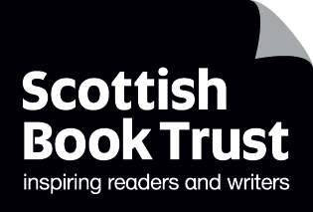
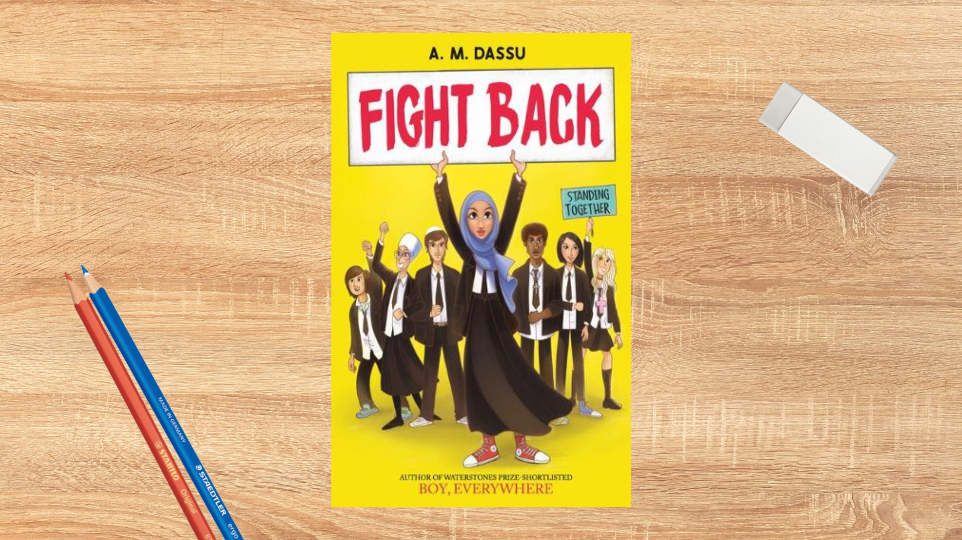

Read Woke: Fight Back Transition Project
Activity ideas to support a transition project using the book Fight Back by A.M. Dassu.

Second level
Resource created by Scottish Book Trust

scottishbooktrust.com
Scottish Book Trust is a registered company (SC184248)
and a Scottish charity (SC027669).

Contents
Scottish Book Trust 2
Read Woke 2
Read Woke South Ayrshire 3
How to use this resource 3
Learning activities 4
Further resources 8

Scottish Book Trust
Scottish Book Trust is a national charity that believes everyone living in Scotland should have equal access to books. Our work provides opportunities to improve life chances through books and the fundamental skills of reading and writing. Access to books and a love of books bring many important benefits from family bonding and advancing children’s learning, to unlocking creativity, helping employability and improving mental health & well-being. Scottish Book Trust aims to support all communities across Scotland, with particular focus on those who are vulnerable and under-represented.

Read Woke
‘Read Woke is a movement. It is a feeling. It is a style. It is a form of education. It is a call to action; it is our right as lifelong learners. It means arming yourself with knowledge in order to better protect your rights.’
– Cicely Lewis, Founder of Read Woke.
The Read Woke challenge was developed by Cicely Lewis in Georgia, USA in 2017. Motivated by the political climate and seeing students grapple with issues of social injustice daily, Cicely realised the need to empower them with knowledge. Knowledge about the issues they (and others) face and knowledge about their own rights. The aim is to educate children and young people through reading. Find out more on the Read Woke website.

Read Woke South Ayrshire
The Read Woke challenge was brought to Scotland in 2020 via the School Library Improvement Fund. A collaboration of South Ayrshire secondary schools created a book list and incentivised reading programme for S1–6 students with the aim of improving representation within library collections, celebrating diversity and encouraging students to be socially aware. Further backing from the Scottish Library and Information Council has allowed this work to be expanded into a primary school setting with Read Woke South Ayrshire Primaries launched in February 2022.
Providing carefully chosen books to schools – along with tailor-made resources and activities through the year – is allowing us to educate and empower students to engage with social justice issues and stand up for the rights of themselves and others. The resources produced will help schools embed themes of equality, diversity, social justice, and human rights throughout their curriculum from P1–7. Learn more on the Read Woke South Ayrshire website.

How to use this resource
In Fight Back we learn of the importance of an individual’s identity, of being free to make their own choices and decisions without prejudice. There is an important lesson about standing up to misrepresentation and stereotypes but also of standing together with allies, using the power of words to influence change.
With all Read Woke resources, we highly recommend that you read the book before using it with your class and use your best judgement about whether teaching about this topic is appropriate for the children in your class. It is important teachers are mindful of discrimination and inclusivity when approaching the book.
Concurrent themes of family and friendships weave through the story and are relatable for pupils at transition stage.
You could:
- Start reading the book in P7 and continue in S1 – possibly after the friends come together to create change in school/community
- Used in P7 and then revisited in S1 for more in-depth study

Learning activities

Activity 1: Words are Powerful
LIT 2-16a, RME 2-05b, RME 2-09d
Discuss the title and the use of the word “fight”. What do the pupils think it will be about? Throughout your reading, talk about the word “fight” as it appears throughout the book with lots of different meanings. Once you’ve read the book together, ask them to talk about what they think was meant by the title.
For S1 classes, you could talk about how “fighting back” ties into protesting, and when it’s wrong or right to fight back against something. For example, how it’s important to fight against racism, sexism, etc. You could also talk about what this fighting or protesting might look like. Fighting something is not always physical, and can look like, for example, telling a teacher if you see someone being racist or bullying someone else, or telling your friend why a joke they’ve made is actually not okay.

Activity 2: Identity
SOC 2-16b, SOC 2-16c
Ask pupils to bring in a photograph of themselves that they can glue to a sheet of paper. Discuss with them what might make them who they are, including:
- Family
- Religion
- Belief
- Hobbies and interests
- Appearance
- Possessions
- Favourite and least favourite things (e.g. food, music, films, animals, books)
Now ask them to complete their picture by adding words that show the different things that make up their identities. If they’re a new class, this can also be a great way to talk about respecting one another’s identities, and establishing a non-tolerance attitude towards any bullying.

Activity 3: Classroom Bingo
HWB 2-12a
Print the Classroom Bingo Table on page 9 and distribute one to each pupil. Give them five minutes to try and find someone who fits in each category. If they’re in S1, or new to their class, you can give them longer. This can be a great ice-breaker for getting to know a new class!
Once the five minutes is up, discuss with them:
- Which square was the easiest to find? Which was the hardest?
- Did anyone fit in more than one square?
- Did they discover something new about someone they didn’t know?
- Do we know everything about someone just by looking at them?
Establish with them that we all have some things in common, and might overlap on some of the squares, but that our difference is what makes us unique. Everyone’s identify is unique and is made up of lots of different ideas, facts, memories, beliefs and experiences.

Activity 4: Stereotypes
SOC 2-16b
P7 | S1
Girls are not good at football | Most crimes are committed by people of colour
Old people don’t know how to use technology | Most people who are homeless are so because of addiction
Boys can’t cook | People with mental illnesses are dangerous
People who wear glasses are nerds | Women are more emotional than men

Based on the age – and what you think is appropriate – of your class, discuss the above example of harmful stereotypes.
- Who did, or does, think these are true?
- What kind of evidence is there for these claims? You could talk about the different types of evidence – e.g. anecdotal versus fact etc.
- Are there examples that contradict them?
- What effect does it have on individuals when they’re stereotyped in this way?
- Should we make assumptions about people based on who they are or how they look?
- Look at the words “stigma” and “prejudice” – what do they mean?

Activity 5: School visit or event
RME 2-04c
Invite someone from the community to come and talk about their religion – if you can, try to host different speakers from different religions. This could be in your class or a whole school assembly.
In your class, plan a community event that could bring people together. This could be cooking different foods from different cultures and inviting people to eat, a book café where there’s reading and baking or a scavenger hunt. Ask the pupils to plan the event, design posters and flyers, and use maths to consider what they might need to buy (e.g. ingredients or prizes).

Activity 6: Emotions and expressions
HWB 2-04a
Ask the pupils to cut or rip an A4 piece of paper into eight squares. On each square, ask them to write down an emotion they remember from the book (e.g. excitement, panic, anger, happy, sad etc.) Put all the pieces of paper into a box and ask pupils to pull one out at a time.
Without saying anything, they have to act out the emotion on their piece of paper and everyone else has to guess. Once they’ve correctly guessed, talk about some times in the book where a character felt that emotion.
Put the pupils into groups and give them a scene from the book to discuss. Ask them to think about the different emotions displayed in this scene and write a short script based on their emotions. You can choose your own scene or think about:
- The excitement of going to a first concert
- The panic after the explosion
- The supermarket incident with the mum and racist man
- Ali’s time with the neighbour’s cat

Activity 7: A good friend
HWB 2-05a
Ask pupils to think about what makes a good friend and mind-map their ideas. You can use their words to create a display, or create an acrostic poem.
The novel mentions Snappo and Insta – ask them to talk about how social media affects the relationships in the book. In pairs, ask them to create a list of possible good and bad uses of social media.

Activity 8: Children’s rights
SOC 1-17a, SOC 2-17a, RME 2-05b, HWB 2-09a
Visit the UNCRC website to read through Children’s Rights. In groups, ask them to discuss what issues affect them, and what responsibility they have to protect other people’s rights. Print the Rights and Responsibilities Table on page 10 and ask them to fill in what responsibility they have for each of the rights in the left-hand column.
If they identify an issue they’d like to write about, you can get them to write a letter to your local MP, council or head teacher. This could be about bullying, recycling, littering, or a charity they’d like to support.

Further resources
Read Woke
- Read Work South Ayrshire website
- Read Woke resources on the Scottish Book Trust website
- Scottish Book Trust book lists on empowering books for girls and books for Black history month.

Children’s Rights
- Amnesty International
- UNICEF: Convention on Rights of the Child

Activity 3: Classroom Bingo table
Print this page
Someone who has an older brother | Someone who speaks another language | Someone who doesn’t like broccoli
Someone who has brown eyes | Someone who has a pet cat | Someone who likes video games
Someone whose favourite films are superhero movies | Someone who likes ice cream | Someone is an only child
Someone who likes playing football | Someone who wears glasses | Someone who has a parent or family member from another country

Activity 8: Rights and Responsibilities table
Print this page
My right is… | My responsibility is…
I have the right to express my thoughts and opinions

I have the right to privacy, including a private life at home and with my family

I have the right to express my wishes and views about my life

I have the right to learn and use the language, customs and religion of my family

I have the right to an education

I have the right to live with my family (so long as I am safe and supported)

I have the right to meet with other children and to join groups and organisations

I have the right to the best possible health

I have the right to an identity, including a name, family and nationality

