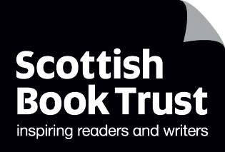
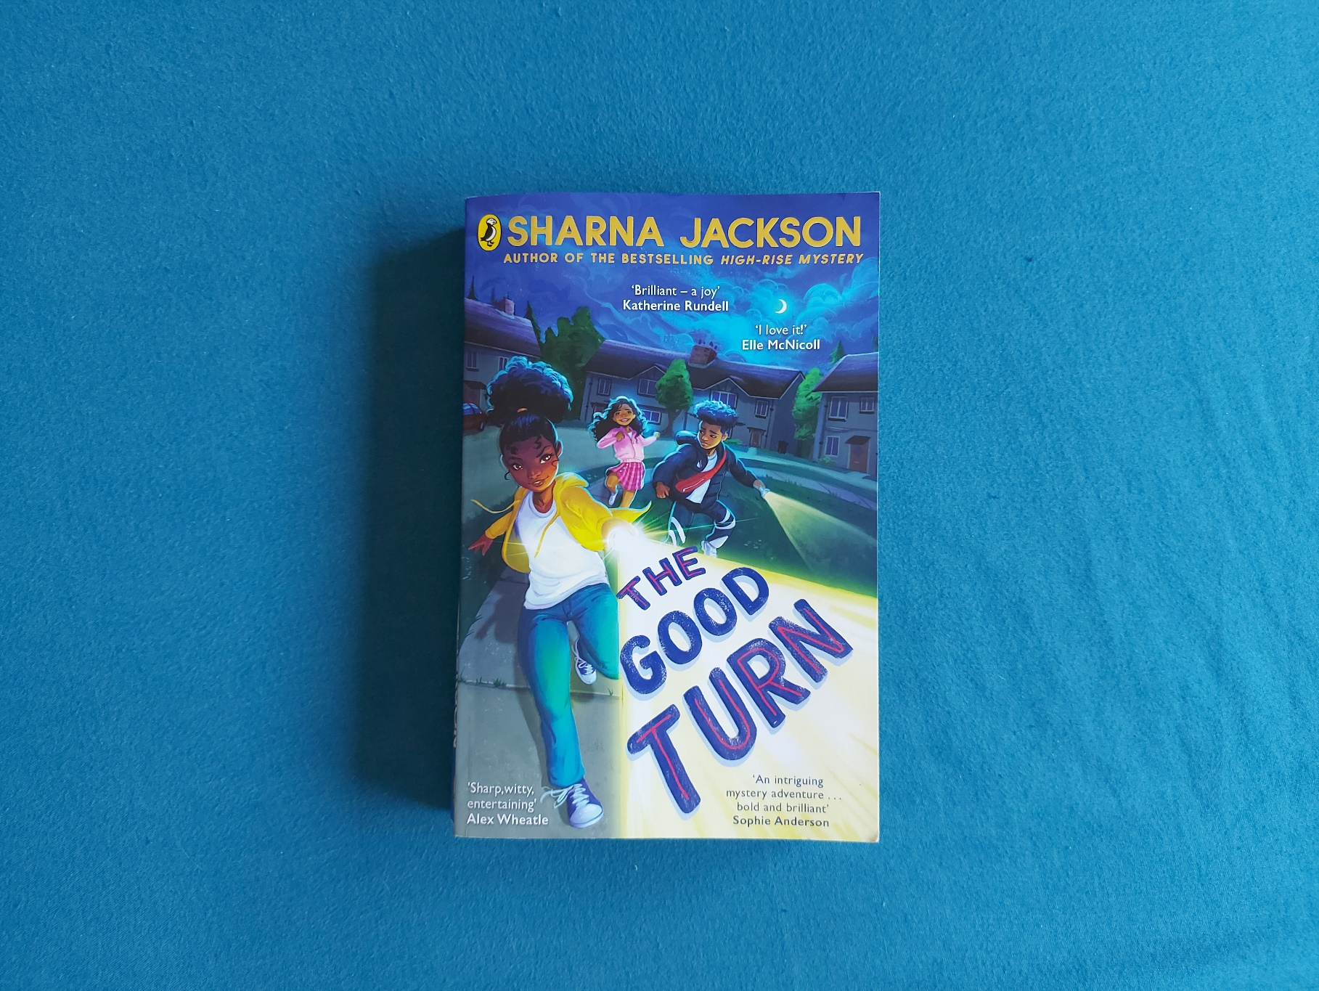

Read Woke: The Good Turn

Activity ideas to support classroom use of the book The Good Turn by Sharna Jackson.

Second level
Resource created by Scottish Book Trust

scottishbooktrust.com
Scottish Book Trust is a registered company (SC184248)
and a Scottish charity (SC027669).

Contents
Scottish Book Trust 2
Read Woke 2
Read Woke South Ayrshire 3
How to use this resource 3
Learning activities 4
Further resources 8

Scottish Book Trust
Scottish Book Trust is a national charity that believes everyone living in Scotland should have equal access to books. Our work provides opportunities to improve life chances through books and the fundamental skills of reading and writing. Access to books and a love of books bring many important benefits from family bonding and advancing children’s learning, to unlocking creativity, helping employability and improving mental health & well-being. Scottish Book Trust aims to support all communities across Scotland, with particular focus on those who are vulnerable and under-represented.

Read Woke
‘Read Woke is a movement. It is a feeling. It is a style. It is a form of education. It is a call to action; it is our right as lifelong learners. It means arming yourself with knowledge in order to better protect your rights.’
- Cicely Lewis, Founder of Read Woke.
The Read Woke challenge was developed by Cicely Lewis in Georgia, USA in 2017. Motivated by the political climate and seeing students grapple with issues of social injustice daily, Cicely realised the need to empower them with knowledge. Knowledge about the issues they (and others) face and knowledge about their own rights. The aim is to educate children and young people through reading. Find out more on the Read Woke website.

Read Woke South Ayrshire
The Read Woke challenge was brought to Scotland in 2020 via the School Library Improvement Fund. A collaboration of South Ayrshire secondary schools created a book list and incentivised reading programme for S1–6 students with the aim of improving representation within library collections, celebrating diversity and encouraging students to be socially aware. Further backing from the Scottish Library and Information Council has allowed this work to be expanded into a primary school setting with Read Woke South Ayrshire Primaries launched in February 2022.
Providing carefully chosen books to schools – along with tailor-made resources and activities through the year – is allowing us to educate and empower students to engage with social justice issues and stand up for the rights of themselves and others. The resources produced will help schools embed themes of equality, diversity, social justice, and human rights throughout their curriculum from P1–7. Learn more on the Read Woke South Ayrshire website.
How to use this resource
The Good Turn is a chapter book about three children who live in a cul-de-sac in Luton. Inspired by Josephine Groves Holloway, the founder of America’s first Girl Scouts group for Black girls, they decide to create their own version and earn badges by doing good deeds around their area. Whilst exploring an abandoned car factory behind their house, they meet an elderly couple, Felix and Audrey, who are part of the Windrush generation and have been evicted from their home.
With all Read Woke resources, we highly recommend that you read the book before using it with your class and use your best judgement about whether teaching about this topic is appropriate for the children in your class. It is important teachers are mindful of discrimination and inclusivity when approaching the book. For more resources on how to teach about Windrush in your classroom, see the end of this resource.

Learning activities

Activity 1: Create your own Copseys
LIT 2-24a
In the book Josie, Margot and Wesley create their own version of the Girl Scouts called “The Copseys”, after the street they live on. Split your class into groups and ask them to come up with their own Copseys. Ask them to discuss the following:
- What is their group’s name?
- What is their motto?
- What would they like to focus on improving in your school or where they live?
Ask them to think of five adjectives they would like people to use if describing their group, e.g. kind, thoughtful, hardworking, fun, helpful etc. Ask them to create a poster introducing their Copseys and be ready to present it to the class.

Activity 2: Earning badges
LIT 2-28a, LIT 2-29a
All of the chapters in the book are named after different badges, all of which are verbs – including “learning”, “cleaning”, “fundraising”, “sharing” and so on. Split the class into pairs and ask them to come up with ways they could earn the following badges:
- Cooking
- Dancing
- Helping
- Throwing
- Talking
- Reading
Alternatively, they can choose their own verbs, and write a few sentences about how they could earn it.

Activity 3: Designing badges and uniforms
EXA 1-05a, EXA 2-02a, EXA 2-03a
Ask pupils to draw three circles on a piece of A4 and think and design three badges they would like to earn if they were in the Copseys. If they’re stuck, you can explore:
- What verbs could describe your hobbies? (e.g. swimming, running, crafting)
- What verbs could describe your dream job? (e.g. talking, acting, helping)
- What verbs could describe your favourite subject? (e.g. writing, playing, drawing)
Ask pupils to design their own version of a Copsey uniform. If you’ve done the “Create your own Copseys” activity, they can use the name and motto they came up with as a group, or think of their own. Ask them to think about:
- What colours they’d like to use
- How they’ll display their badges and/or group name and motto
- What types of clothes they’ll need to wear to achieve their badges (e.g. do they need goggles for swimming, or trainers for running?)

Activity 4: Local Projects
HWB 2-10a, HWB 2-13a, SOC 1-08a, SOC 2-16a
The book explores the idea “think global, act local” which means you can make the world a better place starting from where you live. Print the table on page 9 for them to complete in groups or individually. Ask them to think about different issues and how they can explore them in class, their school and the wider community. There’s also space for them to add in their own.

Activity 5: Who’s your hero?
LIT 2-29a
In the book, Josie in inspired by Josephine Groves Holloway’s story which she finds online after Googling her name. Ask your class:
- Does anyone here know of someone famous with the same name as them?
- Is anyone in the class named after someone else?
Finding out more about their name, its meaning, and someone inspirational who shares it could be a take-home activity.
Josie also puts together a presentation for her friends about Josephine Groves Holloway. Ask your class to write about their:
- Famous or historical idol (e.g. a famous writer, actor, activist)
- Community or local idol (e.g. a local librarian, parent/family member)
Some questions they can cover in their presentation can include:
- Who are they? I.e. their name, when they were born, where they lived, what they did etc.
- Why is this person your idol?
- What’s something inspiring they have done?
- What adjectives would you use to describe this person?
- How do they inspire you?
They can either create a presentation using an iPad or laptop, or create a poster or fact sheet to present to the class. If your class creates posters or fact-sheets, you can make these into a display and revisit them throughout the year. Has their idol changed?

Activity 6: The Windrush journey
MTH 3-17b, SOC 3-04a
In the book Felix and Audrey describe their experience emigrating to, and being rejected by, the UK. Their story is inspired by the Windrush scandal – where Black and Caribbean people who moved to England between the 1940s and 70s were denied the British citizenship they had been promised. People like Felix and Audrey, who have spent most of their lives living in the UK had their right to remain in the UK revoked meaning many of them lost access to housing, employment and healthcare.
Read the section at the end of the book titled “Felix, Audrey and the Windrush Scandal”. Using a map look at the passage the HMT Windrush took to get to the UK. Discuss:
- What would it be like spending two months on a boat?
- Does anyone in the class know someone who moved to the UK?
- How did they travel?

Activity 7: Windrush and living somewhere new
SOC 2-19a, SOC 3-11a
Children who moved to the UK from Caribbean countries had to adapt to a lot of new changes in their life when they arrived. Watch the short video Newsround Generation Meets Windrush Generation (2 minutes, 47 seconds).
Ask the pupils to write down the different interview topics as headings:
- Friends
- Food
- Weather
Ask them to come up with a list of ways that moving to a new country might change their habits in relation to those three headings, e.g.:
- Friends: I’m at a different school and can only see my old friends on video call
- Food: I have to get used to trying new foods, and shops here don’t sell my favourite snack!
- Weather: I have to dress differently, as it’s a lot hotter here!

Activity 8: Windrush and homelessness
SOC 1-11a, HWB 2-09a, SOC 1-11a
The book explores lots of different types of houses and homes – Margot lives in a large house with her father, Josie lives with both her parents, Wesley helps look after his siblings, and Felix and Audrey have to create their own place to live once they lose their home.
Read the chapter “Meeting” (page 157) together and ask the pupils to write down some of the items in Felix and Audrey’s home in the abandoned car factory (e.g. lamp, rug, armchairs, television, photographs, oven).
- Which items do they also have in their homes?
- What things make them feel at home?
- What do they use every day?
- What would they notice if they couldn’t use it anymore?
- What are your three favourite things in your home or bedroom?
Ask the pupils to draw a house and think about what they would want to take with them if they had to move home.

Further resources

Read Woke
- Read Work South Ayrshire website
- Read Woke resources on the Scottish Book Trust website
- Scottish Book Trust book lists on empowering books for girls, books to understand the migrant experience and books for Black History Month.

Windrush
- BBC News: What was life like on-board the Empire Windrush? (2 minutes)
- Footage of the Empire Windrush’s arrival in the U.K. (2 minutes, 49 seconds)
- The British Library’s Windrush Teaching Resources
- Royal Museums Greenwich Teaching Resources
- Reading Museums Resources for Windrush Day
- Scottish Book Trust: Read Woke resource on Windrush Child by Benjamin Zephaniah

Homelessness
- Crisis: Learning activities for 3-11 year olds
- Shelter Scotland: Schools resources
- Scottish Book Trust: Read Woke resource on The Invisible by Tom Percival

Activity 4 Table
Print this page
 | In class | In the school | In your community
Example: Recycling | Use recycling bins in your class room | Running a whole school bring-and-buy sale | Creating posters for local shops to encourage recyling
Bullying
Loneliness
Littering
Intolerance and prejudice
Road safety

Add your own:
Add your own:

Add your own:

Add your own:

Add your own:

