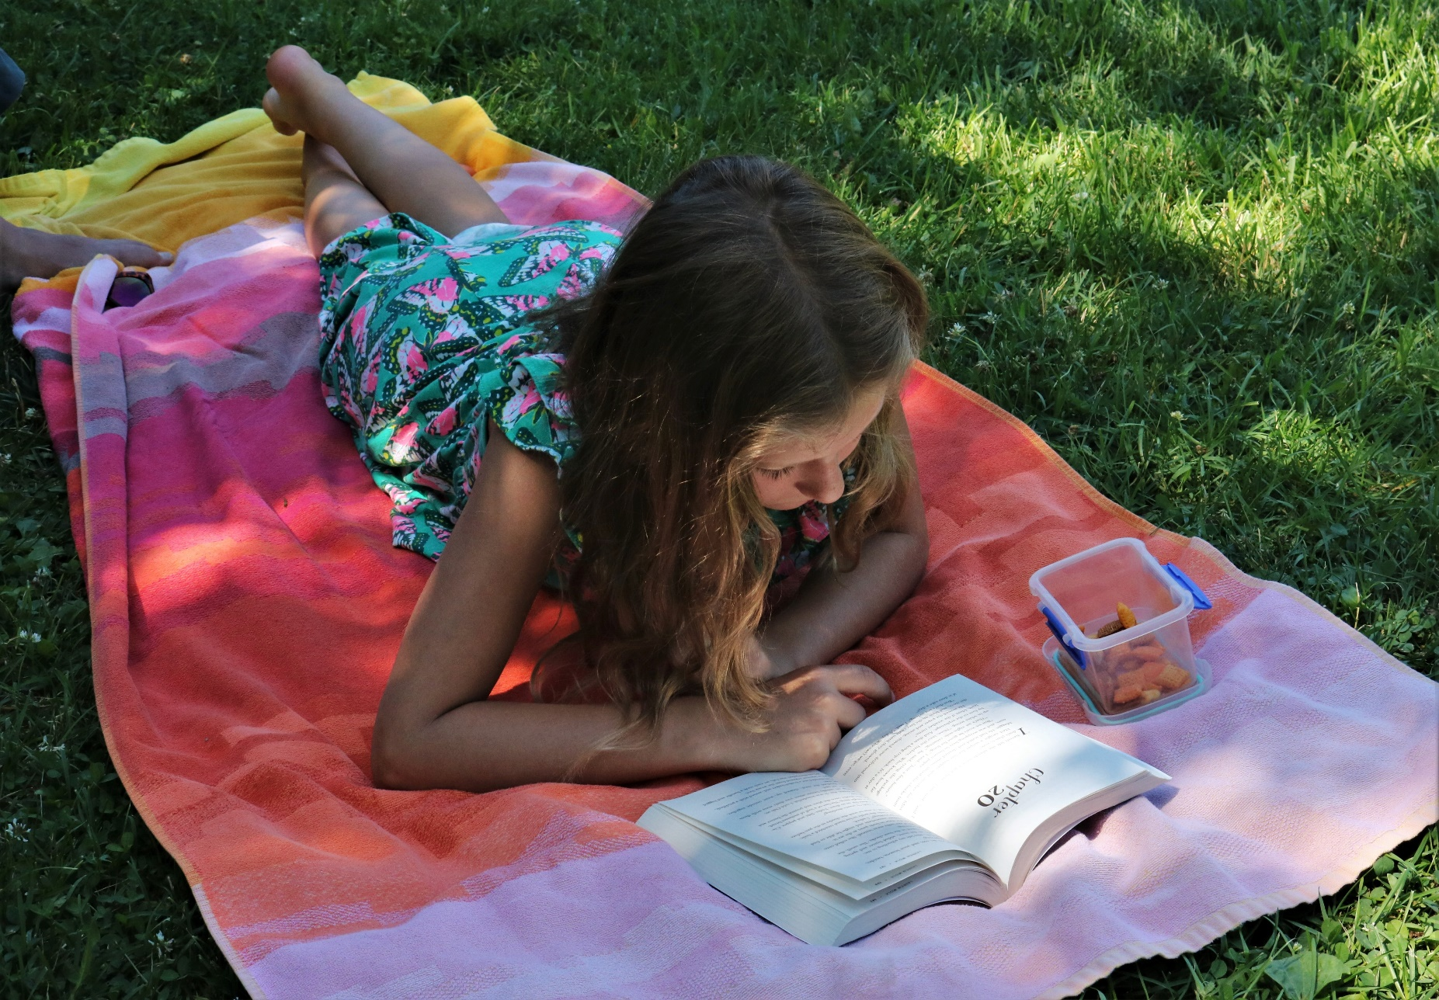

10 things to do with any book outdoors
Outdoors activities you can use with any book.

Suitable for primary schools, secondary schools, libraries and community groups

Resource created by Scottish Book Trust

scottishbooktrust.com
Scottish Book Trust is a registered company (SC184248)
and a Scottish charity (SC027669).

Contents
About this resource 2
Why take reading outdoors? 2
Learning activities 3
Further resources 7

About this resource
The activities in this resource have been designed so that they can be used with almost any fiction text. They are designed to further children’s understanding of aspects such as setting, plot and character and to provide readers with opportunities to discuss, compare and share opinions about different texts. The resource is not a linear progression of activities but rather a range of ideas from which teachers can pick and choose.

Why take reading outdoors?
Spending time outdoors offers incredible learning opportunities across the curriculum, as well as mental health and wellbeing, wonder, fun and inspiration. Taking a book outside, or using the outdoors to explore literacy, can also help children connect the elements of a book, including plot, character or themes, to the world around them. This can further their learning, and bring books to life – especially for children who might find sitting still challenging.
By taking books and stories outdoors, we’re also offering a new perspective on nature. Being outside offers lots of opportunities for movement, sports or physical play, but it can also be somewhere we go to find quiet and calm. Bringing a book outside can give children a way to relax, or another form of engagement with nature if they’re reluctant to spend time outdoors.
There are lots of outdoors spaces you can explore, all of which have different learning opportunities – beaches, forests or woods, lochs or a local park. However, if you don’t have access to a local green space, all the ideas in this resource are adaptable so they can also be used in your playground, local area or in a city.

Learning activities

Activity 1: Outdoor reading spaces
A great place to start is finding opportunities to read outside. When the weather allows, why not hold any reading time outdoors? This could be individual reading time, or you reading to the whole group.
You can also explore creating outdoor reading spaces. This could be
- A permanent structure, e.g. a shed or upcycled campervan
- Seats or benches with storage for storing books
- Book boxes or carts which can be wheeled out during break time
Whatever option you go for, it’s worth involving the pupils in the design – whether it’s about theming it around a particular book, or engaging them with building, painting and decorating, or choosing the books to go in the boxes and carts each week.

Activity 2: Campfires or picnics
Plan an outdoor reading event! Depending on the weather, this could be a campfire where you have hot chocolate and marshmallows, or you could plan a themed picnic. You can involve the children in planning and set-up, whether that’s helping build the fire or planning and making the food to serve. This could be a great way to introduce families to the books you’ll be looking at in class. Invite families to attend and hear the book, or a chapter, being read aloud.

Activity 3: Story walks
If you don’t have a large, or exciting, outdoors space you can also explore retelling a story whilst on a walk. You can play Story Relay where someone has to pick up where the last person left off.
This doesn’t have to focus on testing their memory, you can encourage the children to create their own version. Doing this whilst walking can remove the pressure of worrying about being “right” in front of a whole classroom. For more tips on writing based on nature, watch our video with author Nicola Davies from our Scottish Friendly Book Tour.

Activity 4: Every book is a scavenger hunt
Every book has elements you can use to shape a scavenger hunt. These can include:
- Colour – trying to find a match to colours in the art or cover
- Animals – are there any animals or creatures in the book you can find?
- Clothing – if you live in a city, try and find people whose outfits match people in the artwork or book cover
- Shapes – can you find any shapes or patterns from the art or cover?

For chapter books, you can also think more abstractly. Make a list of items in the book and ask the children to find objects which represent them. A buttercup or dandelion, for example, could represent the sun. A stone could represent the barrier a character faces. This is a great way to teach about metaphor and develop persuasive writing skills!

Activity 5: True or False Races
Write the word “true” on one end of the playground and “false” on the other. When you call out statements about the book, the children have to run to either side depending on if they think it’s true or false.
Other variations of this include
- Agree or Disagree – they have to run to one side or the other based on whether they agreed or disagreed with something a character did.
- Me too or Not me! – you read out facts about the character which may also apply to them, for example, “the main character has a pet fish”, or “the main character loves pizza”. Who has the most in common with the main character?

Activity 6: Story soundscapes
Using a Dictaphone, or device like a phone or tablet, try and find some sounds to record that “sound” like your story. Ask your children to think about where the story is set (e.g. a forest, the sea, a city) as well as some adjectives to describe it (spooky, busy, calm). It’s not about exactly trying to recreate the sounds, but try and listen and see what you can find. You can also explore finding objects to recreate specific sounds – using a stick to mix a puddle to make the sound of a river, or hitting a metal fence with a stick to create an eerie sound effect!
Once you’re back in the classroom, you can use software like Audacity to mix your sounds together to create a layered soundscape. Try reading some chapters along to it – does it feel more atmospheric?

Activity 7: Story maps
Go for a walk around your local area using a pencil to draw a rough map of any key landmarks or specific sites. Then, when back from the walk, pupils can change these into different locations from the book, or create a fusion of your local area and where their favourite character goes.
For example, if you’re reading a fantasy book, your local corner shop could become an apothecary, or if you’re reading a spooky story, could you create a ghost for your local woods?
Some questions that could prompt their maps:
- What would your town look like in the world of your book?
- Where would your favourite character spend time?
- If you had a house in the world of your favourite book, what would it look like?
- If you ran a shop in the world of your book, what would you sell?
If their favourite book is set in a real place, you could also spend some time researching that city or country. Learn about its architecture or any landmarks and look at it on a map.
You can also collect different natural resources and textures to make your map into a collage. Gather items like flowers or leaves, or pencil rubbings of different trees, stones, rocks, leaves or on the side of different buildings or walls. This is a great activity for talking about adjectives. How do the different textures feel?

Activity 8: Create a breadcrumb trail
Breadcrumb trails get their name from the story of Hansel and Gretel, and involve leaving things outside for people to find! Put your pupils in charge of creating a breadcrumb trail – what would they like to leave? Where would they like to leave it, or can they create a route? This is also a good way to learn about environmental impact – have a conversation about ensuring what you leave is safe and can either be removed or will fade or biodegrade over time.
Here’s some ideas for your breadcrumb trail:
- Laminate QR codes for books or audiobooks from your local library – put your pupils in charge of choosing what books to recommend
- Be Book Fairies – put books in waterproof packaging and hide them throughout your local area, or work with local businesses to put some books in their shops or window displays for people to find
- Use chalk to write their favourite book quotes along pavements
- Create a chalk mural based on the art or cover of a favourite book
- Create poetry stones and use them to create a long poem, or encourage people to create their own poem from the words they find

Activity 9: Create a book inspired garden
If you have any planters, or grassy areas, explore creating a Book Garden. This could be part of your outdoor reading area, or you could look into the different meanings of flowers to create connections between different themes or characters and what you plant.
You can also use different colours of plants, props, or paint to create a garden based off your favourite story. If you need some inspiration on creating a story garden, have a look at the Pocket Garden Showcase on the Keep Scotland Beautiful website.

Activity 10: Book trips
Try and identify somewhere, or something linked to, your book that you could visit. This could be in your local area or a longer day trip. You can also put learners in charge of the process of planning the trip. How far away is it? How will they get there? Do they need to plan money for transport or entry?
The benefit of this is that it helps learners connect what they’re engaging with in a book with the real world. Take the book with you so you and the children can revisit specific sessions.
Here are some ideas for thinking about a text:
- Animals – if there are animals in the book can you see them in real life at a zoo, farm or in the wild?
- Eras – if your book is set in a certain era, look for a museum or historical site you can visit to learn more about how they lived!
- Setting – can you find a town, city or place with a similar feeling to the book?
- Jobs – do any of the characters have a job with a workplace you could visit?

Further resources
Although this resource is designed so you can use it for any book, we also have resources which look at specific books, including:
- Eco-Schools Live Lessons from Scottish Book Trust, RZSS, the Fairtrade Foundation and Keep Scotland Beautiful on Biodiversity and Water
- Book lists including books for outdoor learning, your P.E. classroom and exploring the outdoors
- Tour On Demand events with Allison Galbraith, M.G. Leonard and Dermot O’Leary
- Authors Live on Demand with Gill Lewis
- Resources to support using What a Waste by Jess French
- A resource on running a cross curricular book project with Tidy by Emily Gravett

We also have a Heading Outdoors section of our website that focuses on reading, books and the outdoors.

