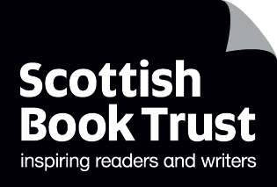
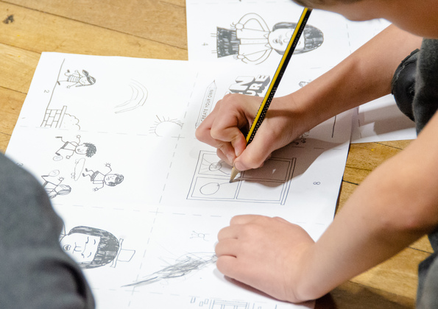

Make a Hat Inspired by a Book
Make a hat fit for a Mad Hatter’s tea party!

Suitable for: Primary schools, libraries, community groups

scottishbooktrust.com
Scottish Book Trust is a registered company (SC184248)
and a Scottish charity (SC027669).

How to make a hat
Whether you’re attending a Mad Hatter’s Tea Party, or running a special event in your classroom, school, library or community group for Book Week Scotland, make sure you’re properly dressed!
Print pages 3-5 so everyone has one of each. Then follow these steps to assemble your hat:
- Cut out all the shapes
- Glue the two rectangles onto the main hat shape where it says “glue here”
- Try the hat on your head and glue the two strips together at the back so it fits your head
- Cut along the dotted line on the final shape, then apply glue where it says “glue here”
- Slot the final shape over the hat so that the glued section is behind the main shape. Your hat is complete!
- Decorate your hat with drawings, characters, favourite book covers or quotes – then you’re ready to go!

Further activities
- Plan a full book-inspired tea party – who would be your dream guest to invite, either an author or a fictional character!
- Make some tea party food. Do any of your favourite books have recipes? Or can you bake a cake inspired by a book cover?
- Use our resource on how to make a Mini Book to create one that matches your hat!
- Watch Jon Klassen read This Is Not My Hat on Authors Live on Demand.
- Explore our resource on 10 expressive arts activities to do with any book for more creative ideas of engaging with a book the children you work with enjoy.

