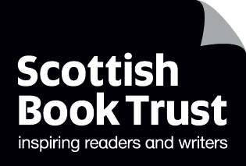
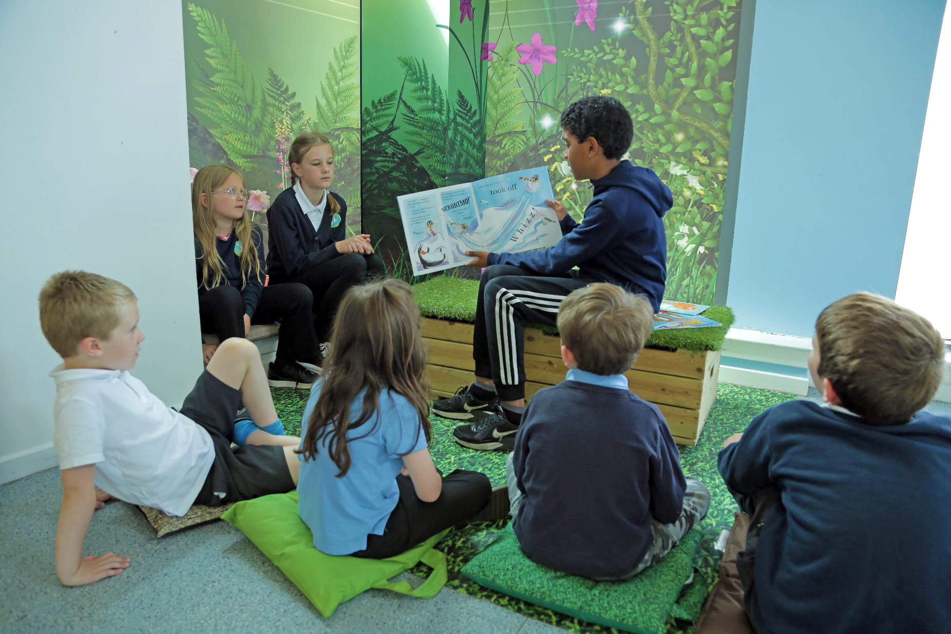

ag

Close the attainment gap with books
2022–23
With help from Scottish Book Trust

scottishbooktrust.com
Scottish Book Trust is a registered company (SC184248)
and a Scottish charity (SC027669).

Contents
Creating a reading culture 2
Reading Schools 4
First Minister’s Reading Challenge 6
Read, Write, Count 7
Authors Live 8
Bookzilla 9
Scottish Friendly Children’s Book Tour 10
The Bookbug Picture Book Prize 11
Live Literature 12
Book Week Scotland 13
Sharing Sensory Stories 14
Creative writing 15
Learning resources 16
CLPL 17

Creating a reading culture
At Scottish Book Trust, we want to support you in creating a vibrant reading culture in your classroom and across your school.
A vibrant reading culture is proven to help improve attainment across the curriculum, as well as pupils’ creativity, health and wellbeing.
This booklet highlights the variety of programmes we offer that will help you inspire a lifelong love of reading in your pupils. From initiatives like Reading Schools and the First Minister’s Reading Challenge, which put reading for pleasure at the heart of Scottish education, to our Authors Live broadcasts which stream author events directly to your pupils, there are lots of programmes, funding opportunities and resources available to support you.
Stay in the loop about upcoming events, opportunities and CLPL sessions by signing up to our schools and libraries newsletter at scottishbooktrust.com/newsletters.
We’d love to hear from you about how you are using our programmes, and to answer any queries you might have. Get in touch with us at schools@scottishbooktrust.com.

Reading Schools
Reading Schools is a flexible, step-by-step programme that supports schools across Scotland as they embed the magic of reading into school life.
All schools in Scotland are now eligible to take part.
Reading Schools offers:
- An accreditation for your school at one of our three levels – core, silver and gold – with the option to advance through the levels
- An improvement framework mapped to HGIOS4
- Professional development opportunities for staff
- A way to champion pupil voice
- Opportunities for collaboration within and between schools
- Pathways to engage families and the wider community
- Resources, training and support from Scottish Book Trust

Funding
Schools that have submitted an action plan will be able to apply for funding to help them achieve their accreditation. Funding can be used to buy books and create appealing reading spaces.

Key dates
- 8 September 2022: CLPL: Starting your Reading Schools journey
- 20 September 2022: CLPL: Leadership of learning
- 25 October 2022: CLPL: Creating family and community partnerships
- 17 November 2022: Funding applications deadline
- 7 December 2022: CLPL: Shared practice event

Evidence for Reading Schools
‘I can say with absolute certainty that the huge strides we have made in building our reading culture this year have been due to the focus we have on Reading Schools’ – Principal teacher, secondary school
- 100% of learning professionals told us that Reading Schools had contributed to improved attainment at school
- 95% of learning professionals told us that reading for pleasure had become a routine activity in school
- 98% of learning professionals told us that pupils now enjoy reading more, model positive reading behaviours to each other, and identify as readers
- 56% of learning professionals told us that pupils identified as socio-economically disadvantaged were reading more as a result of Reading Schools
- 63% of learning professionals reported that through Reading Schools, health and wellbeing had improved ‘quite a lot’ or ‘a lot’
- 100% of learning professionals told us that Reading Schools helped them to monitor their schools’ progress
‘We are a rural community and do not have local access to a library or book shop. Many families have to travel by public transport to our nearest library and shops. There is not much spare money in families to purchase books and they are not seen as an essential item. Many of our children do not own a book.
‘By promoting reading in school and providing the children with a wide variety of texts to choose from we have noticed their interest in reading has grown.
‘One family in particular have four children in school and had no access to books at home. We noticed that they were becoming interested in reading different types of books in school either through recommendations from friends or book tasting sessions facilitated by class teachers. Their parents attended our book reading lunch which was a first for them to become involved. We also noticed an increase in their attainment in reading and writing.’ – Principal teacher

Find out more
readingschools.scot

First Minister’s Reading Challenge
The First Minister’s Reading Challenge is back for another year, with a focus on building a reading culture in your classroom.

Challenges
We have a range of challenges to enter, recognising the reading journeys of individual pupils, groups and classes. We’ll celebrate these reading journeys and the winners in June with a week-long online festival of author events and activities.

Classroom resources
Access brilliant CfE-linked resources for free, including digital and printed versions of our Reading Passports.

Funding opportunities
Registered schools, community groups and libraries can apply for funding to hold an event with an author or creative practitioner, either in person or remotely.

Key dates
12 September 2022: Registration and funding applications open
8 September 2022: CLPL: Get inspired with the First Minister’s Reading Challenge
17 November 2022: Workshop funding application deadline
27 April 2023: Submissions deadline
June 2023: Celebration event

Find out more
readingchallenge.scot

Read, Write, Count
The Read, Write, Count bags are filled with books, maths games and writing materials, and are gifted to all P2 and P3 pupils in Scotland. They are gifted by Scottish Book Trust and are part of the Scottish Government’s commitment to addressing the attainment gap.
Read, Write, Count provides a great opportunity to build relationships with parents and strengthen links between home and school learning.
‘I think Read, Write, Count is a great initiative. Many families cannot afford to buy new books and number games for their children so receiving this lovely gift is very exciting for the children.’ – Teacher at Gilmerton Primary School

Learning resources
Visit our website to download CfE-linked resources for each item in the bags, which have been created with Education Scotland.
You’ll also find activities, videos and lesson plans to help make the most of the bags at school and at home.

Bag gifting
Hold a celebration event and gift your bags during Book Week Scotland, and join one of our CLPL events for more ideas.

Key dates
From September 2022: Bags for P2 and P3 pupils will arrive at your school
15 September 2022: CLPL: Gifting Bookbug P1 Family Bags and Read, Write, Count bags
27 September 2022: CLPL: Using Read, Write, Count to support outdoor learning
4 October 2022: CLPL: Supporting STEM with Read, Write, Count
14–18 November 2022: Hold your celebration event and gift your bags during Book Week Scotland

Find out more
scottishbooktrust.com/readwritecount

Authors Live
Authors Live brings world-class author and illustrator events directly to your classroom, library or home for free, in partnership with BBC Scotland.
Register to watch the live broadcasts with your pupils, and catch up with previous events through our On Demand library. To help you embed reading for pleasure in the classroom, there are also free CfE-linked activities to support each broadcast.

Watch on demand
Visit the Authors Live On Demand library to explore over 90 author and illustrator events. Highlights from the last year include events with Patience Agbabi, Brian Conaghan and Mark Bradley.

Key dates
20 September 2022: Sue Cheung shares her laugh-out-loud series Maddy Yip’s Guide to Life (P4–7)
4 October 2022: Rachel Bright, author of The Lion Inside, shares her melodic, heartwarming picture books illustrated by Jim Field (P1–3)
25 October 2022: Phil Earle discusses his award-winning novel When the Sky Falls and his new novel While the Storm Rages (P5–S2)
22 November 2022: Keith Gray discusses his new dyslexia-friendly novel The Climbers, a moving story about competition and friendship (S1–6)
Keep an eye on our website and schools and libraries newsletter for further dates as they are announced.

Find out more
scottishbooktrust.com/authorslive

Bookzilla
Whether a pupil always has their nose in a book or hasn’t picked one up for a while, our Bookzilla app is here to help them find their next great read.
Developed by young people for young people, Bookzilla helps upper primary and lower secondary pupils to:
- keep track of what they’ve read, and what they’d like to read next
- find tailored recommendations based on the genres they like
- see how books have been rated
- by other users of the app
- take on reading dares
- set themselves reading challenges
- find their nearest bookshops and libraries
The app was developed to help children and teens broaden their reading horizons and to spark a love of reading.
We also have a resource on our website on using Bookzilla in your school, as well as a downloadable poster and bookmark.
Bookzilla is free to use, and doesn’t collect any personal data.
‘It helps me find books I haven’t seen before then I’ll read them.’ – Pupil

Find out more
scottishbooktrust.com/bookzilla

Scottish Friendly Children’s Book Tour
The Scottish Friendly Children’s Book Tour brings the best authors and illustrators to schools across Scotland for fully-funded events. Previous authors on the tour have included Jessica Townsend, Cressida Cowell, Malorie Blackman and Patrick Ness.
Giving your pupils the opportunity to meet brilliant authors and illustrators can inspire a life-changing love of reading, writing and illustration.
We’re now back on the road delivering tours in schools, but we’ll continue to run virtual events too.
You’ll find information about tours and events on our website and in our schools and libraries newsletter as they are announced throughout the year.
‘To see the engagement on the faces of those who can often be reluctant to learn is fantastic and for them to ask for a book to read after is priceless.’ – Teacher after a tour visit to their school

Find out more
scottishbooktrust.com/booktour

The Bookbug Picture Book Prize
The Bookbug Picture Book Prize celebrates Scottish picture books, and the winner of the prize is voted for entirely by children across Scotland.
All P1 pupils receive the three shortlisted books in their Bookbug P1 Family Bag. Lots of schools vote as a class (or even a whole school!), and families can also vote from home. Children don’t have to be in P1 to take part – we encourage children of all ages to get involved and cast their votes.
We work with CALL Scotland to produce symbol resources and digital versions of all the shortlisted books.

Key dates
7 September 2022: Shortlist announced
15 September 2022: CLPL: Gifting Bookbug P1 Family Bags and Read, Write, Count bags
October/November 2022: Bookbug P1 Family Bags will arrive at your school
14–18 November 2022: Hold a celebration event and gift your bags during Book Week Scotland
27 January 2023: Voting deadline
2 March 2023: Winner announcement

Find out more
scottishbooktrust.com/bpbp

Live Literature
Live Literature helps to fund and support author events in communities and schools across Scotland.
Meeting authors, illustrators, poets and storytellers face-to-face can inspire pupils with their own writing and reading.
You can apply for part-funded visits with the authors, storytellers and other creative practitioners on our author directory. You pay just £75 plus VAT per session, and we cover the rest of the visitor’s fee and all travel expenses. All Live Literature events and residencies can take place remotely or in person.
‘I noticed that so many pupils were reluctant to start writing as they though they can’t be good writers if they struggle with spelling words or grammar. I think it was very important that the author residency encouraged them to write anyway and don’t focus on mistakes, and showing them that anyone can be a writer.’ – Teacher after taking part in a Live Literature School Residency

School residencies
Fully-funded residencies give you the chance to work with an author, storyteller or creative practitioner over a school year on a creative project you devise together.

ASN school residencies
Work with an author-in-residence on an extended project for pupils with additional support needs.

Key dates
23 September 2022: Deadline for applications for ASN residencies
21 November 2022: Deadline for applications for events taking place before 31 March 2023
Early 2023: Applications open for events taking place from April 2023 to March 2024

Find out more
scottishbooktrust.com/live-literature

Book Week Scotland
Book Week Scotland is an annual celebration of books and reading, which will take place on 14–20 November this year.
The theme is Scotland’s Stories, as part of Scotland’s Year of Stories.
There are lots of ways to get involved:
- Host an event to gift your Bookbug P1 Family Bags and Read, Write, Count bags to get your pupils and their families excited to use them
- Enjoy events from the Authors Live on Demand library
- Use the resources on our website to create a school-wide celebration of books and reading, with fun activity ideas and printable display materials
There will also be ways to take part online, and events taking place in communities across Scotland. Keep an eye on our social media channels and website for details on these as they’re announced.

Find out more
bookweekscotland.com

Sharing Sensory Stories
Sharing Sensory Stories brings the magic of author visits, books and sensory storytelling to pupils with additional support needs.
Multi-sensory storytelling is a great way to empower children with a range of needs to express their thoughts and ideas.
The programme is open to special schools, ASN settings and pupils with additional support needs in mainstream education. The offer includes:
- Author residencies and events (online and in person)
- CLPL for staff
- Funding for books and resources
- An Inclusive Stories Festival, with authors and practitioners exploring sensory stories and lived experiences of neurodiversity and disability
‘The highlight of my year (career!) has been our ASN Storyteller residency. Everyone felt like this was for them. There has been a real change in the group dynamic, and I think that’s fed into their confidence in other areas of the curriculum as well.’ – School librarian

Key dates
1 December 2022: Deadline for funding applications

Find out more
scottishbooktrust.com/asn

Creative writing
We have a new hub on our website to support teachers with creative writing lessons and projects, which features a mix of learning resources, top tips and fun activities.
Encouraging pupils to write creatively can improve their writing across the curriculum, as well as boost:
- emotional resilience and regulation
- creative problem-solving skills
- social, communication and critical-thinking skills
- confidence and pupil voice
- engagement with the wider curriculum
Highlights from the hub include:
- Creative writing toolkit linked to HGIOS4
- Top tips for getting started with creative writing
- Research on the benefits of creating a writing culture in your school
- Resources on creative writing in Scots
- Phil Earle’s writing masterclass
- Fun writing activities, including using poetry stones, story cubes and story sticks
- Printable display materials, including our Why Write? poster, an interactive journal and a template for making story cubes

Find out more
scottishbooktrust.com/creative-writing-for-schools

Learning resources
To help you to build a reading culture in your school we have a library of fantastic free CfE-linked learning resources on our website. The resources offer guidance and support as you embed reading for pleasure in your classroom.
Highlights include:
- General activities to be used with any book – there are versions of this for early years, primary schools, secondary schools and ASN settings
- Resource packs and activities for pupils with additional support needs
- Activities and resources to support our Authors Live broadcasts
- Resources to help you explore a topic or plan a project
- Resources to support pupils through the transition from nursery to primary and primary to secondary
- Resources on using Scots and writing in Scots
- Resources for gifting the Bookbug and Read, Write, Count bags, including mind maps, lesson plans and videos
- Book Discovery Guides – issues #1–4 are available now, with more to come!
- A resource on understanding and challenging racism, written with Show Racism the Red Card Scotland
- Fun activities, like how to make a mini book
- Book lists on lots of different themes with recommendations for all ages

Find out more
scottishbooktrust.com/learning-resources

CLPL
We deliver a huge range of CLPL and training online and in person each year. Our sessions cover topics such as:
- Creating a reading culture in your classroom and across your school, and working towards your Reading Schools accreditation
- Gifting the Bookbug P1 Family Bag and Read, Write, Count bags
- Boosting staff knowledge of contemporary books
- Using books to support outdoor learning, STEM and sustainable development
CLPL sessions will help you to engage with our programmes and ensure they have a deep and lasting impact on your pupils. You will gain practical ideas to implement in your school, as well as the opportunity to share ideas and experience with professionals in your area and across Scotland.
This year, we will also have a new offer of pre-recorded CLPL webinars that you will be able to watch on demand.
We also offer bespoke training on request. If you are interested in attending or arranging a CLPL session, please get in touch.
‘The webinars are wonderful. Unpretentious and inclusive and jam-packed with information and ideas. It’s so great to hear from colleagues across Scotland!’ – Class teacher after attending a CLPL webinar

Find out more
scottishbooktrust.com/clpl

Scottish Book Trust would like to thank
- Creative Scotland
- Scottish Government
- CALL Scotland
- BBC Scotland
- Comhairle nan Leabhraichean (The Gaelic Books Council)
- Scottish Friendly
- Smarter Scotland
- Parent Club
- Education Scotland
- Browns Books
- Walter Scott
- The Mohn Westlake Foundation

About Scottish Book Trust
Scottish Book Trust is a national charity that believes everyone living in Scotland should have equal access to books. Our work provides opportunities to improve life chances through books and the fundamental skills of reading and writing.
Access to books and a love of books bring many important benefits from family bonding and advancing children’s learning, to unlocking creativity, helping employability and improving mental health and wellbeing. Scottish Book Trust aims to support all communities across Scotland, with particular focus on those who are vulnerable and under-represented.

