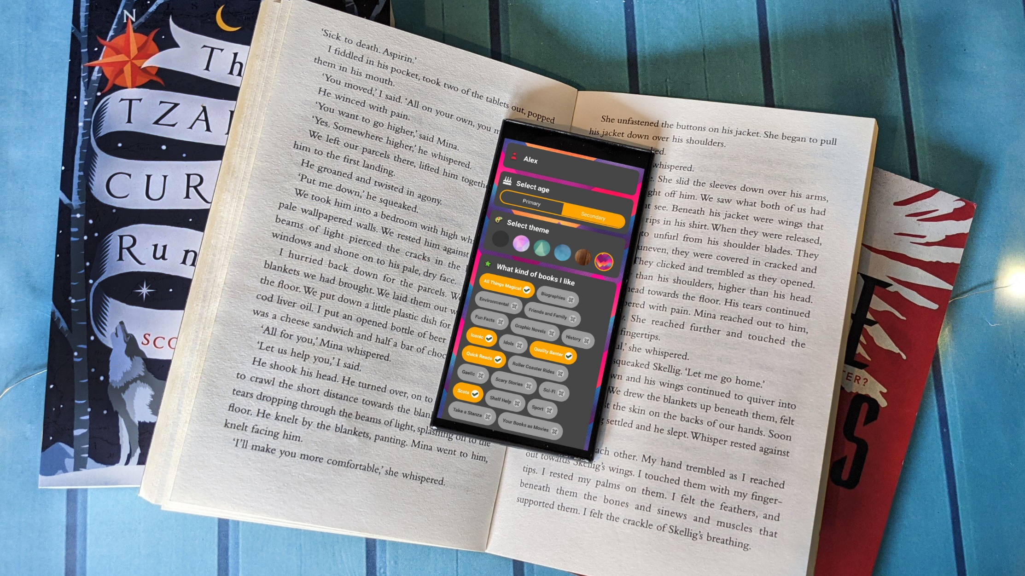

Using Bookzilla in your Secondary School
Ideas and activities for using the Scottish Book Trust app Bookzilla class or in a library, written by Calum Smith, librarian at Larbert High School.

Age: 12-14

Resource created by Calum Smith

scottishbooktrust.com
Scottish Book Trust is a registered company (SC184248)
and a Scottish charity (SC027669).

Contents
About this resource 2
Activities for using the app in the classroom 3
Predict a book 3
Twitter review 3
Publisher pitch 3
Choosing a reading challenge 3
Review the Bookzilla App 4
Activities for using the app in a library 5
Introduce Bookzilla 5
First lines 5
Books I want to read 5
Review reading and creating a bullet journal 6
Activities for using the app with a book group 6
Reading tastes and preferences 6
Who am I? game 7
Book group reading choice 7
Sharing reading recommendations across the school 7
Worksheet 1 8
Worksheet 1— key for librarians 9
Worksheet 2 10

About this resource
This resource includes a variety of different activities for secondary school pupils using the Bookzilla app. Teachers and school librarians can use these activities to introduce the app and its features to their pupils, encouraging them to use it in their personal reading journeys.

Activities for using the app in the classroom

Predict a book
TCH 3-01a, LIT 3-02a, LIT 3-11a, LIT 3-15a
Class teacher introduces Bookzilla or reminds pupils following initial library session. Pupils should look for a book they would like to read next using Bookzilla and take a few minutes to make notes on their predictions of what the book would be like using the synopsis and genre as clues. Then in pairs, each pupil presents their predictions and talks about them. Feed back to the class with opportunities for comparison – have any pupils picked the same book with different predictions?
Predictions can be revisited later to see how accurate they were.

Twitter review
TCH 3-01a, LIT 3-11a, LIT 3-23a, ENG 3-27a, LIT 3-29a
Class asked by teacher to think about a book they would like to recommend to others and rate it on Bookzilla if they have not already done so. Then write a Twitter review of the book – the review could be tweeted on the school or library account, or you could create a display, but the important part is that pupils have to restrict themselves to 280 characters. You could encourage pupils to mention the Bookzilla genre name in the Tweet as an extra challenge.

Publisher pitch
LIT 3-06a, LIT 3-09a, LIT 3-11a
Pupils asked to choose a book on Bookzilla to sell to their classmates, imagining themselves as booksellers or publishers. Pupils should get a chance to plan their pitch and draw out the book's main selling points, and then either 30 seconds or 1 minute to pitch to the rest of the class – their customers. The class can then vote on which pupil was most successful in selling their book to them.

Choosing a reading challenge
TCH 3-01a, LIT 3-02a, LIT 3-05a, LIT 3-20a, LIT 3-24a
Class teacher introduces class to challenge and reading dare functions on Bookzilla, casting from phone to screen. Pupils given time to explore the options and are then tasked with interviewing a partner to find out their reading habits and tastes to help them choose a dare or challenge for them. They should take time beforehand to plan their interview questions and think about interview manner. When they are ready, they should interview their partner for about 5 minutes.
Returning to working by themselves, pupils should choose a dare or challenge from the app for their partner, thinking about suiting their current reading habits, but pushing them a little bit out of their comfort zone. Pupils should write out the chosen challenge in the form of a mission statement and take turns to read these aloud to their partner. Pupils should log their challenge or dare on the app.

Review the Bookzilla App
TCH 3-01a, TCH 3-08a, TCH 3-15a, LIT 3-02a, LIT 3-09a, LIT 3-10a
At the end of the academic year, students can be asked to reflect on the Bookzilla app. In groups discuss:
- What are the app’s strengths?
- What would you change or improve?
- What would you add to the app to make it even better?
Each group should invent one new feature that they would like to add to the app – big ideas encouraged! However, also encourage pupils to consider the challenges that they might face in implementing this idea, such as cost, online safety, and accessibility. Taking these factors into account, will their idea still work? Do they need to change or adapt it? Encourage pupils to think about it as a real-life scenario, and what they might feasibly be able to achieve.
Ask pupils to prepare a short pitch on their new feature using PowerPoint, storyboarding or whatever other techniques are appropriate.
Groups then take it in turns to present their idea to a panel of teachers and the school librarian in the style of Dragon’s Den. The panel get to decide which pitch is most convincing!
Scottish Book Trust are always working to improve Bookzilla, so would love to hear your ideas! Why not send the pitch ideas or storyboards to schools@scottishbooktrust.com. If pupils want to give individual feedback, they can use a form in the settings page of the app.

Activities for using the app in a library

Introduce Bookzilla
TCH 3-01a, TCH 3-02a
Librarian introduces Bookzilla app with a class discussion, modelling the functionality of the app by casting from phone to a screen. Students split into teams. Each team represents a genre on Bookzilla. The team has 5 minutes to try and find 15 books from a specific genre in the library.
After the 5 minutes are over, the group come together to discuss what they find and see if they can find the books on Bookzilla and see what genre they’re under.
- Do they agree with the genre it is under in the library or Bookzilla?
- If not, why? What genre should it be under?
- Are any of their books missing from an app? (If so, see page 4 for how to contact us through the app or email!)
After discussing, each team can take some time to look at and discuss the books they have found, see if they would like to read any of them and if so, borrow that book from the library.

First lines
LIT 3-02a, LIT 3-09a, LIT 3-11a, ENG 3-19a
Librarian leads class discussion about genre and book types by referring to Bookzilla settings screen and “what kind of books I like” categories, leaving the different genres visible on screen for pupils to consider during the activity.
Use the first lines activity from Worksheet 1 (or librarians can create their own using books available in their library). Set different tables in the library up with the first line of books according to the genres on the app. e.g. a heartbreakers table, a mystery table etc. Students are given 5 minutes per table to look at the first lines, discuss what genre the books might be from and whether the first line makes them want to read on. Groups should feedback on their thoughts and librarian can reveal the books and genres.
Ensure pupils have at least 5 minutes at the end to update their Bookzilla profile with the genres of books they like and any books they discovered that they would now like to read.

Books I want to read
TCH 3-01a, TCH 3-02a, LIT 3-02a, LIT 3-11a
Open with a class conversation about what pupils are reading and what they think of the books. Introduce the idea of using Bookzilla to find and keep track of your future reading through the “Want to read" function and how to add books to this. Students given time to explore books suggested by the app in “Books to try” and different collections to add to their “Want to read” section on Bookzilla, then decide which to read first. Group time to share what they are most excited to read with other pupils.

Review reading and creating a bullet journal
LIT 3-06a, LIT 3-20a, LIT 3-24a, EXA 3-03a
After a term or at the end of the school year, review the reading journey pupils have been on, referring to Bookzilla to recall which books they have read and what they thought of them. What have been the highlights of their reading year, and have there been any difficulties or disappointing reads? Encourage pupils to discuss this is a class or in small groups, before creating a visual representation of their reading year in the style of a bullet journal. Encourage pupils to be creative with this (there are lots of images of bullet journals you can find online to share).
Their work can be displayed in the library or English class, or you could give students the opportunity to present it to the rest of the class as part of a reading celebration event.
Prompts for pupils to consider for their journal page:
- How can I show my favourite books?
- Do I want to include books I have not enjoyed e.g. disappointing reads or books I didn’t finish?
- Do I want to use a themed layout like a bookshelf, scrapbook or map to represent my reading journey?
- Do I want to add illustrations?
- Do I have any favourite quotes to include?

Activities for using the app with a book group

Reading tastes and preferences
LIT 3-02a, LIT 3-11a, LIT 3-16a
Book Group members should complete worksheet 2 to show their tastes in reading based on their Bookzilla profile without putting their names on them. Group members review the sheets, suggest book recommendations for each member and guess whose profile is whose. Discuss everyone’s reading tastes, shared interests and differences.

Who am I? game
LIT 3-02a, LIT 3-06a, LIT 3-09a
Book group members take it in turns to have a post-it note on their head, featuring one of the categories from Bookzilla. Other pupils have to give clues to help them guess it, including how this book might make you feel, what books would appear in this category or even acting it out in the style of charades!

Book group reading choice
TCH 3-01a, LIT 3-02a, LIT 3-11a
Using Bookzilla profiles or profile worksheets, ask group members to compare the genres they each enjoy, and what type of books they would like to explore as a group. Have a look around the library and on Bookzilla to identify potential books they would like to read together and make a list before deciding what to read first. Pupils make sure they add the books to their to-read pile on Bookzilla.

Sharing reading recommendations across the school
TCH 3-01a, LIT 3-02a, LIT 3-11a, LIT 3-20a, LIT 3-23a, LIT 3-24a, LIT 3-26a
As a group, reflect on what books they love the most and would like to recommend to others in the school community. Pupils can use their read books and ratings on Bookzilla to help. Once pupils have decided which books to recommend, think about how best to publicise the recommendations, such as via a printed newsletter, the school Twitter account, a Bookzilla display in the school library, an article on the school website or even short videos to be played on the school screens. Pupils can work together as a group to create their recommendation piece, and make sure it also lets people know about Bookzilla as a place to find more information on these books and other books to read.

Worksheet 1

Genre 1
- “Would the defendant please rise.”
- Josh is Margot’s boyfriend, but I guess you could say my whole family is a little in love with him.
- Welcome to the beautiful Sinclair family. No one is a criminal. No one is an addict. No one is a failure.

Genre 2
- Footsteps. Running. Graham didn’t hear them at first.
- It was almost December, and Jonas was beginning to be frightened.
- On the morning of its first birthday, a baby was found floating in a cello case in the middle of the English Channel.

Genre 3
- “COME DOWNSTAIRS, EVERYONE! FAMILY MEETING!”
- Ask yourself—do I need the money? Robbing a bank isn’t something to do to pass the time, like kicking footballs over the neighbour’s fence or reading.
- My name is Harriet Manners, and I am a geek.

Genre 4
- Long ago, on the wild and windy isle of Berk, a smallish Viking with a longish name stood up to his ankles in snow.
- The journalists arrived before the coffin did.
- The shop from nowhere arrived with the dawn on a crisp November morning.

Genre 5
- The green phone / on the wall in the hall / hardly ever rang.
- How long have I been here? I’ve lost track of time. Nobody’s coming.
- In the old days, when this story took place, time used to run by clockwork.

Worksheet 1— key for librarians

Genre 1—Heartbreakers
- Saint Anything by Sarah Dessen
- To All the Boys I’ve Loved Before by Jenny Han
- We Were Liars by E Lockhart

Genre 2—Rollercoaster Rides
- Divided City by Theresa Breslin
- The Giver by Lois Lowry
- Rooftoppers by Katherine Rundell

Genre 3—Quality Banter
- The Gifted, The Talented and Me by William Sutcliffe
- How to Rob a Bank by Tom Mitchell
- Geek Girl by Holly Smale

Genre 4—All Things Magical
- How to Train Your Dragon by Cressida Cowell
- Nevermoor: The Trials of Morrigan Crow by Jessica Townsend
- The Nowhere Emporium by Ross Mackenzie

Genre 5— Mystery
- Moonrise by Sarah Crossan
- Between the Lies by Cathy MacPhail
- Clockwork by Philip Pullman

Worksheet 2
Genres I love:

Genres I don’t like:

Genre I might like to try:

Best book I’ve read this year:

Book I didn’t finish:

Favourite book or series:

Book recommendations from the group:

