FMRC 2020/21 evaluation
An evaluation of the First Minister’s Reading Challenge in schools

Programme evaluation

November 2021

Summary presented by Scottish Book Trust

scottishbooktrust.com
Scottish Book Trust is a registered company (SC184248)
and a Scottish charity (SC027669).

Highlights

The survey of learning professionals who participated in the 2020/21 First Minister's Reading Challenge found that the programme:

- 100% – helped them encourage pupils to read for pleasure
- 94% – helped them feel empowered to encourage reading for pleasure
- 93% – helped pupils read for pleasure more
- 92% – helped pupils understand the value of reading for pleasure better
- 89% – helped their school integrate reading for pleasure into the curriculum
- 83% – helped them enthuse pupils impacted by lockdown
- 73% – increased the level of reading for pleasure in reluctant readers
- 'Reading for enjoyment has helped a lot of children during lockdown and the encouragement and tasks given by us from the school has meant that the children have developed a new love for books.'
- 'A child completed two group passport sheets with the books she had read on her own and made the comment "I had more journeys with the million words I read than I would have done if I had a million pounds to spend".'
- 'Our young readers have had a flying start to their reading journey. We are so proud of them!'

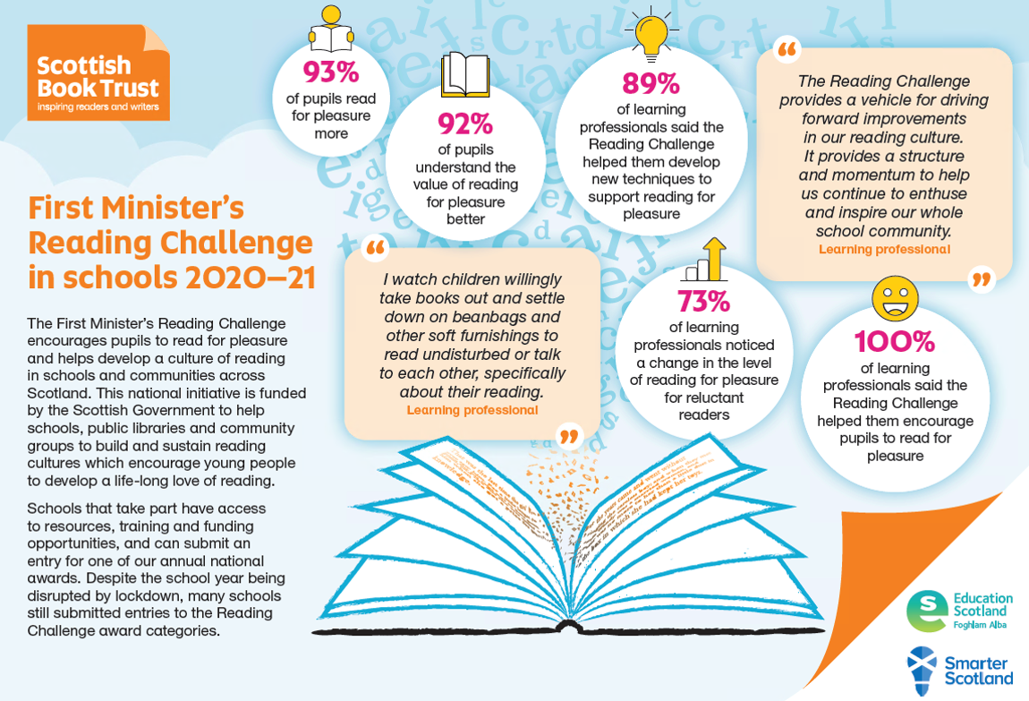

Introduction

The First Minister's Reading Challenge encourages pupils to read for pleasure and helps develop a culture of reading in schools and communities across Scotland. The national initiative is funded by the Scottish Government and delivered by Scottish Book Trust to help schools, public libraries and community groups to build and sustain reading cultures which encourage young people to develop a life-long love of reading.

The First Minister's Reading Challenge was launched in August 2016, initially for P4 to P7 pupils. It has now expanded to provide support and resources for primary schools, secondary schools, libraries and community groups. Schools that take part have access to resources, training and funding opportunities, and can submit an entry for one of the annual national awards. Despite the school year being disrupted by lockdown, many schools still submitted their challenge to one of the Reading Challenge award categories.

Programme outcomes
The Reading Challenge aims to positively impact attainment by building reading cultures in schools, families and communities to support and nurture reading for pleasure. The Reading Challenge is intended to be inclusive and flexible, working alongside other reading programmes taking place in schools, libraries, communities and at home. Participating schools and organisations are invited to submit an entry to one of nine 'challenges'.

The programme has the following objectives, which apply across all areas of the work to support and promote reading for pleasure:

- Being flexible and inclusive
- Supporting schools to build a reading culture
- Supporting involvement of families, libraries and communities
- Securing buy-in and support from teachers and other practitioners, such as library staff and family / community learning contacts
- Supporting attainment
- Supporting closing the attainment gap
- Being sustainable

Evaluation
Previous evaluations of the First Minister's Reading Challenge were undertaken by independent consultants. In 2020/21 the evaluation was conducted by Scottish Book Trust in-house due to budget constraints and focuses on the Reading Challenge in schools due to the small number of libraries and community groups registering. Information for the evaluation was gathered from competition entries, shared practice events and a survey of learning professionals.

The survey was circulated in May and June of 2021, directly after the 2020/21 prize winners were announced. 139 responses were received. The bulk (92) found the survey through the FMRC Twitter, with the remaining responding to an email sent out to all schools that participated in the challenge in 2020/21.

Most responses came from primary schools (63%), with secondary (32%) and all-through schools (4%) also being represented. They occupied a number of roles in their school and represented a spread of local authorities. 73% of respondents had taken part in FMRC in 2020/21 and 27% had not.

Location of respondents
Local authority | Responses from each
Glasgow | 12%
Edinburgh, West Lothian | 9%
South Lanarkshire, Angus | 7%
Falkirk, Midlothian, Perth and Kinross, Fife, Highland | 4%
Aberdeen, Argyll and Bute, East Renfrewshire, Inverclyde, Moray, North Ayrshire | 3%
Aberdeenshire, Dumfries and Galloway, South Ayrshire, Stirling | 2%
East Dunbartonshire, East Lothian, North Lanarkshire, Renfrewshire, Scottish Borders, West Dunbartonshire, Dundee, Shetland, Western Isles | 1%
Clackmannanshire, East Ayrshire, Orkney | 0%

Half reported finding out about the Reading Challenge from an email from Scottish Book Trust, while others received the information from a colleague (23%) or a mailing (21%). Email was the communication method that learning professionals rated as the most convenient for them. Social media was also suggested as a convenient way to pass on information.

The Reading Challenge in 2020/21

In 2020/21 Scottish Book Trust received 132 submissions (686 registrations) from 91 organisations in 27 local authorities. While there were significantly less community and library challenge entries in a year where activities were disrupted by the pandemic, schools used the Reading Challenge to engage their classes in 2020/21.

The reading journey challenges were the most popular, receiving the most entries:

- School Reading Journey: 39
- Pupil Reading Journey: 36
- Reading Inspiration Challenge: 33
- Pupil Reading Most Books: 11
- School Reading Most Books: 3
- GME Reading Journey: 2

The winners of the fifth First Minister's Reading were announced online by the Children's Laureate and bestselling author of the How To Train Your Dragon series, Cressida Cowell. Prizes were awarded for a range of categories that showcased the efforts of schools and pupils to support reading for enjoyment and create a reading culture in their school, home or community. This year, while the winners still received a special trophy, all applicants were awarded a book token in recognition of their work promoting reading.

Learning professionals found innovative ways to integrate a focus on reading for pleasure into their schools or classes:

- 'Watching children engage with books in different ways e.g. book penpal, turning their recommended books into QR codes for wider access, making secret books.'
- 'Our whole school voting at the same time of the day for our Black History Month library book vote.'
- 'Staff are open to exploring different ways of promoting reading for pleasure. I adapted an idea from the World Book Day website and created whole school (staff and students) competition – 'Title Quest'. The event generated discussions of books between staff and students from all year groups, and introduced students to staff they might not otherwise have any interaction with.'
- 'Our whole school extreme reading challenge got the pupils talking about the books they were reading. Younger years enjoyed charting the books they read as a class.'

Some noted a sense of achievement when they reflected on the work realised despite the disruptions of lockdown:

- 'Completing the Reading Challenge and seeing how much we have achieved, over the course of the year, during which time we had been impacted upon by a Lockdown.'
- 'Putting together an entry about our year in lockdown and realising that we had done more than thought. Pupils telling me how much they enjoyed reading during lockdown, some not previously the biggest of readers.'

A number of the projects described using the Reading Challenge structure to celebrate the achievements of individual pupils:

- 'An S1 pupil who had read over 1metre high in books over lockdown as part of our challenge.'
- 'Celebrating the children who complete their passports and have their moment in the spotlight to share their experiences. This isn't one moment but happens across the year... All the author's live sessions and the book friendly tour have been amazing.'

Others focused on developing the reading habits of a class or whole school through shared activities:

- 'Seeing children develop daily routine with reading and a thorough joy of reading for pleasure. It has really helped to develop their independence and confidence.'
- 'When my class set ourselves a challenge of reading a chapter a day of our class novel, there was one day where we were unable to complete the chapter and so my students made me promise to read two chapters the next day to make up for it. It was so lovely to see their enthusiasm for reading!'
- 'Using books to support transition. Keeping reading culture alive during Lockdown.'

Programme feedback: flexibility and accessibility

Overall, 97% felt that the Reading Challenge is flexible enough to suit the needs of their school. Many saw flexibility as a key strength of the programme:

- 'ASN pupils included.'
- 'As a school, we are able to make it fit our needs due to the level of information/ support/ resources on your website.'
- We are able to adapt it to meet the needs in our school and still leave lots of flexibility for teachers to differentiate further where required for their classes.'
- 'The Challenge allows you to work at your own pace and to showcase your achievements in the year from your own start and finish points., it gives pupils and teachers a voice to participate in activities that are relevant to their needs.'
- 'That has been one of the strengths of the Challenge, that it allows all of our reading for pleasure activities to be recognised.'

Others felt that the programme was too flexible and that clear limitations, boundaries, and expectations were key to measuring success:

- 'My keen readers (Primary 5) struggled to complete an entry for the Group Reading Challenge. They found the instructions too open-ended and weren't sure how to document their reading journey. Some examples of previous successful entries on your website would be really useful to give the readers an idea of 'what a good one looks like'.'
- 'The Secondary Schools 'Reading Inspiration Challenge' is a very broad goal – gives a lot of options for what to do but difficult to measure change/success under this challenge.'
- 'It can feel as though the Challenge is a little too flexible, which makes it difficult to know what to do and what is expected.'

However, others used this flexibility to adapt their activities to unexpected periods of lockdown or home learning:

- 'We have created a link with our local children's library assistant. During lockdown/home learning, he provided us with interactive 'Read and Make' videos, where he would record himself reading a story with a focus on mental health for each age group, then give a tutorial of a craft children could make at home to support their learning. These videos were shared with our children on Google Classroom.'

89% agreed that the Reading Challenge was accessible to their pupils. These respondents highlighted using the flexibility of the programme to adapt to the needs of their pupils:

- 'All pupils are able to access this as teachers implement different elements according to the needs in their class. During lockdown resources were easily shared with all families. Children love the competitive edge of who can read the most books and complete the most passports.'
- 'We have a continual focus on equity in the school and remove barriers so that all children can participate. Whether that is providing additional quantity and range of reading materials, providing online reading opportunities, working with male authors to inspire boys more etc.'

Some noted that their pupils did not all have access to books and that this was a key barrier to reading for pleasure:

- 'Not all children have access to libraries, especially those in remote rural areas, and not all children can afford books. An free online reading library for children in remote rural areas or discounted books for children from the poorest backgrounds would help allow all children the luxury of reading for pleasure.'
- 'We have no library or access to a library. Though we are SIMD 10 the reality of rural isolation, deprivation and poverty is the proper story as SIMD data does not drill down to real families. We simply do not have enough access to real books. So a massive challenge.'
- 'Ok for those who have books – we have no library and only have a small selection of books, so for very enthusiastic readers we cannot keep up with their growing appetite.'

Others identified key groups of pupils who needed additional or tailored resources to remove barriers to participation:

- 'We have children with English as an Additional language and it is our resources that are limited in supporting them to read for pleasure.'
- 'Some pupils find the pupil record book difficult to complete due to literacy difficulties.'
- 'More ASN resources perhaps?'

Programme feedback: resources and support
- 'I think the challenge is outstanding. The resources and the process is brilliant.'

89% of respondents considered the quality of online support and resources to be either 'good' or 'very good'. 91% were happy with the availability of online support and resources and 75% with the availability of printed resources. Some told us they would like to see more FMRC ASN resources and others wanted more resources sent through the post to avoid printing costs. They mentioned finding a range of resources particularly helpful:

- 'Classes thoroughly enjoyed following their reading journey on the class passport.'
- 'Reading Dares – have used these in competitions and whole school challenges.'
- 'Reading lists – helped us provide posters for subject depts. Used Bookzilla app lesson at start of term.'
- 'Reading Dares – have used these in competitions and whole school challenges.'
- 'The resources and the website are excellent.'

Suggestions for additional resources included free books and ASN, Gaelic, cross-curricular, or signposting resources:

- 'More that encourage and link to outdoor learning, inter-disciplinary subjects like STEM/Social Studies and the Expressive Arts.'
- 'Videos from well-known authors offering reading challenges or sharing their reading habits as a child.'
- 'Book or online access to books.'

Others felt overwhelmed by the amount of resources available or felt they did not reflect their school's situation:

- 'Excellent resources but sometimes feel I have to delve deep to find what I am looking for.'
- 'I know why you are doing it but it can be frustrating to read about full time well resources libraries doing well – when so many are not.'

41% reported attending an FMRC CLPL session. Suggestions for future CLPL sessions included events in Gaelic, shared practice events, or events that are pre-recorded.

Impact: building a reading culture
89% of respondents said FMRC helped their school integrate reading for pleasure into the curriculum. 90% noted that the Reading Challenge helped them develop new techniques to support reading for pleasure. Comments from learning professionals highlighted their use of the Reading Challenge to establish a school culture where reading for pleasure was valued:

- 'Reading for enjoyment has helped a lot of children during lockdown and the encouragement and tasks given by us from the school has meant that the children have developed a new love for books.'
- 'Keeping the enjoyment of reading a focus for all ages during lockdown was a key aspect of supporting wellbeing.'
- 'The FMRC provides a vehicle for driving forwards improvements in our reading culture. It provides a structure and momentum to help us continue to enthuse and inspire our whole school community.'

100% said the Reading Challenge helped them encourage pupils to read for pleasure, with 94% telling us that the programme helped them feel empowered to encourage reading for pleasure. Respondents were asked to elaborate on the contribution of the Reading Challenge to reading for pleasure in their school. Some pinpointed the programme as having a direct and positive impact on their reading culture:

- 'Reading is now at the heart of our curriculum and books are used to support learning in all areas of the curriculum.'

Sometimes this positive impact was limited to individual pupils or groups:

- 'Some pupils definitely read more, others already read often and widely and some still have to be encouraged to read.'

Others found it difficult to assess or measure the impact of one programme:

- 'I think we'll notice more when can deliver presentations in school as opposed to using MS Teams where engagement was mixed.'
- 'It's quite a difficult thing to measure, but it was good to see some of our S5 students who I wouldn't have thought of as readers, working as paired readers with S2.'

Others highlighted the Reading Challenge as making a positive contribution to their school's reading culture alongside other initiatives:

- 'As a librarian the Reading Challenge has allowed me to engage with teachers about how I can facilitate integrating reading throughout the wider curriculum.'
- 'Our involvement in FMRC supports our mission to enable all pupils to develop a love of reading. Pupils in our school understand how much we value reading for enjoyment. The Challenge helps us to communicate this effectively and powerfully. It has been a great tool and resource for our school and one which continues to provide a national framework.'
- 'We also use Accelerated Reader in our school and this in tandem with the FMRC has had a really positive impact on our pupils and their reading habits. Pupils reading abilities have improved termly as has engagement in books. This has had a positive impact across the curriculum for many pupils – their reading skills being better and increased confidence has given them more independent access to other curricular areas. Pupils have been involved in choosing new titles for our school library and have got their book requests. We hope next year to develop pupil voice further.'

Learning professionals described a range of initiatives introduced during the Reading Challenge to encourage reading for pleasure. These included initiatives focused on establishing reading habits, reading in lockdown, or involving parents and carers in reading activities:

- 'We have read class novels and have tried new authors and genres as a class and as a staff. Pupils were able to take books home over lockdown, class novels were continued and the school had an online membership to myon enabling all pupils to have access to books regardless of their circumstances.
- 'Inviting parents and carers to a library book cafe: seven genre tables, each with five books/courses and a menu for participants to comment on the books (with tea/coffee and tasty treats provided!). This was a mulit-generational event reaching students, parents, carers, grandparents and staff. The relaxed and welcoming environment encouraged discussion of the books between tables/visitors.'
- 'We were still able to set challenges and dares for the pupils remotely via the school Seesaw app.'
- 'I have always valued reading for pleasure and this has always been a strong focus in my class. I wanted to expand this to the whole school and encourage time to be made in all classes. I also was developing the reading and matching skills of my own class by finding and matching the books borrowed from our library and wanted pupils to inform us of how they felt about different types of literature – fact/ fiction/comics etc.'
- 'We had an Advent Readathon in December to encourage daily reading for pleasure.'

In addition to supporting existing reading initiatives, 67% of the respondents noted that the Reading Challenge helped provide opportunities for pupils to have their voice heard or to take on leadership roles. 65% felt the programme improved attainment at their school with just over half reporting that the Reading Challenge contributed to reducing the poverty related attainment gap for pupils in their school.

Impact: pupil attitudes to reading for pleasure

93% of respondents noticed an increase in their pupils reading for pleasure during the Reading Challenge, suggesting that the programme helped foster positive attitudes to reading for pleasure. This is supported by the 91% who believed the programme helped their pupils understand the value of reading for pleasure. 91% thought their pupils read more widely which suggests pupils were trying out new authors or expanding their reading interests to new genres.

Respondents submitted accounts of pupils who tackled the Reading Challenge with relish and grew more enthusiastic about books and reading:

- 'Children were so excited to add a book to their reading passport or the classes.'
- 'A child completed 2 group passport sheets with the books she had read on her own and made the comment "I had more journeys with the million words I read than I would have done if I had a million pounds to spend."
- 'Watching children willingly take books out and settle down on beanbags and other soft furnishings to read undisturbed or talk to each other, specifically about their reading.'
- 'The huge amount the children read during lockdown and the enjoyment which we got from reading together online and sharing our thoughts and opinions.'

When asked if they noticed any changes in the level of reading for pleasure amongst marginalised groups, respondents identified a number of particular groups of pupils who became more enthusiastic about reading because of the Reading Challenge. 71% noted a change in pupils identified as socio-economically disadvantaged, 59% in pupils with Additional Support Needs, and 38% in pupils with English as an additional language.

Learning professionals told us that the hard work they completed during the Reading Challenge had a notable impact on individual pupils from marginalised groups:

- 'As part of the LGBT+ History Month celebrations I created a display with a focus on LGBT+ characters and themes (and invited Edinburgh's Loud & Proud Choir to our school). A comment from a student during while browsing the books after listening to the choir: "This is special. And it means so much to me."'

This included individual pupils who significantly improved their reading ability:

- 'Celebrating the success of one of my pupils who improved their reading age by over 2 years allowing him to join his peers in reading novels.'

73% noticed a change in the level of reading for pleasure in reluctant readers, though more (83%) noted an impact on enthusiastic readers. Learning professionals also sent us accounts of individual pupils who were moved by stories or made a meaningful connection with a book:

- 'The boy who cried at a sad bit in the class novel and then said, "I've never cried at a book before".'

Challenges

83% said it helped them enthuse pupils impacted by lockdown. However, lockdown and restrictions related to the pandemic was a recurring theme in the responses from learning professionals:

- 'It has been difficult to engage with students during lockdown and my impression is that reading has dropped off.'
- 'I am afraid that the Reading Challenge got somewhat lost amongst the pandemic and the changes.'

Challenges related to covid particularly interfered with the ability of the school to engage groups aside from their students (e.g. community groups, libraries or school management) with their Reading Challenge activities:

- 'It feels like reading has been less of a priority this year due to Covid. It would be good to re-launch next year – hopefully in a more normal school environment!'
- 'Not this year (too busy with covid management) but it has been a hit with English teachers in previous years,'
- 'It feels like reading has been less of a priority this year due to Covid. It would be good to re-launch next year – hopefully in a more normal school environment!'

Despite these challenges, 36% reported using the Reading Challenge to win parents and carers round to the benefits of reading for pleasure:

- 'They became more involved in their child's reading journey and developed their understanding of reading for pleasure and its importance.'
- 'It helped to give reading a priority and parents were more inclined to read to and with their child.'
- 'Our parents now share our passion for reading and children are reading a wider range of genres at home.'

Non participation
20 respondents to the survey had not participated in the 2020/21 Reading Challenge. 72% of those who did not participate had been registered in previous years. Some learning professionals told us that they did register but were unable to complete submissions. Not having a school librarian to support the Reading Challenge was cited as a key barrier to participation, as was an individual staff member moving on. Others mentioned barriers particular to covid or lockdown such as staff sickness, disruption to classroom routines, and delayed assessments:

- 'The restrictions posed by the pandemic meant that our usual activities were severely curtailed, although we did our best to encourage reading during lockdown and thereafter. The teaching staff has also been inundated dealing with recovery and assessments.'
- 'We were unable to work with the Reading Challenge during the previous session, and with all of the disruption in schools it seemed pointless.'
- 'The teacher who had really used the Reading Challenge to inspire her pupils in the past left our school. I did try and engage the other teachers but they didn't go for it.'

This included pupils not having access to enough books at home during periods of home learning:

- 'With children working from home they did not have a range a books to read – many families do not have any.'

When asked what would encourage them to participate in future programmes, respondents identified simple guidelines, free books and tailored support among other ideas:

- 'It would be good to be able to share the benefits with the whole staff team as it would be best if it was a whole school approach!'
- 'Step by step guidance on how to achieve and participate in the award.'
- 'It needs to be really simple to run. I don't have the time to wade through lots of materials.'
- 'More support and information for complex ASN.'
- 'Simply more staff at our end. Maybe support with linking with authors.'
- 'Provide reading materials or even access to digital books so that the children could listen to reading at home and school.'

Others had moved from participating in the Reading Challenge to the Reading Schools accreditation model and found this suited their school better:

- 'The Reading Schools programme is more suited to our school because it offers a tangible reward, with clear aims and objectives.'

Suggestions
Respondents to the learning professional survey suggested a number of ideas for improving the Reading Challenge. These included sharing practice and ideas on an ongoing basis, linking with other national initiatives, and new social platforms for pupils:

- 'I feel the reading challenge could benefit from liaising with organisation like the national gallery of Scotland who is already launching a programme to actively engage kids families communities by setting up sort challenges – they involve nature philosophy any kind of expression – the reading challenge could benefit from a boost in energy by engaging with the art sector.'
- 'Have examples of schools taking part throughout the programme showing their progress instead of after the programme finishes.'
- 'Could a database of book reviews be set up in glow which allowed children to share their reading with others in Scotland and which could be browsed to find recommended books? Like Facebook but Bookbook.'
- 'As I said, I think it would be great to have emails every so often with reading recommendations linked to events. Or on certain themes. (To remind people about the challenge and for teachers to pass on the recommendations and ideas to their classes.)'

Some noted that they were keen to see more, or enhanced versions of, resources and events they found particularly useful:

- 'I liked the access to authors and illustrators via the FMRC festive celebration, more of that would be fantastic!'
- 'Love the passports, please keep these! A nice addition might be stickers or stamps at particular goals – '10 books read', 'halfway to 100', etc. Never under-estimate the power of a sticker!'

Others noted the need for more resources in schools to support pupils reading:

- 'Perhaps some actual books for children in schools, it can often be a very large expense for parents and schools.'
- 'I am not IT literate, so would like support with being able to download books to make them available to children.'
- 'Find ways to pass on information about funding which helps us get more books into schools like ours – rurally isolated, no access to library service, very small school budget, a lot of families with very few resources experiencing rural poverty including poverty of opportunity. We need books!'

Conclusion

Survey respondents reported that the First Minister's Reading Challenge had been largely successful in 2020/21. 100% of respondents who had participated in the programme in 2020/21 told us that the Reading Challenge helped them promote reading for pleasure.

Evidence from a number of learning professionals suggested that, combined with the hard work of schools and other initiatives, the Reading Challenge helped improve pupil attitudes towards reading and assisted in the building of a reading culture. 93% of respondents noticed an increase in their pupils reading for pleasure during the Reading Challenge. 96% felt that the Reading Challenge is flexible enough to suit the needs of their school, with 89% agreeing that the programme was accessible to their pupils. 65% even felt the programme improved attainment at their school with just over half reporting that the Reading Challenge contributed to reducing the poverty-related attainment gap for pupils in their school. Learning professionals offered accounts of individual pupils who flourished through the Reading Challenge, including a pupil who increased their reading age by over two years.

The continued restrictions and disruptions to learning in 2020/21 meant this was a particularly challenging year for schools. Some respondents who were unable to participate in the Reading Challenge hoped to do so in the future while others felt the competitive nature of the programme was not a good fit for their school. Others persisted despite the difficult circumstances and reported that their school benefited from participation:

- 'The huge amount the children read during lockdown and the enjoyment which we got from reading together online and sharing our thoughts and opinions.'
- 'Watching children willingly take books out and settle down on beanbags and other soft furnishings to read undisturbed or talk to each other, specifically about their reading.'

The scope of this year's evaluation was more limited than in previous years due to lockdown and budget restraints. It is focused on schools and evidence for outcomes on the support or involvement of libraries or communities was not actively sought due to the small number of submissions from these groups. However, the evidence suggests that, despite the disruptions of lockdown, the First Minister's Reading Challenge successfully met the programme outcomes which were relevant to schools. The learning professionals surveyed considered the programme to be flexible and inclusive and helped to support their work to improve attainment, close the attainment gap and build a school reading culture:

- 'The FMRC provides a vehicle for driving forwards improvements in our reading culture. It provides a structure and momentum to help us continue to enthuse and inspire our whole school community.'
- 'We have worked really hard to promote reading for pleasure and the children have reaped the rewards.'

Case study: P2 pupil reading journey

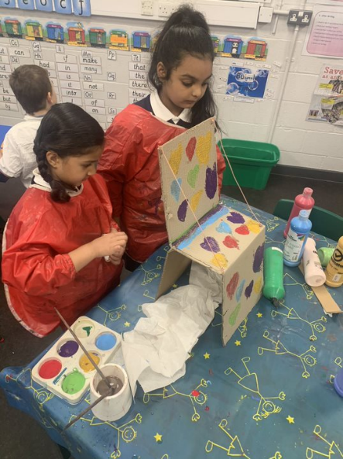
Inspired by Anna Kemp's story of Dave the Lonely Monster, a P2 class went on a journey to befriend a lonely monster in their classroom at Oakgrove Primary School in Glasgow. Using the flexibility of the Reading Challenge, the class embarked on a project which centred creativity as well as developing engineering, writing, and teambuilding skills.

'We loved reading about Dave and we had so many questions we wanted to ask to help us understand the story more.'

Their reading quest started with the arrival of a mystery book with no title and the class banded together to discuss what they knew about monsters and what the book might be called. They delved deeper into the book, expanding their vocabulary and drawing skills:

'We used our visualising skills to listen to a description of Dave, read by our partners, while the other partner tried to create the image on paper. We loved the descriptions of Dave, we spent time identifying the best adjectives in the story. We used them along with our own to create a monster friend for Dave.'

The pupils were encouraged to use their imaginations to decide what their new monster friend might need in his classroom cave. Obviously he needed a rock and roll poster and some wool for his knitting, but he also needed practical items of furniture like a table and chair. The lucky monster even had a guitar crafted for him by a thoughtful pupil.

'We worked extremely hard using our creative, engineering and teamwork skills to create a Cave fit for a monster like Dave.'

Along with the teamwork needed to make an entire cave in the corner of their classroom, the class used the story as a starting point for conversations around celebrating difference as well as health and wellbeing:

'We got the chance to talk about our experiences of feeling lonely and what we did to make ourselves feel better. We though about others in our community. We decided we would smile at people more when we are out and about to help them feel less alone.'
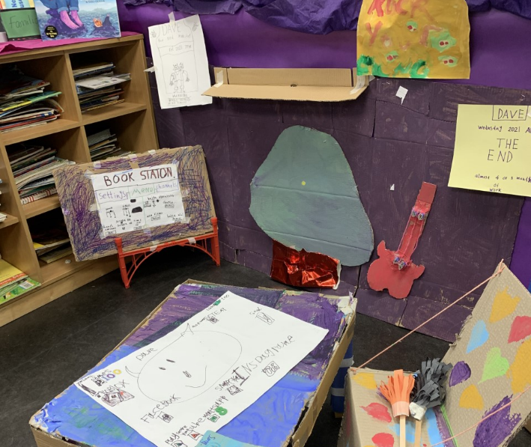
At the end of the project the class reflected on all the exciting activities and conversations they had explored using Dave the Lonely Monster. They developed a deeper love of books, thought about the world around them, and designed and created things from scratch. The learning was led by the pupils but the careful planning behind the scenes gave them a structure in which their creativity could thrive:

'When the children took the learning in different ways or in more depth than I had expected I was required to be responsive and constantly referring back to the experiences and outcomes to ensure that the activities had meaning and purpose.'

The project gave pupils the tools to become creative, confident, and enthusiastic readers after the class moved on to new adventures.

https://www.scottishbooktrust.com/reading-and-stories/first-ministers-reading-challenge/first-ministers-reading-challenge-evaluation

