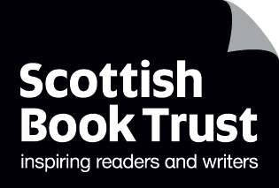
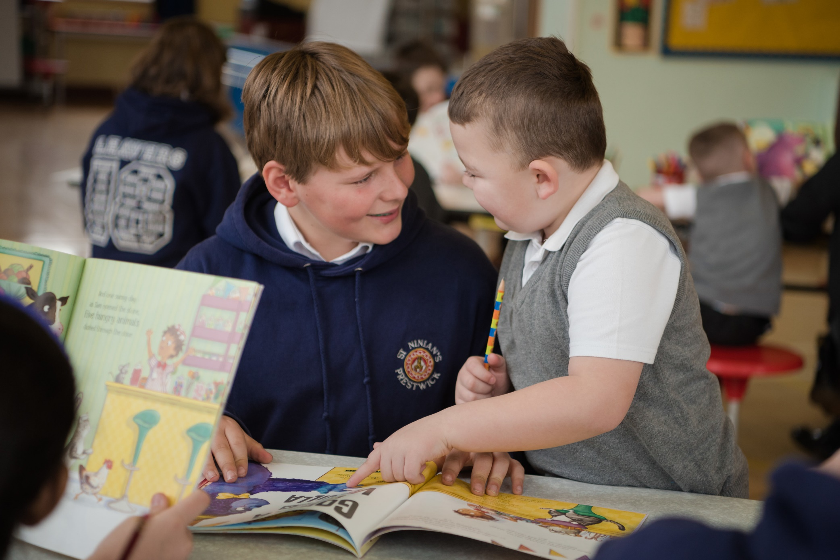

Creating a picture book in class
A resource to support upper primary pupils to write and illustrate a picture book

Suitable for age 8–12

Second level

Resource created by Susannah Jeffries

scottishbooktrust.com
Scottish Book Trust is a registered company (SC184248)
and a Scottish charity (SC027669).

Contents
About this resource 2
Research phase 2
Extension activity 3
Planning phase 4
Planning phase: part one 4
Planning phase: part two 4
Creation phase 6
Book production 6
Sharing phase 7
Questioning 8

About this resource
The aim of this resource is to support older pupils to create a picture book they can share with younger pupils. The activities are designed to be used as a continuous scheme of work but the project is flexible and can be limited or extended to suit your timetable.
Throughout the activities, it would be valuable for the children to have access to a range of picture books. References are made to a range of examples which can be used to illustrate particular ideas or styles.
The activities are based on books by the author/illustrator Ross Collins. However, they are adaptable and can be used with any project or picture book.

Research phase
LIT 2-14a, ENG 2-19a
In this activity, children read through a selection of children’s books to explore the structure and content of the books and how the idea of a ‘problem’ can create drama in a narrative.
The class should begin with a collection of picture books – ideally those with a relatively simple structure as outlined below. Looking at the work of Scottish author/illustrator Ross Collins, There’s A Bear on My Chair and The Elephantom are a good place to start, but you can also cast the net wider and see if you can spot the same structure in other texts. The Loon on the Moon by Chae Strathie or Lost and Found by Oliver Jeffers are just two other examples which spring to mind.
Many picture books follow simple structure. There is usually a main character and they have a problem, e.g. an annoying elephantom in their house. Next, the character gives a number of examples to illustrate the problem, e.g. the elephantom has eaten all the peanut butter, has invited other phantoms around for loud parties, and has done a huge poo in their house. Then the character finds a solution for the problem, e.g. a phantom mouse. At the end you see how their life is now that the problem has been resolved, e.g. the main character is now peacefully spending time with her grandma and the phantom mouse whilst the neighbours are having a nightmare!
With the collection of books you have available, ask the children to consider and make notes on the following questions:
- Who is the main character in this book?
- What is the setting for the story?
- What is the main character’s main problem?
- What examples do they give to illustrate the problem?
- How do they solve the problem?
- What happens at the end of the book? How is the main character feeling?
This activity can be completed individually, in class or as a homework assignment (if availability of books will allow). Alternatively, for scaffolding and peer support this could be completed as a group/discussion activity.
Ask the children to share their findings with the class so that they can all see how this structure works in a variety of stories and with a variety of different characters. The intention of this process is to focus on a particular narrative framework and see how it facilitates storytelling with the intention that, when they come to create their own story, they have a framework to hang their story on rather than a daunting blank page.

Extension activity
As an extension activity or a homework task, you could ask the children to repeat this mapping exercise with a picture book of their choice from home or from the school library. This would give them additional exposure to a greater range of stories and inspiration. It would also encourage them to think about the stories they enjoyed when they were younger.

Planning phase
LIT 2-15a, LIT 2-20a
This activity encourages the children to generate their own ideas for a picture book following the structure outlined in the research phase.
Children should think carefully about their audience. Ideally, you would identify a buddy class in the school, most probably nursery, Primary 1 or Primary 2, for your class to share their picture books with at the end of this project. Before starting on activity two, it would be good for your class to spend a little time with their buddies sharing existing picture books and talking about them so that they have the intended audience in mind when planning.
The children could work in pairs or small groups for this activity. Pairs or groups should be planned to allow for peer support/scaffolding of the process. Alternatively, the activity could be completed individually to provide additional challenge.
All or part of this process could also be set as homework, perhaps over a number of weeks to give the children plenty of time to consider and plan their story.

Planning phase: part one
Give the children a copy of Worksheet 1 (available to download as a separate document from the resource webpage). They can simply make notes, illustrate their ideas or use a combination of both.
They should complete the planning sheet including the following details:
- Identify and sketch your main character.
- Think about the setting of the story – what situation/location they are in.
- Decide on the problem that they have.
- Think of three examples of how this problem presents itself (like the three issues the wee girl faces when the Elephantom is in her house).
- Decide on the solution to the problem.
- Decide how the main character will feel and how their situation will have changed at the end of the story.
Using Worksheet 1 will allow them to create a basic plan for their new picture book.
The next stage is to create a more detailed ‘page plan’ for the story.

Planning phase: part two
A standard picture book is 32 pages long featuring 14 double page spreads containing the story. The remaining pages are taken up with title pages, dedications and copyright information and illustrated pages known as ‘endpapers’. Have a look at some picture books together and count the pages.
Creating a picture book of this length is a substantial project so for the purposes of this activity we are going to use a 16-page format featuring seven double page spreads containing the story plus a front and back cover. You can create a book in this format easily by using four sheets of paper placed on top of each other and folded in half.
There will be:
- A front cover
- Double page spread #1 = introduce characters and setting
- Double page spread #2 = introduce the problem
- Double page spread #3 = example of problem #1
- Double page spread #4 = example of problem #2
- Double page spread #5 = example of problem #3
- Double page spread #6 = the solution to the problem
- Double page spread #7 = how the character feels/how their situation has changed
- A back cover featuring a short ‘blurb’ about the story (optional)
Whilst this is referred to as a ‘planning phase’ this is where the text of the book starts to take shape.
Give the children a copy of Worksheet 2 (available to download from the resource page). This can be enlarged to A3 to provide more room for text and sketching.
Using this planning sheet, the children need to consider the following questions and create an outline plan of their story:
- How do you want to lay out the pages? Do you want to have the text on one page and a picture on the other (e.g. Where the Wild Things Are by Maurice Sendak) or do you want to put text on the pages to interact with the pictures (e.g. The Elephantom by Ross Collins or Stick Man by Julia Donaldson and Axel Scheffler). Perhaps take a look at a selection of existing picture books and see which you prefer?
- What words do you want to include on each page? Spread the story out evenly across the available pages.
- What do you want to include in your illustrations? You can choose a style with lots of detail in each picture (e.g. Shirley Hughes) or something more abstract (e.g. Oliver Jeffers or Jon Klassen).
- Does the content of each picture work alongside the words you have chosen?
At the end of this planning phase, which will require a series of lessons (or a block of homework time) for completion, each child/group will have a detailed picture book plan to work with during the creation phase.
At this stage, it might be valuable to go back to your buddy class and have the children share the story plan with their buddies. This will give them the chance to ask the younger children if they like the story plan and consider the questions and comments of the younger children. It might be that the younger children can give useful feedback about the planned story – they might see elements which need further clarification or potential changes to the story which might improve it, or things that should be included in the pictures. Again, this will encourage the older children to think carefully about their audience when they are creating the final versions of their books.

Creation phase
LIT 2-24a, EXA 2-02a
The detailed plan, which the children have already created, will now form the basis for the creation of the final picture book.
The text was created and refined during the planning phase so this phase is predominantly focussed on illustration. Again, it would be good to spend a little time before you get started looking at the work of a range of picture book illustrators and thinking about how they have each created their images. Some draw with pen, some paint, some use pencil, some use printing – there are many different techniques available.
How you structure the time to allow for the creation of the final picture book will depend very much on the constraints of the timetable in your classroom. Time spent working on the illustrations could be restricted to as little as 20 minutes per illustration to encourage the children to investigate simple, paired-down, ways of communicating the main ideas in the story. Alternatively, the project could run for a number of weeks and take up art and literacy time as well as being something that could be used as a ‘fast-finisher’ activity throughout the week. All or part of the illustration work could also be set as a homework task, assuming that children can have access to their chosen materials at home. In any case, children should be encouraged to work on a double page spread at a time as, in most cases, the images on both pages of a double page spread would interact or work together in some way.

Book production
There are a number of ways to create your final picture books:
- Cut-and-stick books: children can work individually or together to build their books using sheets of card bound with tape or sewn together. They can type and print sections of text and stick their text and illustrations into the book. This gives them the experience of physically building the book and placing the information in the correct order.
- Digital books: you can create a digital version of the book using apps such as Book Creator for iPad. Or you can create a PDF and upload it to a site such as issuu.com which allows you to share digital publications free of charge. Digital books are ideal for displaying on an interactive whiteboard to other classes or sharing online.
- Printed books: it is also possible to have single copies of books printed using online photo-album printers such as Photobox and Snapfish. The children’s illustrations can be scanned or photographed and uploaded to the site as photographs and the text added as an annotation. There is a cost associated with this, but children will be very excited to have a ‘real’ copy of their book.
For books with a cost associated with production, perhaps you could raise funds for the printing by holding a second-hand book sale within school? If children bring in books from home that they are finished with and your class set up a stall and sell all contributed books to other children for a small donation, then you could raise enough money to print a number of books whilst also ensuring that children across the school have affordable access to new books!
Alternatively, if you have a local printer or reprographics company you might even be able to ask them to assist with your project? It would be great to take the opportunity to visit a printing company and find out how books and other printed materials are put together and the different job roles that are involved in the process. Even better if you could see them printing your own books!
If your book is in a digital format, don’t forget to share it online where possible and tweet Scottish Book Trust a link! @scottishbktrust

Sharing phase
ENG 2-12a, ENG 2-17a
The final phase of the project is about returning to your buddy class with the finished picture books and sharing them with the younger children.
This part of the project gives the older children an opportunity to share their stories and the illustrations they have worked on over the past few weeks. It also, critically, gives them an opportunity to practise reading with fluency and expression. It would be great to encourage them to think in advance about the types of expressive choices they want to make to get the most from the story they have created.
You can explore the other resources, activities and ideas in the paired reading toolkit to support you to build pupil confidence and ability in reading aloud.

Questioning
The sharing phase also provides an excellent opportunity for both the older and younger children to create questions for each other and respond to questions based on the stories.
Older children can create questions, perhaps a range of questions from the literal to the predictive, to ask their younger buddies before, during and after the reading of the text. Younger children could also be encouraged to create questions about the stories, characters or about the process of writing for their older buddies.
The process of sharing their hard work, creativity and imagination with its intended audience will be a joyful, exciting and memorable experience for all!

