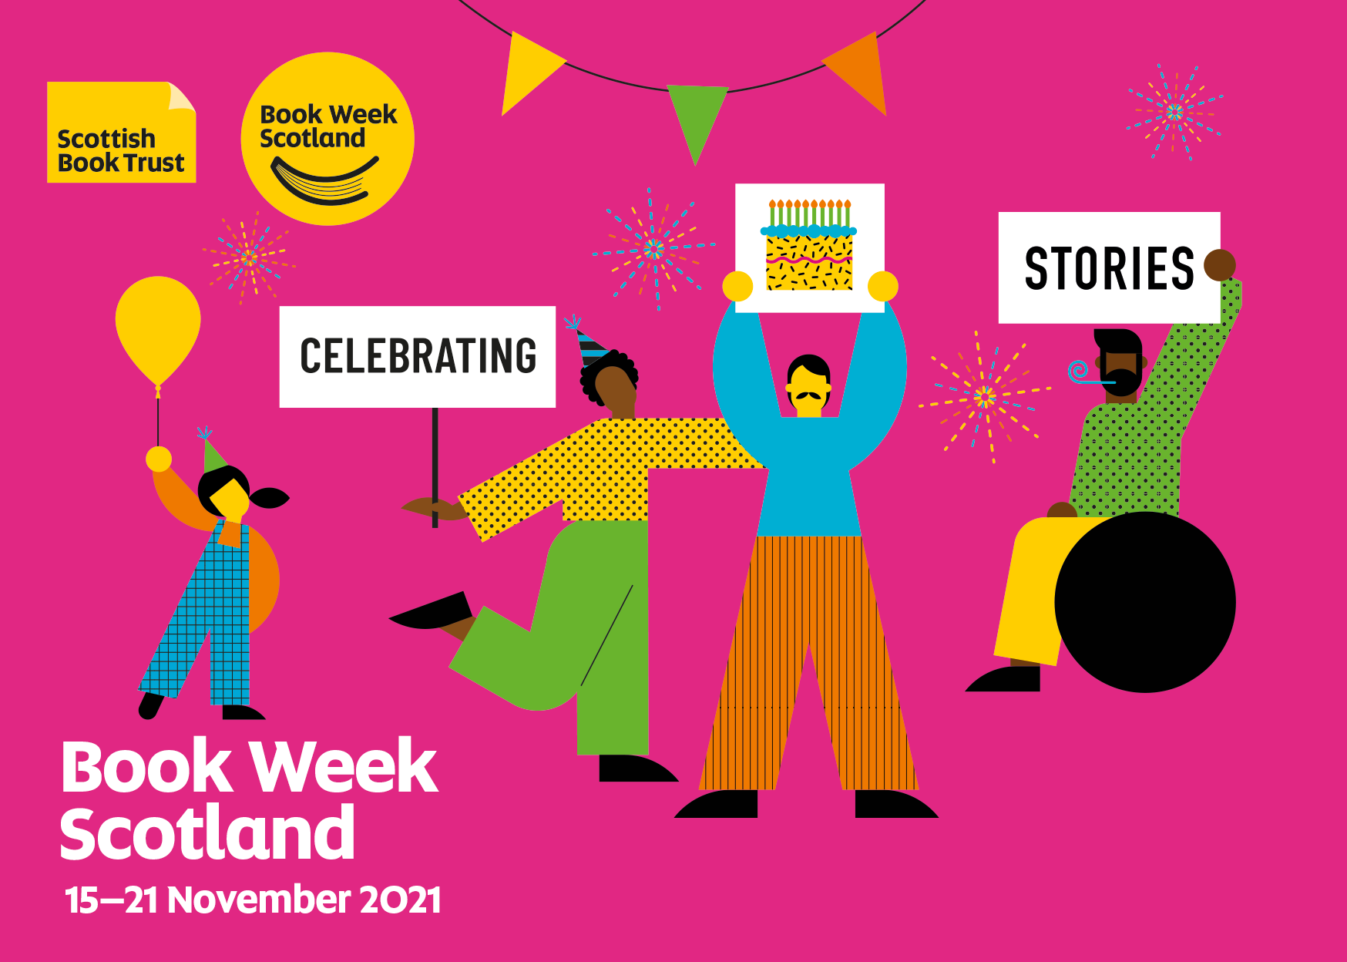

Book Week Scotland resource

Activities to support Book Week Scotland 2021 in your school

CFE first, second and third levels

Resource created by Scottish Book Trust

scottishbooktrust.com
Scottish Book Trust is a registered company (SC184248)
and a Scottish charity (SC027669).

Contents

Authors Live: Patience Agbabi 3
Authors Live: Young Scottish Voices panel 4
Scottish Friendly Children’s Book Tour on demand: Little People, Big Dreams 5
Scottish Friendly Children’s Book Tour on demand: Alastair Chisholm 6
Scottish Friendly Children’s Book Tour on demand: Benjamin Dean 7
Scottish Friendly Children’s Book Tour on demand: Hafsah Faizal 8
Gifting Bookbug P1 Family Bags and Read, Write, Count bags 9
More activities to celebrate Book Week Scotland across your school 10

Authors Live: Patience Agbabi (P6–S1)

Design activity
Think about the environmental problems you are aware of – for example littering, single-use plastic, transport or food production. Can you design a gadget that would solve or reduce the impact of one of these issues? Be creative and imagine what Elle and Big Ben might use in 2048.
TCH 2-07a, TCH 2-09a

Food activity
There are feasts and birthday celebrations in The Infinite. Elle and her friends try to avoid meat and fish whilst at The Academy, as both have an environmental impact. Create a vegetarian or vegan party menu for Elle and her friends. You could even have a go at making some of the food and holding your own meat-free party!
HWB 2-30a, HWB 2-35a

Celebration activity
Imagine that we have made the changes necessary to prevent a climate crisis, and how we would celebrate this achievement. Discuss what the celebration would look like, and what we would need to do to get there.
LIT 2-02a, LIT 2-07a

Authors Live: Young Scottish Voices panel (S3+)

Write a poem that celebrates everyday language
Think of a word that you like, which might not be known to other people – this could be a made-up word that your friends and family use, a Scots word or a word from a particular dialect or other language. Use the word as a title for a poem, using it and other words like it. You might find it helpful to start with a word bank to get you started.
LIT 3-20a, ENG 3-27a, ENG 3-31a

Write a storyboard for the poem
After you have chosen a word to inspire your poem, use a storyboard to help you plan out the structure of your poem. You can use words or images to complete your storyboard, or a mix of the two. Think about how you want the reader or listener to feel during the poem and use your storyboard to plan how you will achieve this.
ENG 3-19a, EXA 3-03a

Write a prose version/creative response
Ask pupils to write a short story, or a comic strip, based on one of the poems or extracts you have heard during the Young Scottish Voices panel. They could continue the poem or extract or focus on a key theme which has been explored in the broadcast. However they choose to respond, it should be creative and original! Remember to share your creative responses with @ScottishBkTrust and the poet or author on Twitter.
ENG 3-19a, ENG 3-31a

Scottish Friendly Children’s Book Tour on demand:
Little People, Big Dreams (P1–3)

Celebrate dance
We learn about Carmen Amaya, a Flamenco dancer, in the event. Watch and learn dances from around the word and then hold a class celebration and perform them.
HWB 0/1-21a, HWB 1-22a, EXA 0/1-08a, EXA 1-09a, EXA 0/1-10a

Create a quote display
In the event, Maria Isabel Sánchez Vegara talks about finding a quote from the person she is going to write about and using this as inspiration for her writing. Collect quotes from different people (real or fictional) that your class finds inspiring and create an inspiring quote wall display. Remember to share your finished wall with us on social media and tag @ScottishBkTrust!
LIT 1-11a, LIT 1-14a

Who would you like Maria to write about next?
Maria writes and celebrates people from all over the world who have done incredible and inspiring things. Who would you like Maria to write about next? Who would you like to celebrate? Write a short story about someone who inspires you.
LIT 1-20a, LIT 1-28a, LIT 1-29a, ENG 1-31a

Scottish Friendly Children’s Book Tour on demand: Orion Lost with Alastair Chisholm and Dynamic Earth (P5–S2)

Working in space travel
It takes thousands of people and years of hard work to get an astronaut into space. Research some of the lesser-known jobs in space exploration. Choose one and make a poster to tell everyone why that job is so important and why you couldn’t go to space without the people who do it. Hold a space event in class where pupils all share their research and posters with each other.
LIT 2-20a, LIT 2-28a, LIT 2-29a, HWB 2-20a

You are the captain
Now you’ve got your starship captain score, imagine what it would be like if you suddenly found yourself in charge of a spaceship. What do you think would happen, and how would you handle your new environment and responsibility?
LIT 2-02a

Packing for Mars
Dr Alastair Bruce talks about how long it would take to get to Mars on a manned mission. If you were one of the first astronauts to go to Mars, what would you take with you? Think about practical needs, like food and water, as well as things to entertain you and keep you comfortable.
LIT 2-20a, SCN 2-20b

Scottish Friendly Children’s Book Tour on demand: Benjamin Dean (P5–S1)

Celebrating Pride
Benjamin talks about how the London Pride Parade was cancelled in 2020 and 2021. Imagine and plan a Pride celebration for 2022 that could take place in your school or community. Remember that Pride is a joyful celebration, but also think about Pride’s origins and the LGBTQ+ fight for equal rights.
HWB 2-10a, HWB 2-13a, LIT 2-09a

Celebrity journalism
Benjamin is a celebrity journalist. If you could interview any famous person, who would you choose? What would you ask them, and what do you think they would say? Write a newspaper article based on your imagined interview.
LIT 2-20a, LIT 2-26a, ENG 2-31a

Positive traits
Benjamin talks about using emotions and traits from real life to inspire his characters. Draw the outline of a character on a piece of paper and write all the traits and characteristics that you like about yourself and your friends around it. Write these next to your character and use this character as a starting point for a story.
LIT 2-20a, ENG 2-30a, ENG 2-31a

Scottish Friendly Children’s Book Tour on demand:
Designing fantasy with Hafsah Faizal (S3–6)

Language touchstones
Hafsah talks about why she includes Arabic words in her books, referring to them as ‘touchstones’. Talk as a group about why including words from more than one language in a book might be useful or helpful to the author or reader. Have you come across any other books or pieces of writing which use more than one language? How do you find it as a reader? You could experiment with trying to write something that uses words from more than one language or editing something you've written previously to include this. How does it change the meaning of your writing?
LIT 3/4-09a, LIT 3/4-20a, LIT 3/4-25a

Creative writing
Hafsah talks about her journey to becoming a published writer, which included some setbacks along the way. Think about your dreams and aspirations, and how you might get there. How would you overcome rejections or setbacks?
LIT 3/4-02a, LIT 3/4-09a, LIT 3/4-10a, HWB 4-19a

Gifting the Bookbug Primary 1 Family Bags and
Read, Write, Count bags

Make the most of the Bookbug P1 Family Bag and the Read, Write, Count bags by holding a gifting party during Book Week Scotland!
Your school should receive a bag for every P1, P2 and P3 pupil, which are theirs to take home. You can find resources to help make the most of gifting and using the bags on our website.

Bookbug P1 Family Bag
All P1 pupils in Scotland will receive a Bookbug P1 Family Bag, which contains three brilliant picture books as well as an activity pack, colouring pencils and a small whiteboard with number magnets and a pen for them to take home!
The three books make up The Bookbug Picture Book Prize shortlist, and children of all ages (not just P1s) can have a say in which book is declared the winner by casting their votes before Friday 10 December. These three books provide a great opportunity for shared reading between younger and older pupils.
We have lots of resources to support gifting the bags and taking part in The Bookbug Picture Book Prize, including lovely videos of the books being read. You can find all of these at scottishbooktrust.com/bpbp

Read, Write, Count
Every P2 and P3 pupil will receive a Read, Write, Count bag, jam-packed with books, writing materials and maths games!
The bags are theirs to take home but to make sure each pupil gets the full value of their new goodies, you can share and enjoy the bag contents in your classroom when you gift them. You could also ask pupils to bring their bags back in from time to time to make use of the brilliant stories and activities throughout the school year!
You can find a full list of what pupils will find in each bag, as well as lots of activity ideas, videos of the stories being read and gifting ideas at scottishbooktrust.com/readwritecount

More activities to celebrate Book Week Scotland across your school

- Make some time to play our Book Week Scotland role-playing game! (Please note, this link will not work until 1 November)
- Try your hands at playlist poems! We're asking people to write poems using song titles this Book Week Scotland. Make sure you share your poems with us on Twitter! (Please note, this link will not work until Book Week Scotland begins on 15 November)
- Take part in our #ILoveMyLibrary campaign! (Please note, this link will not work until Book Week Scotland begins on 15 November)
We'll be celebrating Scotland's libraries during Book Week Scotland. You could try one of the ideas below, and make sure you share it with us on social media!
  - Ask your pupils to write handwritten reviews to go in your school library or local library. This could be a great paired reading activity between younger and older pupils.
  - Create a class display for your school library or local library – this could be a Book Week Scotland display, or a showcase of your pupils' favourite books!
  - Split your pupils into groups and ask them to make a short film about why they love their school library or local library. You could use our film-making resource created with Into Film Scotland to get you started.
- Add what you and your pupils are reading to our Reading Map, and see what other people are reading across Scotland! (Please note, this link will not work until Book Week Scotland begins on 15 November)
- Hold a Drop Everything and Read hour in your school, and join in with our #ReadingLunch on Thursday 18 November!
- Celebrate your class' favourite book or current class read by decorating your classroom door to look like the cover.
- Create a cinema experience with Authors Live and watch one of the live events during the week or one from the On Demand library. Set up the classroom or assembly hall as comfortably as you can, dim the lights and get some snacks ready! There are over 80 events to choose from in the On Demand library, so you can be sure you'll find something to suit your pupils.
- Sign up for The Bookbug Picture Book Prize or the Scottish Teenage Book Prize if you haven’t already, and get your pupils reading the books on the shortlist so they can take part in the national votes. There are videos and resources to support the prizes on our website.

