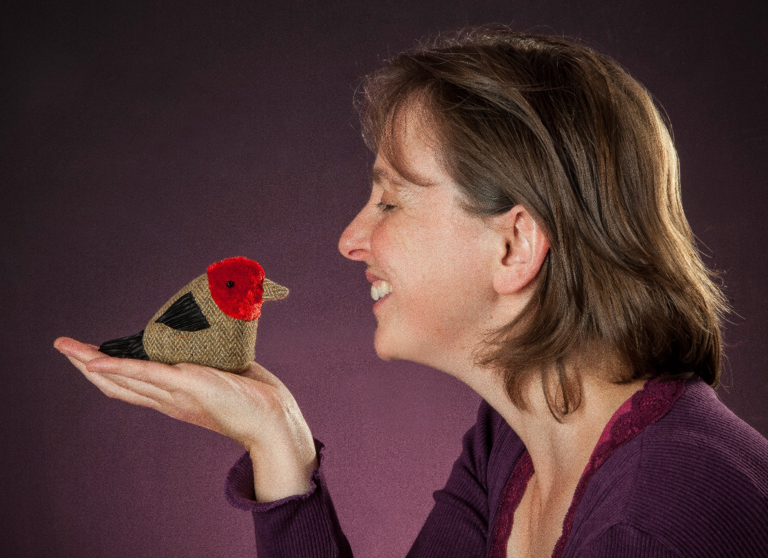

The Wee Bannock sensory story

Age 3+

Story created by
Ailie Finlay

Story created by Ailie Finlay for the Inclusive Stories Festival

scottishbooktrust.com

Props
You will need:
- A pair of slippers
- Child’s bucket or other container
- A stick or child’s spade
- Pillowcase
- Newspaper

Story
Once evening an old lady was making bannocks over the fire.
Suddenly one of the bannocks jumped up and rolled across the floor and out the open door.
Roly-poly, roly-poly…wheee! [roly-poly your arms around each other]
The old lady jumped up and ran after it. She ran down the hill in her slippers! [put the slippers on your hands and bang them together]
Roly-poly, roly-poly…wheee! [roly-poly your arms around each other]
In the garden her grandson was making mud pies. When he saw his granny chasing the bannock he jumped up and ran after her with his bucket still in his hand [bang bucket with stick]
The boy chased his granny.
And granny chased the bannock.
Roly-poly, roly-poly…wheee! [roly-poly your arms around each other]
Near the foot of the hill was a farm. The farmer was hanging out her washing, when she saw the boy chasing his granny, granny chasing the bannock and the bannock rolling down the hill.
She ran out of the garden, flapping a pillowcase. [flap pillowcase]
The farmer chased the boy, the boy chased his granny and granny chased the bannock.
Roly-poly, roly-poly…wheee! [roly-poly your arms around each other]
Near the river was big old house. The old man who lived in the house was sitting in the sun reading his newspaper. He saw the farmer chasing the boy, the boy chasing his granny, granny chasing the bannock and the bannock rolling down the hill.
The old man jumper up, waving his newspaper [rustle and wave newspaper]
The old man chased the farmer, the farmer chased the boy, the boy chased his granny, granny chased the bannock and the bannock rolled down the hill.
Roly-poly, roly-poly…wheee! [roly-poly your arms around each other]
The bannock rolled and rolled and rolled and rolled.
It rolled all the way to the very bottom of the hill.
It rolled right to the big wide river and then….
Splash! It rolled right into the river. [clap hands together to make a ‘splash’]
The old man and the farmer and the boy and his granny all watched as the bannock sank to the bottom of the river.
They all gave a big sigh. [sigh]
….and turned around and walked home as the sun sank behind the hills.
But if you are ever walking by that river listen carefully and you might just hear:
Roly-poly, roly-poly…wheee!

