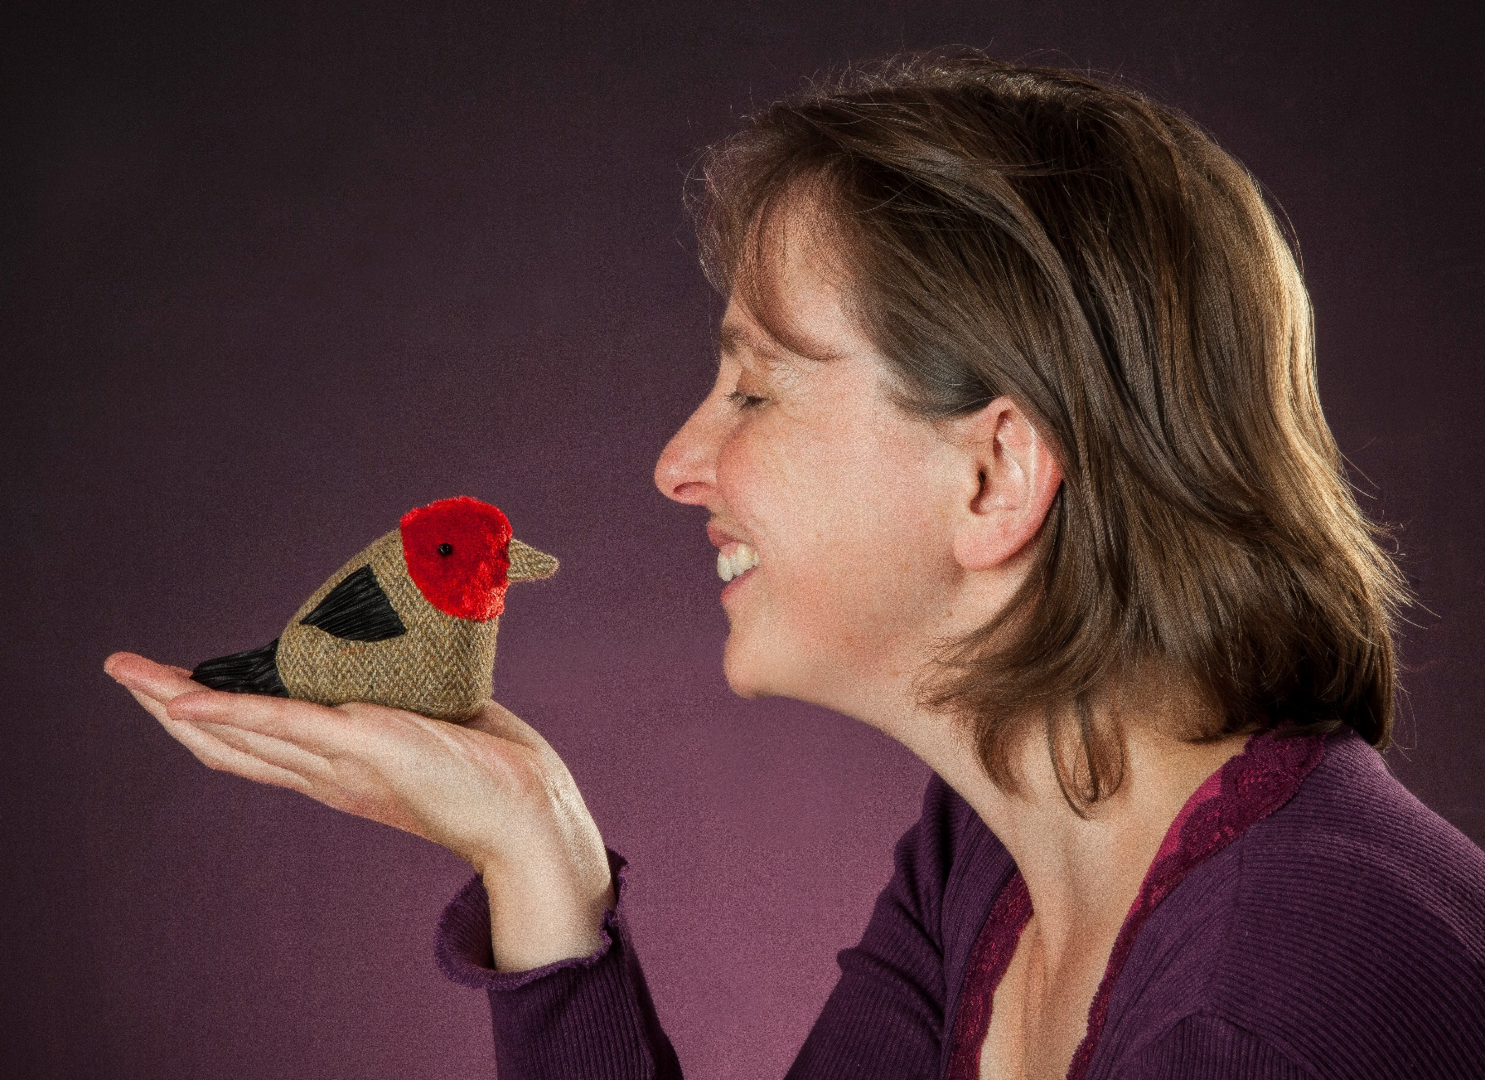

The Runaway Gingerbread Man at the Yard sensory story

Age 3+

Story created by
Ailie Finlay

Story created by Ailie Finlay for the Inclusive Stories Festival

scottishbooktrust.com

Props
You will need:
- Two wooden spoons
- A paint brush
- A superhero cape or piece of fabric to ‘flap’
- Bicycle bell or horn
- Feathers
- A baby’s rattle (or just put some rice or beans into a Tupperware container to shake)
Story
At the Yard Ronnie and Marta and Bruce were making gingerbread biscuits with some of the children. There were gingerbread women and gingerbread men and gingerbread boys and girls.
One little gingerbread boy was all by himself on a plate.
Very quietly he climbed off the plate. He jumped off the counter. And he ran away.
‘Stop!’ said Ronnie and Marta and Bruce.
They ran after the gingerbread boy, banging their wooden spoons together. [Bang spoons together]
The gingerbread boy ran round and round and round. [Make a circle with your index finger on the palm or back of your child’s hand]
And then he ran right over a painting that a little girl was doing in the art corner.
‘Stop!’ said the little girl.
’I’ve run away from Ronnie and Bruce and Marta,’ said the gingerbread boy ‘and I can run away from you, I can!’
The little girl ran after Ronnie and Bruce and Marta waving her paint brush in the air. [Let your child feel the paint brush by ‘painting’ on their hand]
Ronnie and Bruce and Marta ran after the gingerbread boy.
And the gingerbread boy ran round and round and round. [Make a circle with your index finger as above]
Then he ran over the soft play, out the door and past a pair of twins dressed as superheroes.
‘Stop!’ said the twins.
‘I’ve run away from Ronnie and Bruce and Marta, and the little girl,’ said the gingerbread boy ‘and I can run away from you, I can!’
The twins ran after the little girl, their capes flapping. [Flap cape, or piece of fabric]
The little girl ran after Ronnie and Bruce and Marta.
Ronnie and Bruce and Marta ran after the gingerbread boy.
And the gingerbread boy ran round and round and round. [Make circles as above]
He ran right past three teenagers on a trike, a bike and a scooter.
‘Stop!’ said the teenagers.
‘I’ve run away from Ronnie and Bruce and Marta, the little girl and the superheroes’ said the gingerbread boy ‘and I can run away from you, I can!’
The teenagers whizzed after the super-heroes ringing their bells and horns. [Ring bell or honk horn]
The super-heroes ran after the little girl.
The little girl ran after Ronnie and Bruce and Marta.
Ronnie and Bruce and Marta ran after the gingerbread boy.
And the gingerbread boy ran round and round and round. [Make circles as above]
He ran right round a tree.
‘Stop!’ said a bird in the tree.
‘I’ve run away from Ronnie and Bruce and Marta, the little girl, two superheroes and the teenagers on bikes,’ said the gingerbread boy ‘and I can run away from you, I can!’
The bird flew after the teenagers. [Let your child feel the feathers, or make a bird noise]
The teenagers cycled after the super-heroes.
The super-heroes ran after the little girl.
The little girl ran after Ronnie and Bruce and Marta.
Ronnie and Bruce and Marta ran after the gingerbread boy.
And the gingerbread boy ran round and round and round. [Make circles as above]
Suddenly….
CRASH!
The gingerbread boy ran right into a baby playing in the grass.
‘Stop!’ said the baby waving his rattle in the air. [Shake the rattle]
’I’ve run away from Ronnie and Bruce and Marta, the little girl, the superheroes, three teenagers on their bikes and a wee bird,’ said the gingerbread boy ‘and I can run away from you, I can!’
But…
One, two, three…
Snap! [Clap your hands together]
That baby snapped up the gingerbread boy just like that.
That baby ate the gingerbread boy all up!
‘Mmm’ said the baby.
‘Sigh’ said Ronnie and Bruce and Marta, the little girl, the superheroes, the three teenagers and the little bird. And they all went away to bake some more biscuits.

