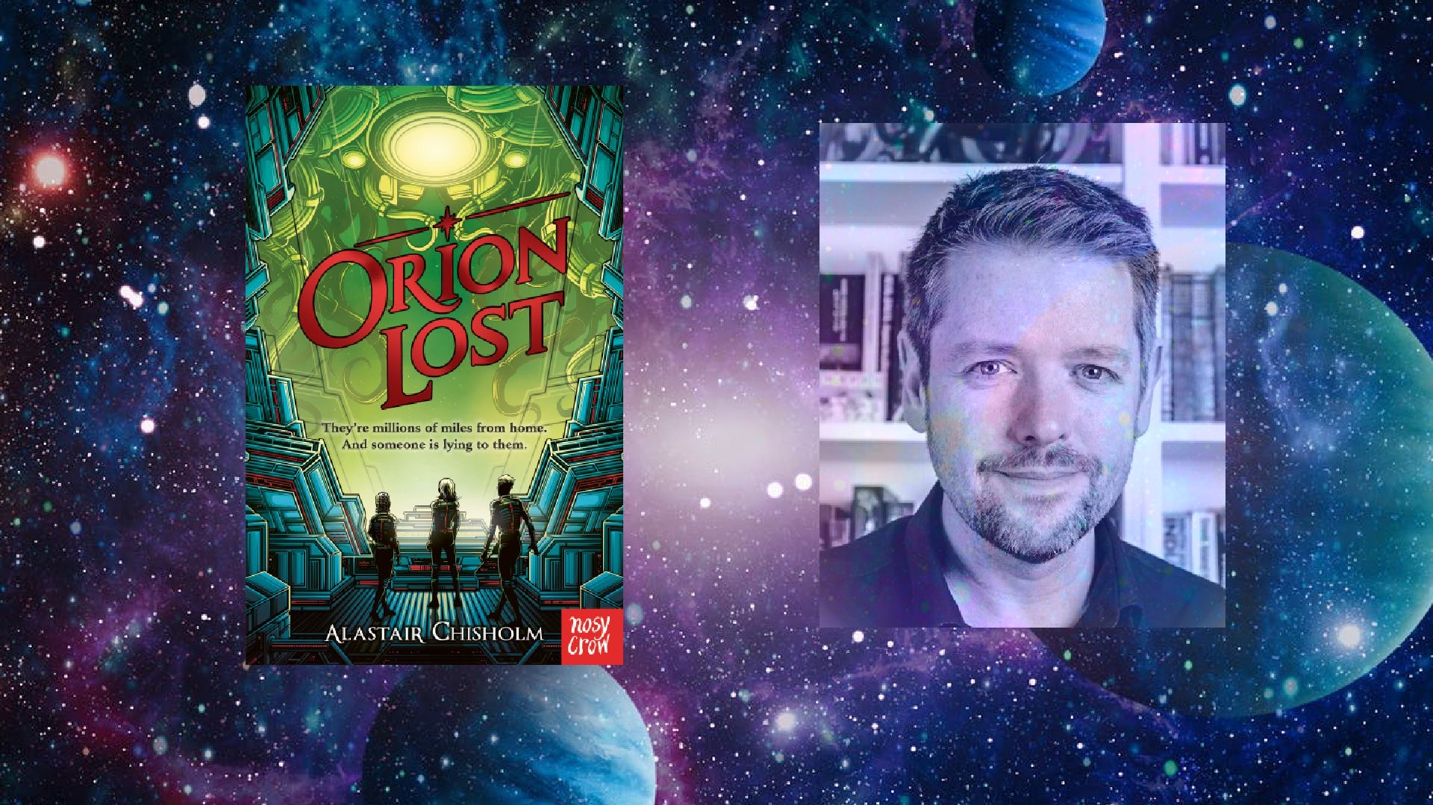
Resource created by Scottish Book Trust

Orion Lost learning resource

Age 8-12

CFE Level 2

Creative activity inspired by Alastair Chisholm’s novel Orion Lost

scottishbooktrust.com

/scottishbktrust

@scottishbktrust

Contents
Robots in Space exhibition 2
Dynamic Earth’s Space Resource 3

About this resource
This resource features a cross-curricular activity to help you explore Orion Lost with your students. Adapt and use as you see fit!
Introducing Orion Lost

The transport ship Orion is four months out of Earth when catastrophe strikes - leaving the ship and everyone on board stranded in deep space. Suddenly it's up to thirteen-year-old Beth and her friends to navigate through treacherous and uncharted territory to reach safety. But a heavily damaged ship, space pirates, a mysterious alien species, and an artificial intelligence that Beth doesn't know if she can trust means that getting home has never been so difficult... Hugely gripping, with incredible twists and a fast-paced, action-packed story, this is an unputdownable science fiction adventure - perfect for fans of Mortal Engines and Star Wars.

Robots in Space
LIT 1-13a, LIT 1-14a, LIT 1-26a, TCH 1-05a, TCH 1-09a, TCH 1-11a
Imagine a future where there are robots in space doing amazing things. Well, what you are imagining is happening today!
Astrobee, NASA’s new free-flying robotic system, help astronauts reduce time they spend on routine duties, leaving them to focus more on the things that only humans can do. They’re quite cute too! See them in action here.
Astrobees are not the first robots to go into space. Here’s some more robots which are each designed for specific tasks and environments.
Split your pupils into groups and assign each group a different robot that they will research online.
Pupils can draw their robot and make a model out of recyclable material. They can also research online to find out as many amazing facts about their robot, which planet it has been to, and what makes their robot useful in space.
Pupils can then use a robot fact file to share information about their robot including information about:
- Robot name
- Applications
- Mission
- Achievements
- Fantastic facts
- Special abilities

Working on a group project/exhibition is a great way for pupils to stay connected whilst apart, and gives them something to look forward to when they return to school. Once pupils are back in school they can display their robot models/drawings and fact files as a space museum exhibition.

The exhibition could also include a map of the solar system showing where each robot has been.

Extension activities:
Write an exhibition label
Write museum labels to accompany all the items to be displayed in your space exhibition. Museum labels tell the viewer essential information about the object to on display, such as production date, where it came from or who it was made by, and usually give a small summary (30-50 words) about the history of the object. You can look at the National Museum of Scotland collection database to help you identify the key information and write your label/s. key questions to think about are:
- What does the viewer need to know about this object?
- What is the most interesting thing about this item?
- What information is extra or surplus to the viewer’s needs? E.g. when it entered the collection.

Share the exhibition
As families are not currently able to see you space exhibition, can you film a guided tour of the display to share with families? Involve all members of the class to help script, film and edit the exhibition video. You could hold an official release or red-carpet-night and encourage families to tune in to the premiere together.

Dynamic Earth’s Space Resource
Dynamic Earth is a state-of-the-art family attraction and science centre which takes visitors through the history of our planet, from the Big Bang to modern day. Based in Edinburgh, it is the largest interactive visitor attraction in Scotland and welcomes schools all year round to learn about Earth science, fossils, dinosaurs, space and more.
In this Space-themed resource, made by Dynamic Earth, you will find a range of activities, crafts, experiments and more to inspire your pupils.

Dynamic Earth is temporarily closed due to COVID restrictions, you can find a wealth of information and resource on their recently launched new website, Dynamic Earth Online.

