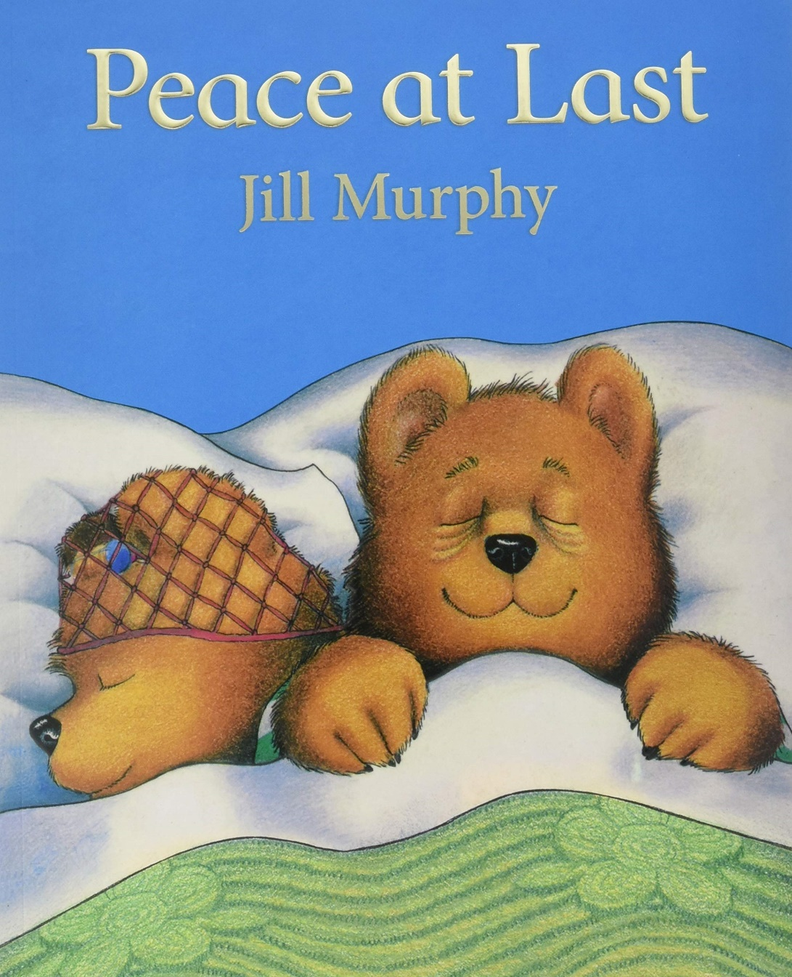

Step by step: Peace at Last by Jill Murphy
Age 3-18

CFE Levels First to Fourth

Resource created by
Ailie Finlay

A guide to turning picture books into sensory story

scottishbooktrust.com

Peace At Last is a great choice to turn into a sensory story; it has a simple narrative with just a line or two of text on each page - and lots of lovely noises!

Here are some suggestions for props and sensory stimuli to include when you are telling the story:
Start the story with some nice big noisy yawns. Make footsteps by ‘marching’ your feet on the floor as the bears go to bed. And then snore very loudly! You could also use a vibrating baby toy for the snore; let the child feel the vibrations on their arm as you pull the string.
A toy aeroplane like Baby Bear’s would be great to include and if you use one with wheels you could try running it up and down the arm of the person you are reading the story to as well as ‘flying’ it around.
I find that a ‘football rattle’ works really well for the ticking clock in the living room. (Turn the handle very slowly to make a tick, tick, tick noise.) The dripping tap in the kitchen can be a drum beaten rhythmically. These ticking and dripping rhythms could also be tapped out on the back of the child’s hand. And then you need to hum like a fridge!
Loud snuffling and meowing noises are needed for the hedgehog and cats. For something more tactile an old-fashioned scrubbing brush makes good hedgehog prickles and a pastry brush is good for cat’s whiskers! The RSPB produce toy birds that make real bird calls when squeezed (widely available on-line) – try the owl toy for the garden scene.
The page where Mr Bear tries to get to sleep in the car is the climax of the story. If possible, the sensory experiences that accompany this page should be the biggest, loudest and most impressive of your story. Try to have lots of noisy birds to squeeze or other bird sound effects. If you are telling the story to a class of children everyone could join in at this point. For children who are more interested in tactile sensations you could use feathers. You could also use a large yellow silk scarf or piece of light fabric for the sunshine. This can be wafted around and even over the top of the child you are reading to as you say ‘shine, shine’.
The ‘Brrrring’ of the alarm clock at the end of the story needs to be a bit annoying! You could try using a real old-fashioned mechanical alarm clock. These vibrate as they ring so let the child feel it in their hand. If the person you are reading to tends to startle easily you could put a recording of the alarm clock ring onto a switch communication device such as a BIGmack so that they can control when it rings and when it stops. (The phrase ‘oh no!’ could also be put on a BIGmack to enable everyone to join in with the story.)
Finish off by stirring a ‘nice cup of tea’ (empty cup!) with a teaspoon.

