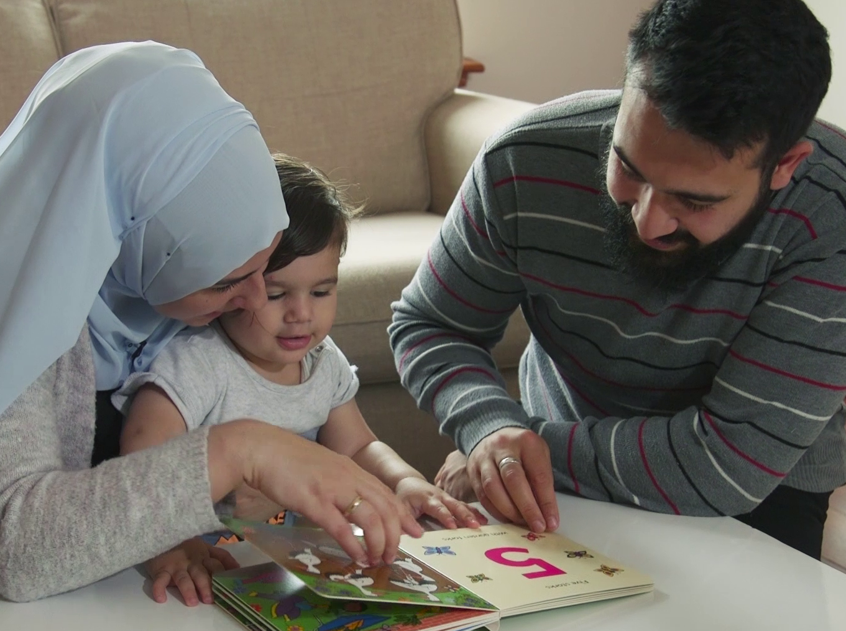

Supporting early numeracy with
Bookbug

Ages 0–5

Resource created by Scottish Book Trust

Ideas and information for delivering a Bookbug Session for Maths Week Scotland

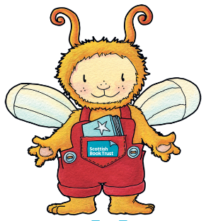
scottishbooktrust.com

Contents
About this resource 1
How can songs and rhymes help to develop numeracy skills? 2
Messages for families 3
Delivering Bookbug Sessions online 3
Bookbug Session Plan: Maths Week Scotland 2020 4

About this resource
Scottish Book Trust and the Bookbug programme are supporting Maths Week Scotland with this special plan for a maths and numeracy themed Bookbug Session. Maths Week Scotland takes place every year during the Autumn term. This year it takes place from 28th September to 4th October.
Maths Week Scotland is a wonderful way to experience the fun and relevance of the maths all around us. Established in 2016, the initiative seeks to transform Scotland into maths-positive nation where we all appreciate the value and importance of numeracy and maths as well as its vital role in all aspects of our lives.
Parents and family have a huge role to play in early learning and development. Early maths is much more than counting - it’s shapes, measuring, estimating, building and problem solving, spatial awareness and the logical thinking that lays the foundations for developing numeracy and maths skills as education progresses. Parental and family attitudes to maths can have a significant impact on children’s confidence in the subject so it’s great to be positive about it, and to regard lots of pursuits like spotting patterns, counting things and board games and digital games as a fun way of building understanding.
A range of family learning and parental engagement sessions are already planned during Maths Week for parents with children at all ages.– showcasing the children’s learning, enjoying maths trails, treasure hunts, challenges and outdoor games.
Any feedback would be hugely welcome and please tag @mathsweekscot in any tweets. If you’re singing, rhyming or reading about numbers please tag @BookbugSBT on Facebook and @Bookbug_SBT on Twitter.

How can songs and rhymes help to develop numeracy skills?
One of the simplest ways to support children’s numeracy skills is to include a range of counting songs and rhymes. Songs and rhymes help them to learn and understand the sequence of numbers e.g. from 1 to 5 or up to 10. Try to include some songs where you count up, and others where you count down. Children need lots of opportunities to practise counting.
Simple actions and using fingers to count will help to reinforce children’s awareness of numbers. At the start of a song or rhyme, ask adults and children to show you the number of fingers they will need to join in with the counting. Choose different songs to vary the numbers you start with e.g. Three Little Speckled Frogs or Ten Fat Sausages.
Counting props will help children understand that the number you are saying corresponds to the physical number of items. For example, bounce five puppets on Lycra or a parachute, and sing Five Little Ducks. After each verse count how many are left, holding up or touching each puppet as you say the number.

Counting songs and rhymes
Three Little Men in a Flying Saucer | Five Little Ducks | One Little Teddy
Hickory Dickory Dock | Ten Red Apples | Ten Fat Sausages
Three Little Speckled Frogs | One Potato, Two Potato | Five Currant Buns
One, Two, Buckle My Shoe | When I Was One | Zoom, Zoom, Zoom
One, Two, Three, Four, Five | Alice the Camel | Ten in the Bed
I Have Ten Little Fingers | Five Fat Peas | Three Craws

Look for more suggestions on the Bookbug app or in the Song and Rhyme Library.
Finger Rhymes
Songs and rhymes which encourage awareness and use of fingers can support children’s early learning. Include songs where you count on each finger, but also songs or rhymes which include finger play e.g. Two Little Dickybirds, Tommy Thumb.
Size, shape and position
Action songs and rhymes featuring size, direction or position will support children’s awareness of these concepts. Examples include:
Size | Direction/position
Five Fat Peas | Roly Poly Up, Up, Up | Forwards and Backwards
A Big Red Bus | The Grand Old Duke of York | Shooglie Wooglie
 | Here We Go Round The Mulberry Bush

Choosing a book
There are lots of books which feature counting, numbers, shapes, sizes and other mathematical concepts. We’ve included a few suggestions on the Maths Week Scotland Bookbug Session plan below. For other ideas, have a look at the Books that support numeracy booklist on our website.

Messages for families
We want families to have fun and to build songs, rhymes and stories into their daily life. Where possible, please share information with parents and carers about how doing this has a positive impact on children's learning and development. We’ve included a few examples below. Remind parents that they are already introducing maths and numeracy to their children by doing songs and rhymes.
- Action songs such as A Big Red Bus and Forwards and Backwards are a great way to introduce to children to children to the concepts of shape, size and direction. Joining in with the actions helps children to grasp these concepts and introduces them to early maths language.
- Finger rhymes help children see numbers represented. This will help them learn to recognise numbers by sight so they will know what 3 looks like and they won't have to count each time.
- Children need lots of opportunity to practise counting. Include a range of songs and rhymes that count forwards and backwards.

Delivering Bookbug Sessions online
Due to the current Covid-19 restrictions, in-person Bookbug Sessions are not running, but you can hold a special online Bookbug Session to celebrate Maths Week. Find lots of ideas in our Maths Week session plan. If you’re new to online sessions, take a look at our guidance document which will help you get started.
Scottish Book Trust will broadcast a themed online Bookbug Session on Facebook on Friday 2nd October at 10am. Please join us then and encourage families to follow @BookbugSBT on Facebook for updates.
Bookbug Session: Maths Week Scotland 2020
Activity type | Title | Benefits | Tips
Introduction | Welcome families and let them know this is a special session for Maths Week and includes songs and rhymes with counting, size, and shape – all of these things help children to develop early maths skills and numeracy.
Introduction song | The Hello Song | Let’s everyone know they are welcome and the session has started! | Clap or tap along to the beat
Finger play rhymes | Two Little Dicky Birds  One Potato  Five Fat Peas | Using your hands gives a visual understanding of the concept of counting. The rhyme and rhythm help with learning the words as well as being important pre-literacy skills. | Use your fingers and hands and encourage families to do the same.  They can do these rhymes on the adults’ hands then on the children’s.
“Transition song” | What is in my bag today? | Builds anticipation and creates interest. | (e.g. Have pebbles, fish/net, shoe/stick) Count your pebbles as you bring them out of the bag.
Counting Up To Ten | *Counting Stones  **One, Two, Buckle My Shoe | Lots of repetition, using hands and objects all help with learning to count. | Use your fingers to count and show numbers.  Encourage everyone to join in with actions in “Buckle My Shoe”
Story | Tall & Short  By Jonathan Litton & illustrated by Fhionna Galloway | This story shows lots of maths concepts like size, weight and speed. | Have fun with animal noises and actions and encourage children to join in.
Size, Speed and Position Action songs | A Big Red Bus  Forwards & Backwards | Repetition and fun actions help with understanding concepts of size, speed and direction. | Have lots of fun and encourage children and adults to join in with the actions.
Counting Down from 5 and adding | Five Currant Buns  Three Craws  Ten Red Apples | The repetition in each verse reinforces the concept of “taking away” | When counting down buns, count how many are left after each one disappears. You can do this on your fingers if you don’t have buns or apples!
Lullabies with finger puppets | Twinkle Twinkle | Lovely for bonding as parent and child cuddle up. | Point up above to the sky and make a diamond shape with your hands.
Final song | The Goodbye Song | This familiar song lets everyone know the session is over. | Thank everyone for joining in.

*Counting Stones
One stone, two stones, three stones four,
Five stones, six stones sitting on the floor.
Seven stones, eight stones, nine stones, ten
Put them in a row and count them all again!

**One, two, buckle my shoe
Three, four, knock at the door
Five, six, pick up sticks
Seven, eight, lay them straight
Nine, ten, a big fat hen.

For more songs, rhymes and stories that support numeracy, check out the Books About Numbers booklist on our website & Counting Songs in the Song and Rhyme Library or free Bookbug app.

