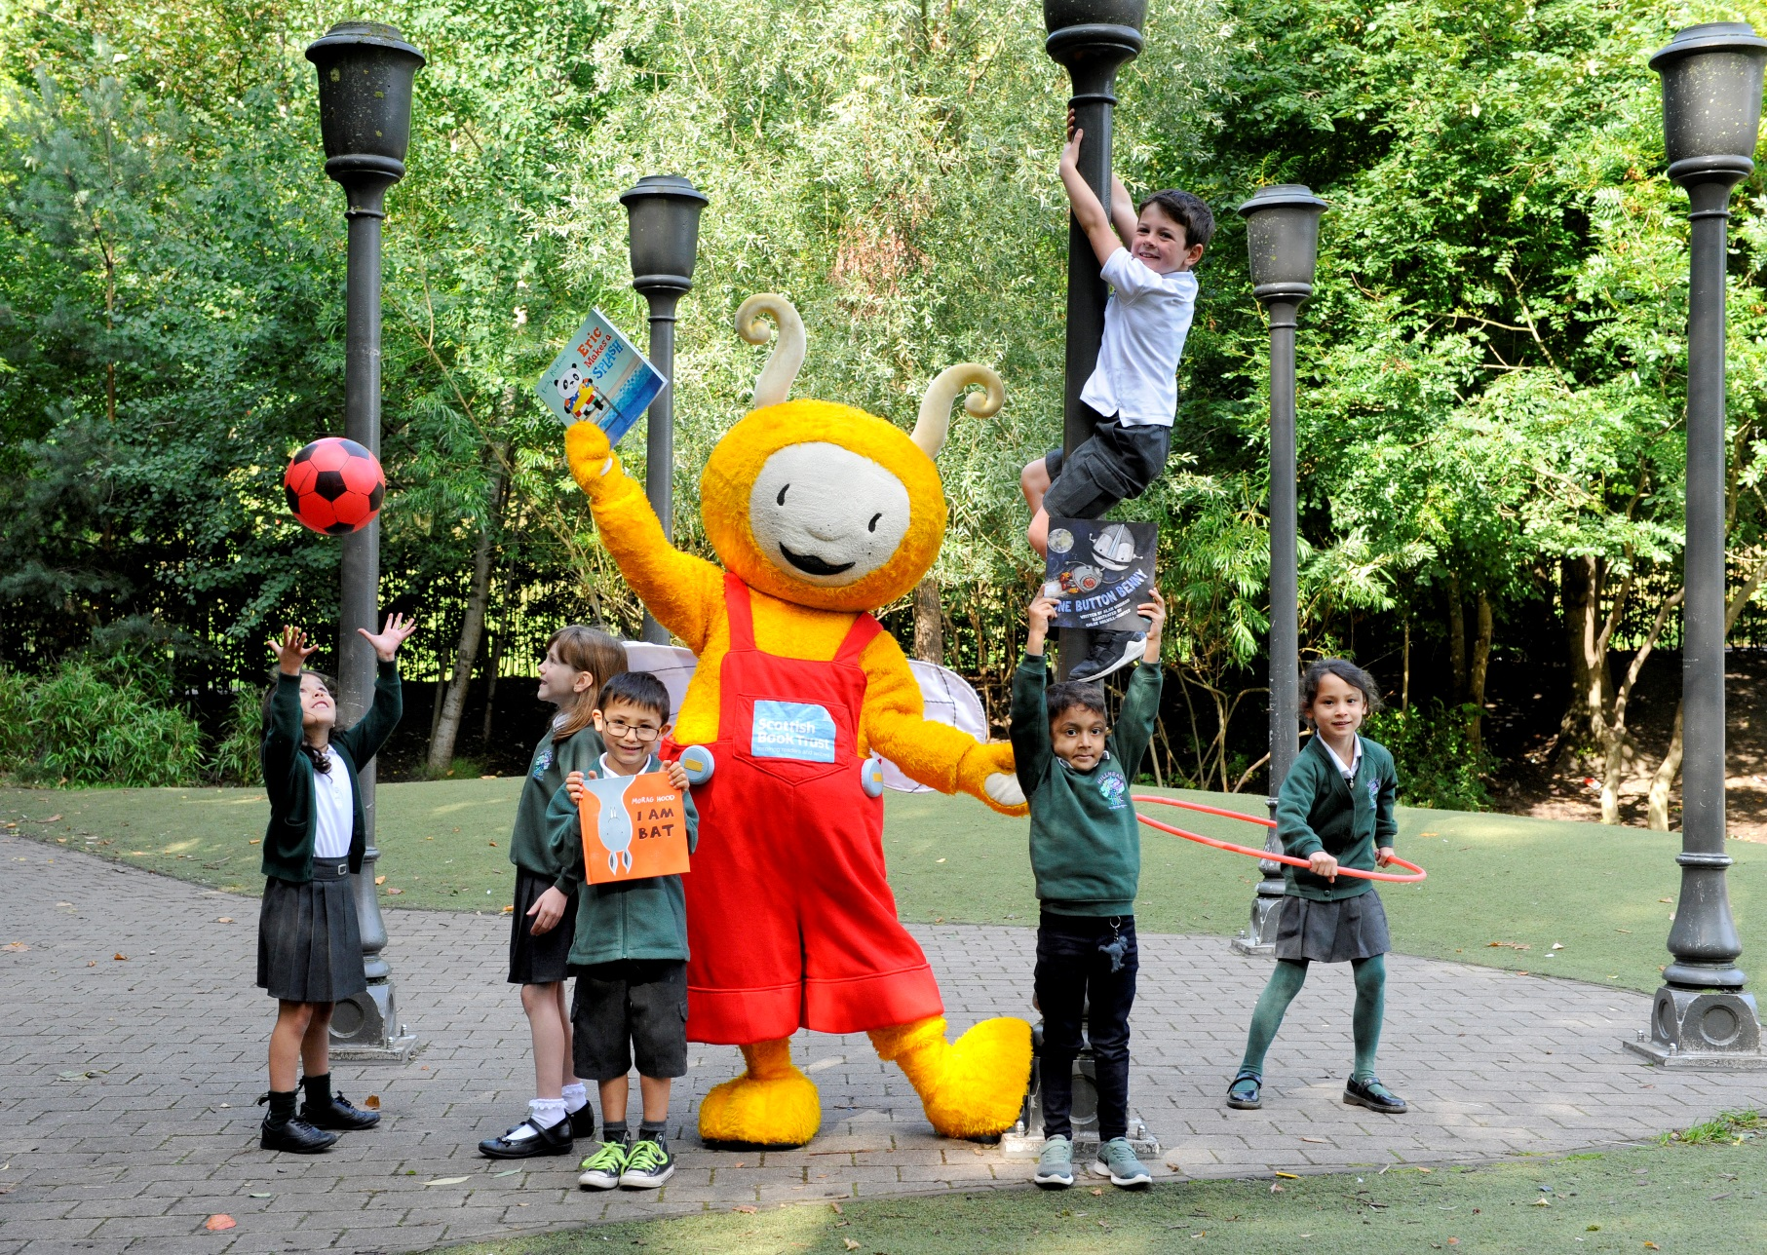

Bookbug Session: TransitionsNursery to P1 transition
Ages 3–5

Resource created by Scottish Book Trust

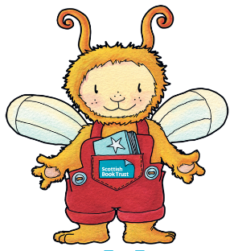
Using Bookbug Sessions to support Nursery to Primary 1 transitions
scottishbooktrust.com

Contents
About this resource 1
Why songs and rhymes are important at this stage 2
Top tips for a transition Bookbug Session 2
Bookbug Session plan ‘Transitions - Nursery to P1 transition’ 4

About this resource
Transition from nursery to primary school can be a challenging time for families and schools. This year, there are the restrictions imposed as a result of Covid 19 to contend with as well.
To support children through transition, we have developed a special Transition Bookbug Session Plan which you can use remotely or in small groups face to face.
This resource includes a video of the session which you can use for reference or share directly with families to use over the summer and all the songs and rhymes can be listened to on our website or our free Bookbug app.
Alongside this we have some information, advice and tips which you may find useful to help you adapt the sessions to your children and setting.
We hope you enjoy it!

Why are songs and rhymes important at this stage?
- Songs and rhymes are some of the building blocks to language and literacy skills. They encourage an awareness of sounds and how they work together. This is needed before children map sounds onto letters.
- They also develop eye contact, turn taking, attention and listening skills which are crucial for good communication and being able to learn.
- Action songs and rhymes help children understand new words and concepts by highlighting keywords visually. They also encourage gross and fine motor development and coordination.
- Counting songs and rhymes help develop early numeracy.
- Especially helpful right now, singing can boost psychological wellbeing – singing together promotes a sense of belonging and endorphins (“happy hormones”) are released when we sing!
Find ideas for songs and rhymes to try or learn the words, tune or actions in our online song and rhyme library or download the free Bookbug app.
For more on the benefits of including songs and rhymes at this stage, the Hanen Centre website has a helpful resource on how they contribute to school readiness.

Ten Top Tips for your Bookbug Transition Session
Repeat, repeat, repeat! It helps everyone learn the words and actions and increases confidence and participation. Children love joining in when they know what is coming.
Be flexible: If you know a more familiar song, use that instead. If you don’t know the tune to “What is in my bag today?” sing “I wonder what’s in my bag today?” to the tune of “Here We Go Round the Mulberry Bush” or another melody that you prefer.
Add words that fit the situation e.g. “If you’re friendly and you know it, wave hello!” for getting to know each other.
Vary it: You can be fast and slow, loud and quiet. This helps keep children interested but is also a way of demonstrating language concepts and linking to themes in the story.
Use symbols to support understanding for children with additional support needs (e.g. Boardmaker symbols in a visual session plan) and keyword signing (such as Makaton or Signalong). CALL Scotland have provided symbol resources for the book used in this session plan.
Incorporate props: Props keep children’s attention and can link to the “real world”! You might want to have a snack table set up to introduce “I’m a little teapot”. If you don’t have your usual props available, be creative – use what you can find. Don’t have your Bookbug doll available? Use a teddy instead!
You are your best resource: Use your voice and your face to add expression. Incorporate actions others can copy. E.g. miming having a cup of tea; peeling a banana or asking “Who can guess what’s for Bookbug’s snack today?” can add interest if you don’t have props available.
Use our book lists to choose a familiar book and signpost to families. There are lists on starting school and on books to share at times of change. In our template session, we have used a book from this year’s Bookbug Explorer Bag, The Same But Different Too by Karl Newson and Kate Hindley. If you don’t have it or have a story that you know would be better for your setting, share that instead.
If you are recording your session, or sharing over social media, check our resource on sharing Bookbug Sessions online for more about book recommendations and information on permissions for book sharing from publishers.
Choose a shorter story: It can be harder to keep attention if reading aloud online. Build anticipation by wrapping the book up or making it appear from a bag or box to encourage curiosity and keep interest. Stories with rhymes or repetitive phrases are great for getting wee ones to join in.
Include as much familiar material as you can. This will help children cope with the changes during the transition period. For children moving from nursery to Primary 1 in Gaelic Medium Education, we have an online Bookbug Session plan full of familiar Gaelic songs and rhymes which you could also use during transition.
Most of all – have fun! This will let children know that Primary 1 is full of fun learning experiences and will inspire parents and children to share songs, rhymes and stories at home again and again… and again!

Bookbug Session: Transitions - Nursery to P1 transition
You can watch this session on our website
Activity type | Title | Benefits | Tips
Introduction song | The Hello Song | Opportunity to model good eye contact as you look at the children and welcome them.  Helps children feel included. | Sing “Hello Everyone” first time round then replace “Everyone” with the children’s names to help them to get to know each other.
Action songs with counting | 1,2,3,4,5  One Little Teddy  Five Little Ducks | Practises early counting skills (adding and subtracting)  Encourages listening skills  This song counts down from 5 to 1 | Encourage counting on fingers  Ask them to “jump” on the word jump.  Use your fingers as “ducks” and ask the children to join in putting one finger down after each verse too.
Action songs  linked to the body | Head, Shoulders Knees and Toes  If You’re Happy and You Know It  Shooglie Wooglie | Gets everyone active!  Links words to body parts and actions.  Great for coordination and motor skills.  Any Scots words the children don’t know will soon be learned thanks to the actions! | Try speeding this one up once everyone knows it.  Miss out a word and just do the action. (“----, shoulders, knees and toes…”)
Transition song | What is in my bag today? (see session plan film for words and tune) | Quietens everyone down and gains attention before story time. | Try singing quietly- what happens? Ask everyone to sit down so they can see what’s in your bag.
Story | The Same But Different Too by Karl Newson and Kate Hindley (Nosy Crow) | Simple rhymes and steady rhythm – pre-literacy building blocks.  Concepts such as opposites explored with visual references.  Encourages discussion about similarities and differences between people. | This could link to extension activities about similarities and differences between the children; a discussion about friendships or playing games about opposites e.g. opposites snap or opposites action game – you do an action and they do the opposite action (hot/cold; up/down; happy/sad).
Action Rhyme/ Song snack time | Bananas Unite  I’m a Little Teapot | Actions help develop motor skills, coordination and understanding new words. | Have fun getting all the children involved with these actions.
Action rhyme | Rub-a-dub-dub  Seashell | Rhymes and repetition of sounds - building up phonological and phonemic awareness.  A useful rhyme to calm things down and encourage good listening skills. | Could be a good handwashing rhyme!  Ask them to put their hand up to their ear like a shell and listen.  Try saying this rhyme really quietly!
Final song | The Goodbye Song | Signals the end of the session. | Take the chance to use the children’s names again and model good eye contact as you sing and wave goodbye!

