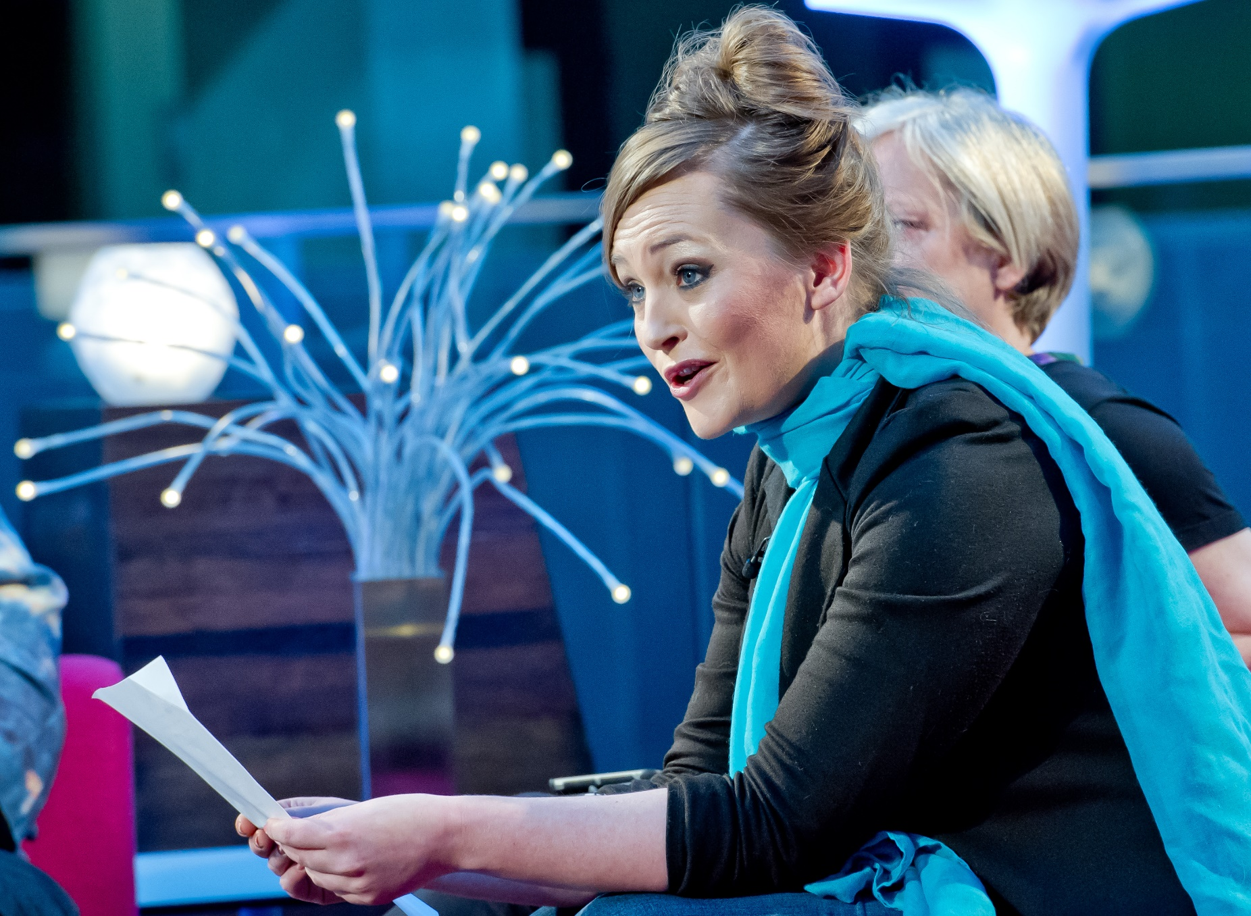

Making a book trailer
Age 12-18

CFE Levels Third, Fourth and Senior Phrase

A guide to studying a book and creating a trailer for it
Resource created by Scottish Book Trust

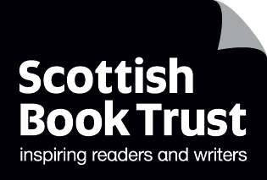

scottishbooktrust.com

Contents
About this resource 1
Useful links 1
Selecting trailer content from novels 2
Watching exemplar trailers and discussing them 2
Planning a book trailer 3
Constructing and editing trailers 5
For teachers – assessing book trailers 6
Worksheet 1 - Mind maps 7
Worksheet 2 - Pupil peer feedback 8
Worksheet 3 - Sounds and images 9

About this resource
Book trailers are a great way to support the building of a reading culture in your school and engage pupils with reading in the digital realm with which they are so familiar. They can support National 5 and Higher studies as a revision tool and generally are a fabulous way to combine a number of different skills across the curriculum.
Book trailers are just like movie trailers, giving a ‘taster’ of a book for its potential audience, designed to leave them wanting to read the book. They encourage pupils to read a book critically, so they have a strong idea of what their trailer needs to convey. This resource pack will take you through the full process of creating a book trailer.
Useful links
Other links and websites you may find useful are:
WeVideo, an excellent online video editor
www.wevideo.com
CC Search – search for free images and music
search.creativecommons.org
Into Film resources
www.intofilm.org/

Selecting trailer content from novels

Reading critically and making decisions about main concerns of a text LIT 4-16a, ENG 4-19a, LIT 4-25a
With a partner, discuss the following questions:
- What do you think is the main purpose of a book trailer?
- How long do you think a good book trailer should be?
- What kind of things would you want to know about a book before buying it?
List 5 things that you think a good book trailer should have in it.

Watching exemplar trailers and discussing them
Showing understanding of texts and giving evidence for my personal response to them
LIT 4-01a, LIT 4-04a, LIT 4-07a
Watch these trailer exemplars then think about the book you have chosen to produce a trailer for and complete worksheet 1. Consider which aspects you wish to highlight.
Book | Age range | Link and comments
Code Name Verity by Elizabeth Wein | 12-16 | http://www.youtube.com/watch?v=dVbZOwbVazU  An innovative trailer in terms of design and content. Good example of effective choice of sound.
Boy Nobody by Allen Zadoff | 16 + | http://www.youtube.com/watch?v=clJ25uwIer8  A very slick official trailer with clever use of narrative voice. Be warned: there is some content only appropriate for older pupils.
The Paper Dolls by Julia Donaldson | 3-7 | http://www.youtube.com/watch?v=bYoVq1LfDIs  A trailer made using stop motion animation. Good for discussing appropriate atmosphere/tone.
Matilda by Roald Dahl | 8-12 | http://www.youtube.com/watch?v=zot8bp2UjdE  A nice trailer which suffers a little from a lack of variation and too much content. Can lead to discussions about showing, not telling, appropriate trailer length, and trimming/editing.

Discuss the following questions with your teacher or classmates:
- How do you think a studio chooses which scenes to put in a trailer?
- Do you need a mixture of different types of scenes in a trailer?
- How much of the plot should you reveal to the audience in a trailer?
When a studio is making a trailer for a movie, they have to decide which scenes to put in the trailer and which ones to leave out.
Think of a movie that you know quite well. Next, go to www.traileraddict.com and see if you can find a trailer for the movie.
Once you have watched the trailer, think about the scenes which the film director has chosen to include in it. Write down three of the scenes that have been included and write down all the reasons why you think the director has chosen to include them in the trailer.

Planning a book trailer
There are two options available to you when you are writing a script for your book trailer:

Option 1: Write a script
A script is quite detailed. It describes each shot of the book trailer, including some or all of the following details:
- Images;
- Music and sound effects;
- Transitions (the way each shot moves into the next – does it cut? Fade out? Wipe? Etc.);
- Voiceovers;
- Text on screen;
- Visual effects.

On the next page is an example of the first part of a script.

Dracula book trailer – script

Shot 1: image of stormy landscape, storm sound effects.

Shot 2: cut to black screen with grey text saying, “In 1897 I was sent to Castle Dracula in Transylvania on routine business.”

Shot 3: Quick fade to a close up shot of vampire staring straight at the camera.

Shot 4: Quick fade to a wide shot of an old castle, black and white visual effect, voiceover of Count Dracula welcoming the narrator into his castle.

Option 2 – creating a storyboard
Storyboards are used all the time by filmmakers. A storyboard is a series of sketches which show what the scenes of the film will look like.
Here is an example of a storyboard drawn by Sav Akyuz, illustrator and storyboard artist. Discover more about his work by watching his Authors Live event.
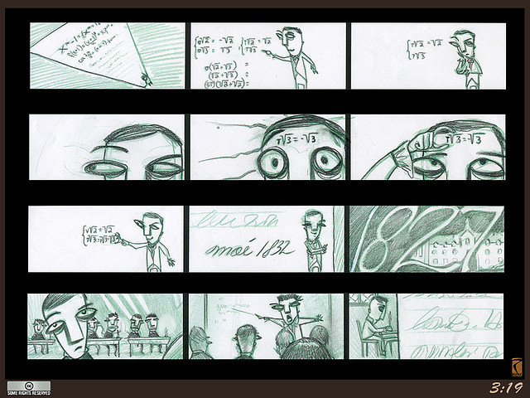

Draw your own storyboard, share it with your friends and ask them to complete Worksheet 2 to give you feedback.

Constructing and editing trailers

Select and justify my choices, developing my own style and reviewing and editing my work to appeal to its target audience. Finding images and sounds to enhance the trailer.
LIT 4-23a, LIT 4-24a, ENG 4-27a, ENG 4-31a, TCH 4-04a, EXA 4-14a, TCH 3-04a, LIT3-14a

Note down the scenes you would like to feature in your book trailer from your book.
When you are gathering images and sounds, you need to remember that when you include them in your book trailer, you will need to put in a slide at the end which gives credit to the owner of the image or sound.
Use Worksheet 3 to get used to the basic details you need to record.

For teachers – assessing book trailers
Book trailer activities demand the same kind of critical reading skills which are used when writing a critical essay: pupils must demonstrate an understanding of plot but also character, setting, atmosphere and genre.
Writing skills are also assessed: book trailers make sparing use of text, so pupils have to be concise and careful with their expression so as to have maximum impact on their audience. Careful decisions also need to be made about structure and layout of the trailer.

Characters, setting, atmosphere | Does the trailer demonstrate an understanding of the central concerns of the text?  Does it demonstrate an understanding of the main characters and how they are characterised in the book?  Does the trailer give a strong impression of the setting an atmosphere of the book?
Layout and structure | Is the length of the trailer appropriate (2 mins max)?  Has the pupil ordered the images, sounds and text in a way that creates impact?
Use of images, sounds and text | Does the trailer demonstrate an ability to use language to achieve particular effects?  Is the use of sounds, images and/or footage apt for purpose?

Worksheet 1 - Mind maps
The mind map below has been completed by someone who has read Bram Stoker’s Dracula. It is only partly complete, and you may wish to put more information in when you do your own mind map.
Narrator becoming suspicious of Dracula
Character
What aspects of the book do I want to bring across to the viewer?
Plot details
Atmosphere
Setting
Dracula’s polite and civilised appearance
Dracula’s ferocious temper
Tension
Mystery at the beginning of the novel

Narrator arriving at Castle Dracula
Victorian era

Bleak weather in Transylvania

Now, complete the mind map below for your own book trailer.

What aspects of the book do I want to bring across to the viewer?

Worksheet 2 - Pupil peer feedback
How has the trailer given an impression of what the main character is like?

How has the trailer given an impression of what the setting is like?

How has the trailer captured the mood/tone of the book?

How does the trailer make its audience want to read the book?

What did you particularly like about the trailer?

What would you change, add or omit from the trailer?

Worksheet 3 - Sounds and images
Use this table to help you to get accustomed to recording the relevant details when you are downloading images and sounds.
In the right-hand column, you will find instructions telling you to look for an image or sound. Look through Flickr, mp3.com and Soundbible to find images and sounds. When you have found something suitable for each instruction, write down the username and website in the columns next to it.

Instruction | Username of person who owns the image/sound | Website
Find an image of an old castle  Find a sound effect of a bomb exploding  Find a sound effect of a crowd cheering  Find some dramatic music | Dave Stokes | Flickr.com

