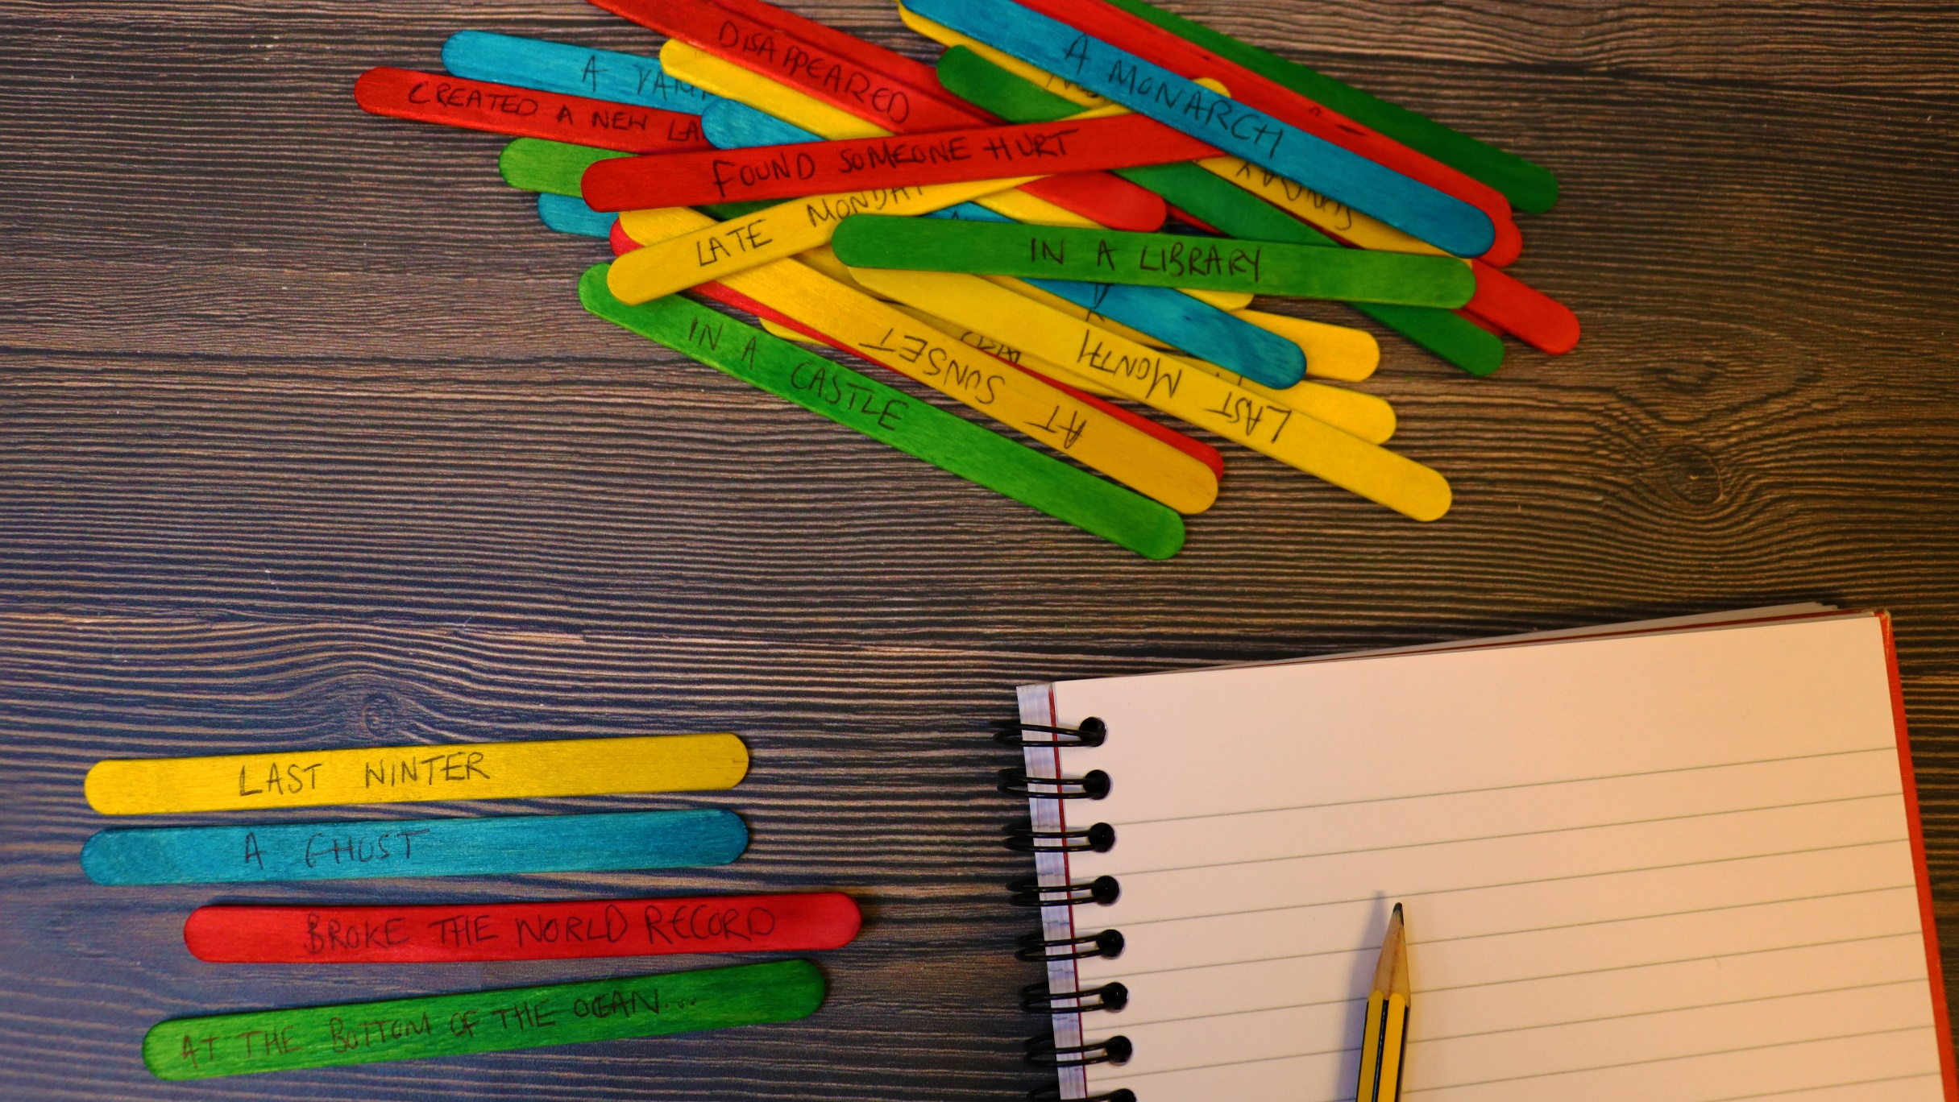

How to create story sticks
Age 8-18

CFE Levels Second to Fourth

Resource created by Scottish Book Trust

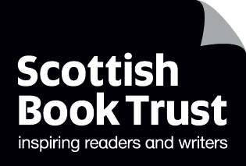
scottishbooktrust.com

/scottishbktrust

@scottishbktrust

A guide to making and using story sticks for creative writing

Contents
How to make story sticks 2
Suggested words 2
Activities for using story stones 3

About this resource
Story sticks are a fun and creative way to generate ideas for creative writing, especially stories, descriptive writing and narrative. When presented with a blank page and asked to write a story, young people can sometimes feel overwhelmed and find it challenging to come up with ideas, or know where to start. Story sticks are a great way to spark ideas. They can be used as an impetus for writing, or for developing verbal storytelling and communication skills. They are versatile and can be used with any age group and made more or less complex, as you require.

How to make your story sticks
All you need for your story is some lollipop or crafting sticks. These are supplies that might be in your setting already in your art room or art box. They can be purchased very cheaply from most craft shops, for £1-£2 per pack.
Before writing on your sticks, it is worth testing a few different pens (biro, fine liner, ballpoint) to see which works best for you and to check which bleed into the wood and might make the prompts harder to read.
There are a number of blogs online that offer suggestions and ideas for creating story sticks, and for how to use them in the classroom. These are just a few which are worth looking into:
- Teaching the 5 W’s with story sticks
- Using books as inspiration for story sticks
- Story sticks for creating ideas
- Using story sticks with lower primary

Suggested phrases
Here are some suggested phrases that you could use on your story sticks. These are just suggestions, and you can explore the blogs above for varied ideas you can adapt to suit your needs.
Our sticks have been divided into four categories: time; setting; character; and action.
You do not have to use all the phrases below; they are ideas to help you get started. You can create your own depending on the genre or age group you are working with.
Time
Last winter
Last summer
This morning
This afternoon
Today
Yesterday
Early in the morning
Late in the evening
At sunrise
At sunset
Last night
Two days ago
Last month
Next week
Two days from now
Christmas Day
Halloween
Sunday afternoon
Late Monday night
4 September
12 July
29 February
OR any time you want

Setting
In a castle
In a desert
On an island
At the bottom of the ocean
At a supermarket
At the corner shop
In the forest
On a sports pitch
In the basement
Under the stairs
On top of a building
In a park
In an attic
At the beach
At the cinema
On the moon
At school
Near a mountain
In a city
In a library
In a shop
In a bookshop
OR Any place you want

Character
A man
A woman
A person
A child
A mouse
A train
An owl
A fox
A teacher
A baby
A vampire
A kitten
A sports team
A werewolf
A monarch
A mythical creature
An ant
A ghost
A zookeeper
A poet
A day dreamer
A cat
A dog
A celebrity

Action
Broke the world record
Were all alone
No one listened
Got into trouble…
Got on a train to…
Had to hide
Found a…
Had a secret
Needed money
Were lost
Learnt something new
Found someone hurt
Missed someone
Got stuck
Found something unusual
Wanted something they could not have
Disappeared
Got on a plane to…
Got into a boat
Wrote a book about…
Planted a tree
Created a new language
Were happy until…
How to use story sticks
There are a number of different ways you can use the story sticks to inspire creativity in young people. Here are some activity suggestions.

Verbal storytelling
This activity can be done in pairs or in small groups. Pick four of the story sticks at random, one from each category the four categories. One person reads the story starter out. For example, “Yesterday, in a shop, an owl disappeared”. The first person adds a sentence onto this, explaining what happens next. Another person using the phrase “And then…” continues the story. The story goes on until the group are happy with the direction of the story, or it comes to a natural end. Alternatively, you could set a limit, such as six “And then” additions to the story starter.
To make it more challenging, you could ask pupils to repeat what has happened in the story thus far before they add to the story using “And then…”. This will test their listening and recall skills as well as developing their oracy and verbal storytelling skills.

Creating characters
This activity can be done in small groups. Each pupil picks a character stick only. The group must work together to create a character profile for each character. They can think about:
- Likes and dislikes
- Description- what does the character look like?
- Hobbies
- Friends and family members
- Any motivations/beliefs
Once each character has a profile, ask the pupils to put the character profiles next to each other. Ask them to discuss how they think the characters might know each other and how they will interact. Will they get on? Or will they disagree? Why? Do they have any similarities or are they more different than they are alike?
Next, ask pupils to select a time, setting and action story stick. This is the base for their story. From this, pupils must create a short story, with a beginning, middle and end, which includes all of the characters. They can work in a group to plan their story, ensuring all characters feature. Remind pupils that not all the characters need to appear at the beginning, some could appear in the story in the middle, or at the end. Once the plan is complete, it can be presented verbally to the rest of the class.
As an extension, pupils can write up their story in full.

Story mapping
Story mapping is a fun and creative way to help pupils plan their story. Ask pupils to select four story sticks, one from each of the four categories. You could select one story for all the class to work on, or each pupil could select their own story sticks. This is the opening line for their story.
Ask pupils to divide their page into eight squares, writing their opening line at the top of the page (they can turn their page landscape). These squares are the eight key points of the story. Rather than writing, ask pupils to draw what happens at each point in the story. Recommend that they draw the first and last panel to start, as this will enable them to see where the story begins and ends. They can now fill in the middle panels, planning visually what happens in their story.
If pupils are struggling, you could play the “And then” game (see above) with other members of the class to generate ideas. You could also ask pupils to think about how they get from the first to last pane- does their character meet someone? Does the setting change? Is there another action? Does the story move forward or backward in time? Pupils could select another story stick from the bundle to help generate ideas for their story.
As an extension, once the story map is complete, pupils can create a written story to accompany it. Alternatively, pupils could think about how the image and text might work together and create a comic strip of their story.

Genre discussion
Ask pupils to select four story sticks, one from each category. In pairs, ask pupils to discuss the story starter in front of them. What genre do they think it might be? Would they like to read it? How do they know what genre it could be? What are the clues from the story sticks? For example, it could be a jumbled line of different things, which might make them think it is a humorous story. Or it could include a character such as vampire or werewolf which might give them a clue.
To encourage pupils to think more critically, ask them to think about the stereotypes and assumptions they are making when categorising the genre - what other books have they read or films they have seen that make them think that way, for example that a vampire would be in a horror story. Can they think of any books that challenge these stereotypes? How could they challenge stereotypes in their own writing?

