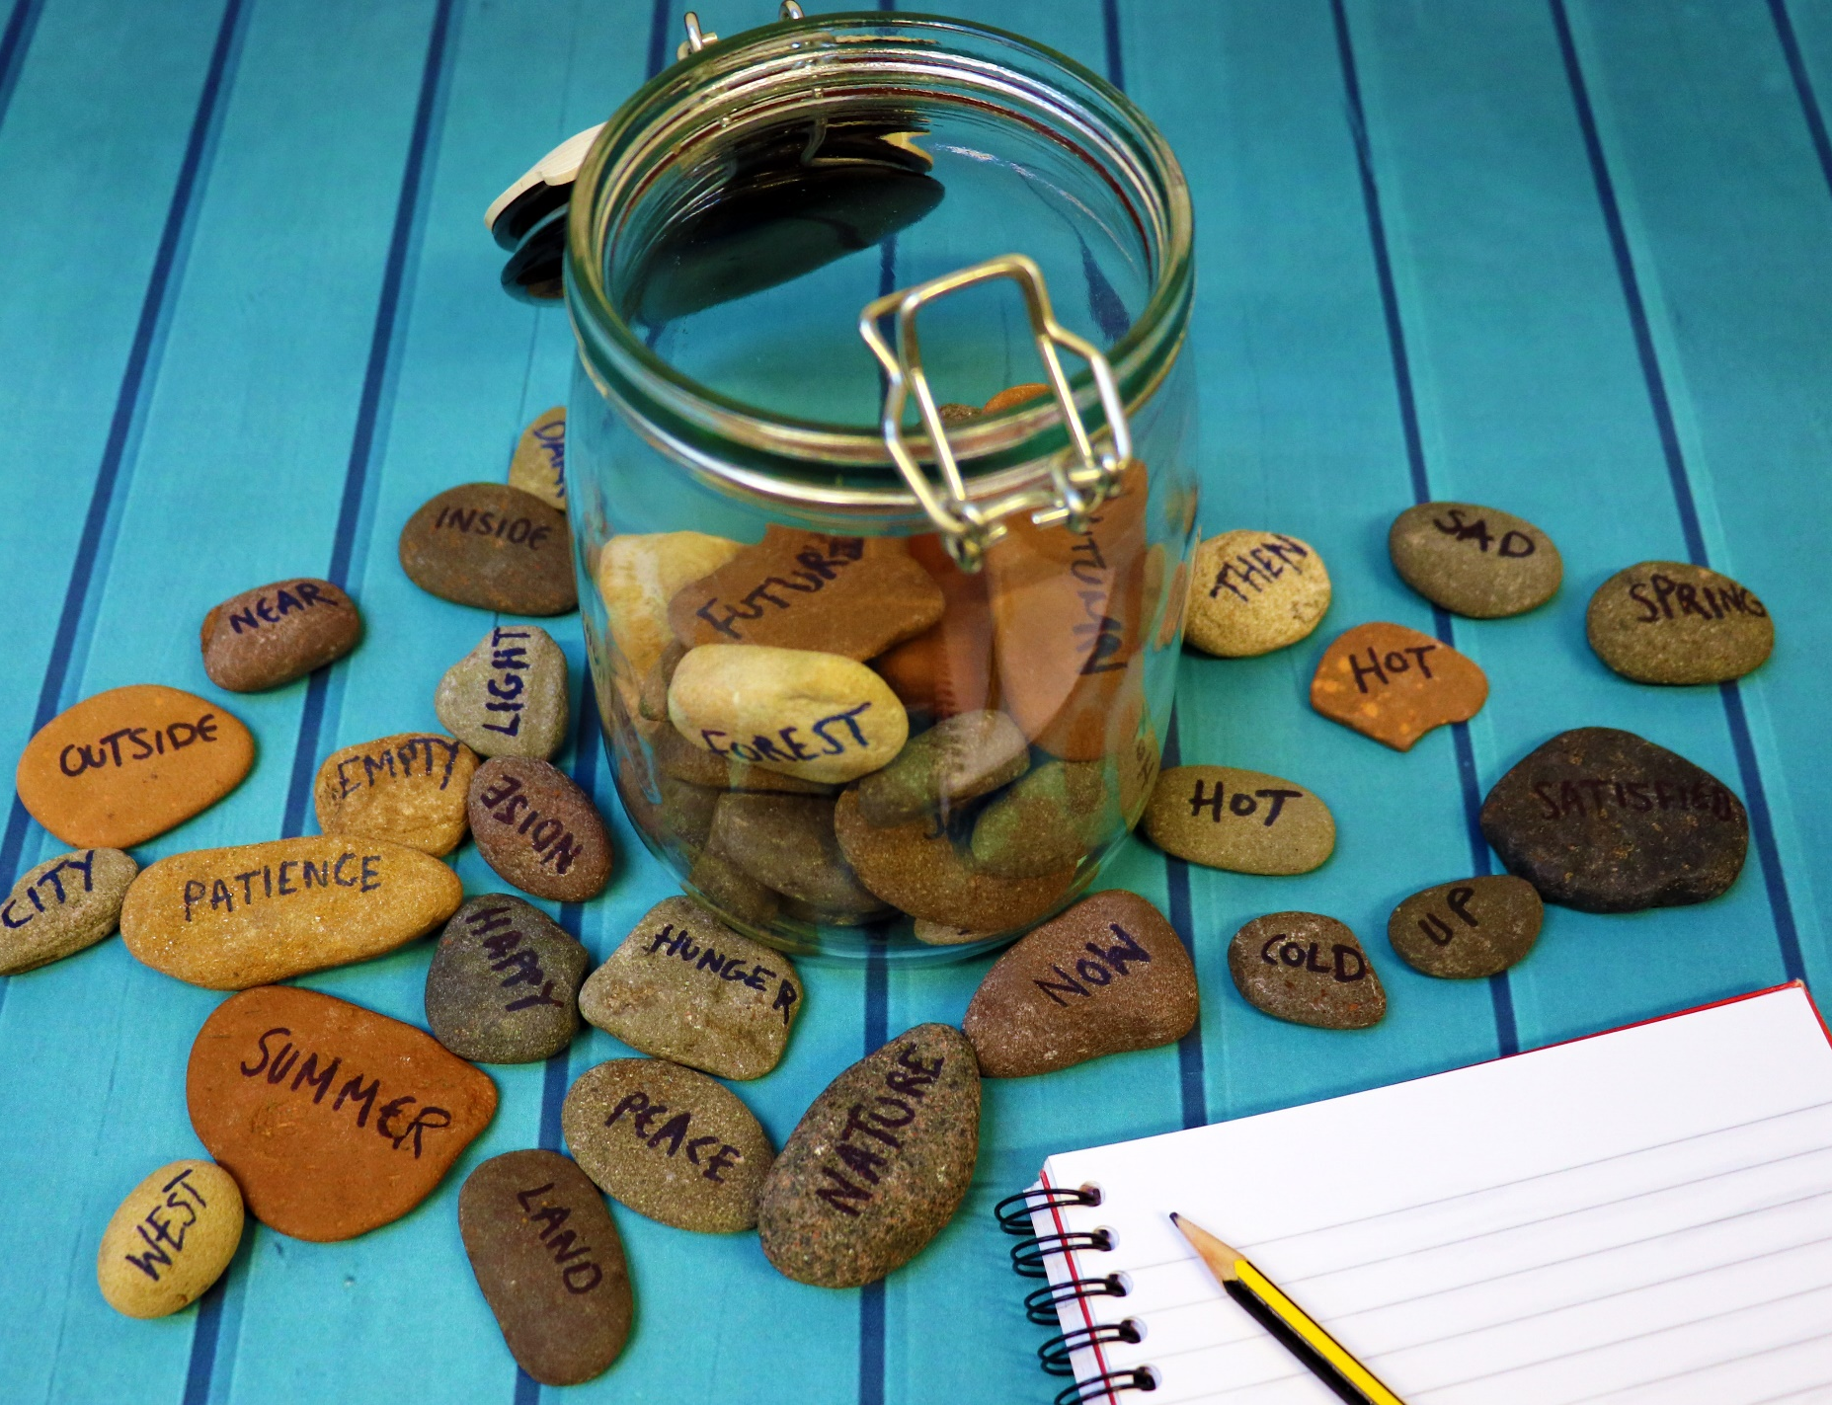

How to make poetry stones
Age 8-18

CFE Levels Second to Fourth

Resource created by Scottish Book Trust

scottishbooktrust.com

/scottishbktrust

@scottishbktrust

A guide to making and using poetry stones for creative writing

Contents
How to make poetry stones 2
Suggested words 2
Activities for using poetry stones 3

About this resource
Poetry stones are a fun and creative way to generate ideas for creative writing, especially poetry. When faced with a blank page and asked to write a poem, young people can sometimes feel overwhelmed and find it challenging to come up with ideas, or know where to start. Poetry stones are a great way to spark ideas. They can be used as an impetus for writing, or as a starter activity for a lesson. They are versatile and can be used with any age group and made more or less complex, as you require.

How to make your poetry stones
All you need for your poetry stones is some pebbles. Pebbles which are relatively round and flat are the easiest to write on. Alternatively, you could use grey card cut into pebble shapes.
Next, all you need to do is use a permanent marker to write your chosen words onto the pebbles.

Suggested words
These are just some words that you could use on your poetry pebbles. They have been created in pairs of opposites or counterparts with the aim to create interesting conflicts when young people select the pebbles.
The pairs have been divided into general themes: emotion, feeling, seasons, place, time and topical. You do not have to use all these words, they are suggestions to help you get started.
Emotion
Joy Despair
Love Apathy
Anger Patience
Happy Sad

Feeling
Peace Noise
Hunger Satisfied
Rich Poor
Little Much
Empty Full

Season
Hot Cold
Summer Winter
Autumn Spring
Cloudy Clear
Time
Dark Light
Moon Sun
Now Then
Past Future
Night Day

Place
East West
North South
Forest City
Sunset Sunrise
Desert River
Ocean Land
Far Near
Inside Outside
Up Down

Topical
Nature Manmade
Plastic Natural
Organic Metal

How to use poetry stones
There are a number of different ways you can use the poetry stones to inspire creativity in young people. Here are some activity suggestions.

Title for a poem
Ask your young people to select two pebbles each. Go around the group until everyone has selected two pebbles. These can now be used as a title and inspiration for a poem, or they could be the core themes for the poem.
Poetry word bank
Ask your young people to pick two pebbles each. Then give them one minute per word to write down all the words that they can think of which relate to that word. It could be the first words that spring to mind, or something that brings back a memory related to that word. By the end of the two minute, your young people should have a bank of words that can be used to create a poem.

Word association game
Ask your young people to pick one pebble. This word is their starting point. They must think of a word they associate with that word and write it down. Then they must think of a word that is associated to the second word, and then the third, so on. At the end of the activity, your young people will have list of words that ends a long way from where they started. For example: Money- cash- bank note- queen (as her face is on the notes)-royal family- Diana- Paris- Eiffel tower- romantic- Love Actually- Christmas- family- home- fire- wood. Your young people will have a wealth of themes and words to use either as inspiration for further creative writing, or words to be included in their poem. You can set a time limit and see how many associated words your young people can collect in an allocated period.

Free writing
Ask your young people to select one or two pebbles. Then give them five minutes to “free write”. Free writing is a continuous stream of consciousness, where they do not worry about spelling, grammar or punctuation. The aim is just to get ideas and words straight onto a page. Once these are finished, ask pupils to cut the paragraph or page up, keeping short phrases, sentences or words they particularly like. They can then move these words and phrases around and use them to create a poem.

