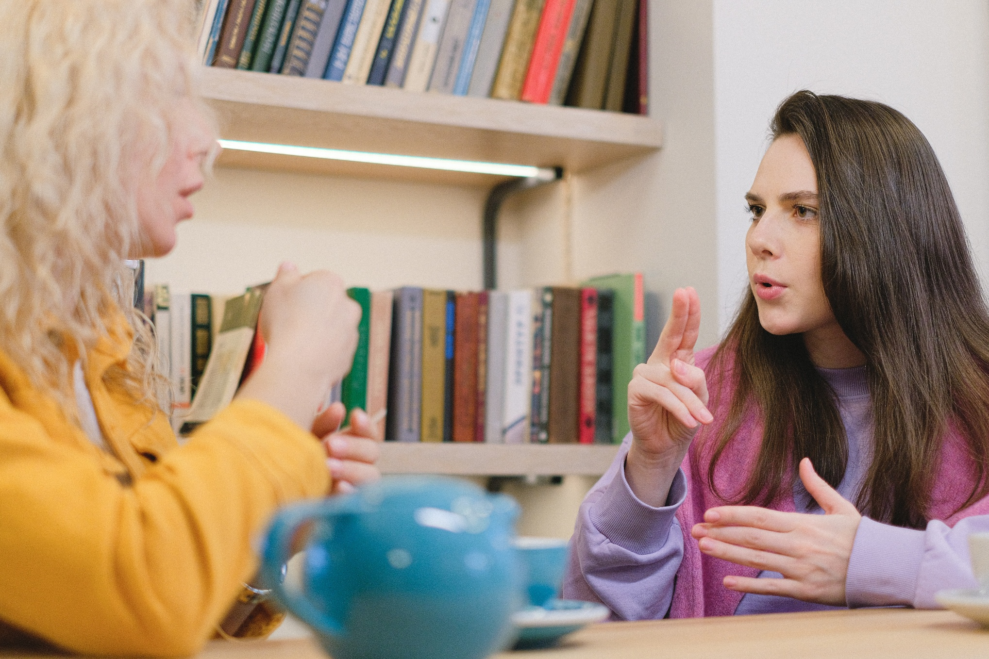

ASN-friendly library toolkit
Support and advice you can use to help make your school library and reading spaces more engaging and accessible for pupils with additional support needs


Suitable for school libraries and reading spaces
Report created by Scottish Book Trust with input from various additional support need settings and schools

scottishbooktrust.com

Scottish Book Trust is a registered company (SC184248)
and a Scottish charity (SC027669).

Contents
About this resource 2
Your library for your pupils 3
Getting your pupils’ input 8
Considering your library space 8
Offering different reading experiences 11
Reflecting on changes 14
Materials and resources that can support you 14

About this resource
This resource has been designed to support you to think about how your library, or school reading space, can best support pupils with additional support needs – including, but not limited to, neurodiversity, physical disability, or sensory processing disorders.
This resource has been created with the input of pupils and staff from additional support settings and schools in Scotland. We are incredibly thankful to: Anne Ngabia and staff and pupils at Carrongrange High School (Grangemouth), Linsey Crooks and staff and pupils at Stanmore House School (Lanark), Stephen Leitch and the students from Buckie Community High School (Buckie), Claire Tierney and the students from Hollybrook Academy and Sophie Robinson, teacher at St. Clement’s School (Dundee).
Each section contains a series of prompts, designed to help you think about how your school’s library or reading space can best work for your pupils. These questions are not exhaustive, and not all of them may suit your context, or the needs or interests of the specific young people you work with. We realise that you may not be able to fulfil every suggestion in this document. Please adapt this as it suits the context and needs of your setting. If you can, we encourage you to work with families and children to discuss their wants and needs for your library or reading space.
If you are taking part in our Reading Schools programme, you can also apply for our annual Reading Schools Fund. Grants of up to £500 are available for books or reading materials for your school and/or furnishings for reading spaces.

Your library for your pupils
The library in your school or setting may not look – or function – like a traditional library, and that’s okay! Libraries are not just about borrowing books and reading looks different for everyone.
Engaging in meaningful reading experiences is not dependent on an individual’s ability to read for themselves. Reading can be understood as a meaningful social experience around a multimodal text (Moore et al 2019) and can take many forms, including sensory storytelling.
Libraries can also take different forms and functions. For children and young people with additional support needs, libraries can also be a safe space. For pupils with noise sensitivity, a library might be the only quiet space in the school. For those who find school stressful or overwhelming, a space to read a book may help them emotionally regulate or have the time and space to feel calmer. For some, it might be a place they can meet others who share their interests.
A great example of this is Dumfries High School (Dumfries), who used funding from the School Library Improvement Fund to modify their library space in order to better support pupils’ mental health. You can learn more about the changes they made in a 2024 news article from the Dumfries News. This is a great example of identifying pupils’ needs, and the benefits of a library outwith simply borrowing and reading books.
As part of this resource, we have included the reflections of the different functions a library can serve for young people with additional support needs. You might like to think about which of these may apply to the specific young people that you work with.

‘A library environment is somewhat predictable with relatively low noise levels, logical layout (usually), they are full of information to absorb, and finding alone time is relatively easy; so, by default, they are rather accommodating to autistic people like myself.’ Rob Mackinlay for CILIPs

‘For a child [the library] might be the make or break thing in the school, especially if things are hard at home, especially if they're not engaging with lessons, especially if they're being bullied, which is very common, and especially if they identify as maybe one of the minority groups within the school, and find that really difficult.’
Response to school librarian survey for “The value and impact of Scotland's libraries” (Scottish Book Trust, 2024)
Here are some responses from young people with additional support needs who we asked about their libraries:
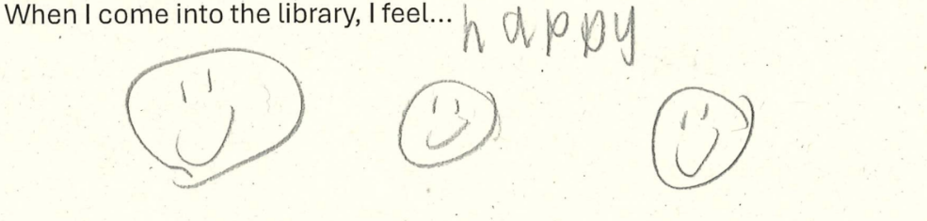
Text reads: “When I come into the library, I feel happy”

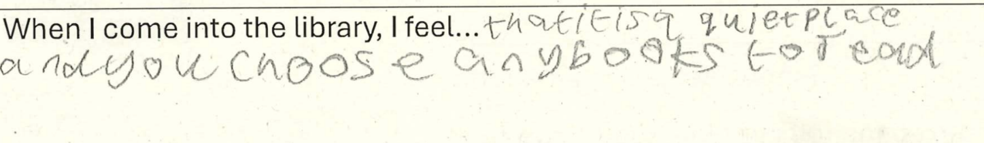
Text reads: "When I come to the library, I feel that it is a quiet place and you choose any books to read"

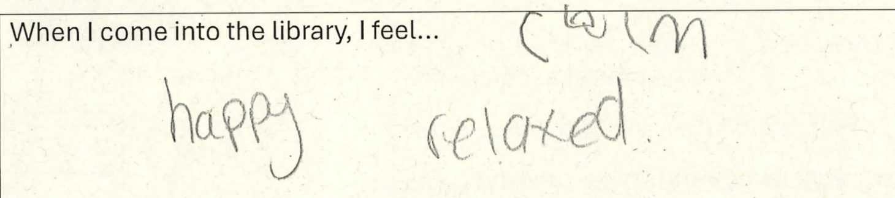
Text reads: “When I come into the library, I feel calm, happy, relaxed”

Examples from schools and settings
In this section we have highlighted examples of good practice which schools and settings are already doing. You may want to try these ideas in your setting, or, where necessary, adapt them for your pupils’ specific needs.

Carrongrange High School (Grangemouth)
‘I honestly think that not many ASN Schools have a library, let alone a librarian. The uptake in Carrongrange has been huge. The use of Learning Resource Services [LRS] has increased also, with Carrongrange staff participating in LRS book club with other teachers and sharing experiences. Pupils are enjoying books, pictures, language, and being involved. We now also have a large collection of story bags- with books and puppets inside- to encourage pupil interaction with stories. These are really popular!’
Anne Ngabia, Librarian at Carrongrange High School, on the impact of having a library in an ASN setting
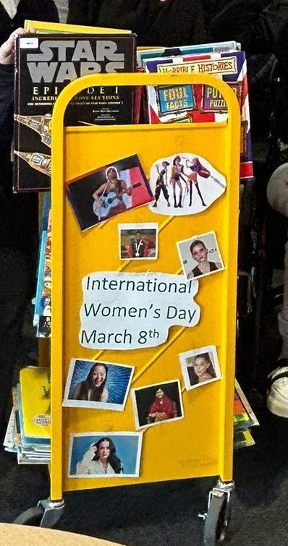
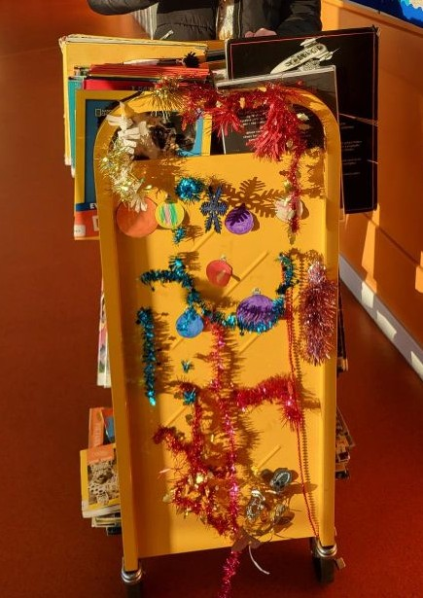

At Carrongrange High, library ambassadors and staff have developed a book trolley which is taken around the classrooms. This allows learners to engage with library materials even when the main library space is inaccessible for them. Pupil library ambassadors take pride in their involvement with the book trolley and over time learners have developed more confidence in using the trolley and borrowing books.
‘Our Trolley Trundle was a great success! The trundle went around different classes and pupils were able to talk about the books they wanted for next time, and about what they chose. In addition, library ambassadors took responsibility for the trolley, talking about books on their trundle, as well as the responsibility of keeping the record of who borrowed what (with some help!). We also started a “loyalty card” system, when each young person who borrowed from the trolley got a stamp on their loyalty card. When the card was full, they went into a “draw” to win a small prize. The Iron horse trolleys from Greswells work well - they also come in nice bright colours (ours is yellow). If I was doing it again, I would get the bigger one, but they are pricey! The trolley was decorated by our library ambassadors for special events: Christmas, Black History Month etc. Even with a new library space opened, the trolley is still popular and in use.’
Anne Ngabia, Librarian at Carrongrange High School

Stanmore House School (Lanark)
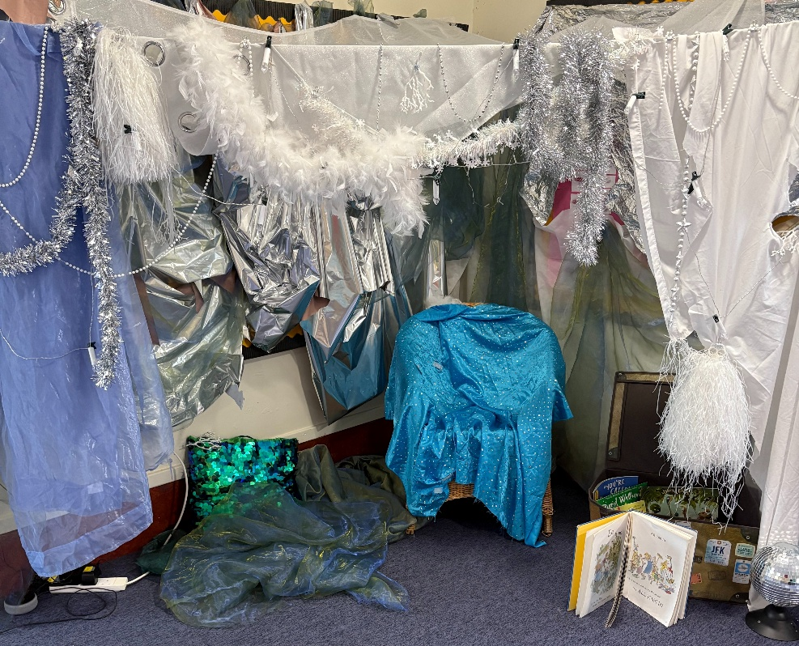

Young people and staff at Stanmore House School have created sensory areas to share stories including the ice-cave pictured here which brought to life a winter themed sensory story and supported a tactile and immersive storytelling experience. To create the space, the young people were given choices of colours, materials and objects to include and were involved in handling and directing the placements of different objects. They also used music, including the Big Top Music Ice World video to set the scene.

St Clement’s School (Dundee)
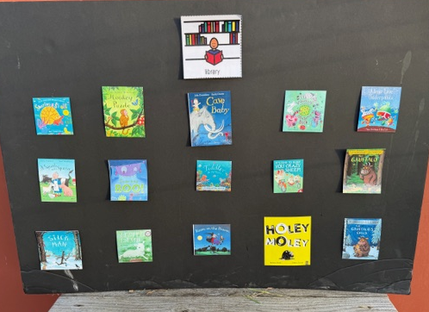
At St Clement’s, they used visual communication to make it easier for pupils to know what books were available in their library and choose one to read.
‘I’ve got a library board, i.e., a very large bit of card that has about 20 laminated mini pictures of favourite book covers which the pupils can choose from. They’re velcroed on so that I can take away / add other pictures of the book covers. The books themselves are stored in a cupboard.’
Sophie Robinson, teacher

Getting your pupils’ input
As much as possible, you should gather your pupils’ opinions about what they want from your school library or reading space. Some key considerations are:
- What do your pupils want from a library or reading space? This could include specific texts, or discussions about what they want in terms of a physical space.
- How is the library talked about in the school?
- How do the adults talk to the children about the library or reading space?

There are various methods you can use to gather your pupils’ responses to the above questions, or their general feelings about the library, including any specific communication tools you currently use. Other ways of gathering their feedback could look like:
Asking them to draw or design their dream library and discussing their pictures with them, asking them to talk you through their choices. They could also use photographs, or you could print photographs of different libraries and ask them what they think.
Use symbols – if the children you work with use symbols as a form of communication, e.g. talking mats or communication cards, you could use these to gather their feelings about the library.
Observe children in your library/reading space, noticing what soothes, excites, overexcites or stresses them. “Engagement” looks different to every child – some children may love moving around whilst listening to a story, for others, that may be a sign that they want to leave that specific activity.

Considering your library space
Your library space may need to offer different types of experiences for different learners based upon their needs. Using the table below, think about which types of needs you do, or do not, currently support. We have also included information on why this experience might be important to include, and possible solutions.
Types of need for your pupils | Why this is important? | Suggestions to consider
Quiet | Some children may experience noise sensitivity or find it hard to read if there’s a lot of noise. | - Creating quiet hours or zones  - Providing ear defenders  - Encouraging pupils to indicate whether they prefer “noisy” or “quiet” library time. Preferences change, so make sure you keep checking what they would like
Loud | Some children need to vocalise or will better engage with sensory storytelling if it uses sounds and music and/or props and sensory toys. | - Creating designated time for louder sensory storytelling  - Creating outdoor reading spaces  - Ensuring children know they are welcome to move around, vocalise and/or stim in the library  - Playing music in the library, or providing a space to listen to music
Dark | Some children may experience sensory issues relating to bright lights. Offering dark or dimmed lighting can help them relax and self-regulate. | - Using dens/tents to create darker zones within the library space  - Providing blankets for children to create their own darker space for reading  - Use lava lamps or coloured lamps to create a soothing environment
Light | Appropriate lighting for people with Visual Impairment or for people who are lip reading. | - Consider the lighting you have – is it bright enough for pupils to adequately see/be able to lip read?
Social | Some children will better engage with reading and stories as part of a group. This might include a group story time, browsing for books to borrow with friends, book groups or playing board games or table-top roleplaying games like Dungeons and Dragons. | - Asking children what kind of social groups they would like in the library  - Encouraging children to read or play games in groups  - Creating specific social spaces or zones in the library
Private | Some children will prefer to read by themselves – this could be a way that they self-regulate, or they might just want to get totally lost in a book! | - Designating different zones or seating as a solo space  - Providing ear defenders  - Creating “my reading time” signs with pupils which they can display when they would like to focus on reading alone
Comfortable | Comfort will look different to different groups. It could be comfy chairs, blankets, specific sensory input, wobble cushions, or having the space to lie down. | - Making furniture movable (where possible), e.g. adding wheels to shelves so they can be rolled away  - Providing cushions, blankets and comfy seating at appropriate heights, or comfy spaces to lie down  - Consider incorporating massage or stretches alongside listening to a story  - If your library/reading space is busy, crowded or uncomfortable, you could explore bringing the library to children’s own classrooms, e.g. with book boxes or a trolley (see the example shared by Carrongrange High School on page 5)
Sensory | Sensory experiences can offer children another way to engage with reading and/or ways to feel relaxed or self-regulate. | - Keeping sensory toys/props in the library e.g. puppets  - Using sensory storytelling with pupils  - Building a “sensory library” with readymade sensory packs or bags for a selection of engaging texts and items
Ownership | Giving children ownership over the library space will make them more likely to want to visit and/or participate. | - Encourage pupils to create or shape displays – for example, displaying their artwork or book reviews, creating displays of books tailored to their interests  - Encourage pupils to start or run social groups within the library space  - Asking pupils about what kind of books or texts they would like to read via e.g. a suggestion box, blackboard, survey, observations.
Navigation | Your pupils may need specific tools to help them navigate your library. This will help them use the library as independently as possible, helping them identify books they might enjoy. | - For blind or visually impaired pupils, this could include use of braille or tactile maps (see RNIB’s guide to tactile maps)  - Blind and visually impaired people may also be able to use communication technology such as NaviLens to find out more about specific shelves or books  - Adapt furniture and space layout so there is room for all wheelchair users to navigate the library  - If children use specific symbols as a communication, include those to label different shelves  - Think about how books are displayed – for example, displaying books so that their covers face out can give children more visual clues than the spine  - Ask learners how they would like books organised and practice finding different books e.g. by genre, alphabetically by writer, by topic

Offering different reading experiences
In terms of reading, your library should also support different kinds of reading experience, including different formats and texts that are accessible to your learners. Using the table below, consider what kind of reading experiences you do, or do not, currently support. We have also included some information on why this is important and some possible solutions.
Types of reading experience | Why this is important? | Possible solutions
Accessible formats | Providing access to inclusive and accessible formats reduces your learners’ barriers to engaging with reading and reading experiences and helps all learners find enjoyment in stories. This could include, but is not limited to, braille, large font, dyslexia-friendly texts or audiobooks. | - Explore our list of inclusive formats in our ASN toolkit on the Scottish Book Trust website  - Seek out texts that match your learners needs. To find out more information about the importance of accessible books, we recommend My Kind of Book’s report “Bold, Clear, Sensory and Strong: creating accessible picture books”  - For braille and tactile books, see our article on How to access tactile and braille books for children  - For more information on dyslexia-friendly texts, see Barrington Stoke  - For audiobooks, you could look into screenless audiobook players such as VoxBlock, or work with your local library to enable pupils to access audiobooks online via their services
Representation | Children are more likely to engage with books when they see characters, authors and illustrators who look, move or think like them. | - Include books that represent different lived experiences, including neurodiversity and disability, BIPOC and LGBTQ+ protagonists  - For book recommendations see our Book lists and Book Discovery Guide
Listening to a story | As mentioned in the section on audiobooks, listening to a story read aloud can offer a more accessible experience for some children. It can also allow them to experience a story as a community and/or enable them to access a story that is more complex than their current reading ability. | - Provide opportunities for pupils to listen to a story read aloud. This could be from a member of staff or from Reading Buddies in different year groups. Find our resource on paired learning on the Reading Schools website  - For audiobooks, you could look into screenless audiobook players such as VoxBlock, or work with your local library to enable pupils to access audiobooks online via their services
Sensory storytelling | Adapted for children with additional support needs, sensory storytelling combines a simple story with use of props or toys that engage a listener’s senses. It is especially good for helping children with additional support needs as it promotes interactive engagement with a story without relying upon traditional forms of communication or complex literacy skills. | - If you are new to sensory storytelling, see our resources Getting started with sensory stories, Make your own sensory story and Turning picture books into sensory stories
eBooks and digital resources | eBooks can offer children a more accessible reading experience, for example, being able to change the font, font size and display colours. Some pupils may also value text-to-speech tools or other forms of assistive technology. | - Provide eBooks through eReaders or tablets  - Use any existing digital communication technologies to support pupils with reading
Wordless books | Wordless books offer another way to engage with a story that is especially good for children who have dyslexia or other visual stress, or who speak English as an additional language. | - Provide wordless texts – you can find recommendations on our Wordless picture books book list and our Using wordless picture books in schools and libraries resource
Books in different languages | Supporting children to read, or listen to stories, in the languages that they use at home – including Scots and Gaelic – is a good way to make reading more accessible to them. | - See our resource on Supporting children with English as an additional language for recommended texts and advice for using multi-lingual texts  - See our resource on Using Scots in the classroom for recommended activities for using Scots day-to-day with pupils

Reflecting on changes
With any change you make to your library, it’s worth taking some time to reflect on the impact it has had. Set aside time to:
- Notice what impact this change has had on your pupils – do they seem more, or less, engaged with your library than they were before?
- Why do you think this change has, or hasn’t, worked?
- Are there any other changes you need to make?
If appropriate, it may be worth gathering responses to these questions from your colleagues and/or your pupils.

Materials and resources that can support you

Text recommendations
- See our Book lists on the Scottish Book Trust website, including:
  - Sensory books for children
  - Great picture books for sensory storytelling
  - Picture books featuring disability and neurodiversity, Books featuring disability and neurodiversity (9-11) and Books featuring disability and neurodiversity (12-14)
- See our bi-annual Book Discovery Guide for text recommendations based upon children’s interests including video games, sports and more

Support with sensory storytelling
- See our resources Getting started with sensory stories, Make your own sensory story and Turning picture books into sensory stories
- See our video Modelling sensory storytelling which shows a family sharing a sensory story
- See Starcatchers Wee Inspirations videos, which suggest creative experiences, including sensory play, such as - Sensory Wow!, Give Me a Sound, Book Explorers, Adventure Walks, Secret Sensory Dens and 5 Ways with Scarves. They also have a series of resources based around schemas that may suit learners who particularly enjoy a specific type of play.
- Explore Story Massage and positive touch communication through the Story Massage Programme

Library resources
- See our resource on Establishing a reading routine with children with additional support needs to find out more about embedding reading into children’s routine
- See BookTrust’s article on Creating the perfect school library space for a nice run down of considerations for a library space

Assistive technology
- CALL Scotland’s website includes information on assistive technology, professional learning opportunities and equipment that can be loaned to individuals with disabilities
Thank you for taking the time to read through and use this resource. We would love to hear about any changes and successes that you make in your library or reading space. If you have any questions then we would be happy to help – you can email us at: schools@scottishbooktrust.com

