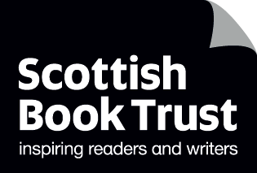
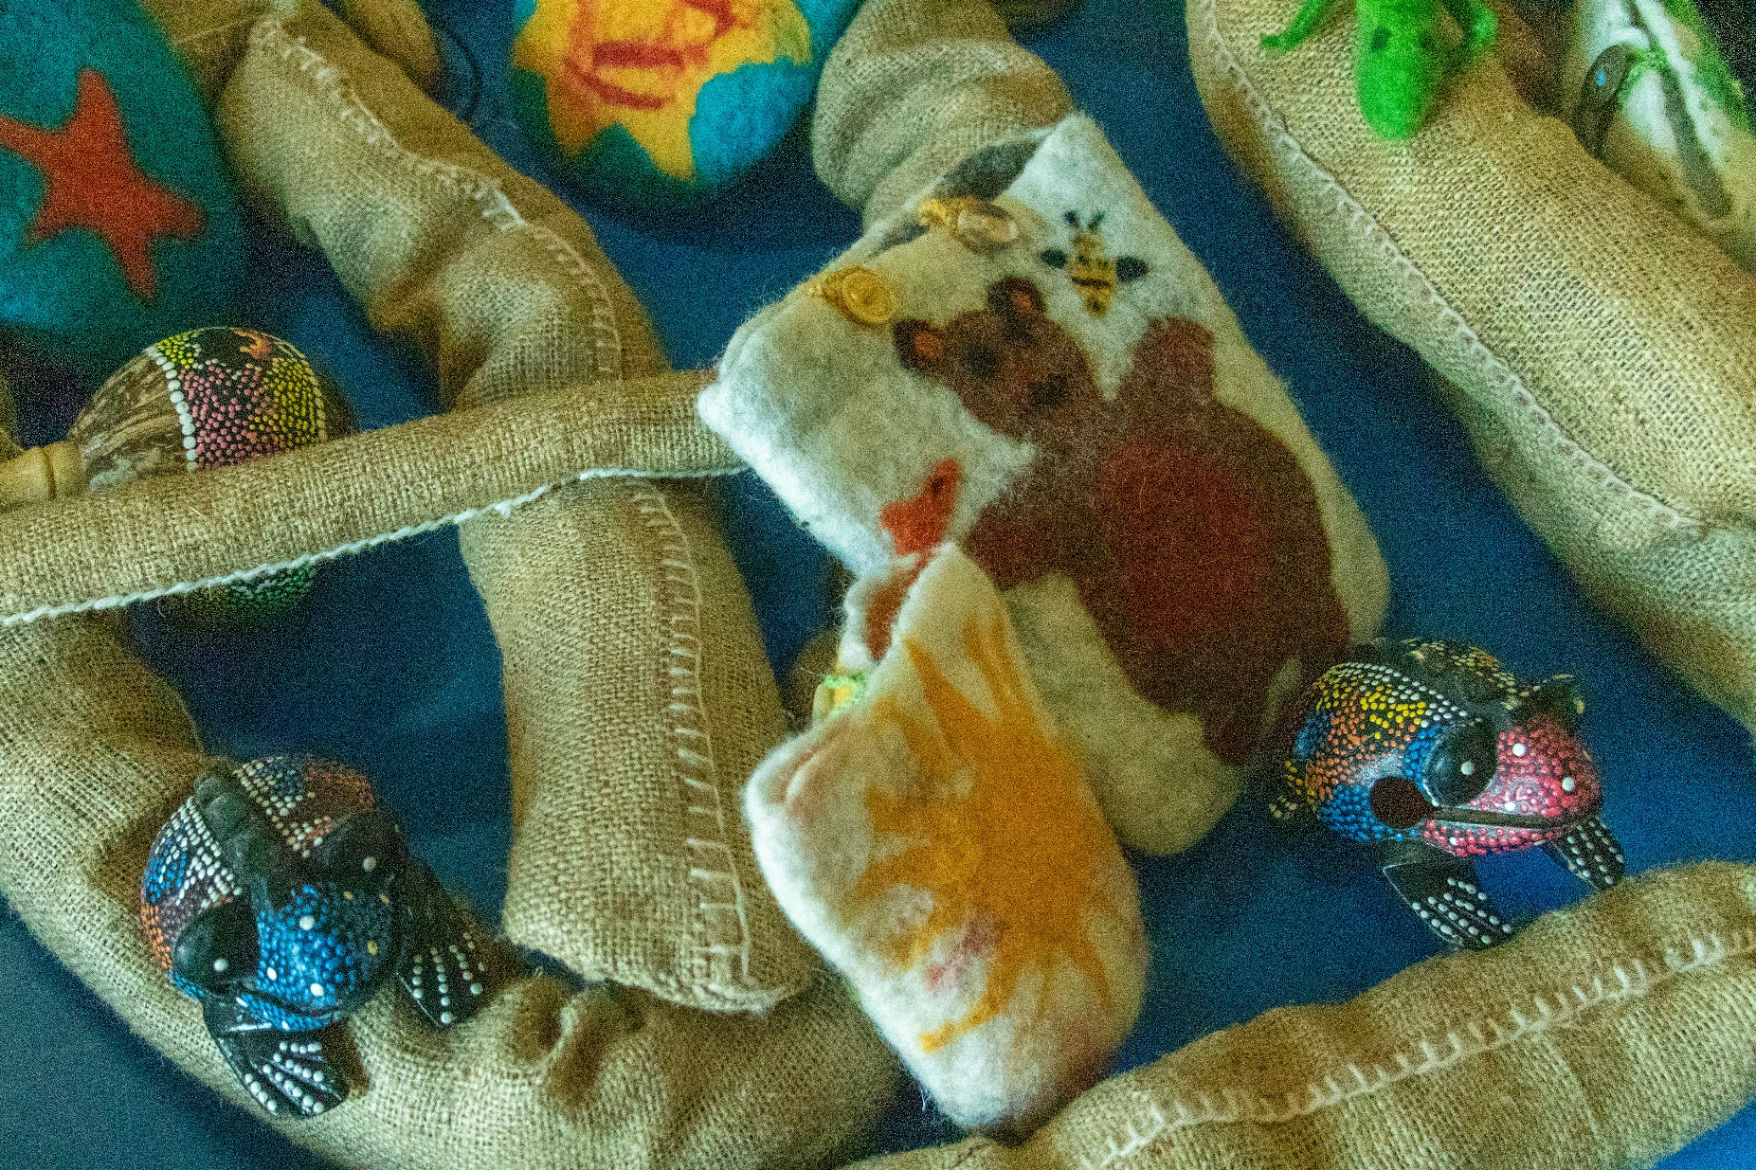

Where to source accessible storytelling materials
A list of organisations with high-quality resources available to help support all learners to engage and access stories.


Age 3-18

CFE Levels Early to Fourth

scottishbooktrust.com

Scottish Book Trust is a registered company (SC184248)
and a Scottish charity (SC027669).

Contents
About this resource 2
How to use this document 3
Purchasable Resources 3
Books 3
Props and toys 4
Learning resources, technology and devices 5
Author visits 5
Free resources 6
Guides and downloadable resources 6
Book lists 6
Video and audio 7

About this resource
The following document has been put together to help you find providers, businesses and organisations providing high-quality resources which aim to support all learners to engage with stories. Scottish Book Trust is not affiliated with these businesses; this list is based on feedback from schools.
If you use a particular resource which you find helpful, please do get in touch at schools@scottishbooktrust.com as we would love to hear about it.
We have also included information on free Scottish Book Trust and external resources you may find useful.

How to use this document
Each organisation is laid out in a table as follows:
Name of organisation and link to their website | A short description of the organisation’s services and, if specified, who they are suitable for, e.g.:  “Graphic novels suitable for autistic or dyslexic readers”
If you want something specific, e.g. “graphic novels” or “outdoor items” you can use the Find button or press Ctrl and F on your keyboard to search this document.

Purchasable Resources

Books
Including board books, tactile books, audiobooks, comics and graphic novels and other formats.
Organisation name | What they sell:
Access2Books | Access2books is a charity that produces and publishes high quality early years books in dual format – giant print (75pt) and braille – with illustrations.
Badger Learning | Dual language books (in English-Ukrainian and English-Polish) and a wide range of Hi-Lo books suitable for dyslexic readers aged 7-14, including graphic novels and non-fiction.
Bag Books | Multi-sensory books, props, story sacks
Barrington Stoke | Short books designed for dyslexic readers, filterable by reading age and interest age.
Books Beyond Words | Word-free picture stories on a variety of topics.
Child’s Play | Large print books, board books, lift the flap books, tactile books, story sacks
CustomEyes Books | Order customised large print versions of contemporary written texts.
Dekko Comics | Comic books and graphic novels designed for children with dyslexia and autism.
Dreaming Fingers (Les Doigts Qui Rêvent) | This French company creates and produces books for tactile readers, with rich tactile illustrations for young and emergent readers (please note both the website and books are in French).
DK Braille Books on Penguin Random House’s website | Non-fiction braille books
Every Cherry | Stories and books for your senses, easy-read and symbolised chapter books, dyslexia friendly chapter books
Heath Books | Large print books, dual language, lift the flap books, tactile books, touch and feel books, story sacks
Jessica Kingsley Publishers | Jessica Kingsley Publishers publish a range of books for children and adults about autism, ADHD, dyslexia, mental health and more.
Listening Books | Listening Books provides an internet-based audiobook lending service
Mantra Lingua | A wide range of dual language books, e-books, story props and cards, talking devices, language packs, and learning courses.
Multisensory Stories on Etsy | Sensory story scripts
Usborne Books | Lift-the-flap, sound and touch and feel books
ROMPA | Books and learning resources for adults and children about disabilities, Makaton, neurodivergence, emotions, social stories, multisensory toys and props, sensory integration range (to find the books and reading resources on their shop, we recommend putting “book” into the search function on their website).
SpaceKraft | Fiction and non-fiction books about autism, social stories, story sacks
Toniebox | Audiobox with purchasable Tonie figures which play stories, songs and rhymes
Vox Block | Screenless audiobook players, audiobooks
Yoto player | Screenless stories, songs and learning

Props and toys
Including story sacks, sensory toys, puppets, musical instruments
Organisation name | What they sell:
Cosy Direct | Sensory toys, loose parts, physical development support, enabling environments
Hope Education | Sensory toys, behavioral aids, games and toys designed to improve communication and language, as well as toys for children with dyslexia.
Jabadao | Movement toys and resources supporting physical development including dens, Lycra and elastics, and kits to engage children with floor and movement play, and online training courses.
TTS | Sensory toys, therapeutic kits, outdoors items.
VICTA | VICTA Early Years Sensory Discovery Packs, intended for babies and toddlers with Visual Impairment; packs consist of sensory items and toys.

Learning resources, technology and devices
Including Augmentative and Alternative Communication (AAC), tablets or smart devices, talking point recordable buttons and learning resources and tools
Organisation name | What they sell:
Crossbow Education | Learning resources, props and toys for children including ASN, dyslexia and dyscalculia
Communication Matters | A database of providers of AAC searchable by need.
HelpKidzLearn | Digital, interactive sensory stories and resources for learners with a wide range of educational needs.
Liberator | AAC, communication aids, software and systems, computer access, learning and inclusion aids
TSS | Learning resources, props and toys for children including ASN, ADHD, dyspraxia, dyslexia, dyscalculia as well as visual aids and physical and sensory needs.

Author visits
Scottish Book Trust’s Live Literature Author Directory lists authors from across Scotland; you can filter authors by their focus as a writer, areas they can travel to and audiences they can work with. Here are some direct links:
- Writers who can work with young people with additional support needs
- Writers who can work with vulnerable young people
- Writers who can work with people with English as an additional language

Free resources

Guides and downloadable resources
- Scottish Book Trust: “Sharing books with children with additional support needs”
- Scottish Book Trust: “10 things to do with any book (ASN)”
- Scottish Book Trust: “Multi-sensory songs and rhymes: hints and tips”
- Scottish Book Trust: “Turning picture books into sensory stories”
- Scottish Book Trust: “Sensory storytelling using LOUD! by Rose Robbins”
- Scottish Book Trust: “Let there be dragons: a tactile and sensory art project”
- Books for All: Books for Scottish curriculum in accessible formats
- Flotsam and Jetsam: Resources for multi-sensory storytelling
- My Kind of Book: Guides, story scripts and story videos
- Oily Cart: “‘Being With’ in Sensory Theatre”
- PAMIS: Online library of publications and resources
- Rhyming Multi-Sensory Stories: Story library and videos
- Starcatchers: Puppetry and sensory wonders with Charlotte Allan
- Paths to literacy: Ideas and resources for sensory lessons and materials

Book lists
- Scottish Book Trust: “Sensory books for all”
- Scottish Book Trust: “Books featuring disability and neurodiversity (age 9-11)”
- Scottish Book Trust: “Books featuring disability and neurodiversity (age 12-14)”
- Scottish Book Trust: “Why representation of neurodiverse and disabled characters is important on your bookshelves”
- The Catchpoles: Children’s books by disabled authors

Video and audio
- Scottish Book Trust: Bookbug for children with additional support needs
- Scottish Book Trust: Modelling sensory storytelling video resource
- Scottish Book Trust: Authors Live with Elle McNicoll: Main character energy for autistic girls
- Scottish Book Trust: Webinar on using accessible books and symbol resources
- Scottish Book Trust: Webinar on how to support dyslexic children through sensory stories
- Stories With Symbols: Videos of storytelling through books with additional symbols

