Our learning resources for specific books

About this resource
You can search this resource for specific titles or authors. Each title is linked to the resource page on our website where you can download the activity pack for each book in different formats. You can also find all of our resources by visiting the Learning and resources section of the Scottish Book Trust website.

Fourth Level texts
Cover image | Title and author | Themes
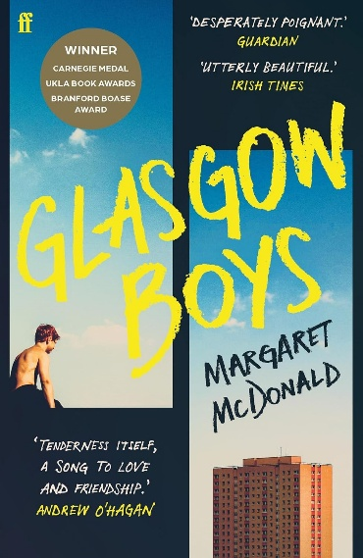 | Glasgow Boys by Margaret McDonald | In partnership with Empathy Lab, this class text resource for Glasgow Boys allows you to explore the book as a set text with a focus on developing empathy skills and an understanding of other people’s feelings and life experiences.  Glasgow Boys follows two care-experienced boys as they try to make the best of their lives whilst also processing the trauma of their shared past. This resource includes in-depth literacy and cross-curricular activities.
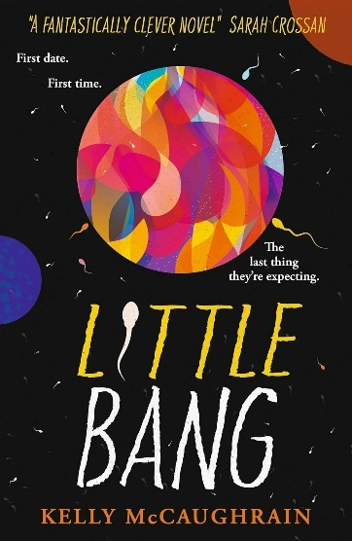 | Little Bang by Kelly McCaughrain | Little Bang is set in 2018 against the background of the Irish referendum on abortion rights. After their first date, Mel discovers she is pregnant with Sid’s baby, and the book follows them and their families as they navigate what this means. This class text resource contains in depth literacy and cross-curricular activities to use alongside a class reading of Little Bang. Resources developed in partnership with Empathy Lab.
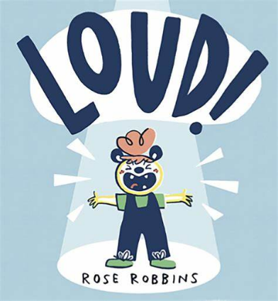 | LOUD! by Rose Robbins | LOUD! is a picture-book full of sounds and textures, making it perfect for sensory-storytelling. The recommended props and actions described in this resource will bring the book to life for all ages and abilities. Suitable for first to fourth level.
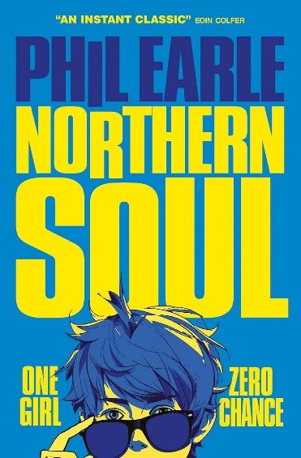 | Northern Soul by Phil Earle | Developed in partnership with Empathy Lab, this resource for Northern Soul allows you to explore the book as a set text with a focus on developing empathy skills and an understanding of other people’s feelings. Become a music journalist, learn about Otis Redding and explore healthy relationships through these in depth Literacy and cross-curricular activities connected to this Barrington Stoke dyslexia friendly text.
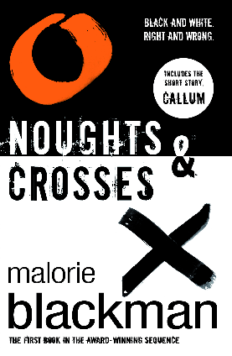 | Noughts and Crosses by Malorie Blackman | Develop a news broadcast, research the civil rights movement, and write your own powerful political speech using these five cross-curricular activities suitable for third, fourth and senior phase.
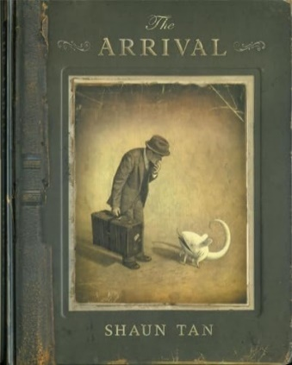 | The Arrival by Shaun Tan | Write an interactive story about a journey, discuss and create your own ‘citizenship test’, and make a scrap album of things you’d want to look at to remind you of home using these cross-curricular activities. This resource can be used for intense week or day activities, or as a yearlong project. It is designed to promote multi-disciplinary connection and collaboration and is suitable for third and fourth level.
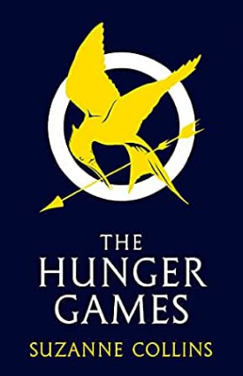 | The Hunger Games by Suzanne Collins | Have a camouflage challenge, make music like a mockingjay, learn basic first aid and how body systems work, and design your own outfit for the games using these cross-curricular activities. This resource can be used for intense week or day activities, or as a yearlong project. It can be used with one class or across the whole school and is suitable for third to senior phase.
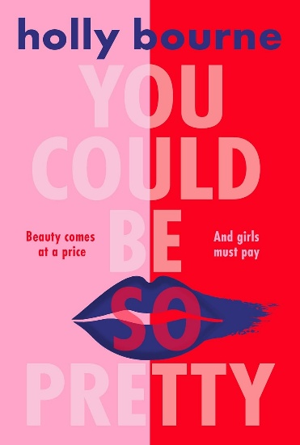 | You Could Be So Pretty by Holly Bourne | In partnership with Empathy Lab, this class text resource focuses on developing empathy skills. You Could Be So Pretty is a feminist dystopian novel which follows Belle and Joni, two very different young girls who live under the Doctrine, a sexist system that divides women and girls into Prettys and Objectionables. Explore dystopian fiction, misogyny and human rights through our literacy and cross-curricular activities. See content warnings in resource.
Teen Discussion Guides
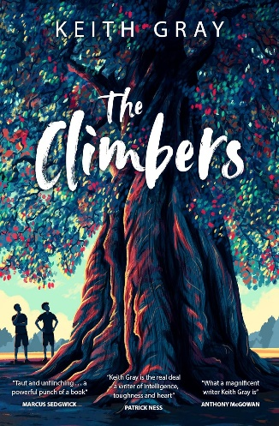 | The Climbers by Keith Gray | Part of our Teen discussion guides. Various titles suitable for 12+ readers. Each guide contains 3-4 discussion prompts and 2 creative writing prompts, as well as suggestions of other books that readers might like.
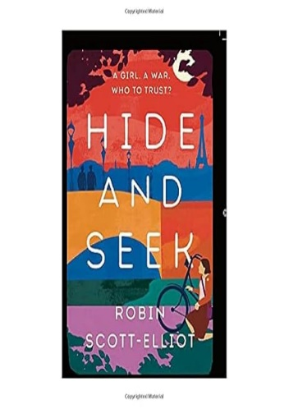 | Hide and Seek by Robin Scott-Elliot | Part of our Teen discussion guides. Various titles suitable for 12+ readers. Each guide contains 3-4 discussion prompts and 2 creative writing prompts, as well as suggestions of other books that readers might like.
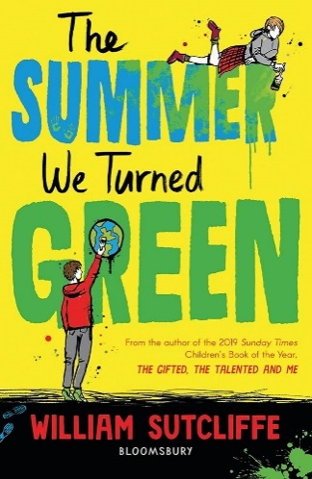 | The Summer We Turned Green by William Sutcliffe | Part of our Teen discussion guides. Various titles suitable for 12+ readers. Each guide contains 3-4 discussion prompts and 2 creative writing prompts, as well as suggestions of other books that readers might like.
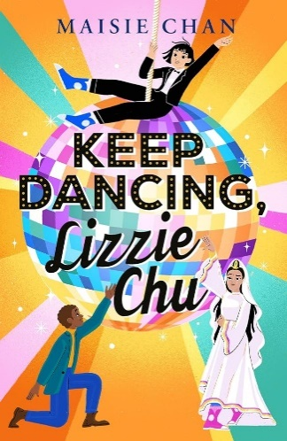 | Keep Dancing, Lizzie Chu by Maisie Chan | Part of our Teen discussion guides. Various titles suitable for 12+ readers. Each guide contains 3-4 discussion prompts and 2 creative writing prompts, as well as suggestions of other books that readers might like.
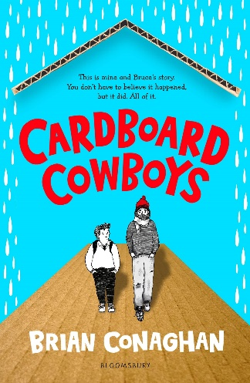 | Cardboard Cowboys by Brian Conaghan | Part of our Teen discussion guides. Various titles suitable for 12+ readers. Each guide contains 3-4 discussion prompts and 2 creative writing prompts, as well as suggestions of other books that readers might like.
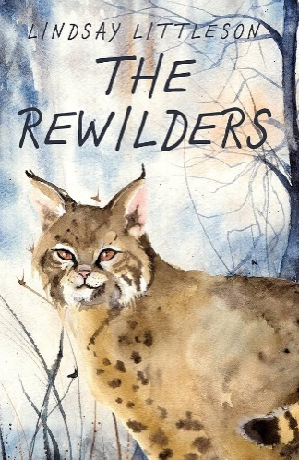 | The Rewilders by Lindsay Littleson | Part of our Teen discussion guides. Various titles suitable for 12+ readers. Each guide contains 3-4 discussion prompts and 2 creative writing prompts, as well as suggestions of other books that readers might like.
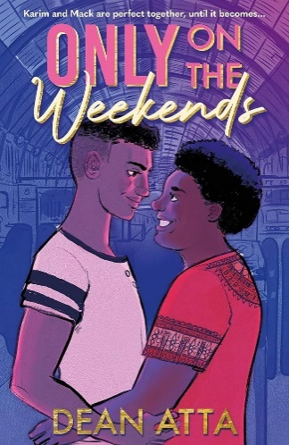 | Only On the Weekends by Dean Atta | Part of our Teen discussion guides. Various titles suitable for 12+ readers. Each guide contains 3-4 discussion prompts and 2 creative writing prompts, as well as suggestions of other books that readers might like.
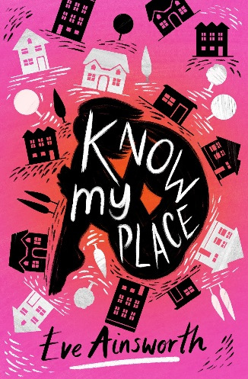 | Know My Place by Eve Ainsworth | Part of our Teen discussion guides. Various titles suitable for 12+ readers. Each guide contains 3-4 discussion prompts and 2 creative writing prompts, as well as suggestions of other books that readers might like.
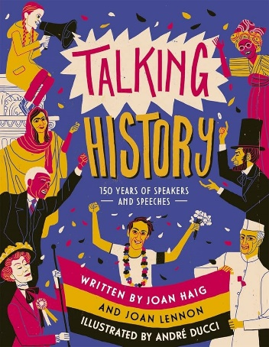 | Talking History by Joan Lennon and Joan Haig | Part of our Teen discussion guides. Various titles suitable for 12+ readers. Each guide contains 3-4 discussion prompts and 2 creative writing prompts, as well as suggestions of other books that readers might like.
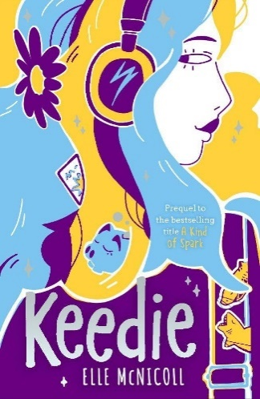 | Keedie by Elle McNicoll | Part of our Teen discussion guides. Various titles suitable for 12+ readers. Each guide contains 3-4 discussion prompts and 2 creative writing prompts, as well as suggestions of other books that readers might like.
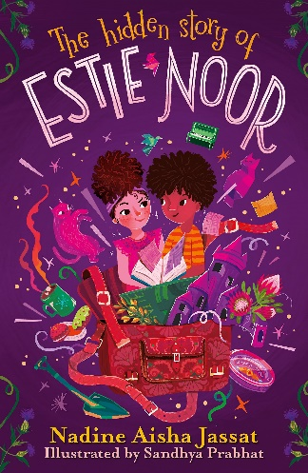 | The Hidden Story of Estie Noor by Nadine Aisha Jassat and Sandhya Prabhat | Part of our Teen discussion guides. Various titles suitable for 12+ readers. Each guide contains 3-4 discussion prompts and 2 creative writing prompts, as well as suggestions of other books that readers might like.
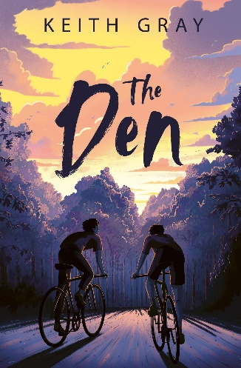 | The Den by Keith Gray | Part of our Teen discussion guides. Various titles suitable for 12+ readers. Each guide contains 3-4 discussion prompts and 2 creative writing prompts, as well as suggestions of other books that readers might like.
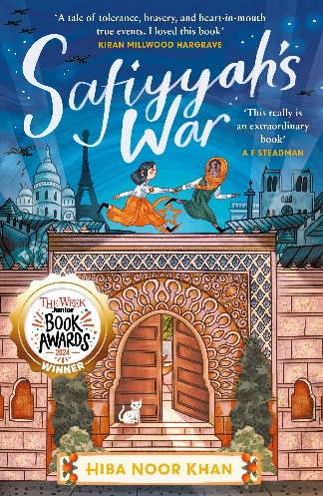 | Safiyyah's War by Hiba Noor Khan | Part of our Teen discussion guides. Various titles suitable for 12+ readers. Each guide contains 3-4 discussion prompts and 2 creative writing prompts, as well as suggestions of other books that readers might like.
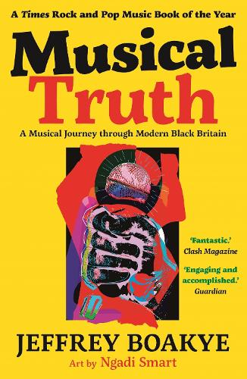 | Musical Truth by Jeffrey Boakye and Ngadi Smart | Part of our Teen discussion guides. Various titles suitable for 12+ readers. Each guide contains 3-4 discussion prompts and 2 creative writing prompts, as well as suggestions of other books that readers might like.
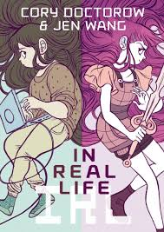 | In Real Life by Cory Doctorow and Jen Wang | Part of our Teen discussion guides. Various titles suitable for 12+ readers. Each guide contains 3-4 discussion prompts and 2 creative writing prompts, as well as suggestions of other books that readers might like.
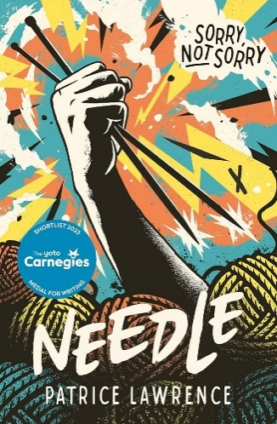 | Needle by Patrice Lawrence | Part of our Teen discussion guides. Various titles suitable for 12+ readers. Each guide contains 3-4 discussion prompts and 2 creative writing prompts, as well as suggestions of other books that readers might like.
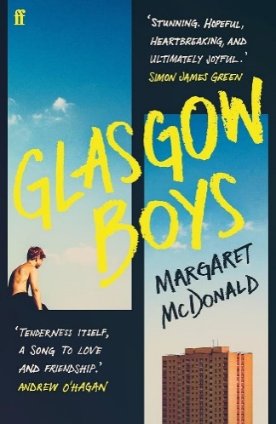 | Glasgow Boys by Margaret McDonald | Part of our Teen discussion guides. Various titles suitable for 12+ readers. Each guide contains 3-4 discussion prompts and 2 creative writing prompts, as well as suggestions of other books that readers might like.
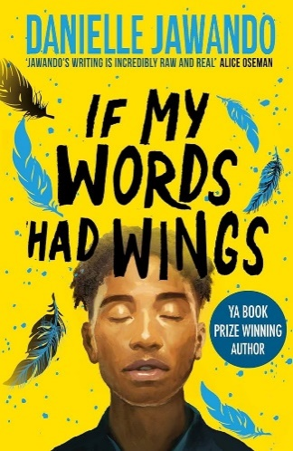 | If My Words Had Wings by Danielle Jawando | Part of our Teen discussion guides. Various titles suitable for 12+ readers. Each guide contains 3-4 discussion prompts and 2 creative writing prompts, as well as suggestions of other books that readers might like.
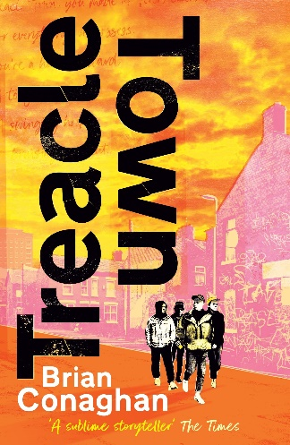 | Treacle Town by Brian Conaghan | Part of our Teen discussion guides. Various titles suitable for 12+ readers. Each guide contains 3-4 discussion prompts and 2 creative writing prompts, as well as suggestions of other books that readers might like.
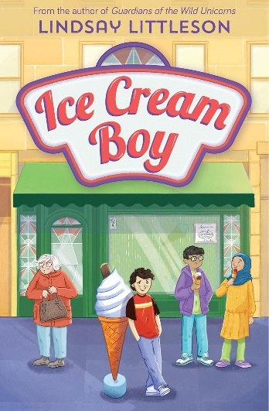 | Ice Cream Boy by Lindsay Littleson | Part of our Teen discussion guides. Various titles suitable for 12+ readers. Each guide contains 3-4 discussion prompts and 2 creative writing prompts, as well as suggestions of other books that readers might like.
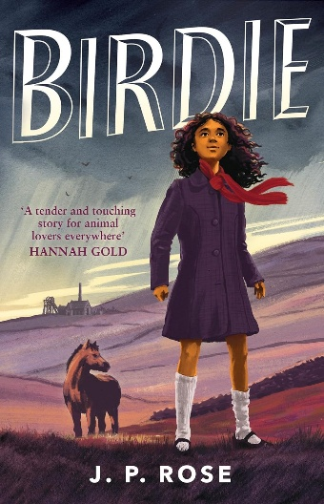 | Birdie by J.P Rose | Part of our Teen discussion guides. Various titles suitable for 12+ readers. Each guide contains 3-4 discussion prompts and 2 creative writing prompts, as well as suggestions of other books that readers might like.
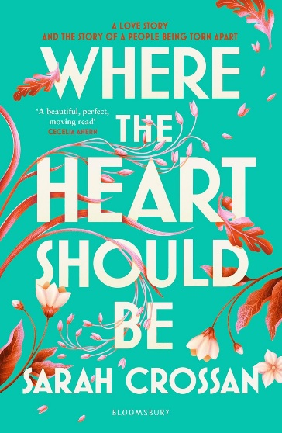 | Where the Heart Should Be by Sarah Crossan | Part of our Teen discussion guides. Various titles suitable for 12+ readers. Each guide contains 3-4 discussion prompts and 2 creative writing prompts, as well as suggestions of other books that readers might like.
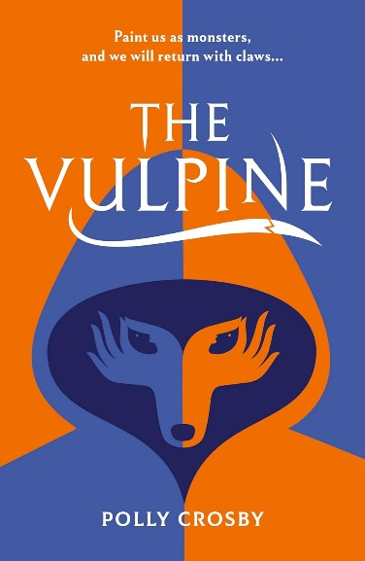 | The Vulpine by Polly Crosby | Part of our Teen discussion guides. Various titles suitable for 12+ readers. Each guide contains 3-4 discussion prompts and 2 creative writing prompts, as well as suggestions of other books that readers might like.
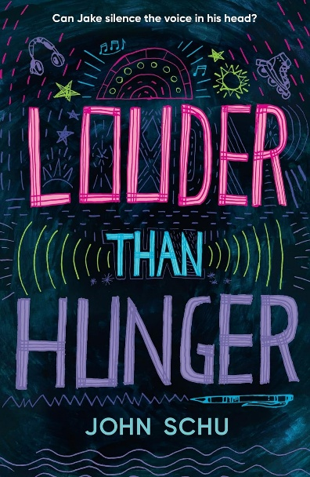 | Louder than Hunger by John Schu | Part of our Teen discussion guides. Various titles suitable for 12+ readers. Each guide contains 3-4 discussion prompts and 2 creative writing prompts, as well as suggestions of other books that readers might like.
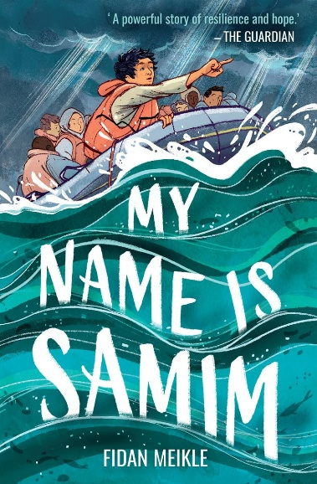 | My Name is Samim by Fidan Meikle | Part of our Teen discussion guides. Various titles suitable for 12+ readers. Each guide contains 3-4 discussion prompts and 2 creative writing prompts, as well as suggestions of other books that readers might like.

