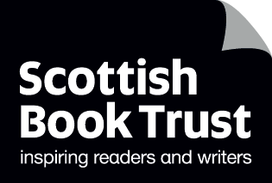
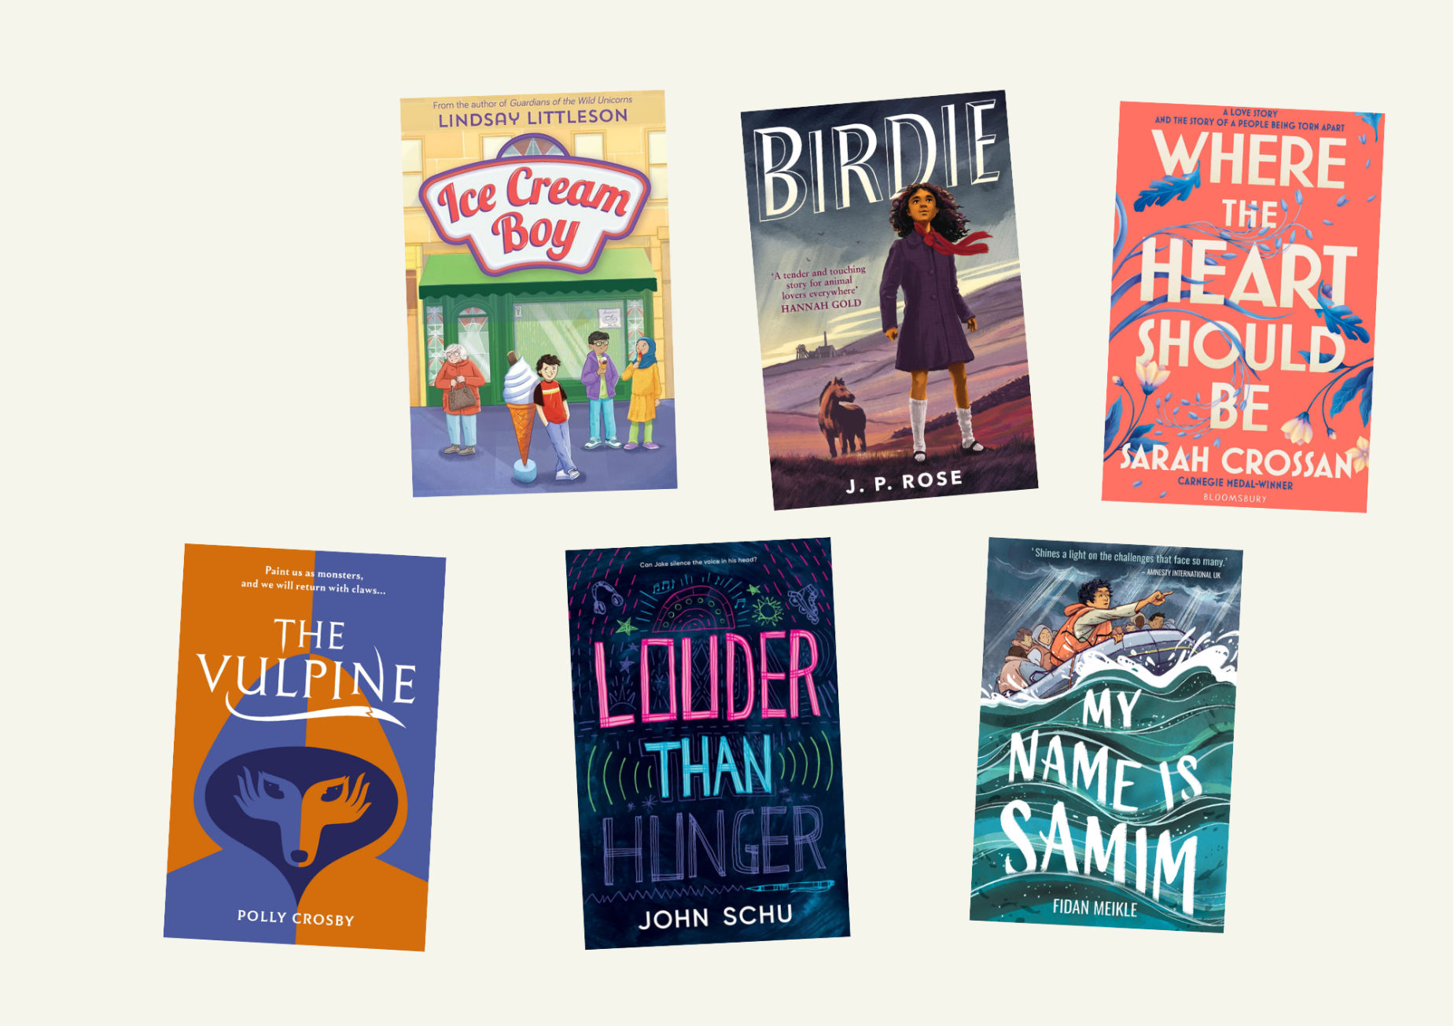

Teen book discussion guides 2026
Discussion questions and creative writing prompts for running your own book group

Age: 10+

For use in classrooms, libraries or book groups

Resource created by Scottish Book Trust


scottishbooktrust.com

Scottish Book Trust is a registered company (SC184248)
and a Scottish charity (SC027669).

Contents
About this resource 2
Content notes 3
Book synopses 4
Ice Cream Boy by Lindsay Littleson (printable) 7
Ice Cream Boy by Lindsay Littlseon (plain text) 8
Birdie by J.P. Rose (printable) 10
Birdie by J.P. Rose (plain text) 11
Where the Heart Should Be by Sarah Crossan (printable) 13
Where the Heart Should Be by Sarah Crossan (plain text) 14
The Vulpine by Polly Crosby (printable) 16
The Vulpine by Polly Crosby (plain text) 17
Louder than Hunger by John Schu (printable) 19
Louder than Hunger by John Schu (plain text) 20
My Name is Samim by Fidan Miekle (printable) 22
My Name is Samim by Fidan Meikle (plain text) 23
Further resources 25

About this resource
This guide has been created to help you run a book club with pupils or teenagers in your library. We advise looking at the titles with the young people you work with and asking them which ones they’d like to read!
Each discussion guide contains some discussion and creative writing prompts. We have made both printable versions and plain text versions.
On each discussion guide we’ve included three cards from our Story Deck which we
think summarise the feeling or atmosphere of the piece. If you have Story Deck in
your school or library, we encourage you to use this as an icebreaker. What do they
think of the cards we’ve included? Which cards would they use?
To find out more about Story Deck visit the Story Deck page on our Reading Schools website.
For more book recommendations, please see:
- Our Book Discovery Guides
- Our Book Discovery CLPL sessions for teachers and librarians
- Our book lists

If you are taking part in Reading Schools, the activities in this resource could support delivery of Key Area:
- 1.2.5: Staff knowledge of contemporary children’s literature
- 1.5.1: Access to high-quality books
- 2.3.2: Staff meaningful conversations around books
- 2.3.3: Creating learner social networks
- 2.3.4: Opportunities for learners to respond to what they’re reading

Content notes
With all our resources, we highly recommend that you read the book before using it and use your best judgement on whether teaching about this topic is appropriate for the pupils you work with.
Some of the books in this content guide include depictions of:
- Racism and discrimination: Ice Cream Boy, Birdie, My Name is Samim
- Abuse: Where the Heart Should Be
- Ableism: The Vulpine
- Disordered eating: Louder than Hunger

Book synopses

Ice Cream Boy by Lindsay Littleson
- Lower secondary (Age 10+)
- Themes: family, community, coming of age, dementia
Luca Verani is only twelve years old, yet he already dreams of running his family’s ice cream café in Glasgow. However, Luca’s plans are disrupted when he discovers that his aunt is selling the café, and his nonna is beginning to lose her memories. Meanwhile, at school, his best friend, Sitara, is being targeted by racist bullies. Ice Cream Boy is a kind-hearted and humorous novel about our dreams, our families and our communities.

Birdie by J.P. Rose
- Lower secondary (Age 10+)
- Themes: social history, racism and discrimination, animals
Set in 1950, Birdie has just arrived in the pit village of Barrington Dale after growing up in in a children’s home all her life. Despite her initial excitement to meet the family who tracked her down, she finds both her aunt and the village have trouble accepting her. At school, at home and with the other children in the community, she faces racial discrimination. Birdie finds friendship, instead, with the village’s last pit pony. When his future is in danger, Birdie is determined to save his life. We love this historical novel about resilience, friendship and belonging.

Where the Heart Should Be by Sarah Crossan
- Mid to upper secondary (Age 12+)
- Themes: history, Ireland, romance, class
Set during the Irish famine in 1846, this novel-in-verse follows Nell, a scullery maid in a large house. Her days consist of working for Sir Philip Wicken, the man who owns her home and her family’s land. Upstairs, the new inhabitant, who has come from England, is Johnny – nephew to the owner who will, one day, inherit everything. As Nell’s family are subject to the hunger and disease sweeping Ireland, Nell and Johnny find themselves drawn closer together. This novel-in-verse explores first love whilst offering a rich personal exploration of history.

The Vulpine by Polly Crosby
- Mid to upper secondary (Age 12+)
- Themes: ableism and disability activism, dystopia, folklore
Ora lives in a world where to succeed is to be perfect – and this means no disabilities or illnesses. Imperfect children are stolen away by the Vulpine, fox-like creatures straight from fairy stories. Then, one day, Ora’s mother reveals a long-hidden secret that Ora has a genetic illness that affects her lungs. Ora has only one choice: to seek out the fabled Vulpine. An excellent novel for interrogating misconceptions and assumptions about disabilities, illness and ableism.

Louder than Hunger by John Schu
- Mid to upper secondary (Age 12+)
- Themes: disordered eating, recovery, family, musicals
Jake has a life full of skating, reading comics and watching musicals with his favourite person, his grandmother. However, Jake also has an eating disorder and has to take time away from his usual life to live in inpatient care. This novel-in-verse uniquely uses font, formatting and layout to let us into Jake’s mind and follow him on his path to recovery.

My Name is Samim by Fidan Meikle
- Lower secondary (Age 10+)
- Themes: migrant and refugee journeys, maths,
Sam is a refugee. Aged only 13, he’s forced to make a long journey from Afghanistan to the U.K. in search of safety. Now, in order to stay, he has to tell his story to convince the authorities. Moving between Samin’s journey and his new life in the U.K., we learn more about Samin, his love of mathematics, chess and pi, and the realities of both his journey, and many others’.

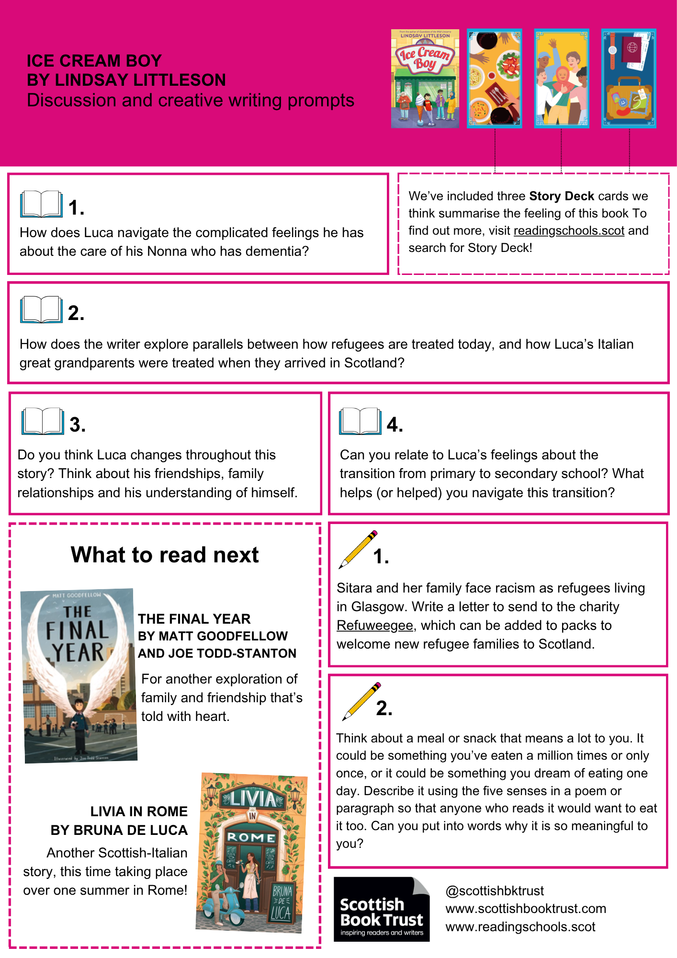

Ice Cream Boy by Lindsay Littleson (printable)

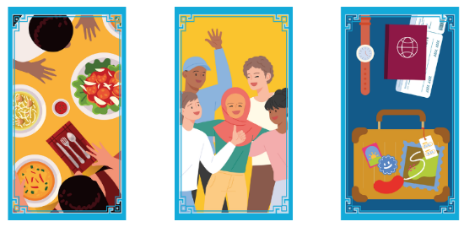
Ice Cream Boy by Lindsay Littlseon
(plain text)
We’ve included three Story Deck cards we think summarise the feeling of this book. Do you agree with our choices? What would you pick?

Discussion questions
- How does Luca navigate the complicated feelings he has about the care of his Nonna who has dementia?
- How does the writer explore parallels between how refugees are treated today, and how Luca’s Italian great grandparents were treated when they arrived in Scotland?
- Do you think Luca changes throughout this story? Think about his friendships, family relationships and his understanding of himself.
- Can you relate to Luca’s feelings about the transition from primary to secondary school? What helped/helps you navigate this transition?

Creative writing prompts
- Sitara and her family face racism as refugees living in Glasgow. Write a letter to send to the charity Refuweegee, which can be added to packs to welcome new refugee families to Scotland.
- Think about a meal or snack that means a lot to you. It could be something you’ve eaten a million times or only once, or it could be something you dream of eating one day. Describe it using the five senses in a poem or paragraph so that anyone who reads it would want to eat it too. Can you put into words why it is so meaningful to you?

What to read next
The Final Year by Matt Goodfellow and Joe Todd-Stanton
For another exploration of family and friendship that’s told with heart.
Livia in Rome by Bruna de Luca
Another Scottish-Italian story, this time taking place over one summer in Rome!

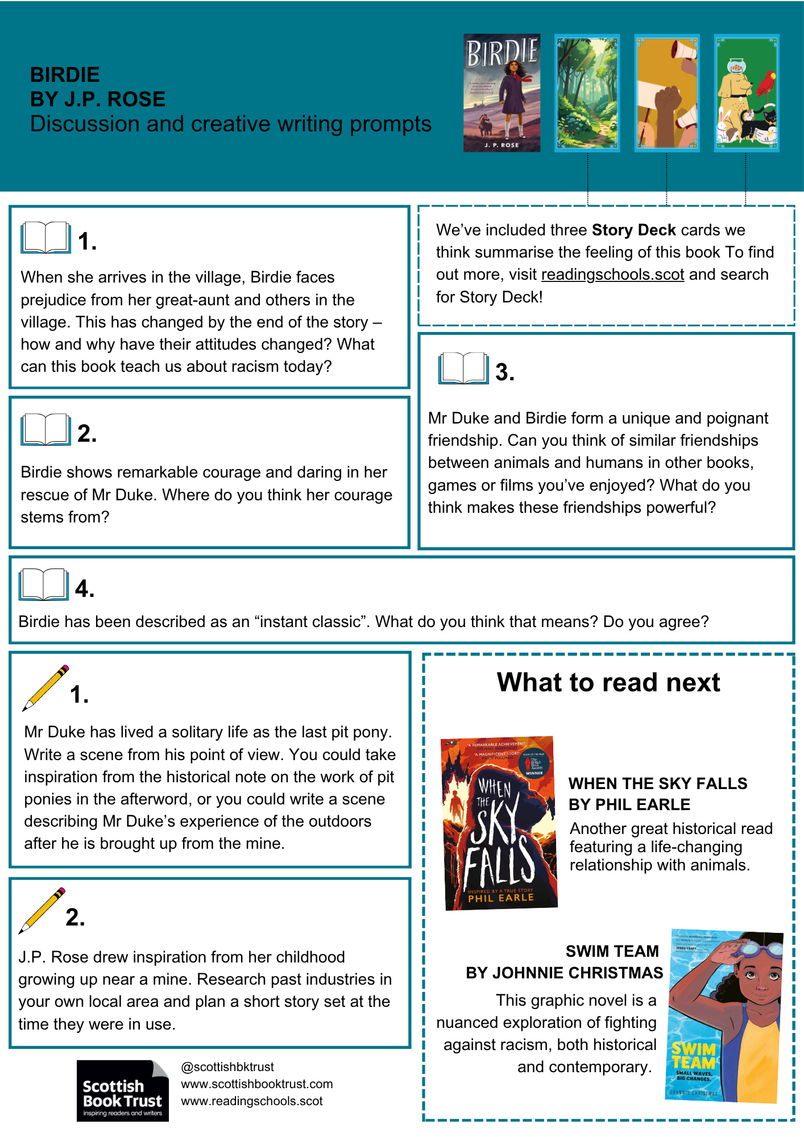
Birdie by J.P. Rose (printable)

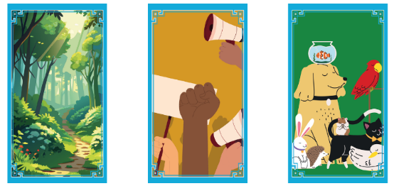
Birdie by J.P. Rose (plain text)
We’ve included three Story Deck cards we think summarise the feeling of this book. Do you agree with our choices? What would you pick?

Discussion questions
- When she arrives in the village, Birdie faces prejudice from her great-aunt and others in the village. This has changed by the end of the story – how and why have their attitudes changed? What can this book teach us about racism today?
- Birdie shows remarkable courage and daring in her rescue of Mr Duke. Where do you think her courage stems from?
- Mr Duke and Birdie form a unique and poignant friendship. Can you think of similar friendships between animals and humans in other books, games or films you’ve enjoyed? What do you think makes these friendships powerful?
- Birdie has been described as an “instant classic”. What do you think that means? Do you agree?

Creative writing prompts
- Mr Duke has lived a solitary life as the last pit pony. Write a scene from his point of view. You could take inspiration from the historical note on the work of pit ponies in the afterword, or you could write a scene describing Mr Duke’s experience of the outdoors after he is brought up from the mine.
- J.P. Rose drew inspiration from her childhood growing up near a mine. Research past industries in your own local area and plan a short story set at the time they were in use.

What to read next
When the Sky Falls by Phil Earle
Another great historical read featuring a life-changing relationship with animals.
Swim Team by Johnnie Christmas
This graphic novel is a nuanced exploration of fighting against racism, both historical and contemporary.

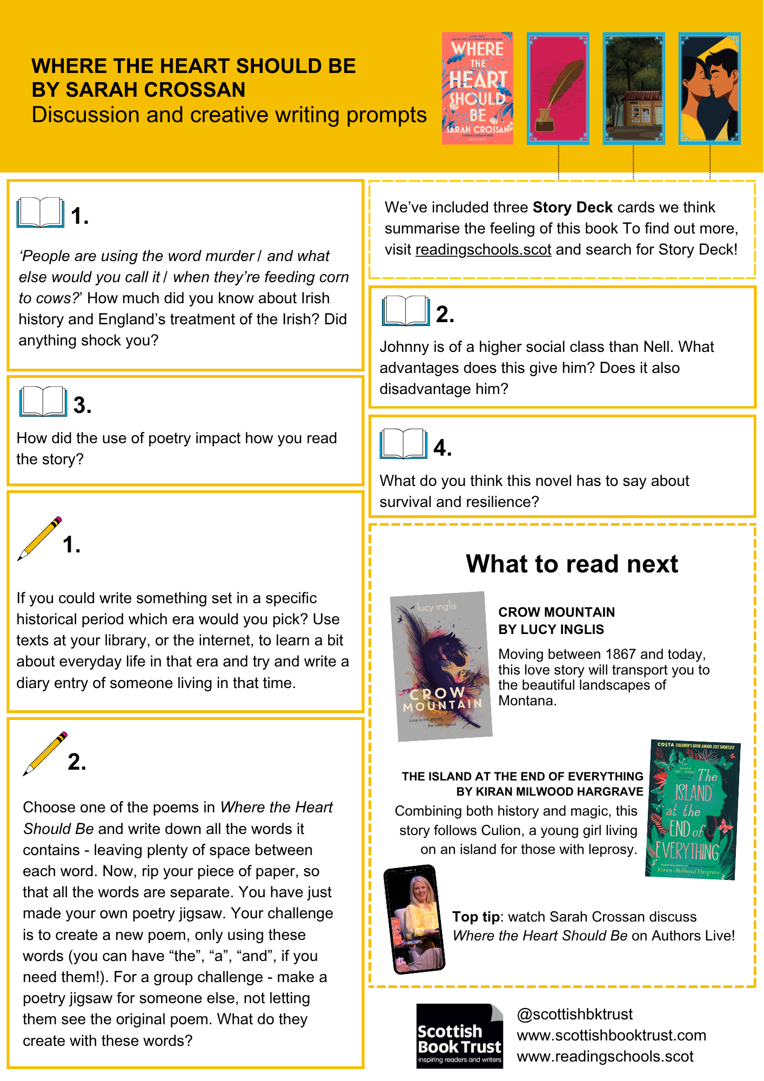
Where the Heart Should Be by Sarah Crossan (printable)

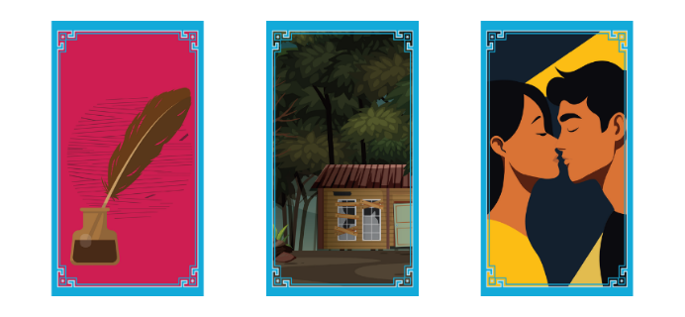
Where the Heart Should Be by Sarah Crossan (plain text)
We’ve included three Story Deck cards we think summarise the feeling of this book. Do you agree with our choices? What would you pick?

Discussion questions
- ‘People are using the word murder / and what else would you call it / when they’re feeding corn to cows?’ How much did you know about Irish history and England’s treatment of the Irish? Did anything shock you?
- How did the use of poetry impact how you read the story?
- Johnny is of a higher social class than Nell. What advantages does this give him? Does it also disadvantage him?
- What do you think this novel has to say about survival and resilience?

Creative writing prompts
- If you could write something set in a specific historical period which era would you pick? Use texts at your library, or the internet, to learn a bit about everyday life in that era and try and write a diary entry of someone living in that time.
- Choose one of the poems in Where the Heart Should Be and write down all the words it contains - leaving plenty of space between each word. Now, rip your piece of paper, so that all the words are separate. You have just made your own poetry jigsaw. Your challenge is to create a new poem, only using these words (you can have “the”, “a”, “and”, if you need them!). For a group challenge - make a poetry jigsaw for someone else, not letting them see the original poem. What do they create with these words?

What to read next
Crow Mountain by Lucy Inglis
Moving between 1867 and today, this love story will transport you to the beautiful landscapes of Montana.
The Island at the End of Everything by Kiran Milwood Hargrave
Combining both history and magic, this story follows Culion, a young girl living on an island for those with leprosy.
Top tip: watch Sarah Crossan discuss Where the Heart Should Be on Authors Live on the Scottish Book Trust website!

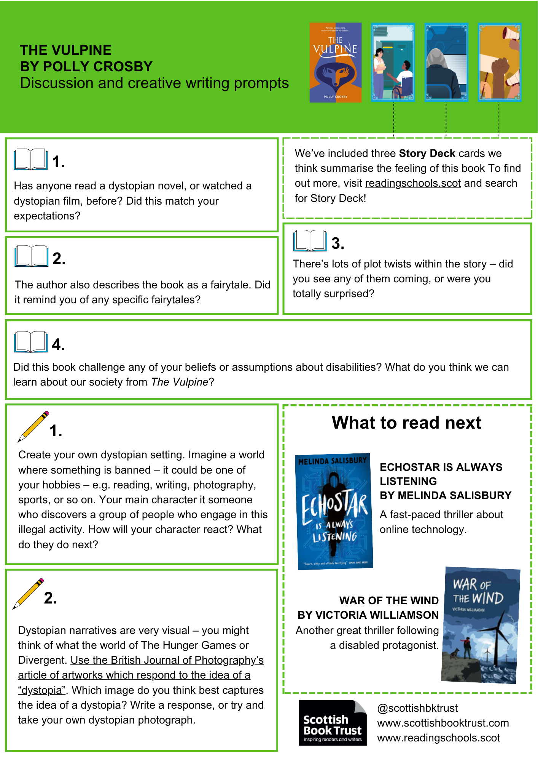

The Vulpine by Polly Crosby (printable)

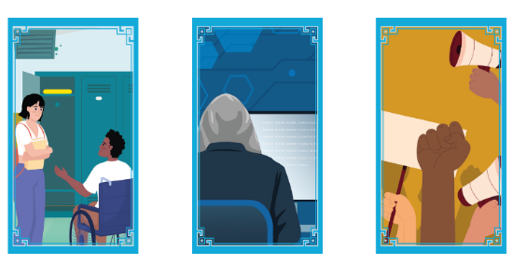
The Vulpine by Polly Crosby (plain text)
We’ve included three Story Deck cards we think summarise the feeling of this book. Do you agree with our choices? What would you pick?

Discussion questions
- Has anyone read a dystopian novel, or watched a dystopian film, before? Did this match your expectations?
- The author also describes the book as a “fairytale”? Did it remind you of any specific fairytales?
- There’s lots of plot twists within the story – did you see any of them coming, or were you totally surprised?
- Did this book challenge any of your beliefs or assumptions about disabilities? What do you think we can learn about our society from The Vulpine?

Creative writing prompts
- Create your own dystopian setting. Imagine a world where something is banned – it could be one of your hobbies – e.g. reading, writing, photography, sports, or so on. Your main character it someone who discovers a group of people who engage in this illegal activity. How will your character react? What do they do next?
- Dystopian narratives are very visual – you might think of what the world of The Hunger Games or Divergent. Use the British Journal of Photography’s article of artworks which respond to the idea of a “dystopia”. Which image do you think best captures the idea of a dystopia? Write a response or try and take your own dystopian photograph.

What to read next
Echostar is Always Listening by Melinda Salisbury
A fast-paced thriller about online technology.
War of the Wind by Victoria Williamson
Another great thriller following a disabled protagonist.

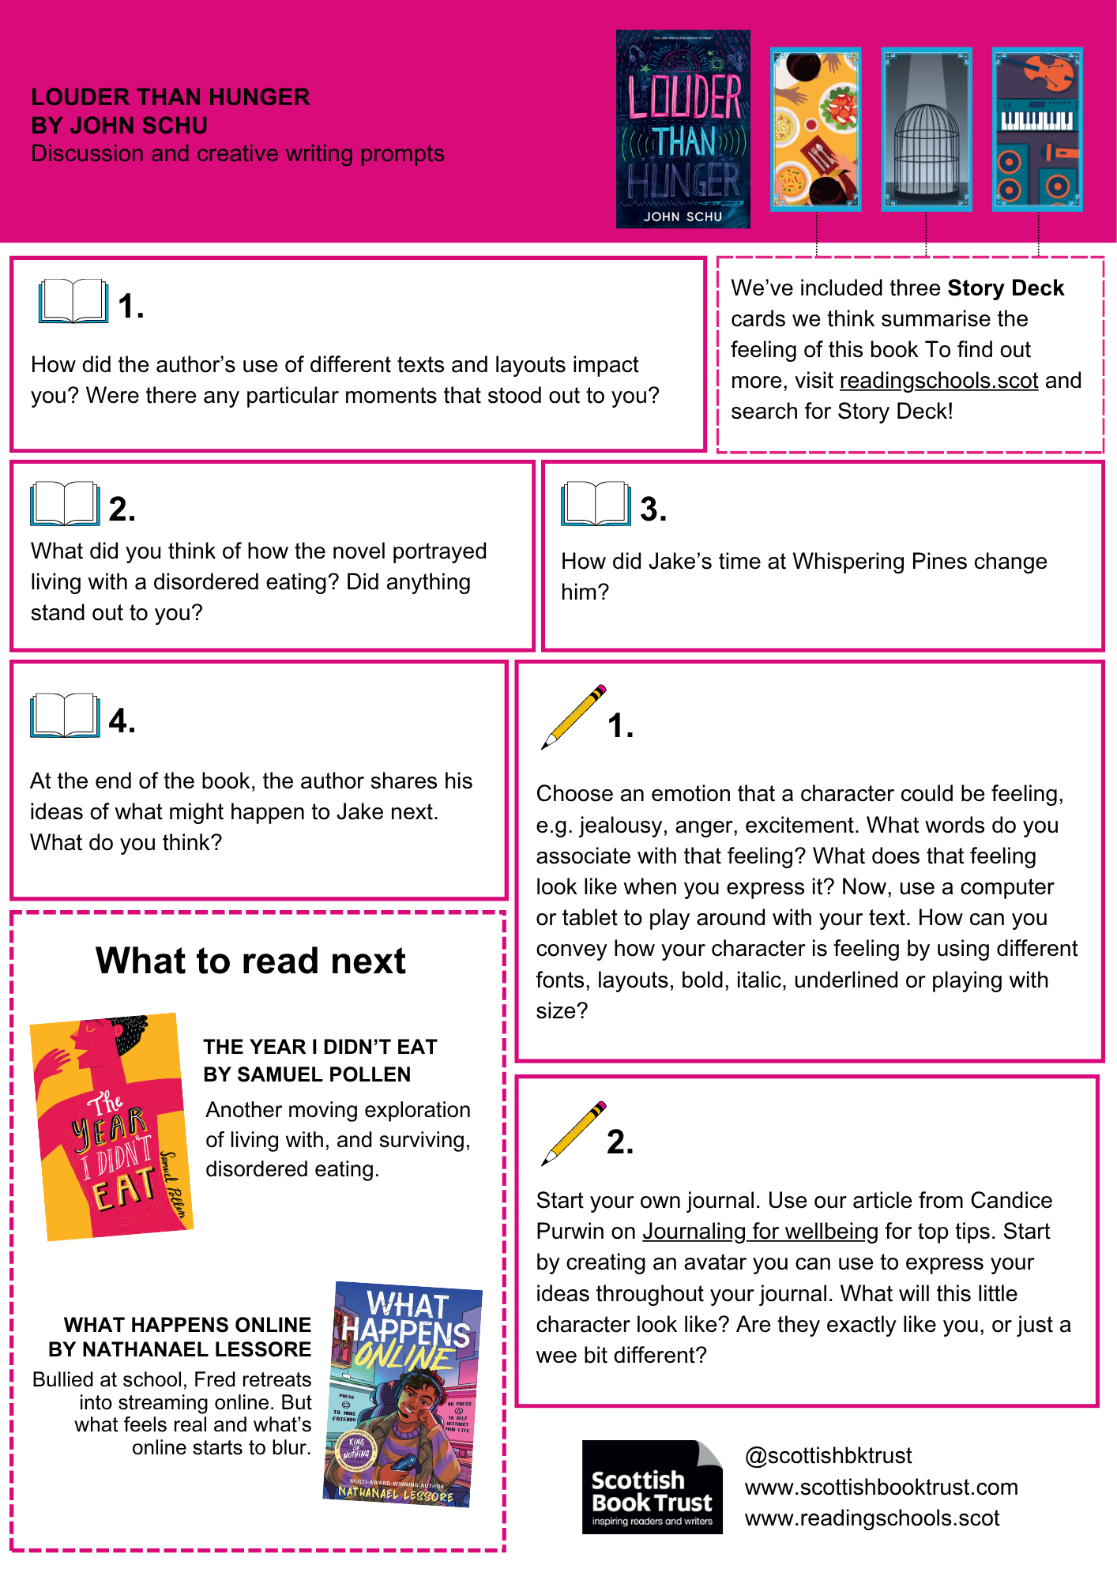
Louder than Hunger by John Schu (printable)

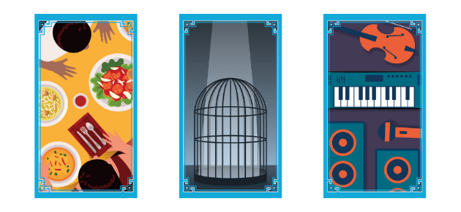
Louder than Hunger by John Schu (plain text)
We’ve included three Story Deck cards we think summarise the feeling of this book. Do you agree with our choices? What would you pick?

Discussion questions
- How did the different layout of the text impact how you read it? Were there any particular moments that stood out to you?
- What did you think of how the novel portrayed Jake’s disordered eating? Did anything stand out to you?
- How did Jake’s time at Whispering Pines change him?
- At the end of the book, the author shares his ideas of what might happen to Jake next. What do you think?

Creative writing prompts
- Choose an emotion that a character could be feeling, e.g. jealousy, anger, excitement. What words do you associate with that feeling? What does that feeling look like when you express it? Now, use a computer or tablet to play around with your text. How can you convey how your character is feeling by using different fonts, layouts, bold, italic, underlined or playing with size?
- Start your own journal. Use our article from Candice Purwin on Journaling for wellbeing for top tips. Start by creating an avatar you can use to express your ideas throughout your journal. What will this little character look like? Are they exactly like you, or just a wee bit different?

What to read next
The Year I Didn’t Eat by Samuel Pollen
Another moving exploration of living with, and surviving, disordered eating.
What Happens Online by Nathanael Lessore
Bullied at school, Fred retreats into streaming online. But what feels real and what’s online starts to blur.

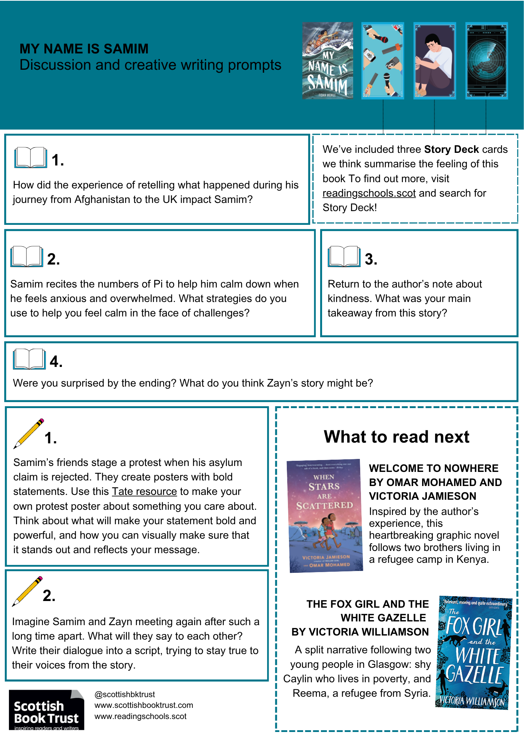
My Name is Samim by Fidan Miekle (printable)

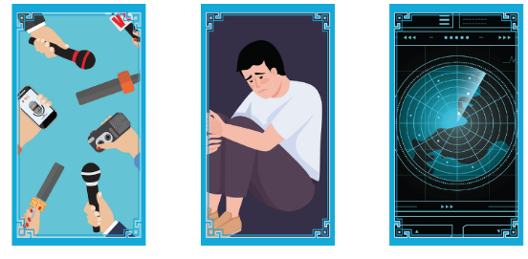
My Name is Samim by Fidan Meikle (plain text)
We’ve included three Story Deck cards we think summarise the feeling of this book. Do you agree with our choices? What would you pick?

Discussion questions
- How did the experience of retelling what happened during his journey from Afghanistan to the UK impact Samim?
- Samim recites the numbers of Pi to help him calm down when he feels anxious and overwhelmed. What strategies do you use to help you feel calm in the face of challenges?
- Return to the author’s note about kindness. What was your main takeaway from this story?
- Were you surprised by the ending? What do you think Zayn’s story might be?

Creative writing prompts
- Samim’s friends stage a protest when his asylum claim is rejected. They create posters with bold statements. Use this Tate resource to make your own protest poster about something you care about. Think about what will make your statement bold and powerful, and how you can visually make sure that it stands out and reflects your message.
- Imagine Samim and Zayn meeting again after such a long time apart. What will they say to each other? Write their dialogue into a script, trying to stay true to their voices from the story.

What to read next
When Stars are Scattered by Omar Mohamed and Victoria Jamieson
Inspired by the author’s experience, this heartbreaking graphic novel follows two brothers living in a refugee camp in Kenya.
The Fox Girl and the White Gazelle by Victoria Williamson
A split narrative following two young people in Glasgow: shy Caylin who lives in poverty, and Reema, a refugee from Syria

Further resources
See our other teen discussion guides on the Scottish Book Trust website.
For more book recommendations, see:
- Our Book Discovery Guides
- Our Book Discovery CLPL sessions for teachers and librarians
- Our book lists
For more resources to use with secondary pupils see:
- Our 10 things to do with any book secondary resource can be used with any books, and contains activities and ideas that can extend pupil’s engagement with any of these titles
- All our learning resources can be filtered by age, including 12-to-14-year-olds and 15-to-18-year-olds

