
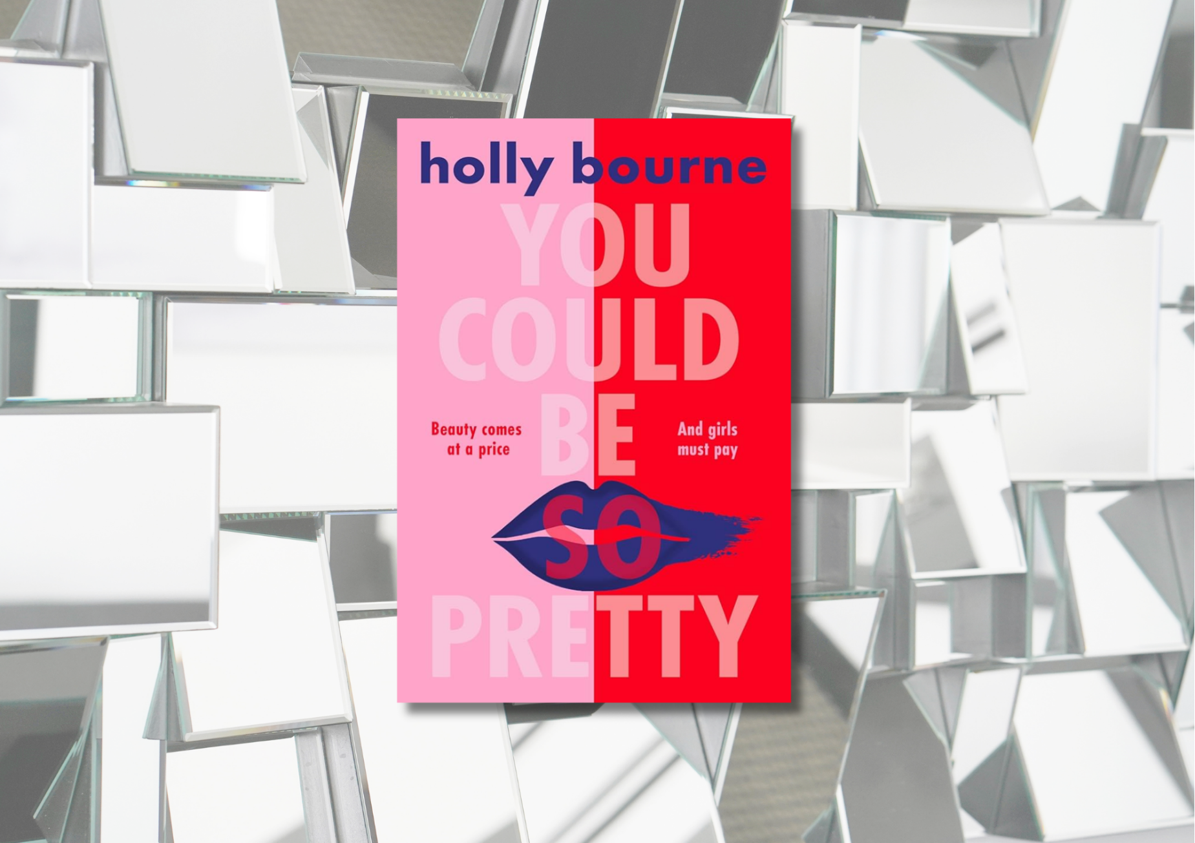

You Could Be So Pretty learning resource
Suggested learning activities for Holly Bourne’s You Could Be So Pretty, focussing on Literacy and English and empathy

CFE Level Third and Fourth

Suitable for 14+


Resource created by Scottish Book Trust and EmpathyLab

scottishbooktrust.com

Scottish Book Trust is a registered company (SC184248)

and a Scottish charity (SC027669).

Contents
About this resource 2
Teaching about sexism 4
Scottish Book Trust learning activities 4
English and Literacy activities 4
Cross curricular activities 17
EmpathyLab learning activities 20
Further resources 27
Printable activity sheet 1: Dystopian words 29
Printable activity sheet 2: Create a character 30
Printable activity sheet 3: Joni’s speech 31
Printable activity sheet 4: The Doctrine and Human Rights 32

About this resource
This resource has been developed by Scottish Book Trust and Empathy Lab to support classroom use of You Could Be So Pretty by Holly Bourne with a focus on literacy and English skills, cross-curricular learning, reading and writing for pleasure as well as using the text with a particular focus on developing empathy skills and an understanding of other people’s feelings and life experiences. We have also created resources for:
- Glasgow Boys by Margaret McDonald
- Little Bang by Kelly McCaughrain
- Northen Soul by Phil Earle
Scottish Book Trust is a national charity that believes in the life-changing power of books. Our school programmes support teachers and other education professionals to put creativity, reading and books at the heart of their learning environment.
EmpathyLab is a charitable social enterprise whose mission is to raise an empathy educated generation, inspired to build a better world for everyone. Our strategy is based on scientific research showing that empathy is a learnable skill, and books are a practical, powerful tool with which to build it. By 2026 we aim to benefit one million children every year.

About You Could Be So Pretty
You Could Be So Pretty is a dystopian novel following two girls who must navigate a misogynist society. Belle is determined to be a “Pretty” – a young girl who follows the sexist Doctrine, takes extreme care of her appearance and is subservient to the boys at her school. Meanwhile, her classmate Joni is an “Objectionable”, someone who is determined to fight back against the sexist Doctrine.

Content warnings
You Could Be So Pretty contains depictions of:
- Eating disorders
- Domestic abuse
- Violent pornography, including mentions of Deep fakes
- Misogyny
- Racism
- Sexual harassment and assault
- Self-harm
- There are also hospital and post-surgery scenes which may be upsetting for some readers.
With all of our resources, we highly recommend that you read the book before using it with your class and use your best judgement about whether teaching about this topic is appropriate for the children in your class. With this specific book, you may want to offer your pupils content warnings before each chapter and, where appropriate, offer them the opportunity to opt out of a specific chapter. Some young people may also need a safe space to discuss some of the themes in this book. We have included some organisations which can offer support in the Further resources at the end of this document.

Teaching about sexism
Whilst engaging in these activities, we recommend you:
- Use your discretion about which activities are appropriate for the children you work with based on their context and experiences.
- Throughout, ensure you make pupils aware of who they can talk to if they see or experience sexist behaviour, bullying or harassment at school.
- Avoid asking pupils to share their personal experiences, especially of misogyny or bullying, as this can put them in a vulnerable position.
- Avoid only mentioning specific online influencers, such as Andrew Tate, as this can glorify them or mark them out as special. If you are talking about them ensure you contextualise them as part of a wider harmful patriarchal system.
- Always ensure you include trans and non-binary identities as part of the discussion. Misogyny also harms trans and non-binary people, including trans girls who face transmisogyny, trans men who are often excluded from being accepted as boys or men, and non-binary people who are often misgendered or bullied for not complying with stereotypical gender roles. For more advice on supporting trans pupils, see: Scottish Trans or LGBT Youth Scotland.

For more support teaching about sexism and misogyny, see the Further resources section at the end of this document.

Scottish Book Trust learning activities

English and Literacy activities
Activity 1: Meet Belle and Joni (up to page 13)
LIT 3-02a/4-02a, LIT 3-04a/4-04a, LIT 3-16a/4-16a
Read the first two chapters, up until the time jump on page 13. Put the pupils into groups and ask them to discuss:
- How are Belle and Joni different?
- How do their relationships with their mothers differ?
- Why do they think the author has shown us these two moments before the main plot of the novel begins?
- How do they think Belle will be shaped by her mother’s breakdown over her hair?
- How do they think Joni will be shaped by her father leaving her and her mother?

Look at the front cover and it’s unique opening – one saying, ‘You could be so pretty’, the other saying ‘You should be so angry’.
- Why do pupils think the cover has been designed like this?
- Which word to they think will apply to which character? Why?
Ask the pupils to write a couple of sentences that describe their first impressions of Belle and Joni, thinking about what adjectives they would use to describe them, and what they think the impact of their mothers could be.

Discussion questions (up to page 25)
Discuss Belle and Joni’s morning routines. Belle’s is on page 17 and 18, Joni’s is on page 23 to page 25.
- How are they different?
- How do these characters feel when they wake up?
- What do these routines tell us about these characters?
- What is most important to Belle? What about Joni?
- How is this impacted by their families?
- What have you learned about the Doctrine and this world so far?

Activity 2: Belle’s attack (page 13-29 and page 30-66)
LIT 3-04a/4-04a, LIT 3-05a/4-05a, LIT 3-07a/4-07a, LIT 3-09a/4-09a,
ENG 3-17a/4-17a, ENG 3-19a/4-19a, LIT 3-25a/4-25a
First, read up to page 29. Belle’s attack takes place on page 25 to 29. You might want to read this section with the class and allow time for pupils to respond to what happens.
- How does Belle react?
- How does Joni react?
- Why does each character react the way they do?
Now, watch the cinepoem “Hopscotch” by Roxana Vilk, based on a poem by Nadine Aisha Jassat (4 minutes, 50 seconds). Ask pupils to share their initial responses to both the poem and the film.
- Did any key words or moments stick with them?
- How does the poem (e.g. the language, word choice) capture the feeling of being catcalled?
- How does the film (e.g. the camera work, film techniques) capture the feeling of being catcalled?

Read on to page 66. As a class, discuss how the attack has a longer-term impact on Belle. What do they notice about her behaviour? How has she changed?
Now ask pupils to write a list, or draw a mind map, of each character which explains all the factors that have led them to their different response. For example:
Joni | Belle
Sees the attack as an attack | Sees the attack as a “compliment”
Raised by her mother, who fights against the Doctrine | Raised by her mother and father, who both agree with the Doctrine
Is seen as an Objectionable | Is seen as a Pretty
Her friends are also Objectionables | Her friends are also Prettys
Sees Belle’s attack as part of a bigger sexist system | Sees her attack as “her fault”
Doesn’t trust The Protection Agency | Trusts The Protection Agency

Put the pupils into groups, asking them to discuss the following questions. Once their discussion is over, you can go through the class group by group, asking for the responses to each question.
- Why do they think the author of You Could Be So Pretty has chosen to create two very different characters?
- How does this demonstrate the impact of the Doctrine?
- How does this add to novel?
- The text starts with the statement: ‘The Doctrine states that the Bad Times are over and true Gender Equality has been achieved’. Think about what you have read so far. How does the writer challenge beauty standards, sexism, and ideas about “choice” in this novel?

Discussion questions (up to page 77)
On page 77, Joni says: ‘Violence against us is never an isolated incident.’
- What do pupils think this means?
- What other violence have Belle and Joni experienced so far?
- How is The Doctrine perpetuating violence against women and girls? Can they think of specific examples in the text?
Activity 3: Dystopian worlds (up to page 100)
LIT 3-04a/4-04a, LIT 3-09a/4-09a, LIT 3-16a/4-16a, ENG 3-17a/4-17a,
ENG 3-19a/4-19a
Read up to page 100. Ask pupils to define the term “dystopian”. Once they have their own definitions, you could use a dictionary. The Collins Dictionary, for example, defines it as: ‘an imaginary place where everything is as bad as it can be’.
Put pupils into groups to discuss the following and feed back to the class.
- Have they read any other dystopian books or watched any dystopian films? (e.g. The Hunger Games, Divergent, Uglies)
- What do they think are the key characteristics of a dystopian story?
Do they think You Could Be So Pretty is a dystopian novel? What clues has the author given us that this is a dystopian novel?
Using Printable activity sheet 1, ask the pupils to go through the two chapters you’ve just read, noting any words that are capitalised or have new definitions. Some examples include:
- Pretty, Objectionable and Invisible
- Mask
- Sin

How many of these words can they find? Ask pupils to share what they found and write each of the words on the board.
Now ask the pupils what they think some of these words mean. Are they referring to something new in this book or are they just a different term for something that already exists? For example, “Body prayer” seems to be exercise, but “Mask” could be make-up, skincare, or a completely new product.
Now ask the class:
- Why does the author use language this way?
- What impact does it have on the reader?
- How does it help build the story and the world it’s set in?
- Why do you think the author chose to set this story in a dystopian or futuristic world?
- Do you think the words the writer uses for certain tools/activities accurately represents what your experience of them is e.g. does Ranking accurately represent social media?

You could extend this activity by:
- Asking pupils to work in groups to create a mind map or a display of all the words or images they associate with “dystopian”
- Working with your school or local library to create a display of some dystopian novels which pupils might like to read

Discussion questions (up to page 122)
Reflect on the conversation about skin colour, modelling, and hair “Correction” between Vanessa, her sister Hope, and Belle. Then read or listen to model Naomi Campbell talk about racism within the fashion industry on BBC Woman’s Hour (4 minutes, 43 seconds). Ask pupils to reflect on diversity within the fashion/beauty industry today.
Activity 4: Design a Mask (up to page 125)
LIT 3-04a/4-04a, LIT 3-08a/4-08a, LIT 3-09a/4-09a, LIT 3-16a/4-16a,
ENG 3-17a/4-17a, LIT 3-20a/4-20a, ENG 3-27a/4-27a, LIT 3-29a/4-29a
On page 120, Joni tells us her mother keeps Mask in the Centre for the women who are staying there: ‘Outside the Centre she’s campaigning against their very existence, but inside she happily deposits them, and doesn’t say anything when the women flock to the cupboard and clutch them like precious jewels.’
As a class, discuss:
- Why do you think Joni’s mother purchases Mask?
- Why do the women who are living in the Centre still want to use Mask?
- Sexism is baked into every element of our society. Is it possible to avoid every single sexist product or company? As an example, you could talk about how some companies that promote images of supporting women and girls and/or critiquing beauty standards are owned by larger companies with histories of sexist advertising.
- There are many different opinions on the make-up industry. Some people believe make-up can be used as a form of creative self-expression, and others believe it revolves around the “male gaze”. What do pupils think?
  - What are the negative aspects of make-up?
  - What are the positive aspects of make-up?

We encourage you to follow your pupils lead here – no one should feel ashamed of wearing, or not wearing, make-up, and it’s worth acknowledging that people may wear make-up for a lot of different reasons.
Now, look at some different advertisements for make-up, for example: VintageInn’s article of vintage make-up advertisements, Glamour’s article of celebrity make-up campaigns. Ask pupils to choose a campaign, and write down:
- What kind of beauty standard is being promoted? Is it realistic?
- Who is, or isn’t, present in adverts?
- What do the adverts portray as the benefit of wearing make-up? E.g., self-confidence, attractiveness to others, etc.
Now, ask pupils to work in groups to come up with an advert for a Mask, or make-up, product that focuses on the positive aspects of make-up. What would a feminist make up campaign look like? For example, it could focus on feeling confident, being creative or playful, or how wearing make-up can support self-expression, including for members of the LGBTQ+ community.

Discussion questions (up to page 168)
- Why does Joni offer Belle somewhere to stay?
- Do you think you would do the same if you were in Joni’s shoes?

Activity 5: Creating a character (up to page 169)
LIT 3-04a/4-04a, LIT 3-09a/4-09a, LIT 3-16a/4-16a, LIT 3-23a/4-23a,
LIT 3-26a/4-26a, ENG 3-27a/4-27a, LIT 3-29a/4-29a, HWB 3-09a/4-09a
Read up to page 169. Now watch the video on sexism on the Human Rights Channel website (2 minutes, 18 seconds). Ask pupils to make a note of some of the different ways that sexism impacts women and girls.
- Can they identify examples of sexism that Belle experiences?
- What about Joni?
- Consider any of the other characters, e.g. Belle or Joni’s parents? Vanessa? Joni’s friends?
Now ask the pupils to choose a photograph of someone from Printable activity sheet 2. Ask them to imagine they’re a character in You Could Be So Pretty and write from their perspective, showing what they experience living under The Doctrine. Ask them to think about:
- This character’s unique perspective. Who do you think this person is?
- Examples of sexism or privilege they may experience under The Doctrine – they can use examples from the list they made whilst watching the Human Rights Channel video.

Now, use Lesson 4: Editing your writing (slides 29-32) of Brian Conaghan’s Creative writing lessons on the Scottish Book Trust website to explore the concept of “showing not telling”. Ask pupils to edit their piece of creative writing to ensure it shows and doesn’t tell what life is like under The Doctrine.

Go back to You Could Be So Pretty. Ask pupils to work in groups to develop a short talk on a key moment where the author showed instead of told us about a character. How do they do this? What techniques do they use?

The worksheet from this activity has been adapted from our resource Understanding and challenging sexism in schools.

Discussion questions (up to page 193)
- Do you think Joni should meet up with her dad?
- Is it fair of Joni’s mother to be angry with her?

Activity 6: Create your own iceberg (up to 229)
LIT 3-14a/4-14a, LIT 3-15a/4-15a, LIT 3-16a/4-16a, LIT 3-25a/4-25a
One of the key things that You Could Be So Pretty explores is that acts of sexism are all connected. The system that makes Belle feel like she must wear Mask is the same system that empowers men to harass her. For Joni, the system that caused her father to leave her family is the same system that forces women to flee to the Centre.
Thinking about the last few chapters they have read, ask pupils to write down some examples of the sexism the characters have faced. This could include:
- The stories women share at the Sister Circle
- Carrie being sexually assaulted and photographed
- Vanessa and Joni’s discussion around Smut
- Belle’s mother’s experience at the Empowerment Centre
- Damian harassing Belle

Now show pupils the iceberg image on the Human Rights Channel website. This image is designed to illustrate how sexist violence is connected to everyday sexism.
Now ask pupils to draw their own outline of an iceberg – with only some of it pointing out of the water. On the surface level, ask them to write the moments in the novel that were more shocking (e.g. Carrie’s assault, Belle’s attack). They could think of these as “headlines” – i.e. the kinds of sexism we might report on.
On the area that is below the water, they should write all of the day-to-day sexism that leads to these moments. These might be the moments that are less dramatic, but considered as “everyday” sexism, e.g. the way Damian and Ben speak to Belle and Vanessa.
Ask your pupils:
- Is it easy or hard to distinguish these kinds of acts?
- Can they see how all these acts are linked?

Discussion questions (up to page 214)
‘Choice means nothing if you feel you have no other option than to choose what everyone chooses. Choice means nothing if there are significant consequences for not following the established path.’ (page 214).
Ask pupils to think of a moment when they felt they had to follow the established path – did they feel they had a choice?
The concept of internalised misogyny has been around since the 1970s. It’s a way of understanding how women can absorb sexist ideas from society (including film, TV, social media, etc.) and practice sexist behaviours against themselves and other women.
Discuss how internalised misogyny impacts Belle’s relationships with her mother, her friends, and other women. Does Joni experience internalised misogyny?

Activity 7: Persuasive writing (up to page 306)
LIT 3-08a/4-08a, LIT 3-15a/4-15a, LIT 3-16a/4-16a, LIT 3-18a/4-18a
Read up to page 306. Focus on Joni’s speech about sexism on page 282-290.
- What is the core argument of Joni’s speech?
- Is Joni’s speech persuasive?
- How does she persuade Belle? What techniques does she use?

There are three things we can look for in a piece of persuasive writing:
- Is the argument clear? Does it make sense? Does the writer provide evidence for their claims?
- Is the person speaking an expert in what they’re talking about? Do we trust them?
- Do they make us feel a certain emotion? How do they create a story to show us the impact of what they’re doing?

You could use TED-Ed’s video on “What Aristotle and Joshua Bell can teach us about persuasion” (4 minutes, 39 seconds) to introduce the idea of Aristotle’s definition of logos, ethos and pathos as a framing for these three ideas (the video covers this in a accessible way – so don’t worry if pupils aren’t familiar with these ideas or Aristotle already!)
- Logos – is it logical? Does it make sense to the audience?
- Ethos – do you have a good reputation for talking on this subject? Are you trustworthy or an expert?
- Pathos – does it make the audience feel something?

Ask the pupils to use Printable activity sheet 3 to find evidence of each of these three elements in Joni’s speech.
Now, ask the pupils to use these three elements to create their own talk or piece of persuasive writing. Ask them to think about:
- A clear argument that relates to the audience’s point of view – what is their core argument? How can they describe it in clear and simple language? Do they need to do any research?
- Being a trustworthy expert – why have they decided to write about this? How do they have expertise in this subject – have they researched it? Is it based on their own experiences?
- An emotional connection or story – what do they want the reader or listener to feel? What story can they tell that will create this emotion?

Discussion questions (up to page 293)
Joni says that the Doctrine is ‘here to divide, rather than unite. Remember, it’s absolutely everything to do with being compliant and placid’, (page 293).
Share some examples of anti-suffrage postcards from the Glasgow Women’s Library, used to deter supporters of women getting the right to vote. Ask pupils if these postcards support Joni’s claim. How are the women portrayed in these cards?

Activity 8: Belle and Joni’s plan (up to page 365)
LIT 3-02a/4-02a, LIT 3-06a/4-06a, LIT 3-08a/4-08a, LIT 3-09a/4-09a,
LIT 3-14a/4-14a, LIT 3-18a/4-18a
Read up to page 365. Belle and Joni decide to switch places for The Ceremony, with Belle going in comfortable clothes with no Mask, and Joni going in Mask, heels and full dress.
Divide your class in two. One side must argue why Belle and Joni’s plan was a good idea. The other side must argue why it wasn’t. The pupils can use what they learned in the previous activity about talking and speaking persuasively. How can they persuade the other side that they are correct?

Activity 9: Belle and Joni’s plan (up to the end, including the acknowledgements)
LIT 3-07a/4-07a, LIT 3-16a/4-16a, ENG 3-17a/4-17a, ENG 3-19a/4-19a,
ENG 3-31a/4-31a
Read up until the end, including the acknowledgements. On page 393, a third-person narrator tells us: ‘This isn’t a dystopia. This isn’t a fiction. This is now’.
In the acknowledgements, Holly Bourne also says she told her publisher that: ‘…this will be a contemporary novel […] but I’m writing it in dystopian language because we are actually living this nightmare.’

- What do the pupils think the statement ‘this isn’t a dystopia’ means?
- Were the pupils surprised? Did they agree/disagree?
- How does using the third person change their perspective of the ending or the novel as a whole?
- How does writing this novel – exploring these themes – through the framework of a dystopian fiction impact how they read it? Would it have had as much impact without the addition of the Doctrine?

Now ask the pupils to pick a page from one of the earlier chapters and rewrite it as if it wasn’t a dystopian fiction but was set in their world today. What changes do they need to make? They can use the printable sheet of words they created as part of Activity 3.

Activity 9: Themes (after finishing the novel)
LIT 3-10a/4-10a, LIT 3-16a/4-16a, ENG 3-17a/4-17a, ENG 3-19a/4-19a
There are different ways of exploring a text. These include:
- Plot: what happens in the story?
- Character: who are the characters? What are they like?
- Themes: what are the ideas the novel explores?

Working in groups, ask your pupils to present a five-minute talk on one of the key themes in You Could Be So Pretty. They can come up with this themselves, or you can assign them a theme that they have to find evidence for:
- Dystopia
- Freedom and choice
- Intersectional inequality
- Gender
- Power
- Consumerism and the beauty industry
- Social media
- Violence

Cross curricular activities

Activity 1: Explore sexism and misogyny
LIT 3-02a/4-02a, LIT 3-15a/4-15a, SOC 3-16a, SOC 4-16b/4-16c, HWB 3-49a/4-49a
You can explore further learning from You Could Be So Pretty by investigating gender stereotypes, either with your P.S.E. or Modern Studies department.
Watch our Authors Live broadcast with Alan Bisset where he reads his book Lads: A Guide to Respect and Consent. The full broadcast is 40 minutes, but if you don’t have time, the key part to watch is 9 minutes into the broadcast, where Alan Bissett reads aloud from the book. Now, using two large pieces of paper, split the class into groups. Give each group a word to write in the centre of their piece of paper:
- Man
- Lad
- Masculinity
- Femininity

Now, give them 10-15 minutes to write down all the words they associate with that word. Then, ask them to go through their words – underline or circle all the positive words in green and all the negative words in red. If there are any words they think could be neutral, ask them to circle them in grey. Allow some time for the groups to look at one another’s mind maps.
Now, as a class, discuss:
- Which word has the most positive connotations?
- Which word has the most negative connotations?
- Which word has the most neutral connotations? Discuss these words – do they say something about how men’s perspectives or experiences are often considered the default?
- What’s the main differences they notice between a “lad” and a “man”?
Are there any traits that appear on the “masculinity” and “femininity” that people disagree with? Or think could appear on both?
This activity has been adapted from our resource Understanding and challenging sexism in schools which supports use of the Authors Live broadcast with Alan Bissett.

Activity 2: The Doctrine and Human Rights
ENG 3-19a/4-19a, SOC 3-16a/4-16a, SOC 2-17a/3-17a/3-17b, HWB 3-09a/4-09a
You could work with your Modern Studies or R.M.P.S. department to put The Doctrine and the society that Belle and Joni live in on trial! How does The Doctrine deny people their human rights?
See Printable activity sheet 4. Pupils can research each of the human rights outlined to find a definition, then work together to find evidence for how this right is denied to a character(s) in the book. For example:

Right and article | What does this right mean? | Example of this being denied to a character in You Could Be So Pretty
Article 7: Right to equality before the law | The ability to have the full protection of the law without any discrimination. | When Belle calls the Protection Agency, they don’t work to protect her from her attacker.

Activity 3: The Doctrine and religion or philosophy
ENG 3-19a/4-19a, RME 3-01a/4-01a, RME 3-02a/4-02a, RME 3-04a/4-04a,
RME 3-05a/4-05a, RME 3-09a/4-09a, RME 3-09b/4-09b, RME 3-09c/4-09c
Work with your R.M.P.S. department to consider how The Doctrine conflicts with the religious, or non-religious, belief systems you are studying.
Describe some of the key values of Christianity. You could use evidence from specific parts of the Bible or any further examples you have been learning about. How does The Doctrine conflict with Christian values? Similarly, describe some of the key values of the world religion you are learning about, thinking about any texts or further examples you have been learning about. How does The Doctrine conflict with these values?
Describe the key values, arguments or beliefs of a non-religious belief system you are studying. How does The Doctrine fit within these values or arguments? For example, utilitarianism could be against The Doctrine as it does not maximise happiness for the greatest number of people.

Activity 4: Learn about protest posters
ENG 3-19a/4-19a, EXA 3-03a/4-03a, EXA 3-06a/4-06a, EXA 3-07a/4-07a
Protest art runs throughout You Could Be So Pretty. When Belle stays with Joni, she’s surprised to see so many protest posters in Joni’s home. When Belle and Joni stage their swap for The Ceremony, they are taking part in a performative protest. We might even consider You Could Be So Pretty a protest novel!
Working with your art department, you could use Tate Britain’s resources to learn about the history of protest posters and artwork. Why not design your own protest posters to display in your school?
- Tate Kids: What is protest art?
- Tate Kids: Who are the guerilla girls?
- Tate: The Art of Protest
- Tate: Feminist art

Please note: the Tate Kids links and resources have all been designed for younger learners. The Tate links and resources have been designed for adults and so may contain some artworks that may not be suitable for your learners. Make sure you pick out which pieces you’d like to include!

EmpathyLab learning activities

Activity 1: Character profiles
ENG 3-17a/4-17a, ENG 3-19a/4-19a
- Wider vocabulary to recognise and share own and others’ feelings
- Stronger ability to imagine, understand and reflect on other people’s perspectives and feelings
Create a character profile of Belle and Joni at the start of the book, carefully combing through the first two chapters of the book for clues about how they think (including what they believe), feel and behave. Using a character outline, add things other characters in the story would see on the outside and things that we as readers find out about them that others might not see.
Continue to add to this as you read the rest of the book. You could highlight key changes that happen – either inside or outside. And think about the connection or disconnection between what they think internally and what they express externally.

Activity 2: Posing for pictures
ENG 3-19a/4-19a
- Wider vocabulary to recognise and share own and others’ feelings
- Stronger ability to imagine, understand and reflect on other people’s perspectives and feelings
Read out the description of Belle’s morning routine on page 17 and 18. Get students to close their eyes and picture this happening. Read up to ‘hiding my wince of discomfort’, then ask students to get themselves into a similar pose.
Slowly reread the section ‘I squeeze every muscle in my body’ through to ‘hiding my wince of discomfort’, getting them to follow some of those descriptions as they create Belle’s poses themselves. Ask them to create a few different poses as if they were Belle posing for her photos for Selection Day. For each one freeze and call out “click” as if taking a photo before getting them to move into another one.
Recreate the image of Belle sitting on the bed with her mother refreshing their devices (you could ask pupils to recreate the scene or do a quick sketch, or you could provide a stock image). Ask pupils to call out or write down the feelings that they think both mother and daughter are feeling in this moment.
As you read on, consider how often those feelings are present or not (for Belle or for other characters) and how strong they are on a scale of 0-10. Stop at key moments and use an “emotion-o-meter” or emotions scale to consider the intensity of those feelings.

Activity 3: In the hot seat
LIT 3-02a/4-02a, LIT 3-09a/4-09a, ENG 3-19a/4-19a,
- Stronger ability to imagine, understand and reflect on other people’s perspectives and feelings
- Stronger empathic communication skills: deep listening and conversation
There are a few moments in the story when Joni’s friends can’t stand up to the Doctrine in the way that Joni often does. For example:
- Joni’s friend Jack disagrees with the doctrine and is always telling Joni how great she is at confronting it but often doesn’t confront it himself.
- When Joni is Nominated on Selection Day, she describes how ‘shock has rendered me compliant’ and how she has ‘lost a total grip on who I am and what I stand for and what matters’ but her friends are ‘just shrugging at me in shock, too scared to defend me’.
At one or more of these key moments, ask pupils to volunteer to be one of Joni’s friends. With them sitting on a chair at the front of the class or in the middle of a circle, ask them to describe what they witnessed and what they were thinking or feeling at that moment. Encourage other pupils to ask them questions too.

Activity 4: Creating packages for women at the Centre
LIT 3-16a/4-16a, ENG 3-17a/4-17a, EXA 2-02a
- Stronger ability to imagine, understand and reflect on other people’s perspectives and feelings
- Stronger empathic communication skills: deep listening and conversation
- More developed social values which turn feelings of empathy into moral actions in the home, school and community
Joni’s mother disagrees with Masks and yet she spends a lot of money on buying Mask products for the women at the Centre for Discarded Women. Why do you think she does this even though she is anti-doctrine?
Think about the women in these centres. What else might they need at this point in their lives? If budget were no issue, what would you include in a package for these women. Create a drawing or collages of your packages.
Can you think of groups of people in your local community who might also be at vulnerable moments in their lives? What could you do for them in this moment?

Activity 5: Values
LIT 3-05a/4-05a, LIT 3-09a/4-09a, LIT 3-15a/4-15a,
- Stronger empathic communication skills: deep listening and conversation
- More developed social values which turn feelings of empathy into moral actions in the home, school and community
As a class, make a list of all the values, ideals and rules promoted by the Doctrine. What does the Doctrine expect of its boys/men and girls/women? It’s worth discussing that the Doctrine does define gender in very binary terms of “male” and “female” – so anyone trans and/or non-binary living under the Doctrine would face expectations that do not match their gender.
Once you have a list, split the class into two. Stand in two groups facing each other. Have one group read out the values and rules on the list one by one. The other group stand and listen. Then swap the groups. Afterwards, ask them to reflect on what it feels like to have these expectations placed on them.
Then make a list of the values, ideals and rules they have at school (or at home or as individuals). How do they compare? How are they enacted? You could think about how they do or don’t match what students experience in school. Do they work for everyone? Could they be improved? If so, how? Is there anything that needs to change in the values, ideals and expectations they are holding of others/ themselves? What steps could you take to making this happen?

Activity 6: Ceremony reveal – freeze frames and thought tapping
LIT 3-02a/4-02a, LIT 3-07a/4-07a, LIT 3-09a/4-09a
- Wider vocabulary to recognise and share own and others’ feelings
- Stronger ability to imagine, understand and reflect on other people’s perspectives and feelings
Look at the scenes in which Belle and Joni reveal to their parents how they will attend the ceremony. Create freeze frames of these moments. Encourage pupils to really think about what each of the characters is thinking and feeling in that moment and to embody that in their freeze frame, exaggerating it as much as they can.
While pupils are frozen in position in character, ask them to think about what their character might be thinking. Then tell the pupils that you are going to move around and gently tap them on the shoulder. When they are tapped, they should call out what it is their character is thinking.
Next, ask pupils to name some of the feelings that character might be having and repeat the same exercise of tapping. You can turn this into artwork, representing the scene in photos or sketches and creating word art around the characters, showing their thoughts/ feelings.

Activity 7: Who am I?
LIT 3-09a/4-09a, LIT 3-16a/4-16a
- Stronger ability to imagine, understand and reflect on other people’s perspectives and feelings
Assign different groups different characters (e.g Belle, Joni, Damian) and ask them to write and perform a speech telling the world all about them and what they believe, but without naming the character they are portraying. Other pupils should try and identify which character they represent through the description of the beliefs and values they hold.
For Belle and Joni, you could do this at the start and at the end of the story and discuss what has changed.

Activity 8: Belle’s feelings around “awakening”
LIT 3-16a/4-16a
- Wider vocabulary to recognise and share own and others’ feelings
- Stronger ability to imagine, understand and reflect on other people’s perspectives and feelings
Name and discuss the emotions Belle might be experiencing when Joni “awakens” her by explaining the reality of the Doctrine (pages 280-294).

Activity 9: Wake up Damian!
LIT 3-25a/4-25a, LIT 3-26a/4-26a, ENG 3-27a/4-27a, ENG 3-31a/4-31a
- Stronger ability to imagine, understand and reflect on other people’s perspectives and feelings
- Stronger empathic communication skills: deep listening and conversation
- More developed social values which turn feelings of empathy into moral actions in the home, school and community
Imagine Damian has an “awakening” like Belle does. What would he realise? What would Joni tell him about the way he behaves in the world or sees the world? Come up with a list of all the things Joni or Belle might like to tell Damian. How might his behaviour change?
Choose a scene which features Damian and Belle (e.g. pages 130-131) and rewrite it featuring the awakened Damian. What might he say or do differently?

Activity 10: Ceremony surprise
LIT 3-02a/4-02a, HWB 3-10a/4-10a
- Wider vocabulary to recognise and share own and others’ feelings
- Stronger ability to imagine, understand and reflect on other people’s perspectives and feelings
Read the chapters where Belle and Joni surprise everyone with their ceremony appearances (roughly pages 326-356).
Discuss how each of them might be feeling in the face of the comments they receive about their appearances. Explore the range of emotions and the possible tensions between their conflicting emotions. Consider how these are linked to what each of them has believed all their lives as well as what each of them has learnt about and from each other in the story so far. What could we do, as individuals and a community, to fight against this happening?

Activity 11: Beauty standards
- Stronger ability to imagine, understand and reflect on other people’s perspectives and feelings
- Stronger empathic communication skills: deep listening and conversation
- More developed social values which turn feelings of empathy into moral actions in the home, school and community
Ask pupils to discuss the word “beautiful”. What are some of its different meanings? How does the word change based upon the context its used in? They could look within You Could Be So Pretty as well as using a dictionary and/or thesaurus.
You could expand this by discussing the idea of “beauty standards”. How do images on social media or within marketing further a very specific idea of beauty? Who is, or is not, included in this? What kind of impact does this have?

Further resources

Scottish Book Trust
- For more learning resources see the Learning resources section of the Scottish Book Trust website.
- We also have Teen book discussion guides which you can use for class discussion or to form a book group.
- To find out more about reading and empathy, see our webinar series Connecting empathy and reading in schools in partnership with Empathy Lab, Maisie Chan, the University of Strathclyde and Vanessa Thomson

Empathy Lab
Visit our website www.empathylab.uk for more information about how we support schools to raise an empathy-educated generation, including
- Read for Empathy collections and guides
- EmpathyLab’s Schools Programme
- The Empathy Day Festival
- Training events
Resources to explore sexism in schools
UK Feminista focusses on tackling sexism in schools, combatting sexual exploitation and supporting activism. Their schools resources include:
- An audit tool that can be used to build a whole school plan to tackle sexism in your school
- Guidance articles for both primary and secondary teachers
- Guidance and classroom activities for dealing with online influencers, such as Andrew Tate, and their impact on young people

Equaliteach’s guide “Outside the Box: Promoting Gender Equality & Tackling Sexual Harassment in School” contains information on recognising and responding to sexist incidents in your school, including a step-by-step guide on how to respond, investigate and report claims.
Votes For Schools article on “Misogyny and Andrew Tate” contains useful advice for how to talk to young people about online misogyny, including online influencers and sexist bullying and harassment online.
Oxfam’s International Women’s Day resources encourage global considerations of equality, looking at gender stereotyping, structural oppression and violence against women. Oxfam Education also has a more general teacher pack on Teaching Controversial Issues.
Misogynistic bullying often hurts trans pupils, including young trans girls who can be subjected to both sexist and transphobic bullying, or the exclusion of trans boys and non-binary pupils. Stonewall’s “Getting Started” resource outlines how to tackle transphobic bullying in schools and how to support LGBTQ+ pupils.
The Young Women’s Movement is Scotland’s national young women’s feminist leadership and collective action against gender inequality. Their website contains information about the status of young women and girls in Scotland, as well as initiatives with your pupils can follow or get involved with.

Resources and support for pupils
- Samaritans have a free 24/7 helpline for anyone struggling with emotional distress
- Shout have a free 24/7 text-messaging service for young people

Printable activity sheet 1: Dystopian words
Read pages 15-31 of You Could Be So Pretty, paying attention to any words that are capitalised or have different definitions to how we use them. Make a note of them here, as well as what you think their definitions might be.

Word | Definition

Printable activity sheet 2: Create a character
Choose one of the photographs on this page. Think about:
- Who they are – how old are they? What are their likes/dislikes? What is their personality like?
- What would their life be like under The Doctrine?
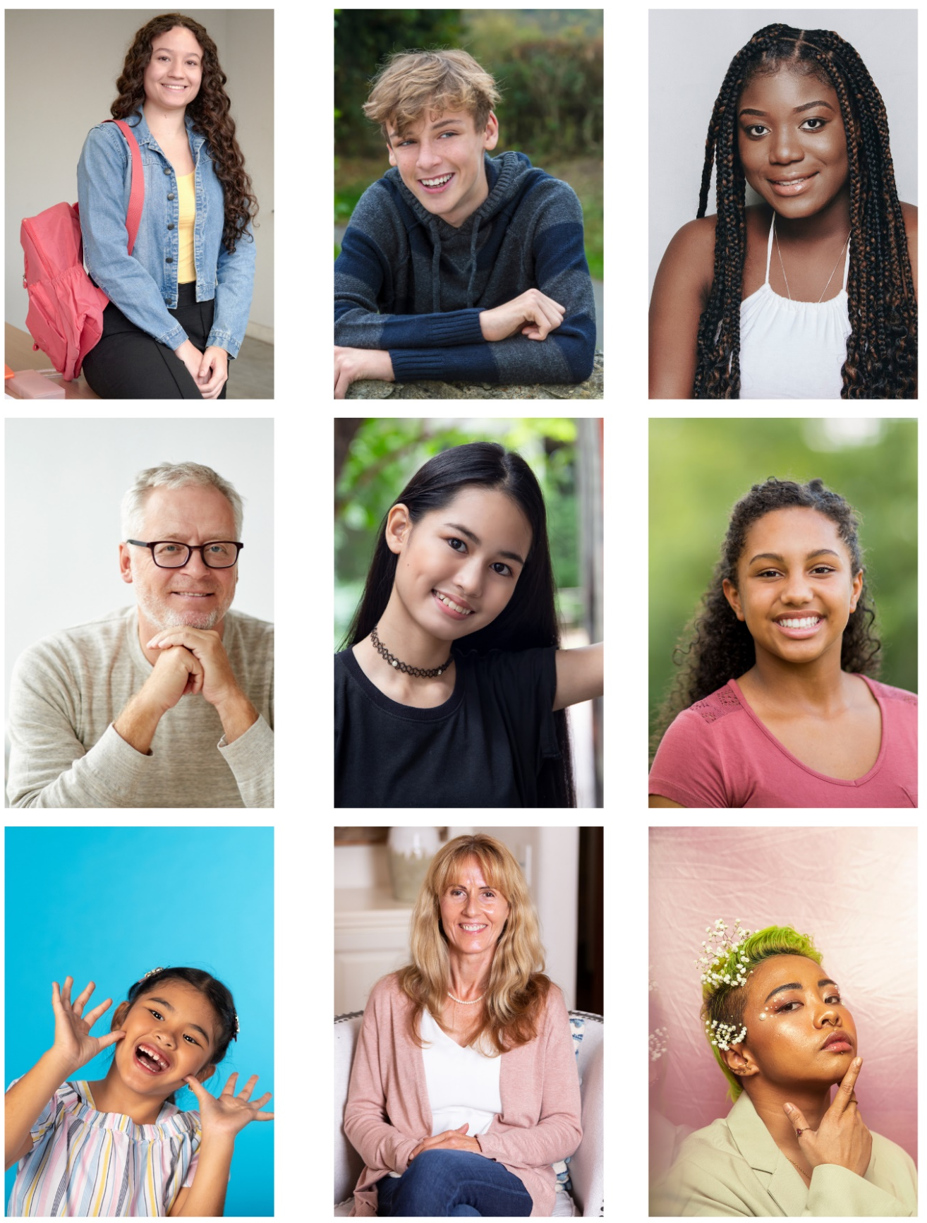

Printable activity sheet 3: Joni’s speech
Read Joni’s speech (page 282-290). How does Joni persuade both Belle and the reader? Find evidence for the following three core skills of persuasive writing below.
Logos: A clear argument that relates to Belle’s point of view. | Ethos: A speaker or writer who is a trustworthy expert. | Pathos: An emotional connection or story that makes Belle feel something.
Examples of this in Joni’s speech: | Examples of this in Joni’s speech and/or the rest of the book: | Examples of this in Joni’s speech:

Printable activity sheet 4: The Doctrine and Human Rights
What do our human rights look like under The Doctrine? Define each of the following rights, then think of an example where this might be denied in the novel.

Right and article | What does this right mean? | Example of this being denied to a character in You Could Be So Pretty
Article 2: Freedom from discrimination

Article 3: Right to Life, liberty and personal security

Article 7: Right to equality before the law

Article 17: Right to own property

Article 23: Right to desirable work and to join trade unions

Article 26: Right to education

